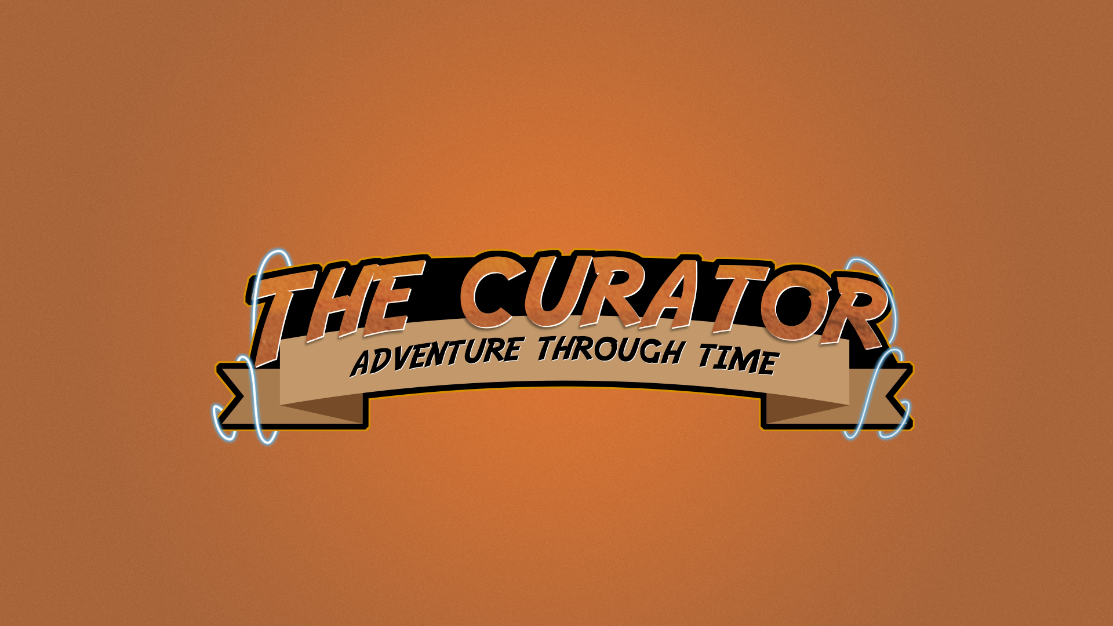

Gameplay styles will vary per level: from defeating increasingly difficult waves of enemies before facing a final boss battle, to stealth (sneak past the guards), to puzzle solving. All set in various times of the past/future or ‘Eras’.

**Target market**

There is a large established fan base for 2.5D top down games and the market for roleplaying games is even larger. The target demographic is all gamers between 18-40yrs old due to possible adult themes and extreme gore.

**Visuals**

The game is hand drawn in pixel art in a 2.5D style inspired by titles such as Hyper Light Drifter, the original Zelda games, and the original Pokémon games. Being simplistic encourages a greater focus on gameplay elements such as story, difficulty, and balance.

**But is it fun ?**

With aesthetic freedom to represent whichever time period or genre we choose, you never know what could happen next! By using random seeds and weighted percentages in level creation and enemy behaviour we ensure that no two playthroughs are alike.

**How is it different ?**

What makes our game stand out is the sheer variety of levels! The open ended nature of the protagonist’s task allows for great scope in storytelling and plot, both centric to each Era and overall throughout the game.

**Let’s talk about time . . .**

The beauty of the game concept is the great flexibility in design. Developers can work in pairs to produce a single Era or can collaborate for complex levels when faced with large challenges. With a series of short individual story lines specific to each Era, there is endless scope to increase the game length if desired.

**High concept**

You are the ‘The Curator’ a mysterious figure whose fashion sense is only surpassed by his ability with weapons! His aim is to acquire items for a futuristic museum.



