Welcome in the manual of your new game Lorann!

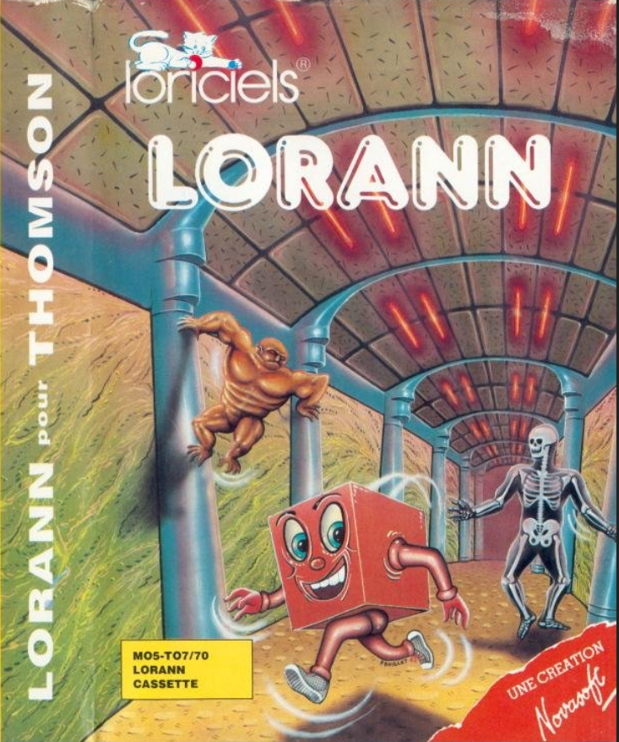

This manual will explain how to play this game and succeed in beating the demons!

SUMMARY

1: ENVIRONMENT 3

2: CONTROLS 5

3: CREDITS 6

Lorann, Great Wizard, the World of Nova-Ann needs you!

Release the five crypts possessed by the Mask of Nekron, touching the Energy Bubble which is in each of them.

Pick up the fabulous treasures waiting for you and your wealth will be immense!

Avoid the attacks of the four appalling Demons created by the infamous Nekron, skillfully using your very powerful multicolored Spell that obeys your will.

Glory is waiting for you, Lorann ... May the spell protect you!

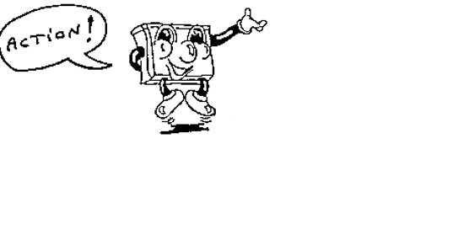

# 1: ENVIRONMENT

In this game, you will play Lorann a great wizard!



You will face many challenges in dangerous dungeons!

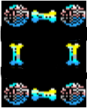

To escape, recover the energy sphere to open the door!



Careful! If you don’t have the sphere this magic door will kill you!



When you get the sphere run at the door!



The 4 demons of Nekron will prevent you from getting there! do not let them catch you!

 Arrbarr! The demon prince!

 Cargyv! The ghost king!

 Kyracj! The evil witch!

 Maarcg! The dangerous skeleton!

But do not worry! thanks to your talent and your magic powers you will be able to defeat them!

 You have only one magic spell to use! For use it again catch it!

# 2: CONTROLS

for movements, you use the arrow keys:

UP

LEFT 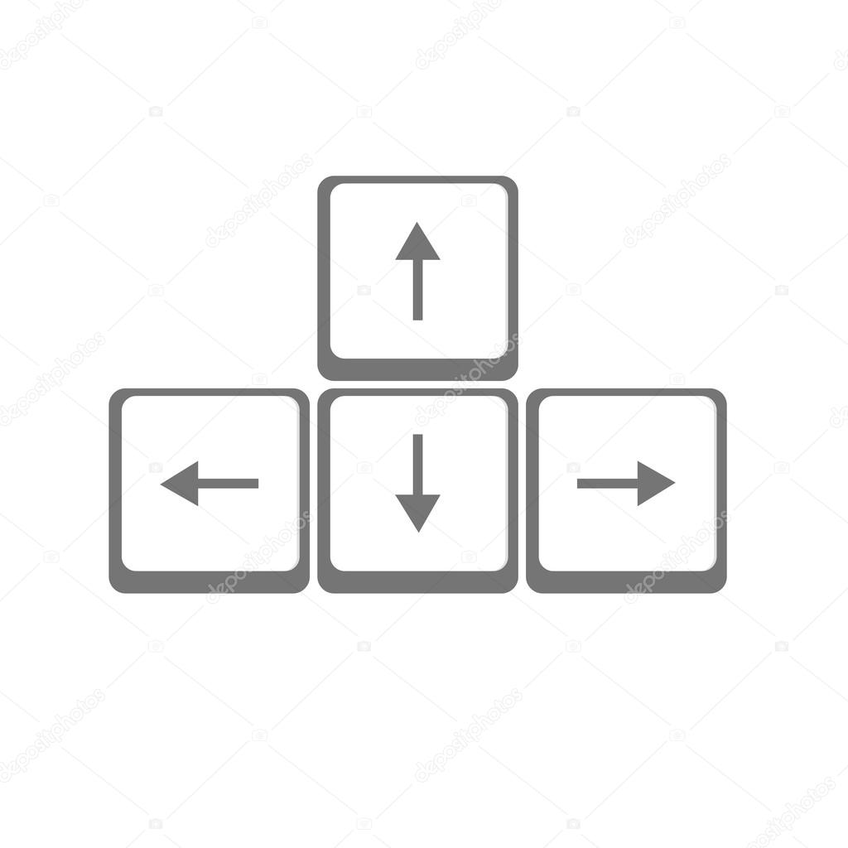 RIGHT

DOWN

For use the spell use the space bar:



# 3: CREDITS

Lorann the Game

BOULESTEIX Tristan

KARDOUS Jean-Pierre

AZZOUZI CLAUSEL Zacharia

MAITRE Maxime

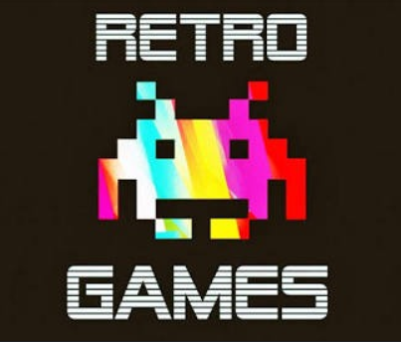

Résultat de recherche d'images pour "copyright" ALL RIGHTS RESERVED 2018 RETRO GAMES PRODUCTIONS