DRC Pay - Staff Guide
For the person who approves businesses
Table of Contents

This guide is for the person who approves businesses and manages who else can do that. You do not need to understand how the app is built to use it.
Almost everything happens on one page: the Staff page.

1. The three pages, and which one is yours
The app has three separate pages. They look similar, so it is worth knowing them apart.
Page | Who it is for | Address ends in
Staff page | You. Approve businesses, manage staff. | /staff/
Merchant page | Business owners taking payments. | /console/
Customer page | Shoppers paying a business. No sign-in. | /customer/
Your sign-in only works on the Staff page. If you try it on the Merchant page it will say the username or password is wrong. That is deliberate, not a fault: staff accounts and business accounts are kept completely separate, so neither can see the other’s information.
This catches people out because the plain web address sends you to the Merchant page. Add /staff/ to the end, and bookmark it.

2. Signing in
Open the Staff page address and sign in with your own staff username and password.
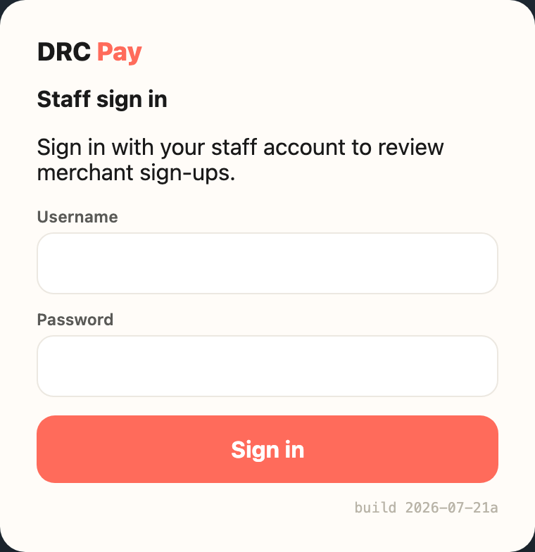
The staff sign-in form
That is the only password you need. If you reach a page that asks for a business name and payout number instead, you are on the Merchant page - add /staff/ to the address.

3. Approving a business
When a business signs up it lands in a waiting state. Until you approve it, that business cannot sign in and cannot take any money. Nothing happens automatically. It waits for you.
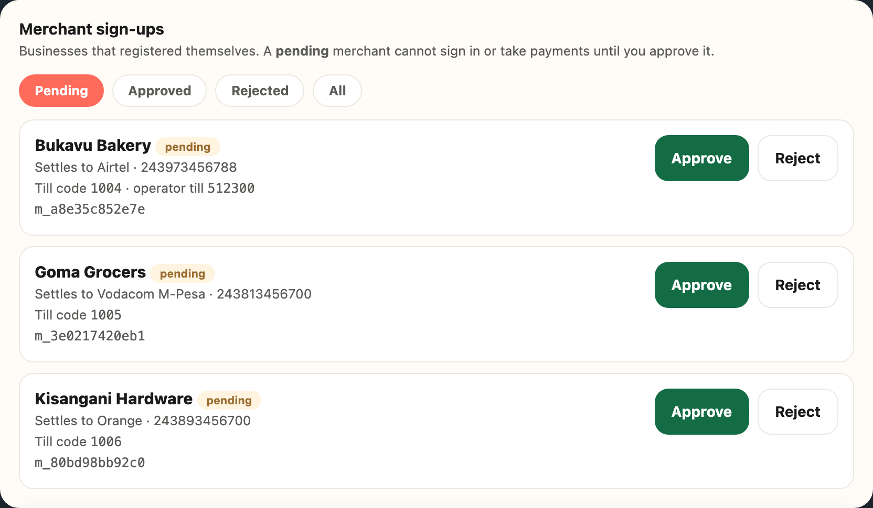
The list of businesses waiting for approval
- Sign in to the Staff page.
- Look at Merchant sign-ups. The Pending tab is already selected and lists everyone waiting.
- Read the details (see the table below).
- Click Approve or Reject.
The list updates by itself every few seconds, so a new sign-up appears without reloading.

What each detail means
On screen | What it means
Business name | What the owner typed when signing up. Nothing verifies it, so read it critically.
Settles to | The mobile money network and phone number where this business receives its money. The important one.
Till code | A short number the app assigns automatically. Customers can use it to pay from a basic phone. You do not choose it.
The long code starting m_ | The app’s internal reference. Ignore it unless someone technical asks.

Before you approve, check
- Does the business name look like a real business, not a test or a joke?
- Does the phone number look right for the network shown beside it?
- Do you recognise this business, or were you told to expect it?
Approving is what allows money to start flowing to that phone number. If anything looks wrong, do not approve it. Ask first. Approving the wrong account costs far more than making someone wait.

The four tabs
Tab | Shows
Pending | Waiting on your decision. Your daily work.
Approved | Already approved and able to trade.
Rejected | Turned down. Can be re-approved (see below).
All | Everything, whatever its state.

4. Changing your mind about a rejection
Rejecting is not permanent. Open the Rejected tab and the business shows a Re-approve button. Clicking it restores full access immediately, exactly as if you had approved it first time.
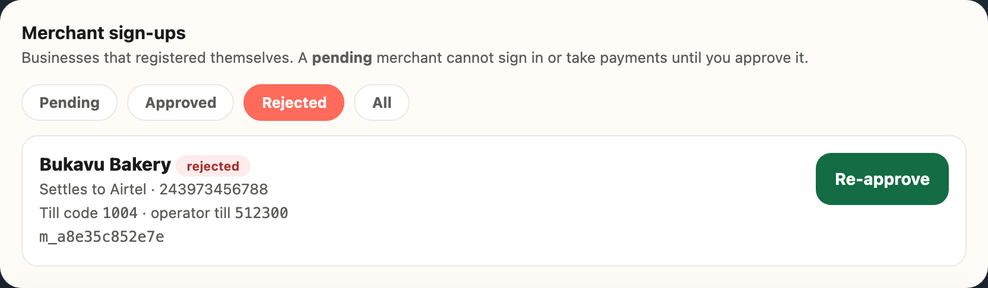
A rejected business showing the Re-approve button

5. Adding another staff member
Anyone you add here can approve businesses, exactly like you. Only add people who should have that power.
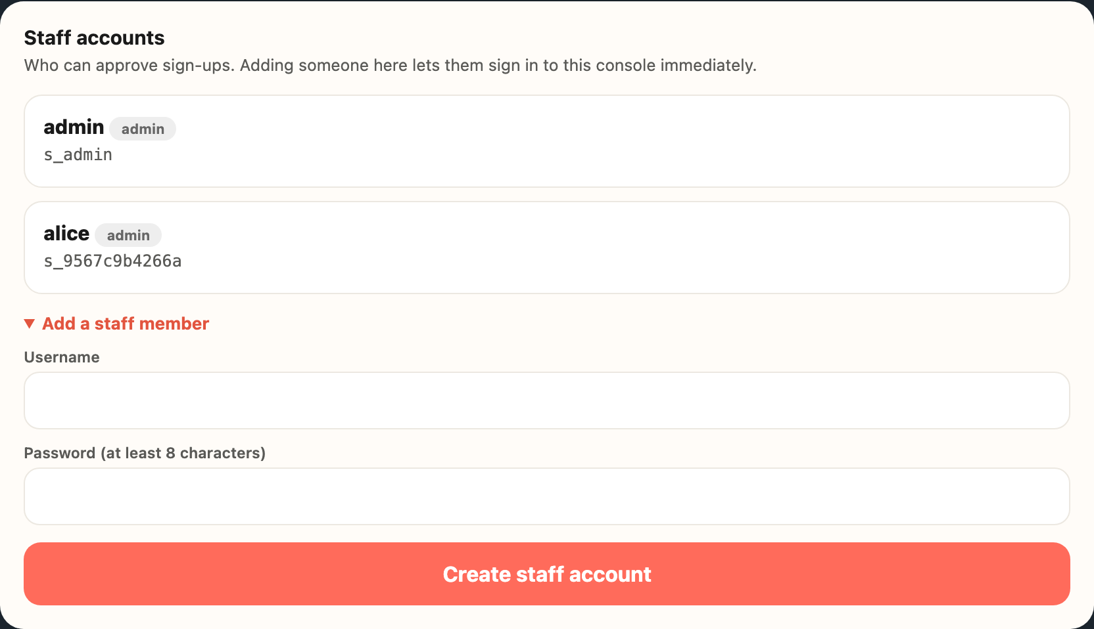
The staff accounts list and the form for adding someone
- On the Staff page, find Staff accounts. It lists everyone who currently has access.
- Click Add a staff member.
- Enter a username and a password of at least 8 characters.
- Click Create staff account.
They can sign in straight away on the Staff page.
Give them the password in person or by private message. Never by shared email or group chat.
If the username is taken you will see “That username is already taken.” Nothing changes when that happens, and in particular the existing person’s password is left alone. Choose another username.

6. What this page cannot do yet
Ask someone technical for these. The commands are in the appendix.
Task | Why it is not here
Reset a forgotten staff password | Needs a command run against the system
Remove a staff member who has left | Same. The app refuses to remove the last remaining account, so someone can always sign in
Suspend a business already approved | Not built yet

7. When something looks wrong
What you see | What it usually means
A business says it cannot sign in | Check the Approved tab. If they are not there, they are still in Pending (waiting on you) or Rejected. Approving or re-approving fixes it.
You cannot sign in yourself | Usually the Merchant page instead of the Staff page, or the wrong capital letters in the username. Otherwise ask for a password reset.
A payment looks stuck | Payments confirm on their own, usually within seconds, and anything still waiting is re-checked automatically. Not something you fix from this page.
Someone you do not recognise in Staff accounts | Treat it seriously and raise it at once. Anyone listed there can approve businesses, and so can direct money to a phone number.

8. Words you will see
Word | Meaning
Pending | Signed up, waiting on your decision, can do nothing yet
Approved (shown as active) | Can sign in and take payments
Rejected | Turned down and locked out, but can be re-approved
Settles to | The network and phone number where a business receives its money
Till code | The short number a customer dials to pay a business from a basic phone
Same-network payment | When a customer pays a business on the same mobile money network, the money goes straight to the business and the owner confirms they received it. It never reaches your page.

Appendix: for whoever helps you technically
These run against the deployed database and are not available in the browser.
Reset a password, or create an account outside the page:
python -m drc_pay_api.create_staff --username NAME
Remove a staff member. This signs them out everywhere, and refuses to remove the last remaining account:
python -m drc_pay_api.create_staff --username NAME --remove
The first staff account on a brand-new deployment comes from the DRCPAY_ADMIN_USERNAME and DRCPAY_ADMIN_PASSWORD settings. Changing the password setting and redeploying updates that same account rather than creating a second one.

