Web Forge 11 Site Plan

Sulaiman Waheeduddin

WDD 130

Overview

Purpose
This website showcases my web design work and demonstrates how I help small businesses improve their online presence. It features a portfolio of projects, information about the services I offer, client feedback, and a contact page for potential clients. The site is designed to be clean and simple, focusing on affordable and practical web solutions for small businesses.

Audience
Small business owners, entrepreneurs, and individuals who need a professional, modern website. They may not have a website or may have one that looks outdated, and they are looking for a practical solution.

Branding

Website Logo
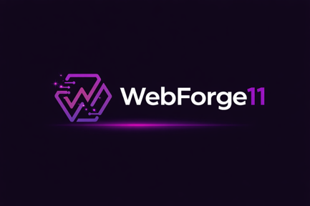

Style Guide

Color Palette
Primary | Secondary | Accent 1 | Accent 2
#3a015c | #11001c | #220135 | #190028

Typography

Heading Font: Zen Dots

Paragraph Font: Inter

Navigation
Home Services Projects

Content

Welcome to WebForge11
We build stunning, high-performing websites that bring your brand a powerful online presence.

Custom Design, Responsive Development, User-Friendly Interface

"Working with WebForge11 was an greet experience. The website they created for my business exceeded all expectations. It perfectly captures my brand. Communication was seamless, deadlines were met, and they went above and beyond to make sure every detail was perfect. I have received so many compliments on the site, and I could not be happier. Highly recommend!"
— James Walker

Basic Web Package
Affordable and professional. Get a clean, website with 1–3 pages including Home, About, and Contact. Perfect for small businesses or individuals starting online.

Premium Web Package
Complete, custom, and fully functional. A 5+ page website tailored to your brand, with custom design, and optional features like a portfolio or blog. Ideal for businesses looking for a full online presence that looks professional and performs flawlessly.

Images

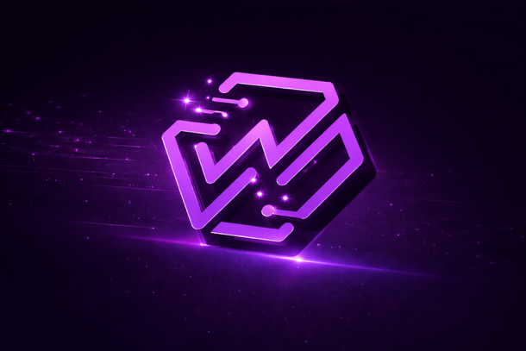


Wireframes

Home
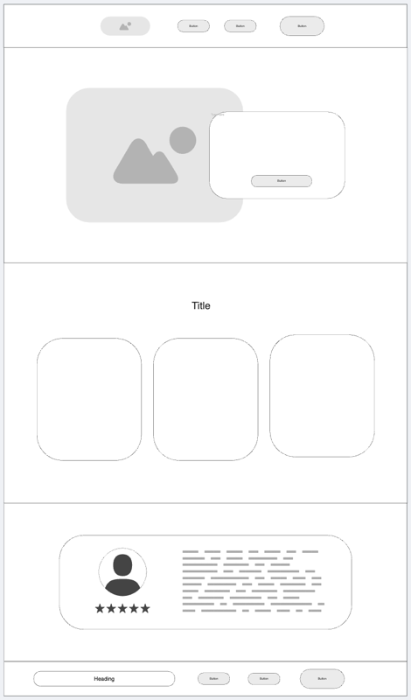

Child

