Credit Risk Modeling Documentation: SOTA Strategies
1. Temporal Dynamics (Capturing Velocity)
In credit risk, a "snapshot" of a borrower's financials is often less predictive than their direction of travel. Since your data likely tracks entities over time, you should capture the "velocity" of their financial health.
- Lagged Differences: Calculate the change between the current row and the previous row ($f_{t} - f_{t-1}$). A sudden drop in a feature like f1 (even if still high) is a major red flag for default.
- Rolling Window Statistics: Instead of a single point, use a moving average or moving standard deviation (e.g., a 3-period window). This smooths out seasonal noise and identifies volatility in the borrower's behavior.
- Slope Calculation: For key features (f1–f11), calculate the simple linear trend over the last few observations to see if the borrower is improving or deteriorating.

2. Sector-Level Normalization (Relative Risk)
Credit metrics are highly contextual. A "Small" company in the "Real Estate" sector has a different risk profile and financial structure than a "Large" company in "Wholesale."
How to implement on your dataset:
For each continuous feature ($f1$ to $f11$), you should calculate a Grouped Z-Score. This tells the model how an entity compares to its direct peers rather than the entire market.
$$f_{norm} = \frac{x - \mu_{sector, size}}{\sigma_{sector, size}}$$
- Implementation: Group your data by both sector and size. Calculate the mean ($\mu$) and standard deviation ($\sigma$) of f1 within those groups.
- The Result: A feature value of 2.0 would now mean "This borrower is 2 standard deviations above the average for their specific industry and size," which is a much cleaner signal for a machine learning model.

3. Feature Interactions (Financial Ratios)
Gradient Boosting Trees are good at finding interactions, but they are "greedy" and may miss complex ratios. Manually creating "Domain Logic" features often provides the winning edge.
- Multiplicative & Divisive Interactions: If f1 represents assets and f2 represents liabilities, creating a new feature f1 / f2 (Solvency) is more powerful than letting the model try to approximate that division through tree splits.
- Categorical-Numerical Aggregates: Create features like "The average f3 for this sector." This allows the model to see if a specific borrower is an outlier compared to their industry's average risk.

4. Stacking & Boosting Architecture
The final "Winning" architecture involves an ensemble of diverse models.
- Diverse Base Learners: * LightGBM: Fast, leaf-wise growth; excellent for large datasets and capturing fine-grained patterns.
  - CatBoost: Specifically handles your sector and size factors natively, reducing the need for manual one-hot encoding.
- The Meta-Learner (Stacking):
  - Train the boosting models using Cross-Validation.
  - Collect the "Out-Of-Fold" (OOF) predictions (the probabilities).
  - Use these probabilities as the only inputs for a Logistic Regression or Ridge Regressor.
  - Result: The Meta-Learner corrects the biases of the individual models, significantly increasing the Gini/AUC score.
5. Graph-Based Peer Features
Financial entities don't exist in a vacuum. They are connected by sector, size, and geography.
- The Idea: Use Graph Neural Networks (GNN) or simpler Graph-Aggregated Features.
- How to do it here:
  - Treat each sector as a node in a graph.
  - Calculate the "Sector Health" (average $y$ or average $f_i$) and map it back to the individual.
  - Advanced: Create a feature that measures "Distance to Sector Leader"—how much better or worse is this company (f1–f11) compared to the top 10% of companies in the same size and sector.

-------------------------------------------------------
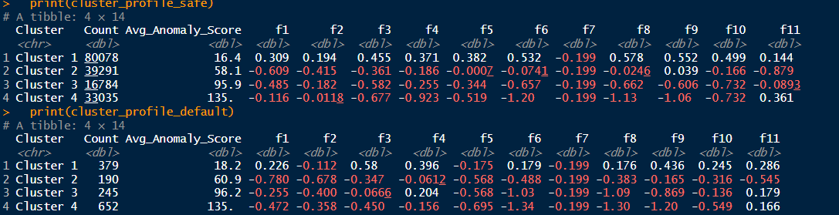

1. Feature Analysis: The "Big Four" Drivers
- f5 (Cash / Kassenbestand): The Liquidity Trap
  - The Finding: Defaulters in "healthy" clusters have negative median cash (-0.175) compared to non-defaulters (+0.382).
  - Accounting Reality: This is the most critical predictor of False Negatives. A company can report a profit (Accrual Accounting) but still fail if it lacks the physical cash to pay bills (Cash Accounting). This suggests Illiquidity Insolvency—the firm is solvent on paper but liquidly dead.
- f6 (Equity / Eigenkapital): The Solvency Buffer
  - The Finding: Defaulters consistently show lower median equity. Even in the "Safe" Cluster 1, defaulters have significantly less equity buffer (0.179) than survivors (0.532).
  - Accounting Reality: Equity is the "distance to bankruptcy." Lower equity means less ability to absorb shocks. When f6 turns negative (as in Safe Cluster 4, median -1.20), the company is technically Over-indebted (Überschuldet).
- f8 (Net Profit / Bilanzgewinn): The Performance Metric
  - The Finding: Defaulters in Cluster 1 have much lower median profit (0.176) compared to non-defaulters (0.578).
  - Accounting Reality: Profit generates new equity. Low profit (f8) combined with low cash (f5) creates a "death spiral" where the company cannot reinvest or pay down debt, leading to eventual default even if the balance sheet looks "okay" today.
- f11 (Liabilities / Verbindlichkeiten): The "Zombie" Paradox
  - The Finding: In "False Positive" groups (Safe Cluster 4), liabilities are surprisingly high (0.361), and higher than in healthy groups (0.144).
  - Accounting Reality: This creates the False Positives. High liabilities usually signal risk, but for companies with negative equity (f6), high liabilities likely represent Internal Funding (Shareholder loans or Parent Company support). Investors are keeping the "Zombie" alive by pumping in debt, which prevents the default the model expects.

