Title page (Slide 1):
- Good morning. Welcome to my master’s thesis proposal presentation.
- Today, I would like to introduce my thesis topic: “The Agony and the Ecstasy – constructing a “crash-filtered” equity index using Machine Learning.
- I am very thankful that you, Prof. Hornik, agreed to supervise my thesis!
Motivation (Slide 2):
- Passive investors face a dilemma. While indices capture 'Ecstasy' stocks—extreme winners like NVIDIA—they also force investors to hold 'Agony' stocks that implode and never recover.
- Cembalest (2014) notes that the Russell 3000 Index is driven by a small tail of extreme winners, while approx. 40% of index constituents are negative return contributors, with many suffering “catastrophic declines” without recovery.
- Tewari et. al (2024) formalize these events as Catastrophic stock implosions (CSI):
A CSI is a distinct event, in which a severe price downturn is followed by a “zombie” period of prolonged stagnation.
- By investing passively, one captures the winners, but fails to filter the “Agony” of stocks until it is too late. Many methods to identify and filter these imploding stocks, such as low-volatility or bankruptcy-indicators (like Altman’s Z-score), have been tried out. Yet, they fail to accurately distinguish between recoverable volatility and terminal implosion. And in the end, as a long-term investor terminal wealth outcomes are the crucial factor.
Research Question (Slide 3):
- Now, let’s dive into my proposed research questions.
- The main research question asks to what extend does a “crash-filtered” equity index, constructed via probabilistic implosion modeling, generate superior risk-adjusted returns compared to the market benchmark and traditional minimum-volatility strategies?
- This RQ is the core of my thesis: Can one use Machine Learning to ex-ante identify CSI events and can these model predictions be used to construct a smarter, “crash-filtered” equity index?
- This is supported by three sub-questions:
- Feature Engineering: How do Autoencoders impact Average Precision compared to raw data?
- Filtering: Do Ensemble methods reduce the False Positive Rate compared to traditional volatility strategies, while maintaining Recall? This validates the ML approach over simple filtering.
- Feature Importance: Which features specifically distinguish 'zombie' firms from normal firms? With it, one can find out if there are particular features, which are useful for predicting CSI events.
Limits of traditional models (Slide 4):
- When modeling CSI-events traditional models suffer from two major drawbacks:
- The Quality Trap: Features are often hard-coded. For example, a low Book-to-Price ratio is traditionally a value signal, but Penman and Reggiani (2018) suggest it often reflects uncertainty rather than value. Thus, perceived safety signals can be misleading when using “conventional” wisdom.
- Secondly, in many instances, traditional models face a false positive dilemma. They fail to distinguish between “good” volatility (high growth firms with uncertain future cash-flows) and “bad” volatility (stock implosions). Thus, they systematically exclude at least some of the winners.
Methodology I (Slide 5):
- To answer the previously stated research questions, I propose the following research design:
- First, the response/dependent variable needs to be set up for modelling. Following Tewari et. al (2024), a stock is classified as a CSI if it satisfies:
- In the first step, it suffers from an initial crash; a drawdown of more than 80% from the trailing peak, which initiates the zombie period.
In the zombie period, two conditions need to be fulfilled:
- The stock must have a maximum cumulative return of -20% in the zombie period.
- The zombie period lasts for a minimum duration of 1.5 years.
- In this context, a yearly prediction horizon is used for the classification of the response:
- To summarize, the response y_i at time t is a 1 if the stock c triggers a minimum C of 80% within t to t+h and the zombie criteria are met, otherwise the firm is not suffering from a CSI.
Methodology II (Slide 6):
- Having now set up the data generating process, we can look into the modelling stage.
- I use Autoencoders to test for feature denoising and signal generation.
- I apply Ensemble methods (like Random Forest and Boosting) to predict CSI probability. I use Average Precision (AP) as the loss metric during cross-validation. Since the dataset is imbalanced, AP is more robust than accuracy. Crucially, model selection is evaluated on Recall at a fixed False-Positive Rate. This aligns with a portfolio 'Risk Budget'—maximizing the identification of Agony stocks while capping the accidental exclusion of Ecstasy stocks."
Methodology III (Slide 7):
- For modelling and index-construction the dataset will be split into three parts:
- A training set for cross-validation.
- A test set for model-selection
- And an Out-of-Sample / Out-of-Time set for backtesting the constructed index.
- At the core of my thesis is index construction. The “crash-filtered” index systematically excludes stocks where the predicted probability of a CSI is greater than a desired FPR-rate (theta). This threshold theta can be dynamically calibrated to satisfy a specific tracking error / risk constraint to ensure that the exclusion rate aligns with the investor’s “budget” for opportunity cost.
Data – CRSP (Slide 8):
- Now, let’s get more hands on and look into the proposed dataset. The thesis relies on the WRDS-database for the CRSP and COMPUSTAT data.
- The universe for the CRSP dataset are all US common equities traded on the NYSE, AMEX and NASDAQ from 1998 to 2024. Originally, I planned to use all data from 1960 to 2024, but the required Compustat data for the accounting features is not available for the whole timespan.
- Constraint.
- In total, the current dataset includes a total of 2,236 CSI events. Table 1 shows the categorization of CSI events dependent on the event time.
- When comparing the imploded firms (CSI events) and the firms never suffering from a CSI, the difference in the Value-Destruction categories is astonishing. 64.8% of firms, which at least imploded once, are classified as “Value” destroyers, meaning that their geometric annual return was lower than -2% in their lifetime even though they made some temporary recoveries. In the “control” group, the firms, which never imploded, only 15.4% fall in the same category. Imploding firms are also much less likely have a high or moderate growth rate over their lifetime.
- Thus, the CSI methodology seems to make sense in distinguishing these distributions of stocks.
Data – Compustat (Slide 9):
- For the features, Compustat is used to access the accounting variables (like balance-sheet and income-statement items).
- In addition, I propose using Macro variables, obtained from the FRED-database, to look into possible interactions with the accounting variables.
Expected Contribution (Slide 10):
- With this thesis, I would like to make three specific contributions:
- First, I want to replicate the results of Tewari et al. (2024) using the CRSP and Compustat datasets and explore whether one can arrive at a similar conclusion.
- Secondly, I would like to extend the results by including autoencoders for extracting the information in the features and by using the model-predictions for index construction.
- Last but not least, I want to challenge traditional risk-scaling approaches:
Ideally, I would like to show that ML applications are better suited to distinguish between Ecstasy and Agony stocks compared to classical risk-scaling methods.

1. Average Precision (AP)
General Definition:
Average Precision is a single-number metric used to evaluate the performance of object detectors or binary classifiers, particularly when dealing with imbalanced datasets or ranking tasks. It summarizes the Precision-Recall curve by calculating the weighted mean of precisions achieved at each threshold.
Formula:
For a set of thresholds where the recall changes, AP is calculated as:
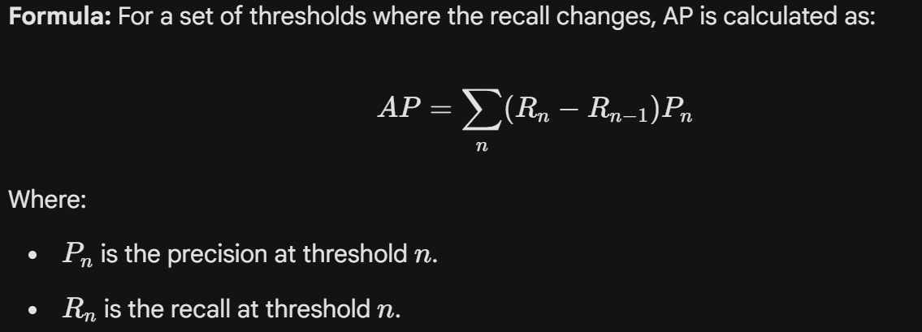
Where:
- $P_n$ is the precision at threshold $n$.
- $R_n$ is the recall at threshold $n$.
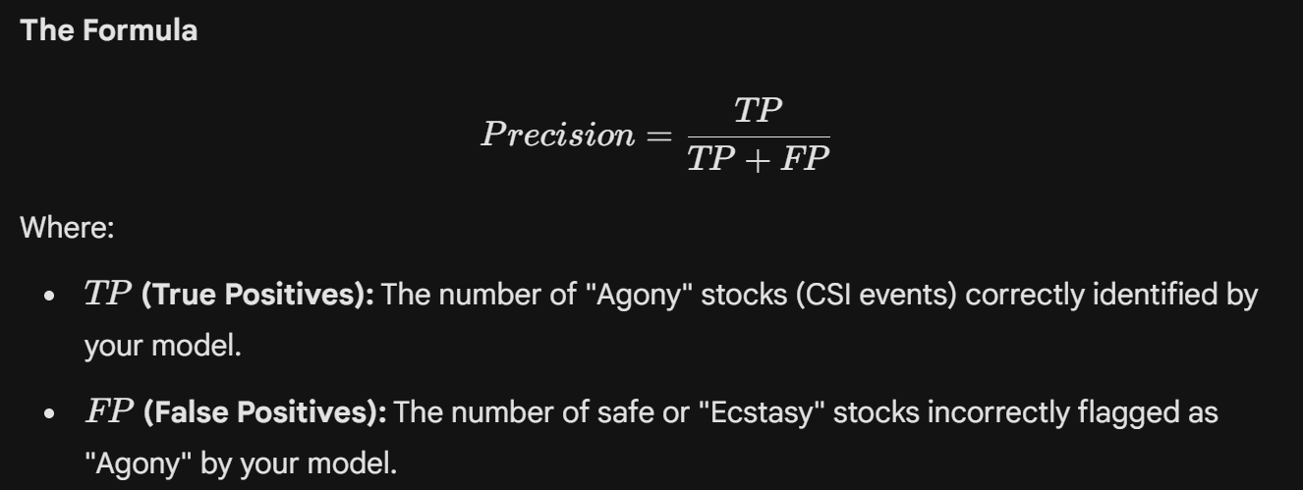
In your Thesis: You use AP as the loss metric within cross-validation because your dataset is imbalanced. It allows you to tune hyperparameters based on the quality of the model's ranking (separating "Agony" from "Ecstasy") without committing to a specific decision threshold ($\theta$) prematurely.
2. Recall (Sensitivity)
General Definition:
Recall (also known as Sensitivity or True Positive Rate) measures the proportion of actual positive cases that the model correctly identified. In risk modeling, high recall means capturing most of the danger signals.
Formula:
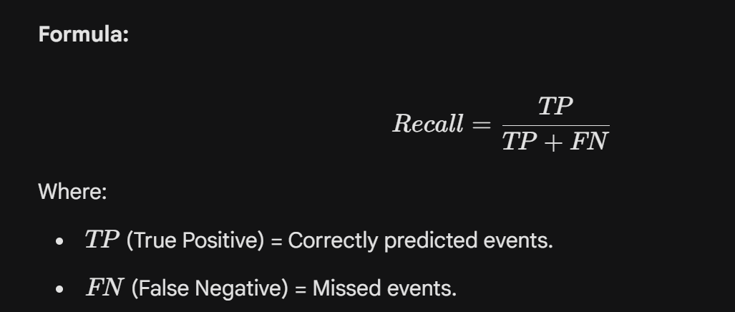
Where:
- $TP$ (True Positive) = Correctly predicted events.
- $FN$ (False Negative) = Missed events.
In your Thesis: Your objective is to maximize Recall (identifying the "Agony" stocks). However, simply maximizing Recall often destroys returns by flagging everything as dangerous. Therefore, you evaluate Recall at a fixed False-Positive Rate (FPR) to align with a practical "Risk Budget".

3. Altman’s Z-Score
General Definition:
The Altman Z-Score is a financial formula developed by Edward Altman (1968) to predict the probability of a company going bankrupt within two years. It is a linear combination of five financial ratios, weighted by coefficients estimated from historical data.
What it does:
It classifies firms into three zones:
- Safe Zone: Low probability of bankruptcy.
- Grey Zone: Uncertain.
- Distress Zone: High probability of bankruptcy.
The formula is expressed as:
$$Z = 1.2X_1 + 1.4X_2 + 3.3X_3 + 0.6X_4 + 1.0X_5$$
Here are the specific ratios used:
- $X_1$: Working Capital / Total Assets
  - Measures: Liquidity. It indicates the company's ability to cover short-term obligations with short-term assets relative to its size.
- $X_2$: Retained Earnings / Total Assets
  - Measures: Cumulative Profitability (and leverage). This ratio effectively measures the age and earning power of the firm. Young firms (often the "Ecstasy" stocks in your thesis context) often have lower retained earnings.
- $X_3$: Earnings Before Interest and Taxes (EBIT) / Total Assets
  - Measures: Operating Efficiency. This is often considered the most heavily weighted component ($3.3$) because it measures the productivity of the firm's assets independent of tax or leverage factors.
- $X_4$: Market Value of Equity / Book Value of Total Liabilities
  - Measures: Solvency and Market Confidence. This introduces a market dimension, showing how much the firm's assets can decline in value (measured by market cap) before liabilities exceed assets.
- $X_5$: Sales / Total Assets
  - Measures: Asset Turnover. It indicates how effectively the firm uses its assets to generate sales.

4. Category definition specifics.
geometric_mean > 0.10 ~ "High Growth (>10%)",
geometric_mean > 0.05 & geometric_mean <= 0.10 ~ "Moderate Growth (5-10%)",
geometric_mean >= 0.02 & geometric_mean <= 0.05 ~ "Low Growth (2-5%)",
geometric_mean <= 0.02 & geometric_mean > -0.02 & max_annual_ret < 0.15 ~ "Stagnation (-2-2%)",
geometric_mean <= -0.02 & max_annual_ret < 0.02 ~ "Value Destruction (No Recovery)",
geometric_mean <= -0.02 ~ "Value Destruction (<-2%)",

