Research questions/topics:
We want to model how order flows (buys and sells) impacts prices during FOMC announcements (the release of the FOMC minutes and the subsequent speech by the chairman of the Federal Reserve System. To do so, we utilize a Kyle (1985) model to research whether larger orders have a price impact, because they likely contain some measure of informed trading.
In addition, we want to explore whether there is a difference between the announcement of the minutes data and the informational processing of the speech. In the former, public information should be processed simultaneously whilst in the later, during subperiods, it could be possible to find a significant lambda due to new information being released.
Theory: How much do prices move in response to order flow? Lambda measures the price impact.
In Kyle's theoretical model, an "Insider" (informed trader) strategically breaks up their trades to hide among "noise traders" (uninformed). Market makers, who are not informed, see the total order flow and must update their price based on how likely they think it is that the order came from an insider.
A large order is more likely to be from an insider, so the market maker moves the price more to protect themselves. The coefficient you are estimating, Kyle's Lambda ($\lambda$), is precisely this: the degree to which market makers move prices in response to order flow.
It's a measure of illiquidity or price impact. A high $\lambda$ means the market is very sensitive to order flow, believing it to be highly "informed."
The Model: delta_p ~ d_t + q_t + delta_d_t
The Terminology: This specific empirical model is a classic specification from Glosten & Harris (1988) or Hasbrouck (1991). It's the standard way to estimate the parameters (like Kyle's $\lambda$) from real-world tick data.
Your Variables:
- q_t (Signed Volume): This is your key variable. The coefficient on q_t is your estimate of Kyle's Lambda ($\lambda$). It measures the permanent, informational price impact per share (or unit of SIZE).
- d_t (Trade Direction): The coefficient on d_t captures the fixed component of price impact—the part that's just due to a trade happening (e.g., fixed adverse selection costs), regardless of its size.
- delta_d_t (Change in Direction): This is a clever and crucial control variable. As you correctly noted, it captures the transient bid-ask bounce. A negative coefficient (which is very common) confirms your interpretation: a buy following a sell (or vice-versa) causes a price "reversal" as the price bounces from one side of the spread to the other. This is not information, just market mechanics.
Theory: PIN/VPIN-model
Structural model based on trade arrivals. What is the probability that informed traders are active? It measures the likelihood of information.

Extensions: Rolling regressions.
We can conduct rolling regressions within shorter time-periods (per minute) and match it to the content of the transcript (with the exact timestamp) of the FOMC speech. Then we need to classify the informational content in that part of the speech and investigate how it was priced in.

Appendix: VPIN-Example
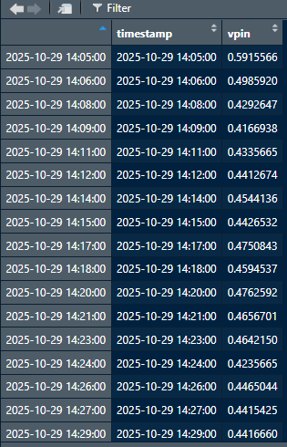

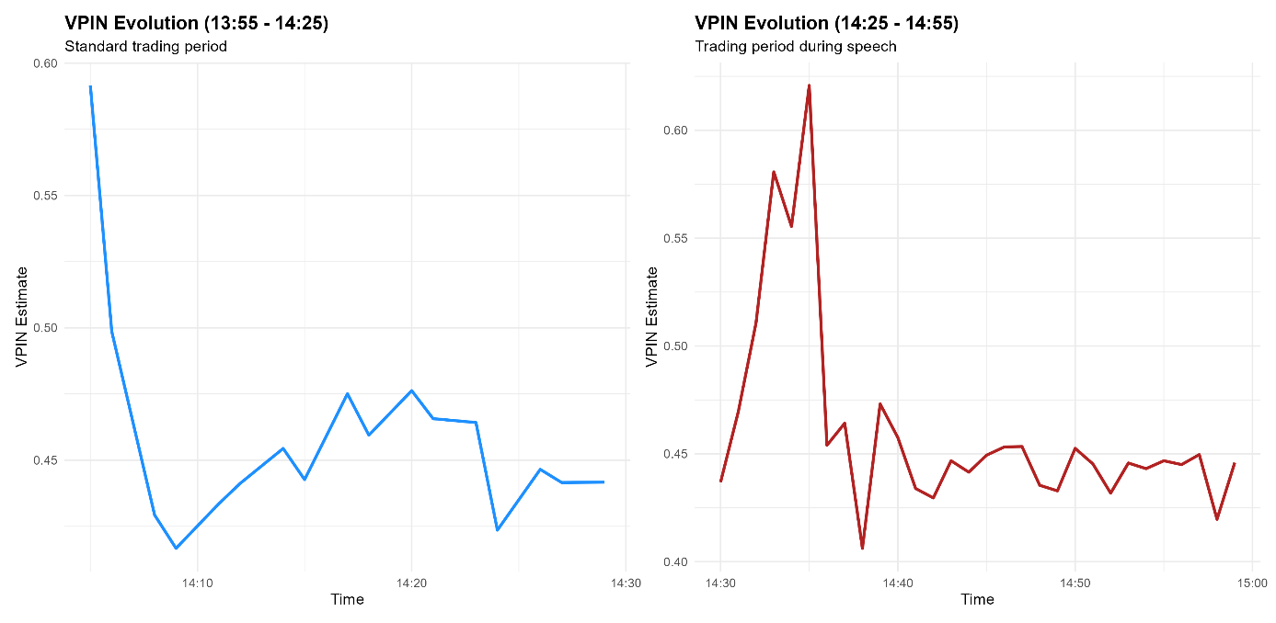

Yes, you have captured the core intuition perfectly.
A spike in the VPIN measure during an event like an FOMC speech or the subsequent Q&A session is the direct signal that the market is collectively digesting information it deems to be of real, immediate value.
Here is a more detailed breakdown of that chain of events and why the VPIN is designed to capture it:
The Chain of Events: From Speech to Spike
- Release of Valuable Information:
During a normal trading period (like your 13:55-14:25 dataset), the order flow is relatively balanced. There are buyers and sellers acting for a variety of reasons (portfolio adjustments, liquidity needs, etc.). This results in low order imbalances within each volume bucket, and consequently, a low and stable VPIN.
- Creation of "Informed" Traders:
When the FOMC official speaks, they might say something that is new, unexpected, or confirms a market bias with high certainty. For example:
  - A more hawkish tone than expected (suggesting faster interest rate hikes).
  - A more dovish tone than expected (suggesting a pause or cuts).
  - A surprising detail about the economic outlook.
In that instant, a group of traders (hedge funds, institutional desks, algorithmic systems) process this information faster than the rest of the market. They become, for a brief period, the "informed traders". They have a strong conviction that the market is now mispriced.
- Urgent, One-Sided Trading:
These informed traders must act urgently to capitalize on the information before the rest of the market catches up and the price moves.
  - If the news is bearish, they will aggressively sell, hitting the bid to get their orders filled immediately.
  - If the news is bullish, they will aggressively buy, lifting the ask.
This creates a sudden, massive, and one-sided flow of orders.
- High Order Imbalance (What VPIN Measures):
This aggressive, directional trading floods the market. Inside the VPIN calculation:
  - Volume buckets fill extremely rapidly because of the high trading activity.
  - Within each of these newly completed buckets, the volume is heavily skewed. For example, a bucket might contain 80% seller-initiated volume and only 20% buyer-initiated volume.
  - This results in a very high order imbalance for each new bucket.
- The VPIN Spike:
The VPIN is a rolling average of these order imbalances. As the new, highly imbalanced buckets are added to the rolling window (and the old, balanced buckets from before the speech are dropped), the average skyrockets.
The VPIN spike is the mathematical representation of this temporary, but intense, imbalance between aggressive buyers and sellers.
The Market Maker's Perspective
From a market maker's point of view, this VPIN spike is a critical warning signal for order flow toxicity. It tells them:
"Warning: The order flow is no longer random. There is a high probability that a significant portion of incoming orders are from traders who know something you don't (or have processed it faster). If you continue to provide liquidity passively, you are likely to be on the wrong side of a large price move."
This is why they would immediately take defensive action, such as widening their spreads or reducing their exposure. The VPIN doesn't analyze the content of the speech; it simply and effectively measures the market's reaction to it as expressed through the order flow.

Analysis: Correlating the VPIN Pattern with FOMC Announcements
Yes, the dramatic difference between the two periods strongly suggests the VPIN measure is capturing the precise moments when high-value, market-moving information from the FOMC event is being released and acted upon.
Your hypothesis about the sequence of events is highly plausible and aligns perfectly with how these announcements typically unfold:
- The "Standard" Period (13:55 - 14:25):
  - Anticipation Phase: This is the calm before the storm. Trading volume is often lower as institutions and traders are "pencils down," waiting for the new information.
  - Initial VPIN Drop: The sharp drop at the beginning of your blue chart is likely the market settling after the 2:00 PM (14:00) FOMC statement release. Algorithmic traders would have instantly parsed this text document, leading to an initial flurry of activity that subsides within minutes. Your chart beautifully captures the tail-end of this, showing VPIN returning to a low, stable "equilibrium" by around 14:10.
  - Baseline Established: The period from 14:10 to 14:25, where VPIN fluctuates in a relatively low and contained range, represents the market's baseline level of order flow toxicity while it waits for the next catalyst: the press conference.
- The "Speech" Period (14:25 - 14:55):
  - The Main Event (Starts 14:30): The Fed Chair's press conference begins at 2:30 PM (14:30). This is where the unscripted, nuanced information comes out.
  - The VPIN Spike: Look at your red chart. The VPIN begins its dramatic ascent almost exactly at 14:30. This is the signal. As the Chair begins speaking, traders (both human and algorithmic) are parsing the prepared remarks and the live tone for any deviation from the written statement.
  - Peak Information Content: The VPIN peaks sharply around 14:35 at a very high level (over 0.60). This pinpoints the moment the market digested the most surprising or impactful piece of information. This could have been a specific phrase in the prepared remarks or a response to an early question in the Q&A session that had significant implications. This is the point of maximum order imbalance, where "informed" traders are aggressively acting in one direction.
  - The Aftermath: After the peak, the VPIN rapidly decreases but doesn't immediately return to the pre-event baseline. It settles into a new, elevated, and volatile state. This perfectly represents the Q&A session, where follow-up questions can introduce smaller, secondary waves of news and uncertainty, keeping the market on edge and order flow more imbalanced than normal.
In short, the VPIN is acting as a real-time "information seismograph," with the spike's magnitude corresponding to the significance of the informational "earthquake."

To-Do:
Your observation is a compelling case study. To turn it into a robust and defensible finding, you need to prove that this pattern is not a coincidence. Both of your suggestions are excellent and form the basis of a solid research methodology.
Here are the logical next steps, combining and expanding on your ideas:
1. Broaden the Time Period (Strengthen the Event Study)
Before comparing across days, strengthen the analysis of this specific day.
- Establish a More Robust Baseline: Instead of just 5 minutes, plot the VPIN for the 60-90 minutes leading up to 14:00. This will give you a much more stable and reliable "normal day" VPIN level to compare against, making the subsequent spikes appear even more statistically significant.
- Analyze the "Information Decay": Extend the analysis to 60 minutes after the press conference ends (e.g., until 16:00). This will allow you to measure how long it takes for the market to fully digest the new information and for the VPIN to revert to its baseline mean. This is a powerful metric for market efficiency.
2. Compare with Control Days (Test for Specificity and Repeatability)
This is the most critical step for validation. You need to show that this VPIN behavior is unique to these types of events.
- Control Group 1: Non-Event Days:
  - Action: Run the exact same VPIN analysis on several randomly selected trading days that had no major scheduled economic releases.
  - Hypothesis: On these "boring" days, the VPIN should remain relatively low and stable throughout the 14:00-15:00 period, without any of the dramatic spikes seen on the FOMC day. This proves that the spike is not just random daily noise.
- Control Group 2: Other FOMC Days:
  - Action: Repeat the analysis for the last 6-8 FOMC announcement days.
  - Hypothesis: You should observe a similar pattern of VPIN spikes clustered around 14:00 (statement) and 14:30 (press conference) on most, if not all, of these days. This demonstrates that the phenomenon is repeatable and reliably linked to the FOMC event itself. You could even go a step further and correlate the magnitude of the VPIN spike with how "surprising" the FOMC announcement was, as determined by analyst consensus.
- Control Group 3: Other High-Impact News Events:
  - Action: Analyze a different type of major scheduled release, such as the monthly Non-Farm Payrolls (NFP) report, which is released at 8:30 AM ET.
  - Hypothesis: You should see a significant VPIN spike precisely at 8:30 AM on NFP days, but not at 14:30. This demonstrates the specificity of the VPIN signal—it spikes when and where the valuable information is released.

Additional:
Yes, that is an excellent time window to use. Downloading data from 12:30:00 to 16:00:00 ET is the ideal approach for a robust event study of an FOMC announcement.
It provides a comprehensive view by perfectly segmenting the trading day into the three critical phases of analysis: before, during, and after the event.
Here is a breakdown of why that specific window is so effective:
Why the 12:30 to 16:00 Window is Ideal
1. The Pre-Event Baseline (12:30 - 14:00)
- Purpose: To establish a clean, stable "control" period on the same day as the event.
- What it Captures: This 90-minute window shows how the market behaves when it is purely in an anticipatory state. Trading volume often subsides, and major players are hesitant to take on large positions.
- What to Look For: In your VPIN chart, this period should show a relatively low and stable VPIN level. This is your baseline against which the subsequent event-driven spikes will be measured, making their significance undeniable.
2. The Core Event Window (14:00 - ~15:00)
- Purpose: To capture the market's real-time reaction to the two main information releases.
- What it Captures:
  - At 14:00:00: The initial, instantaneous reaction to the release of the written FOMC statement. This is primarily processed by algorithms.
  - From 14:30:00 onwards: The more complex, nuanced reaction to the Fed Chair's live press conference and Q&A session. This is where human interpretation and new, unscripted information drive trading.
- What to Look For: You should look for two distinct patterns here: a very sharp, but possibly brief, VPIN spike exactly at 14:00, followed by the larger, more sustained spike starting at 14:30 that you've already identified.
3. The Post-Event Digestion ( ~15:00 - 16:00)
- Purpose: To measure the "information decay" and see how long it takes for the market to absorb the news and return to a normal state.
- What it Captures: This period shows whether uncertainty lingers or if the market has quickly reached a new consensus. The press conference typically ends around 15:15-15:30. This window gives you ample time to see the aftermath.
- What to Look For: You will be able to observe how quickly the VPIN falls from its elevated state after the press conference ends. Does it revert back to the pre-14:00 baseline before the market closes at 16:00? Or does it remain elevated, suggesting that the news has introduced lasting uncertainty into the market?
Summary of Your Improved Research Plan:
- Data Collection:
  - Event Day: Download trade and quote data for your FOMC day from 12:30 to 16:00.
  - Control Days: Download data for the exact same time window (12:30 to 16:00) on at least 3-5 other recent trading days that had no major economic news scheduled.
- Analysis:
  - Run your continuous VPIN simulation on all datasets.
- Visualization:
  - Create a multi-panel plot using patchwork. Show the FOMC day on top and a few of the control days below it, all on the same time axis.
This approach will provide a very strong and visually compelling argument. It will clearly demonstrate that the VPIN spikes are not random market noise but are a direct, measurable consequence of the high-value information being released during the FOMC event.

