WRDS TAQ: Quote:
https://wrds-www.wharton.upenn.edu/pages/get-data/nyse-trade-and-quote/millisecond-trade-and-quote-daily-product-2003-present-updated-daily/consolidated-quotes/
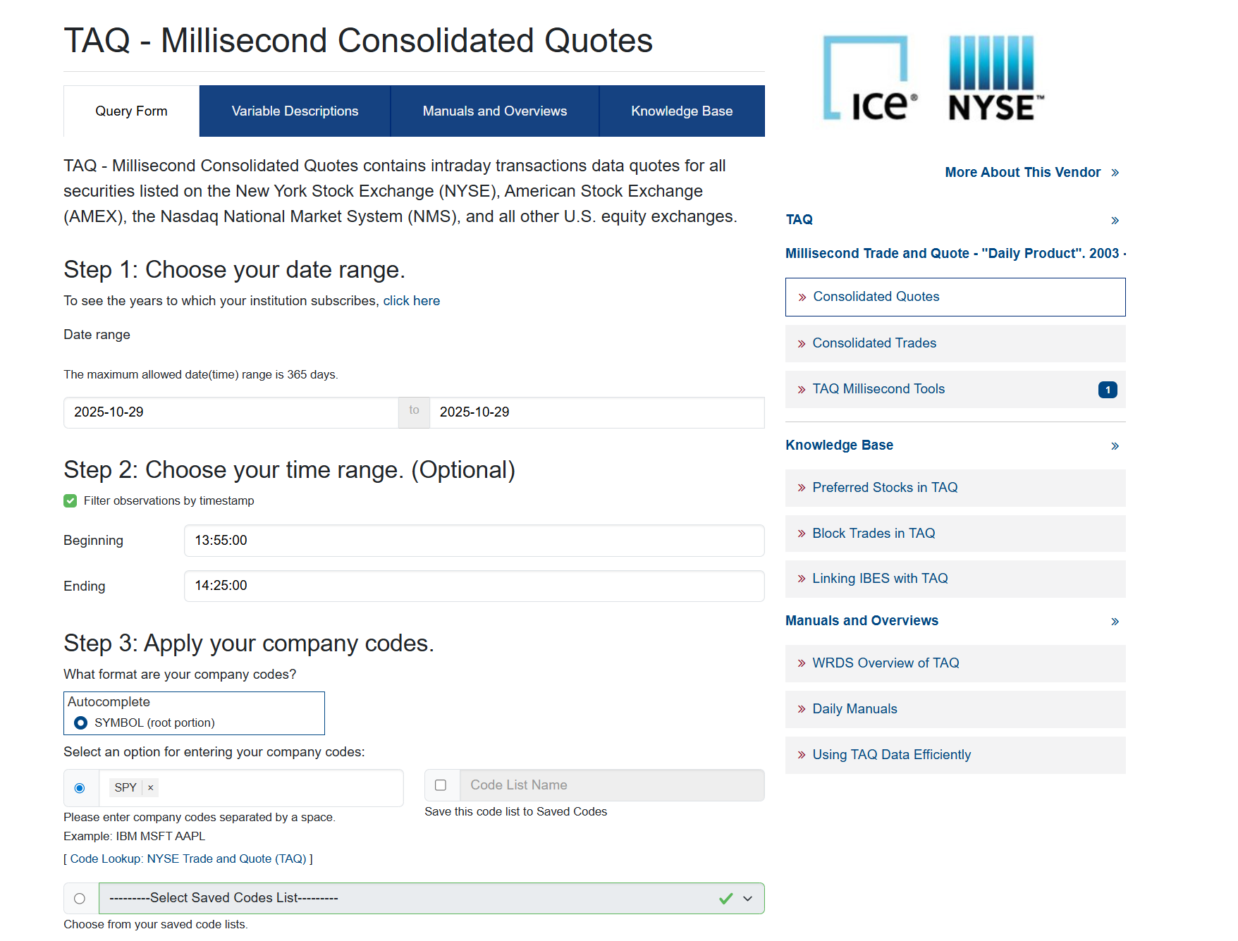

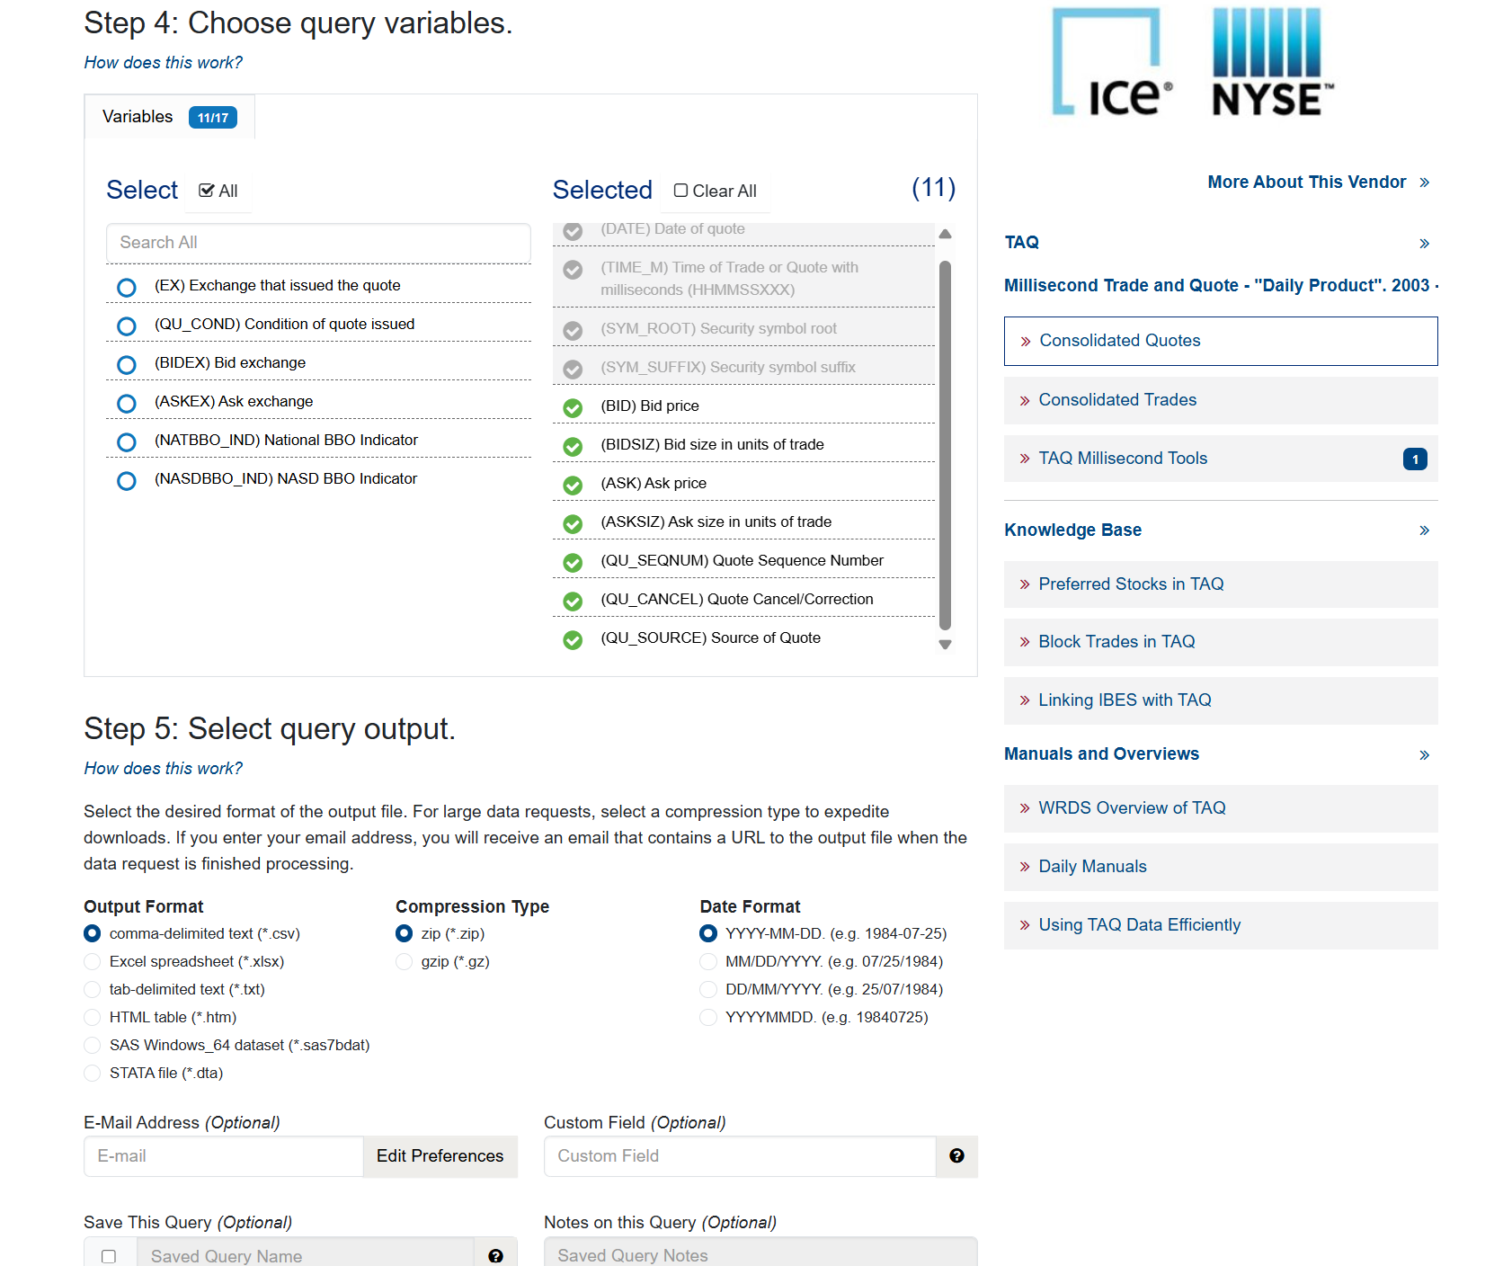

WRDS TAQ: Trade:
https://wrds-www.wharton.upenn.edu/pages/get-data/nyse-trade-and-quote/millisecond-trade-and-quote-daily-product-2003-present-updated-daily/consolidated-trades/
