GF Capture The Flag
By Steven Tucker

Application

Programming Interface
November, 2018

Overview

GF Capture The Flag is a competitive programming game. A competitor programs a set of autonomous bots to do battle in the Capture The Flag arena. The goal is to retrieve your flag from enemy territory before your enemy is able to retrive their’s from you. Some bots may be attack bots, some may concentrate on defence, others may take on both roles. If caught in enemy territory (tagged by an enemy bot), you will be placed in jail. You can only escape from jail when a bot on the same team tags you.

Bots are programed using the Python programming language. You can use any Python features to determine your strategy and next move, however the bots themselves must only be manipulated through the API provided in this document.

Bot Files
There are 5 Bots per side, so 5 Blue Bots and 5 Red Bots.
When competing, you put forward either your Red Team or your Blue team, naturally your competitor will put forward the opposite of your choice.
Each bot has its own file inside the Objects folder. If it is a Red bot, the name will start with the word red, followed by the bot’s number in the team.
For Example, the 2nd bot in the Red team, uses the file
red2.py
and the 3rd Bot in the Blue team uses the file
blue3.py
Be sure to only code in these files! When you compete, you provide only the bot files, so any changes made to any other file will be lost.

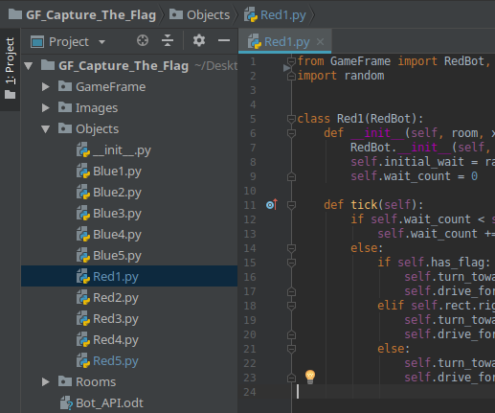

Battle loop

def tick(self):
The tick function is called at every frame of the game. That is, it is called 30 times every second. Everytime it is called, your bots can make their strategic decisions and make a move.
Every bot must implement this function, it is the entry point to the bot code.

Global Variables

Globals.red_bots
This is a list of all the Red Bots. You can use this list to find out information about a red bot. For instance, you may want to find the x and y coordinates of Redbot 1
red_bot_1_x = red_bots[0].x
red_bot_1_y = red_bots[0].y

Globals.blue_bots
This is a list of all the Blue Bots. You can use this list to find out information about a blue bot. For instance, you may want to find the x and y coordinates of Bluebot 1
blue_bot_1_x = Globals.blue_bots[0].x
blue_bot_1_y = Globals.blue_bots[0].y

Globals.red_flag
This is the red flag. You can use this variable to determine the flags locations
red_flag_x = Globals.red_flag.x
red_flag_y = Globals.red_flag.y

Globals.blue_flag

This is the blue flag. You can use this variable to determine the flags locations
blue_flag_x = Globals.blue_flag.x
blue_flag_y = Globals.blue_flag.y

Globals.SLOW
Used to set the speed to SLOW when turning or driving

Globals.MEDIUM
Used to set the speed to SLOW when turning or driving

Globals.FAST
Used to set the speed to SLOW when turning or driving

Bot Commands

self.turn_left(Globals.SLOW)
Sets the bot to turn left. If called without a speed it will be set to SLOW
self.turn_left()
self.turn_left(Globals.FAST)

self.turn_right(Globals.SLOW)
Sets the bot to turn right. If called without a speed it will be set to SLOW
self.turn_right()
self.turn_right(Globals.FAST)

self.turn_towards(x, y, speed=Globals.SLOW)
Set the bot to turn toward a point, provided by an X and a Y location.
The bot will turn left or right depending on which is the shortest distance.
self.turn_towards(400, 350)
self.turn_towards(Globals.red_flag.x, Globals, red_flag.y, Globals.FAST)

self.drive_forward(speed=Globals.SLOW)
Set the bot to drive in the direction it is currently facing. If a speed is not provided it will be set to SLOW
self.drive_forward(Globals.FAST)

self.drive_backward()
Set the bot to drive backwards. Driving backwards can only be done at a SLOW speed.
self.drive_backward()

self.set_timer(number_of_ticks, function_to_call)
Wait a number of ticks, after which run a function. You can use this function to wait a period of time, then run some code. For instance, you may want a bot to stay in defence mode for 10 seconds (300 ticks), then change to attack mode.

self.set_timer(30, self.set_state_attack)

def set_state_attack(self):
## Change the bot from defence to attack
self.state = STATE.Attack

self.point_to_point_distance(x1, y1, x2, y2)
This function will return the straight-line distance between 2 coordinates.
distance_to_flag = self.point_to_point_distance(self.x, self.y, Globals.redflag.x, Globals.redflag.y)

red1_distance_to_flag = self.point_to_point_distance(
Globals.redbots[0].x, Globals.redbots[0].y,
Globals.redflag.x, Globals.redflag.y
)

GAME_AREA_WIDTH_MIN
The left most point of the arena.

GAME_AREA_WIDTH_MAX
The right most point of the arena

GAME_AREA_HEIGHT_MIN
The topmost point of the arena.

GAME_AREA_HEIGHT_MAX
The bottom most point of the arena

GAME_AREA_BORDER
The line that divides each side of the arena

