GF Capture The Flag
By Steven Tucker

Example Bots
November, 2018
Updated May, 2023

Overview
This document will step through three simple bots for the GF_Capture_The_Flag environment. You should gain an understanding of how to set up a bot and command it to move using the bot api functions. You should view the API document while working through these examples, looking up the funciton calls as you see them in the example. Once you have simple attacking, defending and jail breaking bots, you can then extend the bots to include more advanced strategies and outsmart your competitors.

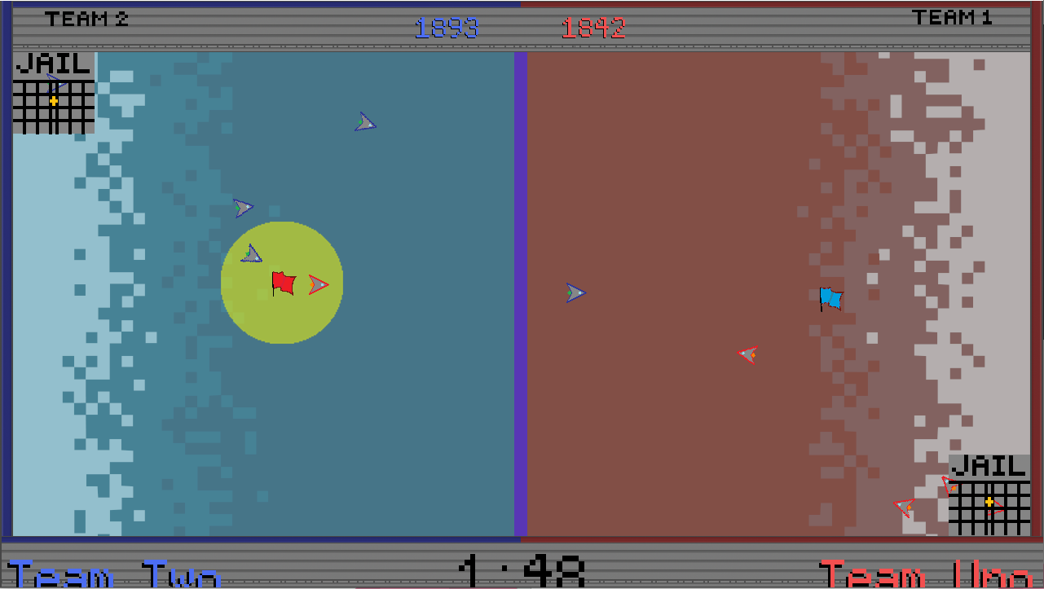

Attacking Bot
This example bot is the simplest. The bot works one of three ways, depending on whether it has the flag or whether it is in home territory or enemy territory.
For this example we will code Red Bot 1.
Opening the file Objects/red1.py we see the set up code is already there, so we can get straight to writing the tick function.

from GameFrame import RedBot, Globals

class Red1(RedBot):
def __init__(self, room, x, y):
RedBot.__init__(self, room, x, y)

The tick function gets called 30 times a second (every time the screen is redrawn). Every tick we decide which of the three actions we will take.
Using an if, elif, else structure, we determine which code to run. The first check is if the bot is holding the flag. If that is the case, the bot heads straight back to the home side. If the bot is not holding the fan, but is on it own side, it heads towards the other side, in line with its starting position. Finally, if it does not have the flag and is in enemy territory, it heads straight to the flag.

def tick(self):
if self.has_flag:
self.turn_towards(Globals.GAME_AREA_WIDTH_MAX, self.y)
self.drive_forward(Globals.FAST)
elif self.rect.right >= Globals.GAME_AREA_BORDER:
self.turn_towards(self.starting_x - 150, self.starting_y, Globals.FAST)
self.drive_forward(Globals.FAST)
else:
self.turn_towards(Globals.red_flag.x, Globals.red_flag.y, Globals.FAST)
self.drive_forward(Globals.FAST)
This bot is simple but basically effective.
You should extend this bot to undertake more advanced strategies.

Defending Bot
Like the attacking bot, the defending bot acts differently depending on its current situation. For this bot we will introduce the concept of a (very simple) state machine.
We keep track of the current “State” of the bot, that is, its current situation and approach. In the case of the Defending Bot, it will either be in a state of Attack, or a state of Waiting. If there is no enemy bot close enough to take the flag, the bot just stays still (State of Waiting). If an enemy bot is approaching the flag, then the defending bot changes to a state of Attacking, where it drives directly at the opposition bot.
With a state machine, the tick function has only 1 job, that is to check what the current state is, then call the code that is associated with that State.
To begin with, we add a structure that determines the “States”

from GameFrame import RedBot, Globals
from enum import Enum

class STATE(Enum):
WAIT = 1
ATTACK = 2

This STATE class, is what is called an “Enumerated” type, or “enum” for short. If something is Enumerated, it means it is numbered. Each of our states is assigned a number, so when we check what our current state is, we are essentially checking which number we are currently storing. When we want to change states, we change this number. So why not just use numbers? Using enums makes our code easier to read. It makes the code look more like the way we think, so the code is easier to follow, easier to program and easier to debug.

Now that we have our imports and our States set up, we can now implement the bot code.

The __init__ function simply sets up the bots initial state. We will set the initial state to “WAIT”. So the bot will not do anything until an enemy bot is detected approaching the flag, then the bot will change to the “ATTACK” state.

class Red5(RedBot):
def __init__(self, room, x, y):
RedBot.__init__(self, room, x, y)

self.curr_state = STATE.WAIT

As mentioned earlier, when we implement the tick function, its only job is to determine what the current state is, then call the function for that State.
As there are only 2 states for this bot, we simply use an if, else, structure.

def tick(self):

if self.curr_state == STATE.WAIT:
self.wait()
else:
self.attack()

When the bot is in the WAIT state, the wait() function is called, otherwise the attack() function is called. That’s it for the tick function, so now, lets write the wait and attack functions.

The wait function does only 1 thing, it checks to see when the state needs to change to Attack. Later we will write a function that finds the distance between the flag and the closest bot to it (called “closest_enemy_to_flag” ), but for now we will assume that the function exits, and just make use of how it will operate. If the distance is small enough, the bot will change to Attack mode, but we only do this as the enemy bot approaches, we don’t want to attack the enemy bot in their territory.
The first line determines the distance as well as the bot that is the closest. If the distance is less than 250px the bot changes its state to Attack.

def wait(self):
bot, distance = self.closest_enemy_to_flag()
if distance < 250:
self.curr_state = STATE.ATTACK

The attack function does one of two things, if the flag is under threat by an enemy bot, it drives towards the enemy bot, but if there is not a bot within 250px of the flag, it changes its state to WAIT.

def attack(self):
bot, distance = self.closest_enemy_to_flag()
if distance < 250:
self.turn_towards(bot.x, bot.y, Globals.FAST)
self.drive_forward(Globals.FAST)
else:
self.curr_state = STATE.WAIT

In both the wait() function and the attack() function, we are relying on a function that finds the enemy bot closest to the flag, as well as the distance between the closes enemy bot and the flag. We need to write that function now.
To determine which enemy bot it closest to the flag and what the distance from the flag that bot is, we need to look at each of the enemy bots.
As we are working on a Red bot, the list of bots we want to check is Globals.blue_bots.
The basic algorithm is to hold a record of what is so far the closest bot found and its distance (to begin with, that will be the first bot in the list as it’s the only bot we have checked). We then step through every subsequent bot in the list, checking its distance from the flag againts our current shortest distance. If the distance of the bot we are checking is less than our current closest, then we reset our current closest to be the bot we are checking. When we reach the end of the list, our current closet bot, will indeed be the closest bot and we can return the bot and its distance. To work out the distance between a given bot and the flag, we use the built in function “point_to_point distance” and provide it with the x and y values of the bot and of the flag.

def closest_enemy_to_flag(self):
closest_bot = Globals.blue_bots[0]
shortest_distance = self.point_to_point_distance(closest_bot.x, closest_bot.y,
Globals.blue_flag.x, Globals.blue_flag.y)
for curr_bot in Globals.blue_bots:
curr_bot_dist = self.point_to_point_distance(curr_bot.x, curr_bot.y,
Globals.blue_flag.x, Globals.blue_flag.y)
if curr_bot_dist < shortest_distance:
shortest_distance = curr_bot_dist
closest_bot = curr_bot

return closest_bot, shortest_distance

This is all the Defending Bot code put together

from GameFrame import RedBot, Globals
from enum import Enum

class STATE(Enum):
WAIT = 1
ATTACK = 2

class Red5(RedBot):
def __init__(self, room, x, y):
RedBot.__init__(self, room, x, y)

self.curr_state = STATE.WAIT

def tick(self):

if self.curr_state == STATE.WAIT:
self.wait()
else:
self.attack()

def wait(self):
bot, distance = self.closest_enemy_to_flag()
if distance < 250:
self.curr_state = STATE.ATTACK

def attack(self):
bot, distance = self.closest_enemy_to_flag()
if distance < 250:
self.turn_towards(bot.x, bot.y, Globals.FAST)
self.drive_forward(Globals.FAST)
else:
self.curr_state = STATE.WAIT

def closest_enemy_to_flag(self):
closest_bot = Globals.blue_bots[0]
shortest_distance = self.point_to_point_distance(closest_bot.x, closest_bot.y,
Globals.blue_flag.x, Globals.blue_flag.y)
for curr_bot in Globals.blue_bots:
curr_bot_dist = self.point_to_point_distance(curr_bot.x, curr_bot.y,
Globals.blue_flag.x, Globals.blue_flag.y)
if curr_bot_dist < shortest_distance:
shortest_distance = curr_bot_dist
closest_bot = curr_bot

return closest_bot, shortest_distance

Jail Break Bot

The Jail Break Bot is much the same as the Defending Bot but with an additional state “JAIL_BREAK”.
When this bot is in the waiting state, it does an additional check to see if any of its team mates are in Jail. If there is at least one bot in jail, then the Jail Break Bot Switches to the JAIL_BREAK state and runs the jail_break() function

def wait(self):
bot, distance = self.closest_enemy_to_flag()
if distance < 250:
self.curr_state = STATE.ATTACK
else:
bot_jailed = False
for team_bot in Globals.red_bots:
if team_bot.jailed:
bot_jailed = True
break
if bot_jailed:
self.curr_state = STATE.JAIL_BREAK
The jailbreak function first checks to see if there remains any of its team mates in Jail. If there are, then the bot heads directly to the jailed bot to tag it for release. If there are no team mate bots in Jail, it sets its state to WAIT.

def jailbreak(self):
bot_jailed = False
for team_bot in Globals.red_bots:
if team_bot.jailed:
bot_jailed = True
break
if not bot_jailed:
self.curr_state = STATE.WAIT
else:
self.turn_towards(Globals.SCREEN_WIDTH - 36, Globals.SCREEN_HEIGHT - 40, Globals.FAST)
self.drive_forward(Globals.FAST)
This is all the Jail Break Bot code put together

from GameFrame import RedBot, Globals
from enum import Enum

class STATE(Enum):
WAIT = 1
ATTACK = 2
JAIL_BREAK = 3

class Red4(RedBot):
def __init__(self, room, x, y):
RedBot.__init__(self, room, x, y)

self.curr_state = STATE.WAIT

def tick(self):

if self.curr_state == STATE.WAIT:
self.wait()
elif self.curr_state == STATE.ATTACK:
self.attack()
elif self.curr_state == STATE.JAIL_BREAK:
self.jailbreak()
else:
self.curr_state = STATE.WAIT

def wait(self):
bot, distance = self.closest_enemy_to_flag()
if distance < 250:
self.curr_state = STATE.ATTACK
else:
bot_jailed = False
for team_bot in Globals.red_bots:
if team_bot.jailed:
bot_jailed = True
break
if bot_jailed:
self.curr_state = STATE.JAIL_BREAK

def attack(self):
bot, distance = self.closest_enemy_to_flag()
if distance < 250:
self.turn_towards(bot.x, bot.y, Globals.FAST)
self.drive_forward(Globals.FAST)
else:
self.curr_state = STATE.WAIT

def jailbreak(self):
bot_jailed = False
for team_bot in Globals.red_bots:
if team_bot.jailed:
bot_jailed = True
break
if not bot_jailed:
self.curr_state = STATE.WAIT
else:
self.turn_towards(Globals.SCREEN_WIDTH - 36, Globals.SCREEN_HEIGHT - 40, Globals.FAST)
self.drive_forward(Globals.FAST)

def closest_enemy_to_flag(self):
closest_bot = Globals.blue_bots[0]
shortest_distance = self.point_to_point_distance(closest_bot.x, closest_bot.y,
Globals.blue_flag.x, Globals.blue_flag.y)
for curr_bot in Globals.blue_bots:
curr_bot_dist = self.point_to_point_distance(curr_bot.x, curr_bot.y,
Globals.blue_flag.x, Globals.blue_flag.y)
if curr_bot_dist < shortest_distance:
shortest_distance = curr_bot_dist
closest_bot = curr_bot

return closest_bot, shortest_distance

