1. Group meeting on 16-03-2021
   1. Notice of meeting:

Date: 16-03-2021

Time: 12:45

Location: Teams

Participants: Group 21 and 55

Referent: XXX

Agenda:

1. VELUX Group
2. Advanced Material Technology (VELUX)
3. Overview – case study
4. Student Questions
5. Feedback

201707020

* 1. Summary:
  2. VELUX
     + Provide lighting and atmosphere.
     + \* Remember to ask for slides afterwards.
     + Sun tunnel = Project light from *another* window – could be light from the roof projected into the living room (could be on another floor)
     + The main business: Roof Windows (Volume, Turnover).
     + Blinds can both be installed on new products but also old windows (add-on).
     + A lot the revenue is donated to science and facilities (e.g. Aarhus University).
     + The focus on providing clean air, sunlight, indoor climate, and environmental care.
     + The focus on sustainability, ‘how may we save the planet’.
     + Dedicated innovation center / teams for developing new products.
     + Front end innovation department → Looks 5-10 years ahead, bringing new concepts.
     + Why buy VELUX?
       - Quality, World-Wide (VELUX adapts product based on geolocation).
         * E.g. ‘Californian’-style skylight for customers on the west coast.
  3. AMT
     + Bunch of nerds from different backgrounds (Nanoengineering, physics…)
     + Scout and research new material technology explore potential opportunities.
     + Ensure that new materials are approved/quality from suppliers.
     + Production sites around the world.
     + Focuses on sustainability (how does material affect carbon footprint)
     + Glass alternatives = Standard glass, plastic, transparent wood
       - Look at carbon-footprint, does the glass have negative effects on frame etc.

\*\*\* Delivery to Velux

* Please delivery the final report to VELUX in May/June, whenever we are done.
* They would like to have us fill out One Pager, 2 min pitch video – see slides from meeting.
* Overview – Case Study.
  + Should it be installable on ‘old windows’?
  + See slides for why. (Update Why-Why diagram?)
  + How would you solve the problem with ‘Black out’ and ventilation?
    - During summertime it is hard to ventilate while covering the window.
    - 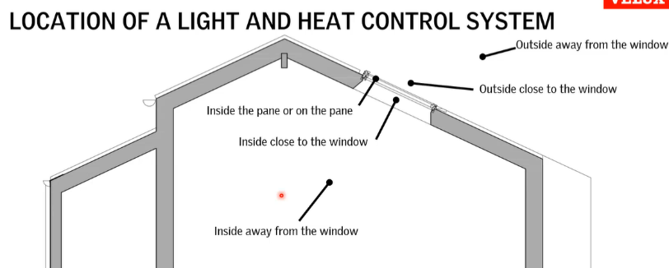An actual dilemma
  + Placement of window blind
    - Inside (Blind), Outside (Shutter)
    - Inside the pane / on the pane
    - Inside room not on the window
    - Outside the building
  + Light (Reason for placement)
    - Heat = Visible light, near-infrared light.
      * You can block infrared light (but not visible if you are not covering window)
      * Ability control heat is usually done outside (redirect)
      * If already penetrated it is indirect heating → heated material that conveys heating into room.
  + Current Products (and fun ideas)
    - Rolling trends between products – VELUX does not sell them all
    - Different trends based on geolocation.
    - See slide from 2nd meeting. (Most of them are probably bad ideas)
    - Products are made to last 25 years, only 1% must fail this.
  + Product Installation
    - Should be able to buy in BAUHAUS and install by themselves
    - Cannot be electricity heavy (no need to be certified engineer / installer)
  + How innovative can we be?
    - Roof window or flat roof window
    - Must interact with light/heat coming through the window.
  + Heat Sources (Mads)
    - What does the filter contain?
      * On the glass (depending on glazing) … see min. 00:57:45 – 01:01:30
      * Control heating outside.