Tristan Murad
1/10/26
CS251
Assignment 1 Transitioning from Java to Python
Part 1:
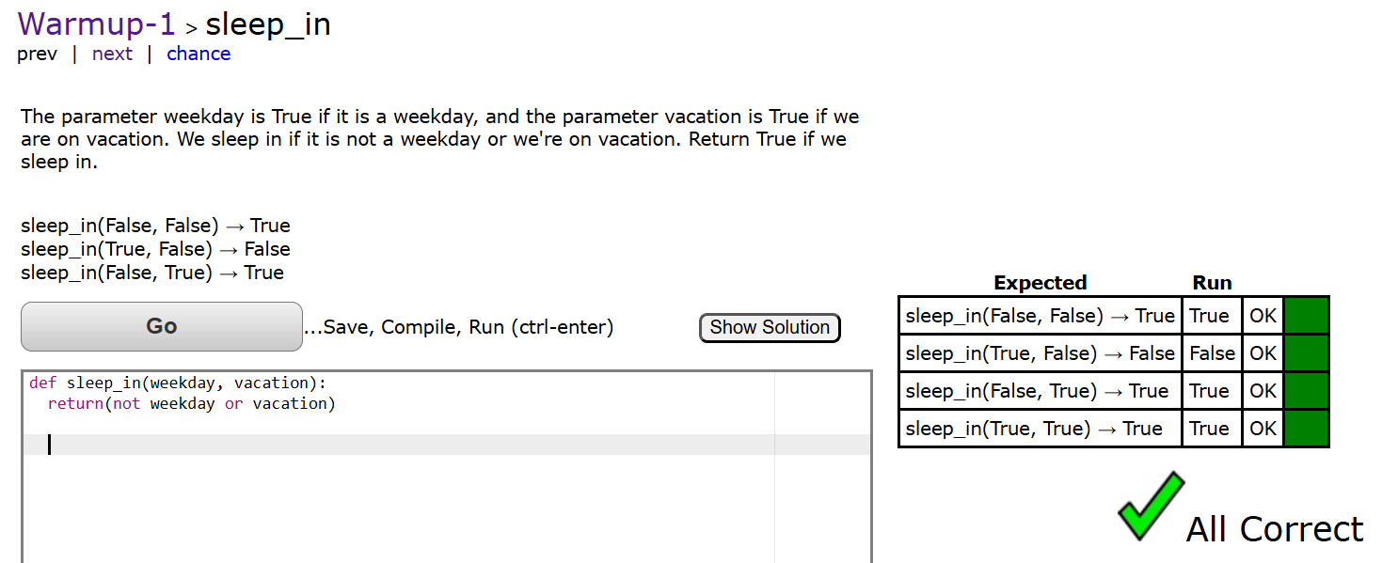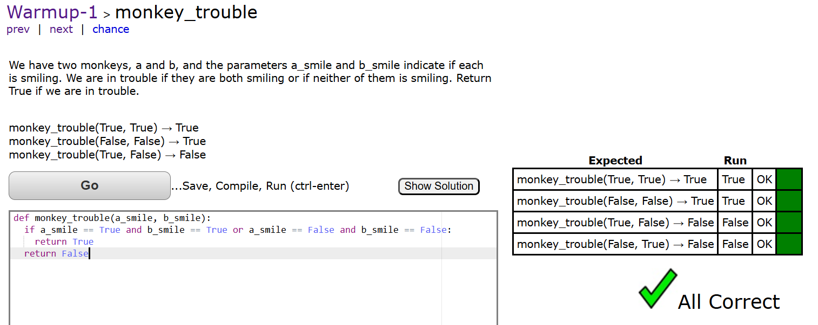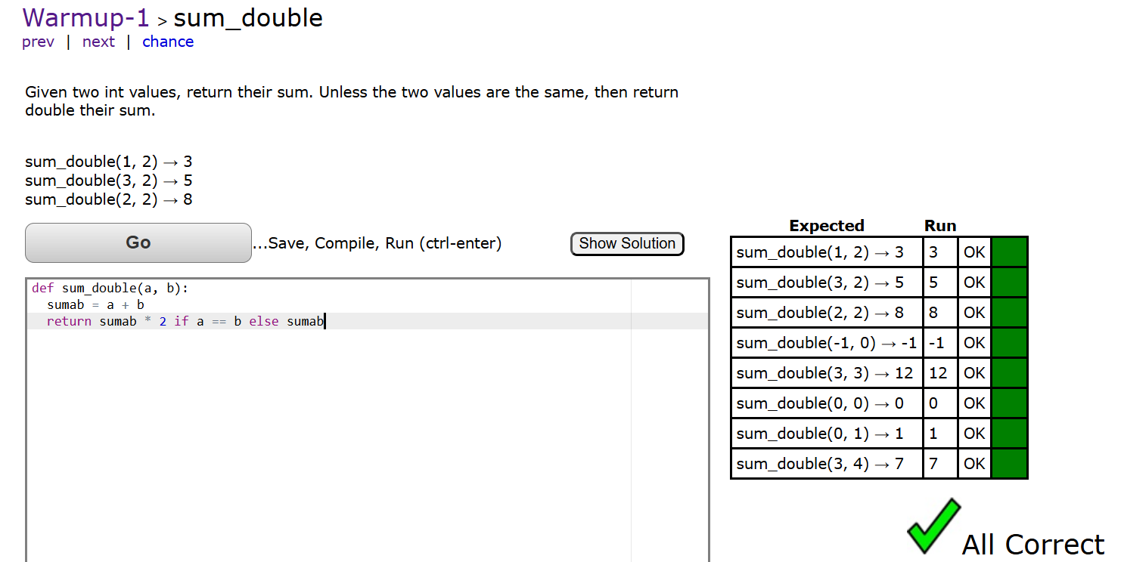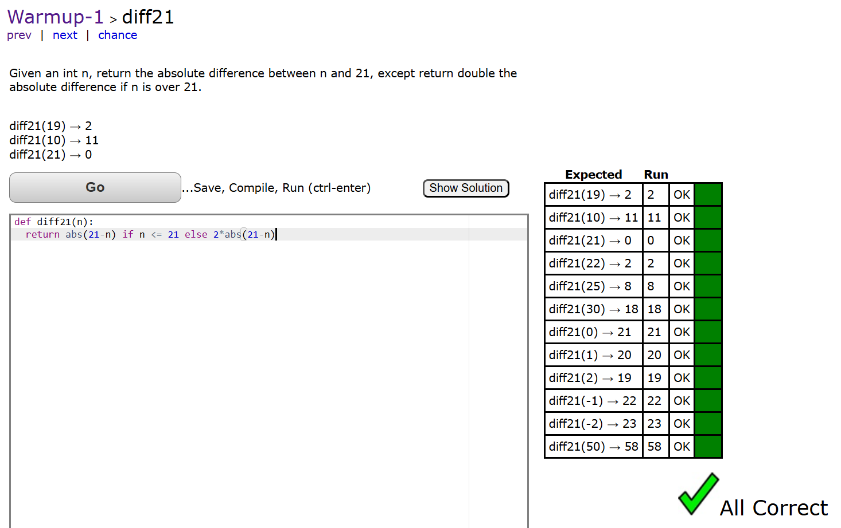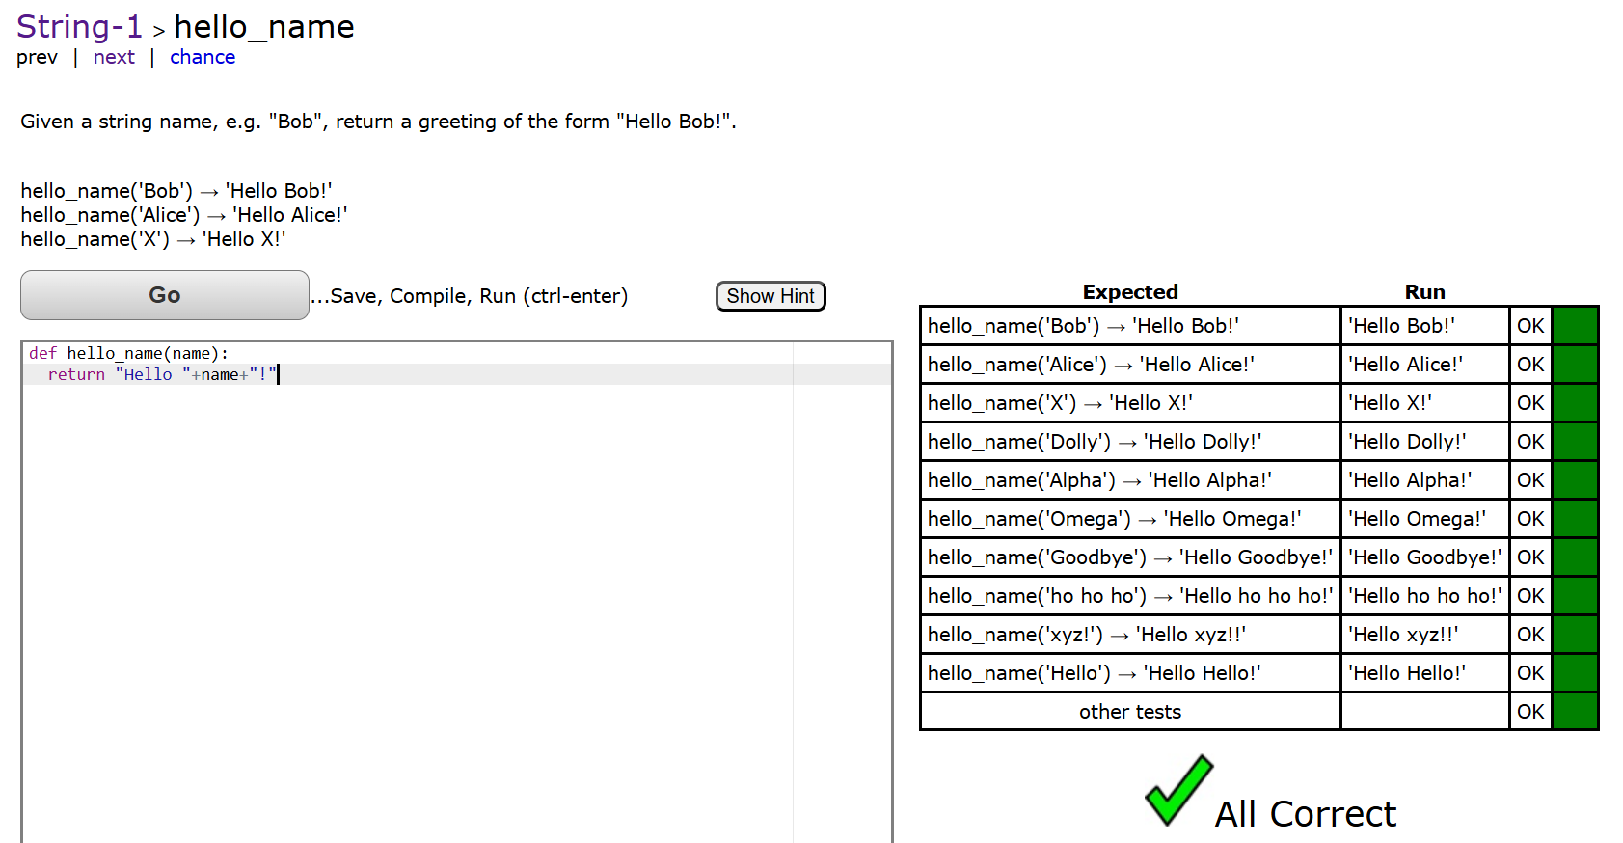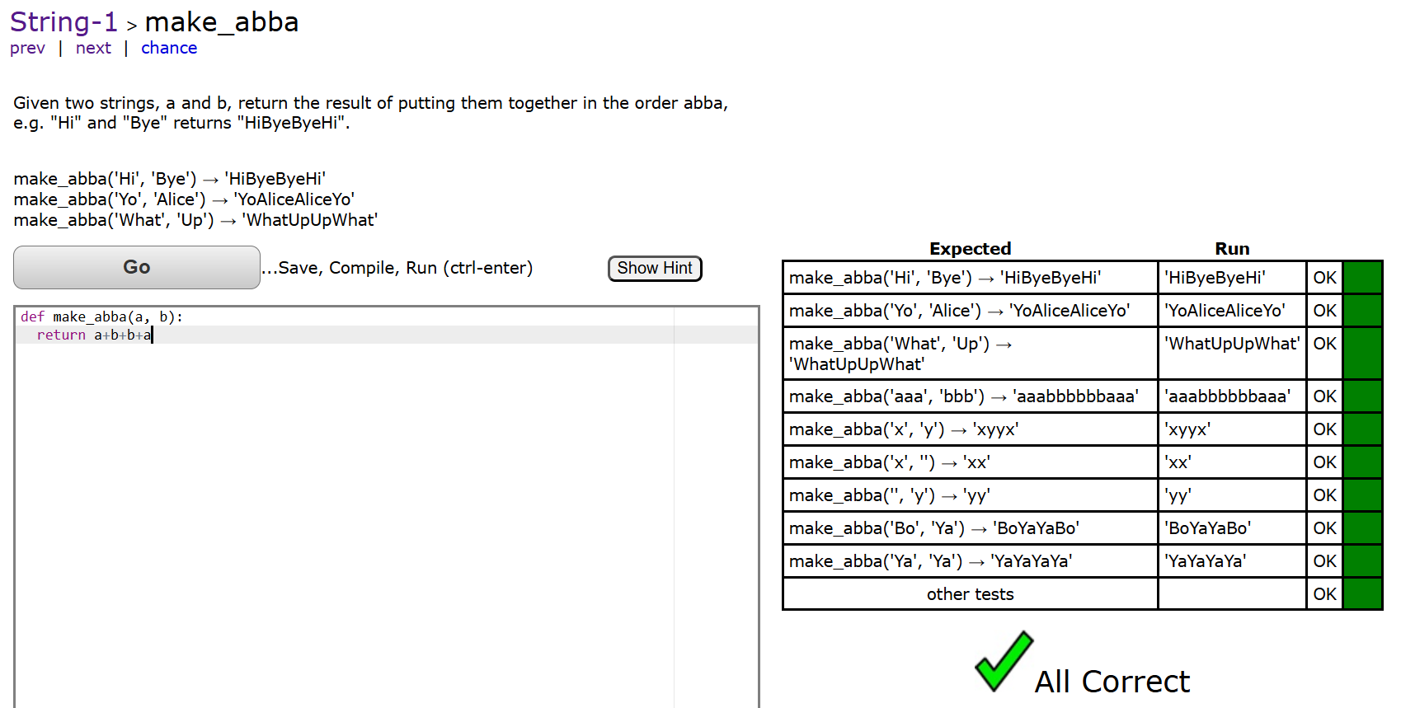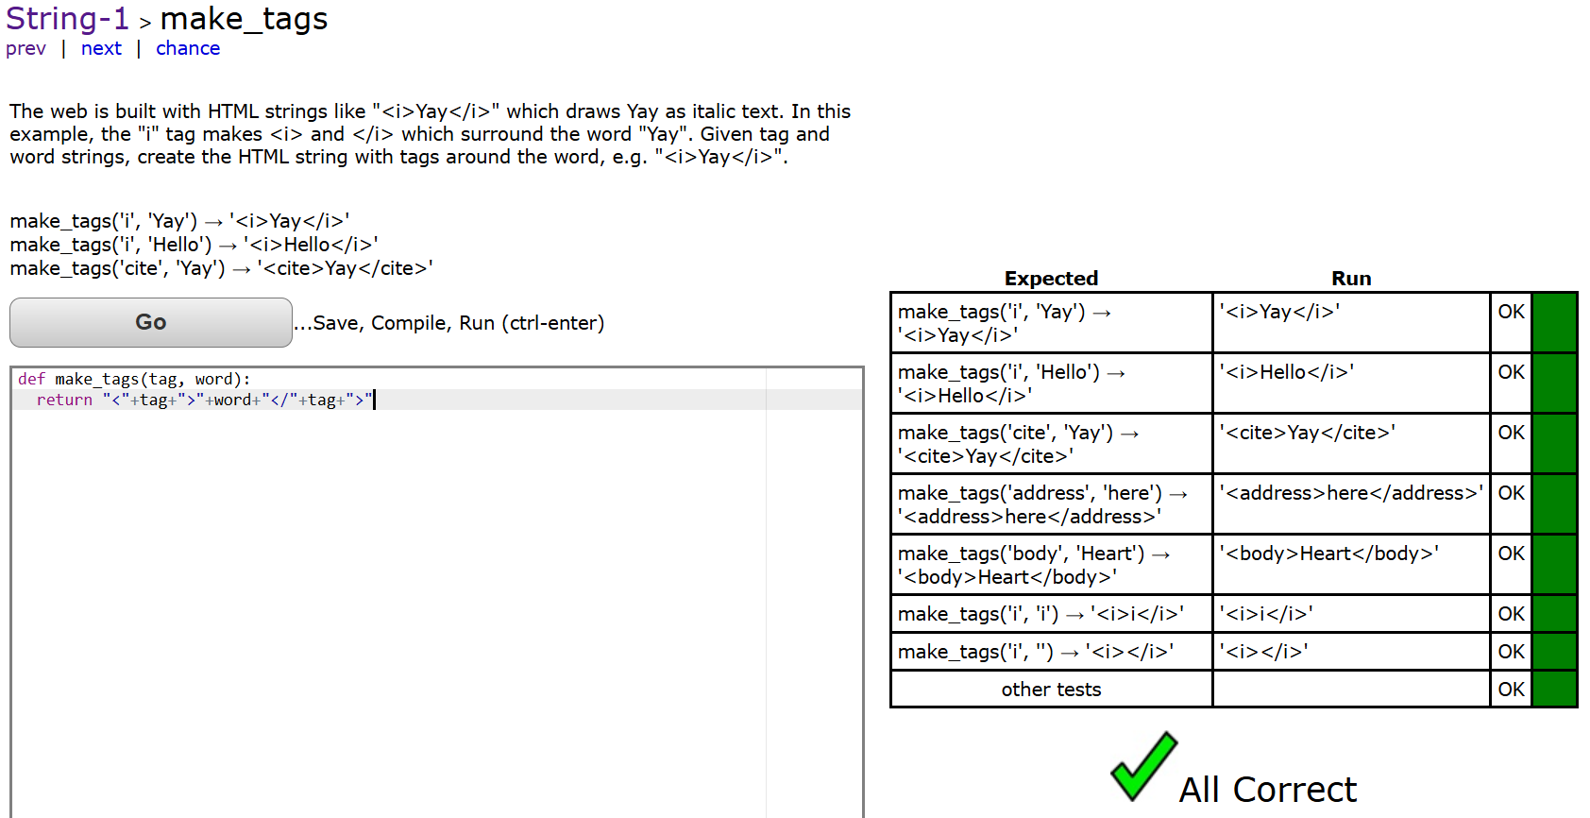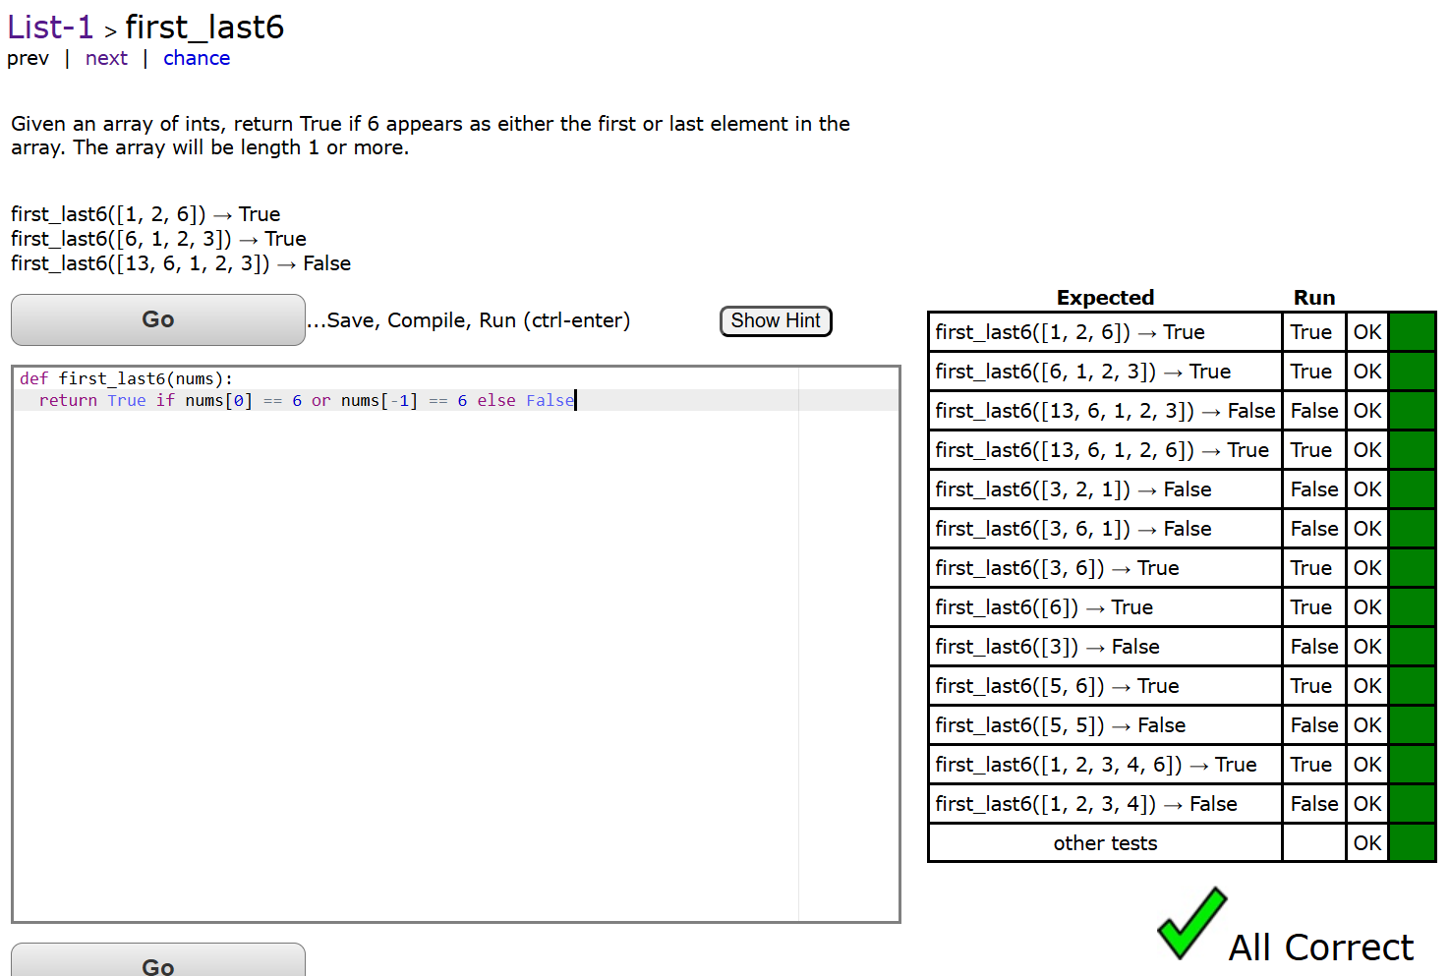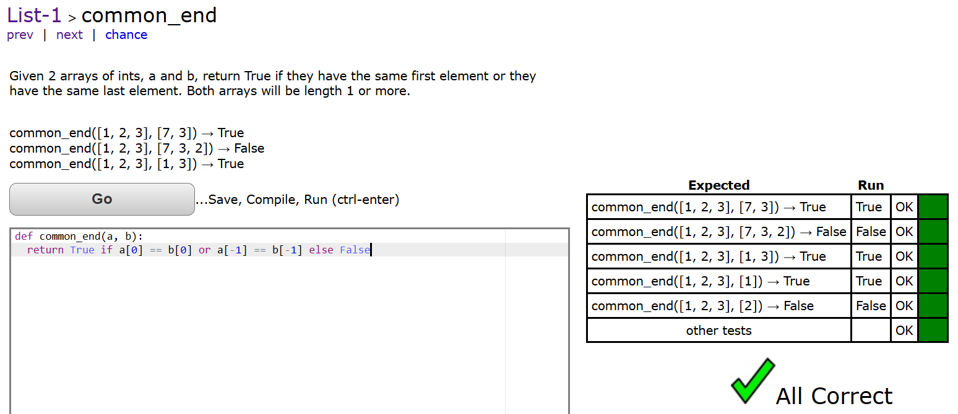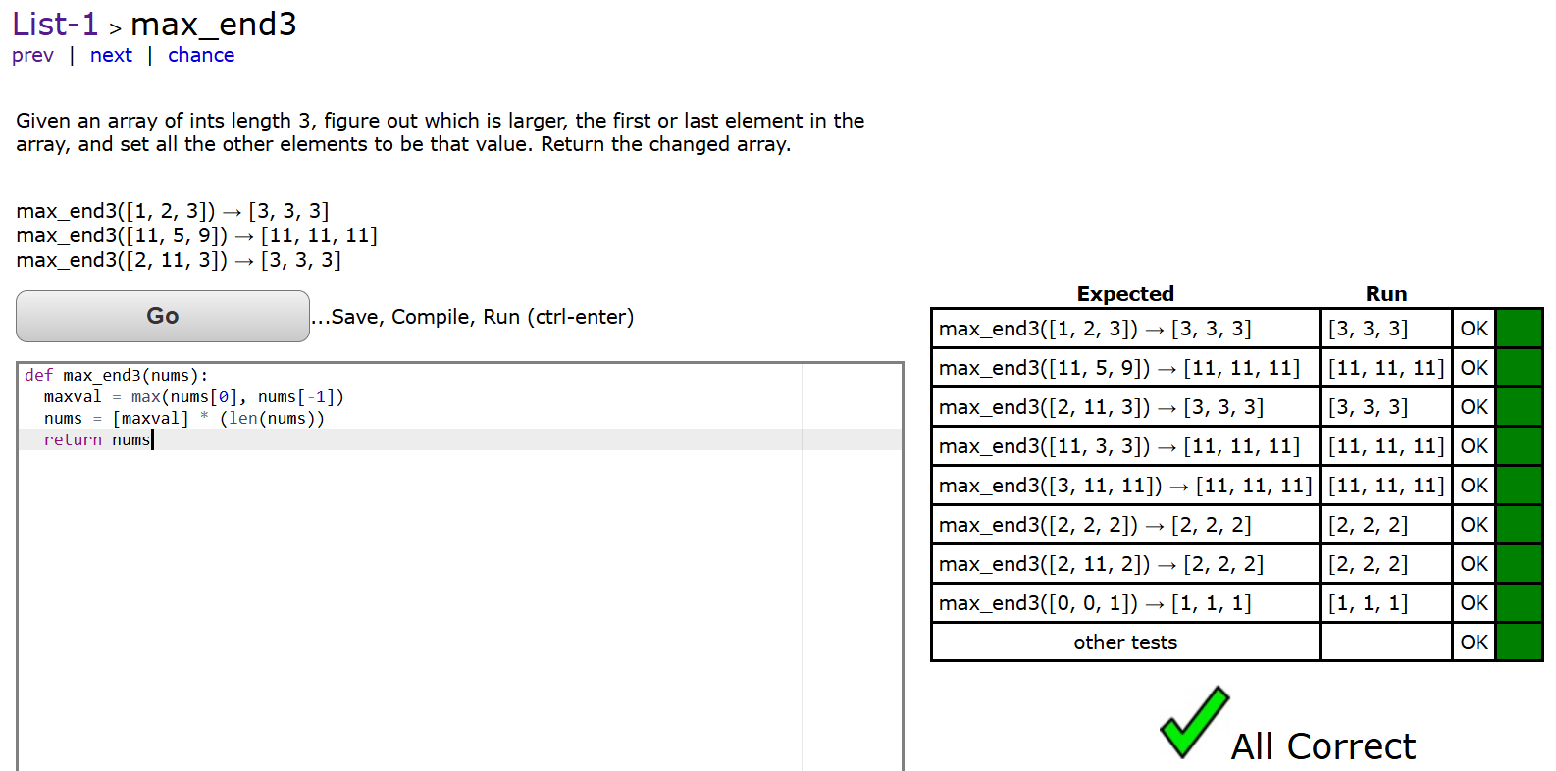
Part 2:
Program 1:

from collections import deque

def main():
stack = deque()

count = int(input("Enter the number of elements: "))

for i in range(count):
stack.append(int(input("Enter an element: ")))

print("Numbers in reverse order: ")
while stack:
print(stack.pop())

if __name__ == "__main__":
main()
(py311) root@TristansLaptop:/mnt/c/Users/murad/revival_project/schoolcs/assignment1# python program1.py
Enter the number of elements: 5
Enter an element: 1
Enter an element: 2
Enter an element: 3
Enter an element: 4
Enter an element: 5
Numbers in reverse order:
5
4
3
2
1
(py311) root@TristansLaptop:/mnt/c/Users/murad/revival_project/schoolcs/assignment1#

Program 2:

def main():
stack = []

print("Enter 'done' when you are finished.")

while True:
try:
num = (input("Enter an integer: "))
if num.lower() == "done":
break
stack.append(num)
except ValueError:
print("Invalid input. Please enter an integer, or type 'done' when finished")

print("Numbers in reverse order: ")
while stack:
print(stack.pop())

if __name__ == "__main__":
main()
(py311) root@TristansLaptop:/mnt/c/Users/murad/revival_project/schoolcs/assignment1# python program2.py
Enter 'done' when you are finished.
Enter an integer: 1
Enter an integer: 2
Enter an integer: 3
Enter an integer: 4
Enter an integer: 5
Enter an integer: help
Invalid input. Please enter an integer, or type 'done' when finished
Enter an integer: done
Numbers in reverse order:
5
4
3
2
1
(py311) root@TristansLaptop:/mnt/c/Users/murad/revival_project/schoolcs/assignment1#

