Tristan Murad
1/19/26
CS251
Assignment 2 Transitioning from Java to Python Part II
Program 1:
class Queue():
def __init__(self):
self.q = []
def enqueue(self, item):
self.q.append(item)
def dequeue(self):
return self.q.pop(0)
def peek(self):
return self.q[0]
def is_empty(self):
if len(self.q) == 0:
return True
return False
def size(self):
return len(self.q)

def main():
q = Queue()
q.enqueue('A')
q.enqueue('B')
print(q.dequeue())
print(q.peek())
print(q.size())
print(q.is_empty())

if __name__ == "__main__":
main()

Output:
(py311) root@TristansLaptop:/mnt/c/Users/murad/revival_project/schoolcs/assignment2# python program1.py
A
B
1
False
(py311) root@TristansLaptop:/mnt/c/Users/murad/revival_project/schoolcs/assignment2#

Program 2:
from PIL import Image

def main():
cell_size = 500
grid_size = 10
padding = 10

image_height = grid_size * (padding + cell_size)
image_width = grid_size * (padding + cell_size)

output_file = "output.png"

canvas = Image.new("RGBA", (image_height, image_width), "white")

dog = Image.open("dog.png").resize((cell_size, cell_size))
cat = Image.open("cat.png").resize((cell_size, cell_size))

for row in range(grid_size):
dogs = grid_size-row
for col in range(grid_size):
x = col * cell_size + padding
y = row * cell_size + padding
if dogs > 0:
canvas.paste(dog, (x,y))
dogs-=1
else:
canvas.paste(cat, (x,y))

canvas.save(output_file)

if __name__ == "__main__":
main()

Output:
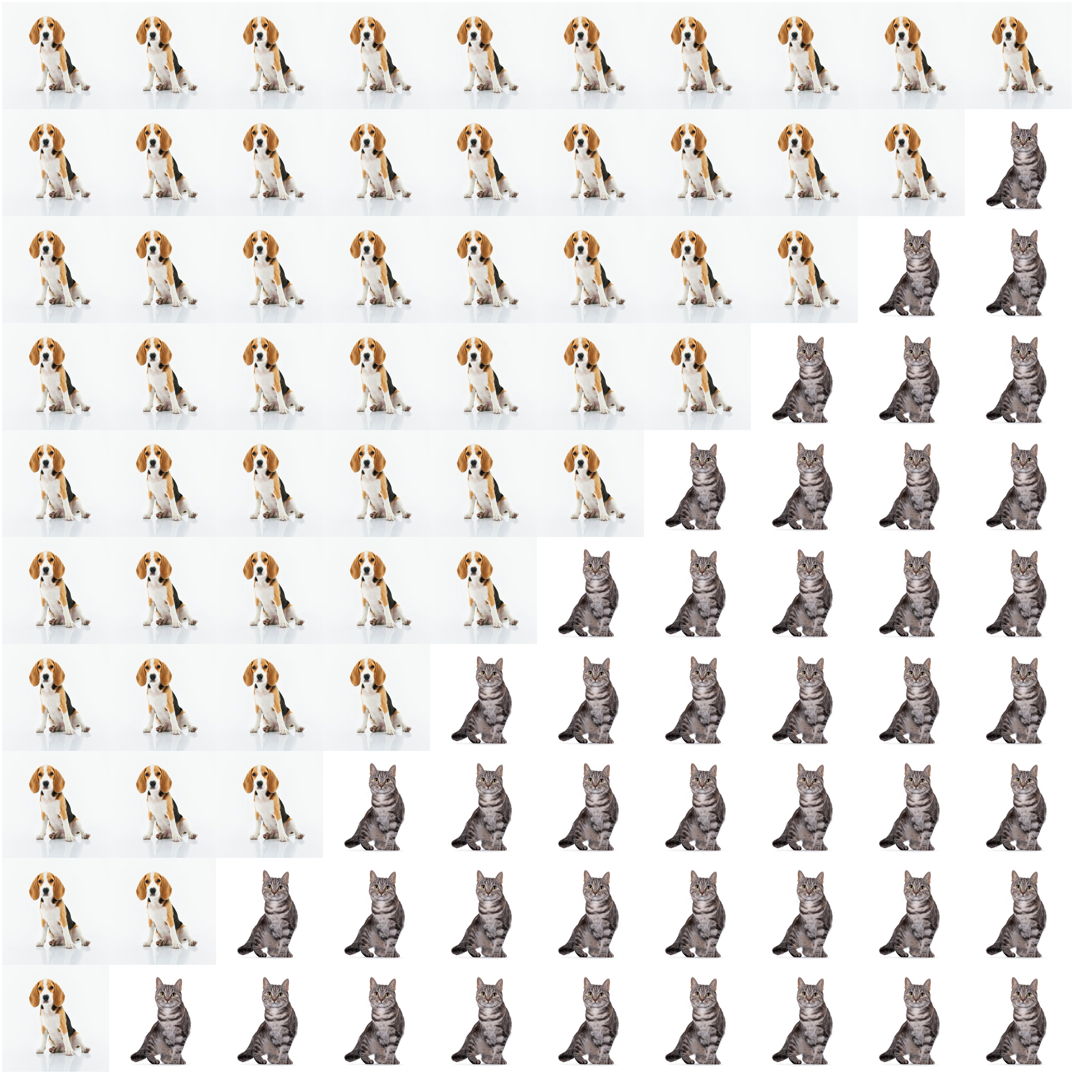

Program 3:
from PIL import Image
import sys

def main():
output_file = "output.png"
with open("input.txt", "r") as f:
lines = [line.strip() for line in f if line.strip()]

cell_size = 500
padding = 10

rows = len(lines)
cols = len(lines[0])

image_width = cols * cell_size + (cols + 1) * padding
image_height = rows * cell_size + (rows + 1) * padding

canvas = Image.new("RGBA", (image_width, image_height), "white")

for row in range(rows):
for col in range(cols):
x = padding + col * (cell_size + padding)
y = padding + row * (cell_size + padding)

char = lines[row][col]
if char == "1":
color = "red"
elif char == "2":
color = "green"
else:
color = "blue"

tile = Image.new("RGBA", (cell_size, cell_size), color)
canvas.paste(tile, (x, y))

canvas.save(output_file)

if __name__ == "__main__":
main()

Output:
