Deep Generative Models for Synthetic Radio-Frequency Signal Generation and Anomaly Detection
Tristan Ruel
Student No. 1012867710
ECE 1508 — Special Topics in Communication, University of Toronto

Abstract—Realistic wireless-signal datasets are hard to collect, label, and balance, especially for the noisy, corrupted, or protocol-inconsistent transmissions that matter most for spectrum monitoring. We study whether deep generative models can learn the distribution of valid radio-frequency (RF) signals well enough to both generate realistic class-conditional samples and flag signals that do not fit the learned distribution. On a fully reproducible synthetic corpus of three 2.4 GHz protocol families—Wi-Fi (OFDM), Bluetooth Low Energy (GFSK), and ZigBee (O-QPSK/DSSS)—we implement and compare four conditional models spanning four families: a variational autoencoder (latent-variable), a RealNVP normalizing flow (explicit likelihood), and a denoising diffusion model (DDPM), all on log-magnitude spectrograms, plus a Mamba selective state-space model that is autoregressive over the raw I/Q sequence. Trained only on normal signals, the models are evaluated on class-conditional generation quality and on detecting four corruption types. The explicit-likelihood flow is the strongest detector (ROC-AUC 0.983), the diffusion model is a close second (0.972) and produces the most realistic samples, while the VAE (0.846) and the raw-I/Q Mamba model (0.829) trail; the Mamba model nonetheless yields a clean exact discrete likelihood. We conclude that likelihood-based and denoising models on spectrograms are preferable for RF anomaly detection under limited data.
Index Terms—generative models, normalizing flows, diffusion models, variational autoencoders, state-space models, autoregressive models, RF signals, anomaly detection, spectrograms.
I. Introduction
Wireless spectrum monitoring increasingly relies on machine-learning models that must recognize not only known transmissions but also unexpected ones—interference, malformed packets, spoofed emitters, or collisions between protocols. The central obstacle is data: realistic RF datasets are expensive to capture, tedious to label, and almost always imbalanced, with anomalous or corrupted transmissions rare by definition. This is precisely the setting in which deep generative modelling is attractive. If a model can learn the distribution of valid signals, it can both synthesize new labelled examples to rebalance a dataset and, using the same learned distribution, score how well any new signal fits—turning generation into an unsupervised anomaly detector.
This project asks a focused question: which family of deep generative model is most effective for RF sample generation and anomaly detection under limited data? We compare four conditional models, each representing a distinct course topic: an explicit maximum-likelihood model (a RealNVP normalizing flow), a latent-variable model (a variational autoencoder, VAE), a denoising model (a denoising diffusion probabilistic model, DDPM), and an autoregressive model — a Mamba selective state-space model over the raw I/Q sequence. All are conditioned on the protocol class, exercising conditional generation as well.
Our contributions are: (i) a compact, dependency-light and fully reproducible synthetic-RF pipeline for three protocol families and four anomaly types; (ii) conditional implementations of a VAE, a RealNVP flow, a DDPM (on a shared spectrogram representation) and a Mamba autoregressive model (on raw I/Q), so that both the model family and the signal domain are compared; and (iii) a controlled comparison on class-conditional generation quality and anomaly detection, with an interpretation of the trade-offs each family offers.
II. Background and Related Work
Four generative paradigms are relevant. Variational autoencoders [1] optimize a variational lower bound (the ELBO) on the data log-likelihood and give a fast amortized encoder; their reconstructions are famously smooth, and reconstruction error or the negative ELBO is a common anomaly signal [7]. Normalizing flows [2],[6] build an exact, invertible map to a simple base density, yielding an exact log-likelihood—appealing for anomaly detection, though prior work shows flows can assign high likelihood to some out-of-distribution inputs [5], motivating an empirical check. Diffusion models [3] learn to reverse a gradual noising process and currently set the standard for sample fidelity; the network's denoising error at intermediate noise levels doubles as an anomaly score. Autoregressive models factorize the joint likelihood into a product of conditionals; the Mamba selective state-space model [8] realizes this in linear time with a constant-size state, a strong fit for long raw-signal sequences and a source of exact discrete likelihoods.
In the RF domain, deep learning is well established for modulation classification [4], but generative modelling of RF and its use for anomaly detection is comparatively underexplored, and rarely compares model families head-to-head on a shared representation—the gap this project targets.
III. Method
A. Data and Representation
Each example is a window of complex baseband I/Q samples synthesized from compact, protocol-like models implemented in pure NumPy (no SDR or MATLAB dependency), so the entire dataset is reproducible from a seed. Wi-Fi is modelled as OFDM (64-point IFFT, 16-sample cyclic prefix, 52 QPSK sub-carriers, boosted comb pilots), giving a wideband block structure; BLE as Gaussian-smoothed 2-FSK (modulation index ≈ 0.5), a narrowband constant-envelope tone; and ZigBee as O-QPSK with 16-chip DSSS spreading and a half-chip quadrature offset. Normal signals receive bounded nuisance variation: AWGN at 8–30 dB SNR, a small carrier offset, and random gain.
Every window is converted to a single-channel 32×32 log-magnitude STFT spectrogram (32-sample Hann window, 50% overlap, two-sided FFT, peak-normalized to [0,1] over a 45 dB range). Peak normalization removes absolute-gain nuisance so the models focus on spectro-temporal structure. All three models share this representation for a fair comparison. Fig. 1 shows real examples (top three rows) and the four anomaly types.
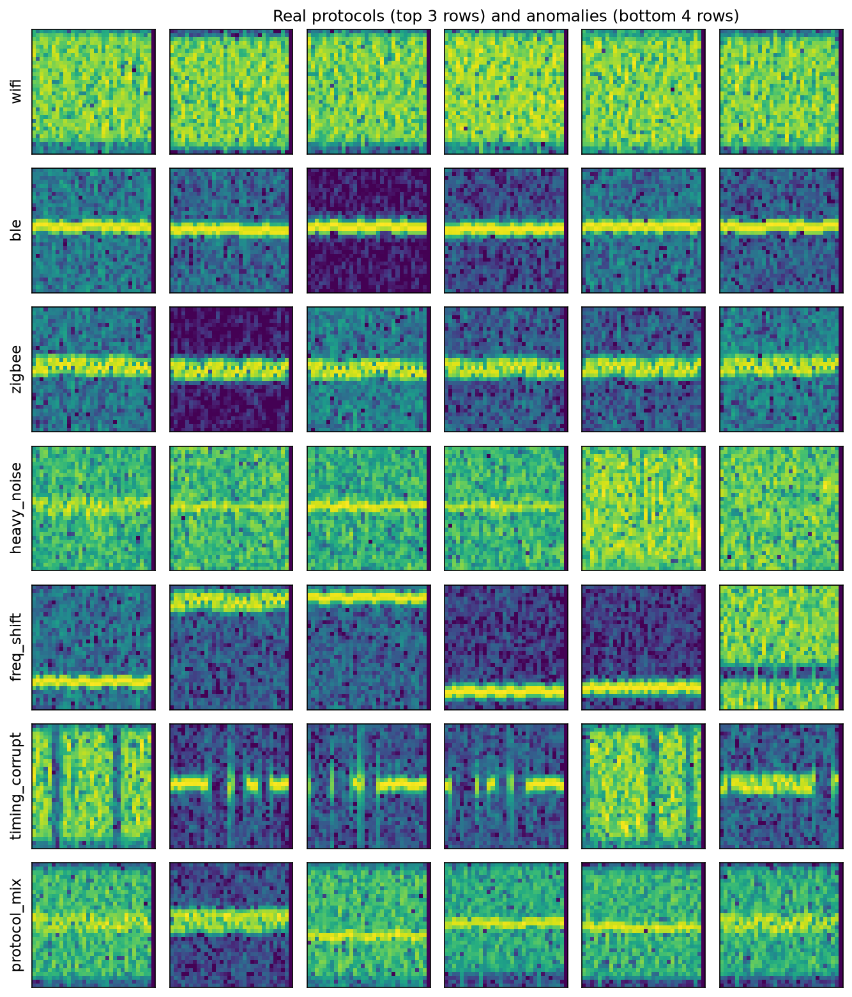
Fig. 1. Real protocol spectrograms (top three rows: Wi-Fi, BLE, ZigBee) and the four anomaly types (bottom four rows: heavy noise, frequency shift, timing corruption, protocol mixing).
Anomalies are valid signals pushed out of distribution four ways, matching the failure modes in the project brief: heavy noise (SNR −6 to 4 dB), frequency shift (a large carrier offset placing energy at the band edge), timing corruption (blanking gaps plus a spliced/repeated chunk), and protocol mixing (two different protocols summed at comparable power). The dataset comprises 6000 training, 1200 validation and 1500 test normal signals (balanced across classes) plus 1500 held-out anomalies used only at test time.
B. Generative Models
The first three models are class-conditional and share the spectrogram. The VAE uses a convolutional encoder–decoder with a 32-dimensional latent and a class embedding, trained by maximizing the ELBO (Bernoulli reconstruction plus KL to a standard-normal prior). The RealNVP flow maps the bounded spectrogram to R via a logit transform (Jacobian tracked) followed by eight class-conditioned affine coupling layers with alternating masks, giving an exact log-likelihood; coupling-layer invertibility is unit-tested. The DDPM trains a compact class-conditioned U-Net (sinusoidal timestep and class embeddings) to predict the noise added at a random step of a 400-step linear schedule; class-conditional samples come from ancestral sampling.
The fourth model, Mamba, is autoregressive over the raw I/Q sequence rather than the spectrogram. Each I and Q sample is mu-law companded and quantized to 256 levels; a stack of Mamba selective state-space (SSM) blocks [8] models the token stream causally, factorizing p(x)=∏_t p(I_t|past) p(Q_t|past,I_t) with softmax heads. This gives an exact discrete log-likelihood (a non-negative bits/dim) and constant-memory recurrent sampling. An SSM processes a length-L sequence in O(L) time with a fixed state, scaling to long I/Q windows far better than a quadratic Transformer. We implement the selective scan in portable pure PyTorch, using an exact chunked form (verified against the naive recurrence) for a roughly 40x training speed-up.
C. Anomaly Scoring and Metrics
At test time the true class is unknown, so the anomaly score is the best match over known classes, s(x) = min_y s(x|y). Each model uses its natural score: the negative ELBO (VAE), the exact negative log-likelihood (flow), the mean denoising error over a grid of noise levels (DDPM), and the exact autoregressive negative log-likelihood on the raw I/Q (Mamba). We report ROC-AUC and average precision (overall and per corruption type). Generation quality is measured by (i) generated-sample classification accuracy—an auxiliary CNN trained on real signals must recognize the intended class in conditional samples (for Mamba, its generated I/Q is converted to a spectrogram first)—and (ii) a Fréchet distance in that CNN's feature space. We also report a family-appropriate likelihood metric: exact bits/dim (flow), an ELBO bits/dim bound (VAE), test denoising MSE (DDPM), and exact discrete bits/dim (Mamba).
IV. Experimental Setup
All models train with Adam (learning rate 2×10⁻⁴) on the normal splits only; the auxiliary classifier reaches 100% test accuracy, confirming the three protocols are cleanly separable. Training is fully seeded. On a single NVIDIA RTX 4080 the three spectrogram models plus the classifier train in about one minute combined (VAE 9 s / 0.6 M params, flow 18 s / 6.9 M, DDPM 37 s / 0.9 M). The Mamba model (0.36 M params) is the outlier: its pure-PyTorch selective scan takes ≈17 min for 25 epochs — a portability-versus-speed choice, as the reference CUDA kernel would be far faster. The spectrogram portion of the study also reproduces on CPU in minutes.

TABLE I — Model comparison (all metrics on held-out test data)
Model | Family | Anom. AUC | Anom. AP | Gen. acc. | Fréchet ↓ | Likelihood
Conditional VAE | latent-variable | 0.846 | 0.869 | 1.000 | 0.175 | 0.728 bpd (ELBO)
RealNVP flow | explicit likelihood | 0.983 | 0.985 | 1.000 | 0.235 | −1.486 bpd (exact)
Conditional DDPM | denoising | 0.972 | 0.977 | 1.000 | 0.157 | 0.103 denoise MSE
Mamba (I/Q) | autoregressive | 0.829 | 0.842 | 1.000 | 2.530 | 5.399 bpd (discrete)

V. Results and Discussion
A. Anomaly Detection
Table I summarizes the comparison. The explicit-likelihood flow is the strongest anomaly detector at 0.983 AUC, the DDPM is close behind at 0.972, and the VAE (0.846) and raw-I/Q Mamba (0.829) trail. The ROC curves (Fig. 2) show the flow and DDPM hugging the top-left corner while the VAE and Mamba are visibly weaker. The per-type breakdown (Fig. 3) explains the gap: all models handle the frequency shift anomaly nearly perfectly, but the VAE struggles with timing corruption (0.75) and protocol mixing (0.82), and the Mamba model is weakest on exactly these two structural corruptions (0.73 and 0.69) while remaining strong on amplitude/frequency anomalies (heavy noise 0.91, frequency shift 0.99). The flow and DDPM remain above 0.95 on every type. Notably, despite the known failure mode of flows on some out-of-distribution inputs [5], the exact spectrogram likelihood here separates anomalies cleanly, likely because the anomalies genuinely leave the narrow manifold of valid protocol spectrograms.
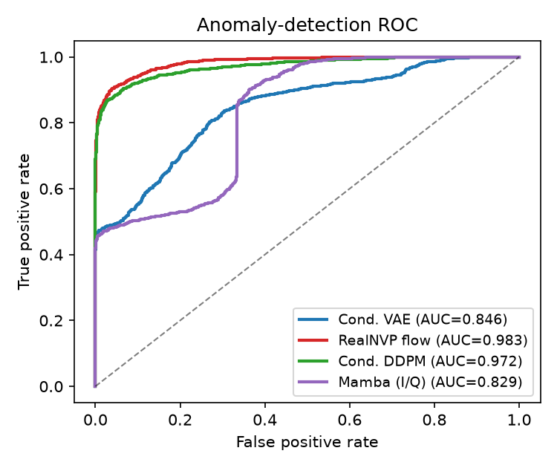
Fig. 2. Anomaly-detection ROC curves. The flow and DDPM dominate the VAE across operating points.
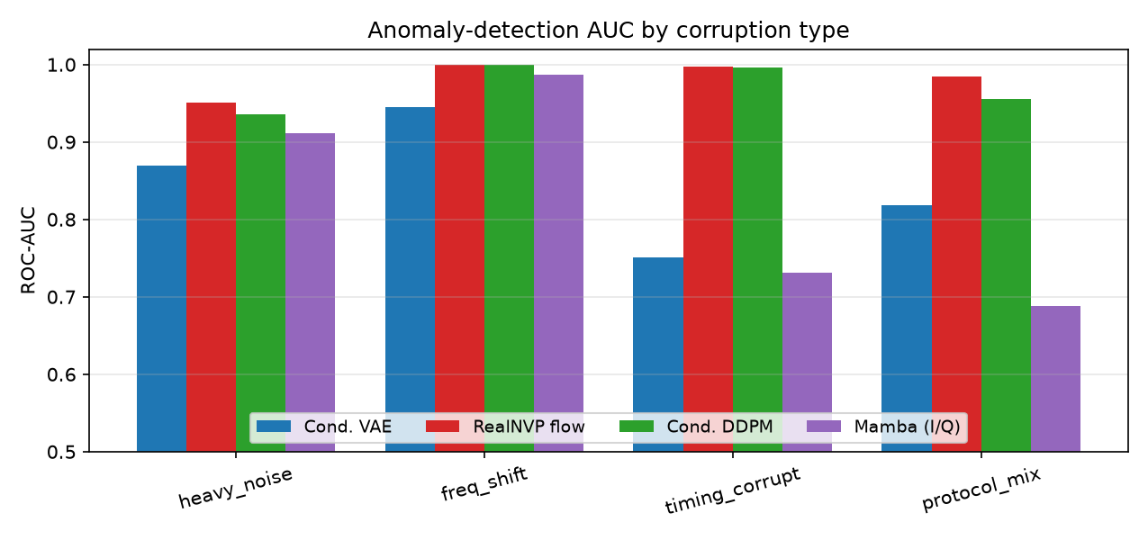
Fig. 3. ROC-AUC by corruption type. The VAE lags most on timing corruption and protocol mixing.
A practical note on likelihood scales: the flow's exact test bits/dim is negative (−1.49). This is expected, not a defect—peak-normalized spectrograms form a concentrated continuous distribution whose differential entropy (hence bits/dim) can be negative. The Mamba model, by discretizing the I/Q into 256 levels, instead reports a clean non-negative 5.40 bits/dim (out of a uniform maximum of 8). In both cases the relative likelihood is what drives detection, and it separates normal from anomalous signals well.
B. Generation Quality
All four models achieve 100% generated-sample classification accuracy: every model — including Mamba, whose generated I/Q is converted to a spectrogram — produces class-conditional signals that the auxiliary CNN assigns to the intended protocol. Because the protocols are well separated, this semantic metric saturates, and the Fréchet distance becomes the more discriminating fidelity measure. There the DDPM is best (0.157), the VAE second (0.175), the flow third (0.235), and the Mamba far higher (2.53). The qualitative comparison in Fig. 4 makes the trade-off visible: real spectrograms carry fine-grained stochastic texture; the VAE over-smooths (recognizable but blurry, the classic VAE behaviour); the flow and DDPM reproduce realistic texture; and the Mamba samples are visually plausible and class-correct but distributionally further from real — autoregressive raw-I/Q generation over 1024 quantized tokens accumulates error, which the feature-space Fréchet distance penalizes.
Together these results describe a clear trade-off. The flow offers the best anomaly detection and exact likelihoods but modest sample fidelity and the largest model; the DDPM offers near-best detection and the best fidelity at moderate cost, but slow iterative sampling; the VAE is the cheapest and fastest with a useful amortized encoder, but a weak detector with blurry samples; and the Mamba model uniquely models raw I/Q with a clean discrete likelihood, but is the weakest detector, lowest-fidelity generator, and by far the costliest to train in pure PyTorch.

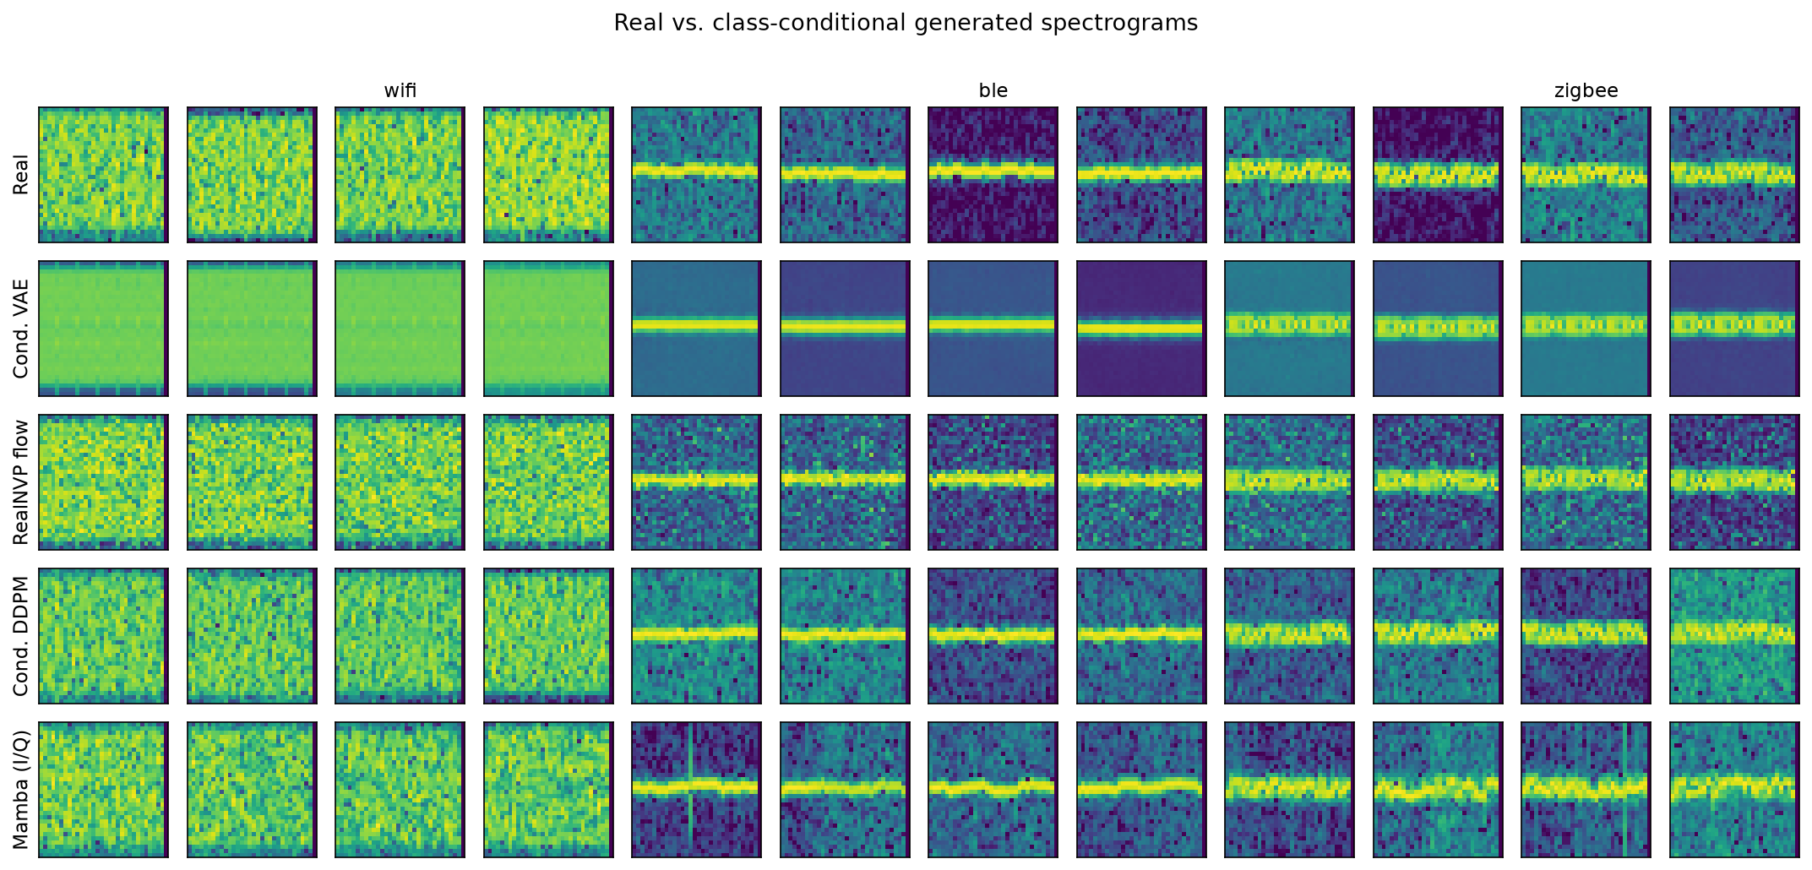
Fig. 4. Real versus class-conditional generated spectrograms (rows: real, VAE, flow, DDPM, Mamba). The VAE over-smooths; the flow, DDPM and Mamba reproduce realistic texture, though Mamba's raw-I/Q samples are distributionally further from real.

VI. Conclusion
We built a reproducible synthetic-RF pipeline and compared four conditional deep generative models—a VAE, a RealNVP flow, a DDPM, and a Mamba autoregressive SSM over raw I/Q—on class-conditional generation and anomaly detection for Wi-Fi, BLE, and ZigBee. Trained only on normal signals, the explicit-likelihood flow detected corrupted and protocol-inconsistent signals best (AUC 0.983), the diffusion model matched it closely while generating the most realistic samples, the VAE was the most economical but least accurate spectrogram model, and the raw-I/Q Mamba model gave a clean exact discrete likelihood but was the weakest detector and costliest to train here. For RF anomaly detection under limited data we therefore recommend likelihood-based or denoising models on spectrograms. Future work includes a GPU-kernel Mamba on longer I/Q windows, scaling to captured over-the-air data, and combining a diffusion generator's fidelity with a flow's exact-likelihood detector.
References
[1] D. P. Kingma and M. Welling, “Auto-encoding variational Bayes,” in Proc. ICLR, 2014.
[2] L. Dinh, J. Sohl-Dickstein, and S. Bengio, “Density estimation using Real NVP,” in Proc. ICLR, 2017.
[3] J. Ho, A. Jain, and P. Abbeel, “Denoising diffusion probabilistic models,” in Proc. NeurIPS, 2020.
[4] T. J. O’Shea, T. Roy, and T. C. Clancy, “Over-the-air deep learning based radio signal classification,” IEEE J. Sel. Topics Signal Process., vol. 12, no. 1, pp. 168–179, 2018.
[5] E. Nalisnick et al., “Do deep generative models know what they don’t know?” in Proc. ICLR, 2019.
[6] D. J. Rezende and S. Mohamed, “Variational inference with normalizing flows,” in Proc. ICML, 2015.
[7] J. An and S. Cho, “Variational autoencoder based anomaly detection using reconstruction probability,” SNU Data Mining Center, Tech. Rep., 2015.
[8] A. Gu and T. Dao, “Mamba: Linear-time sequence modeling with selective state spaces,” arXiv:2312.00752, 2023.

