SpaceX Falcon 9
First-Stage Landing Prediction
IBM Data Science Capstone Project
Final Project Report
Dataset period: 2010-2020
Prepared from executed notebooks, interactive visualizations, and predictive models.

Executive Summary
This project evaluates whether a SpaceX Falcon 9 first stage will land successfully. Successful recovery can reduce launch cost, so prediction supports competitive bid estimates. The work combines API collection, web scraping, wrangling, EDA, SQL, Folium, Plotly Dash, and supervised machine learning.
Key measure | Result
Falcon 9 launches analyzed | 90
Prepared-label success share | 87.8%
Most active site | CCAFS SLC 40 - 55 launches
Largest share of successful launches | KSC LC-39A - 41.7%
Model test accuracy | 83.3% for all four classifiers

Main Findings
- Landing success increases over the observed period.
- Launch site and orbit are associated with different success patterns.
- KSC LC-39A contributes the largest share of successful launches.
- Decision tree led cross-validation, but every model scored 83.3% on the 18-launch test set.

1. Introduction and Business Problem
SpaceX advertises lower launch prices partly because Falcon 9 first stages can be recovered and reused. A competitor or customer can improve bid estimates by predicting whether recovery is likely. The analytical question is: which mission characteristics are associated with successful landing, and how accurately can success be predicted from historical data?

Objectives
- Collect records from the SpaceX API and Wikipedia.
- Create a clean binary landing-success label.
- Explore site, orbit, payload, time, and success.
- Build geographic and dashboard views.
- Compare four classification algorithms.

Workflow
API and web scraping -> wrangling -> EDA and SQL -> Folium and Dash -> feature engineering -> model tuning and evaluation.

2. Data Collection and Preparation

SpaceX API
Past-launch JSON was normalized and enriched using rocket, payload, launchpad, and core identifiers. The final Falcon 9 table contains 90 launches and 17 analytical fields.

Wikipedia Web Scraping
BeautifulSoup parsed a June 2021 historical snapshot. The completed parser extracted 121 launch rows with booster, payload, orbit, customer, launch outcome, and booster landing fields.

Wrangling
Missing payload mass values were replaced with the mean. LandingPad nulls were retained because they indicate no pad use. Unsuccessful outcome categories were mapped to Class=0; all other outcomes were mapped to Class=1.
Launch site | Launches
CCAFS SLC 40 | 55
KSC LC 39A | 22
VAFB SLC 4E | 13

3. Exploratory Data Analysis
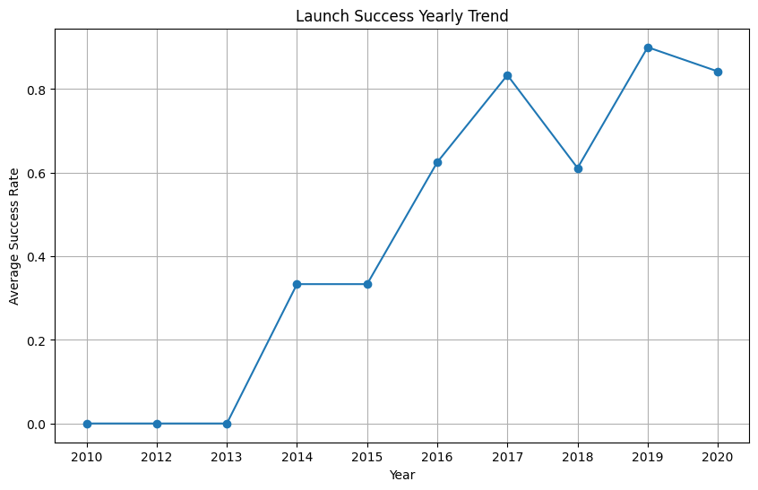
Figure 1. Falcon 9 launch success trend by year.
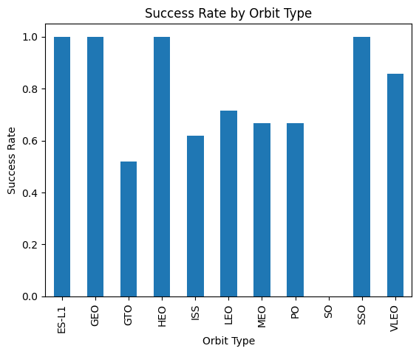
Figure 2. Success rate by orbit type.
Success improves as the program matures, while orbit types show distinct outcome profiles. The most common orbits are GTO (27 launches), ISS (21), VLEO (14), and PO (9).

4. SQL Analysis
Question | Result
NASA CRS payload mass | 45,596 kg
Average F9 v1.1 payload | 2,928.4 kg
First ground-pad success | 22 December 2015
Boosters with drone-ship success and 4,000-6,000 kg payload | B1022, B1026, B1021.2, B1031.2
Drone-ship successes, 2010-2017 | 5
The SQL results establish operational milestones and isolate mission groups by payload, booster, outcome, and date.

5. Interactive Visual Analytics

Folium
The map marks launch sites, success and failure clusters, and distances to selected coastline, city, railway, and highway points. Sites are near coastlines and transport infrastructure.
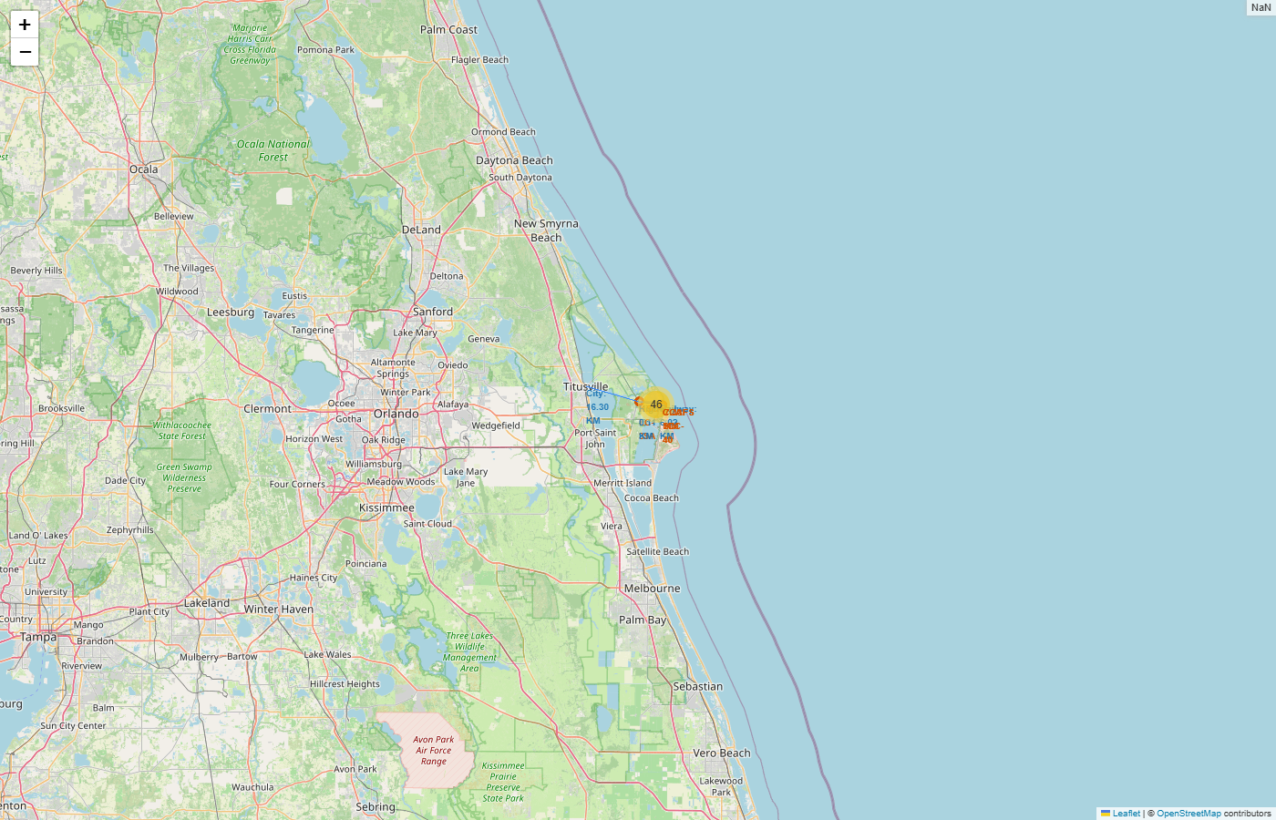
Figure 3. Florida launch-site clusters and proximities.

Plotly Dash
The dashboard provides site selection, success pie charts, a payload range slider, and outcome scatter plots colored by booster category.

6. Dashboard Findings
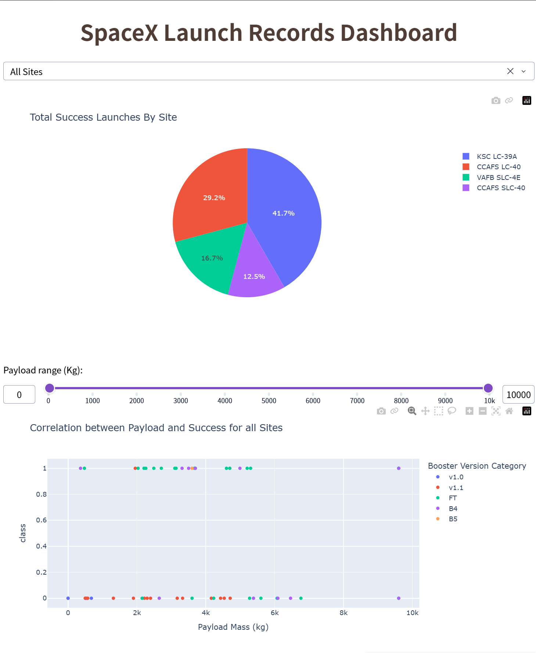
Figure 4. All sites: KSC LC-39A accounts for 41.7% of successful launches.
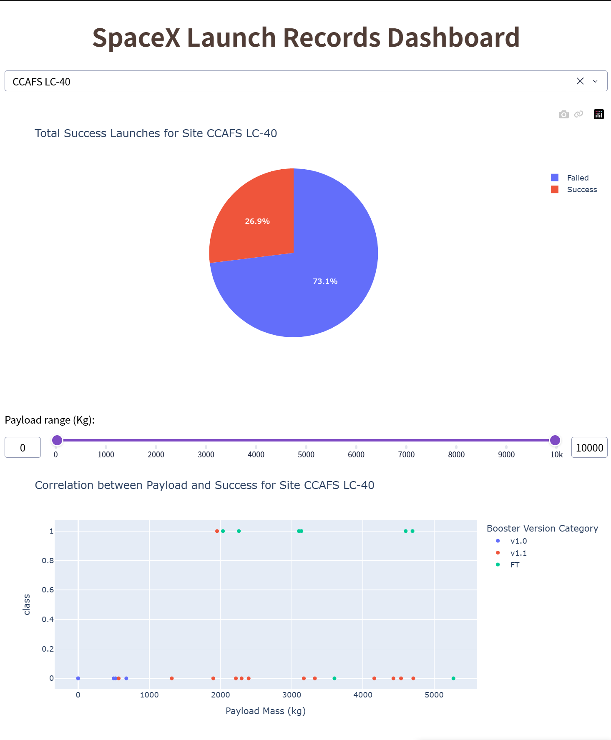
Figure 5. CCAFS LC-40: 26.9% success and 73.1% failure.

7. Predictive Analysis
One-hot encoded features were standardized, then split 80/20 with random_state=2. GridSearchCV used 10 folds to tune logistic regression, SVM, decision tree, and KNN.
Model | Best CV accuracy | Test accuracy
Logistic regression | 84.6% | 83.3%
Support vector machine | 84.8% | 83.3%
Decision tree | 92.9% | 83.3%
K-nearest neighbors | 84.8% | 83.3%
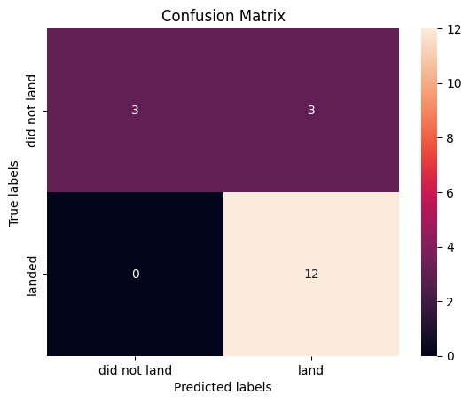
Figure 6. Decision-tree confusion matrix.
Decision tree led cross-validation, but identical test accuracy means the 18-case test set is too small to establish a definitive winner.

8. Conclusions and Recommendations
- Landing performance improved substantially over time.
- Site, orbit, payload, booster block, reuse count, grid fins, and legs provide useful signal.
- KSC LC-39A leads the successful-launch distribution, while CCAFS LC-40 shows a low 26.9% success rate in the site view.
- All models achieved 83.3% test accuracy; decision tree led cross-validation at 92.9%.

Recommendations
- Expand the dataset with newer launches.
- Use repeated or nested cross-validation.
- Evaluate calibrated probabilities and cost-sensitive errors.
- Retain the dashboard and map for stakeholder scenario exploration.

9. Deliverables and Submission Notes
Artifact | Status
Seven analysis notebooks | Complete
Folium HTML map | Complete
Dash application and screenshots | Complete
Final presentation and report | Generated
A GitHub repository URL was not supplied. Add it to the presentation and report before submission, and confirm every notebook and the Dash source file are committed.

Source
All results and figures come from the user-provided executed files under C:\Users\Administrator\Downloads\completed.

