  Final ProjEct  Active Directory and Domain Services Environment | Abstract  This is my documentation for a fully built and configured Active Directory & Domain Services Environment, making use of Windows Server 2022 and built within VMware Workstation as the virtualization platform.  Jacob Pierre

Table of Contents
Original Planning Document 2
Network Diagram 4
ADDS Diagram 5
Server #1 Screenshots 6
Server #2 Screenshots 8
Server #3 Screenshots 12
OU Screenshots 14
Shared Folder Screenshots 17
Client Machine 20

Original Planning Document

- Project Theme: Jujutsu Kaisen
- Domain Name: KyotoGoodwill.net
- Domain Password: Password01
- OS: Windows Server Datacenter

Servers Information
- Server #1 name: TokyoHighF25JP
- Roles: ADDS, DNS
- IP Address: 198.5.0.1
- Subnet Mask: 255.255.255.192
- NO Gateway
- DNS (same as Server #1’s IP): 198.5.0.1

- Server #2 name: KyotoHighF25JP
- Roles: ADDS. DNS
- IP Address: 198.5.0.1
- Subnet Mask: 255.255.255.192
- NO Gateway
- DNS: 198.5.0.1

- Server #3 name: DisasterSpiritsF25JP
- Roles: FSRM
- IP Address: 198.5.0.3
- Subnet Mask: 255.255.255.192
- NO Gateway
- DNS: 198.5.0.1

Objects Information
Note: User Information is filled out in the format of Full name/Username. All object names include “25F” e.g. John Matthews / jmatthews25F, Objects are OUs, Groups, Usernames, and Client PC Names.

- OU #1 name: 1stYearStudents25F
- Group Name: G_1stYearStudents25F
- User #1: Yuji Itadori / yitadori25F
- User #2: Megumi Fushiguro / mfushiguro25F
- User #3: Nobara Kugisaki / nkugisaki25F

- OU #2 name: 3rdYearStudents25F
- Group Name: G_3rdYearStudents25F
- User #1: Aoi Todo / atodo25F
- User #2: Noritoshi Kamo / nkamo25F
- User #3: Momo Nishimiya / mnishimiya25F

- OU #3 name: DisasterSpirits25F
- Group Name: G_DisasterSpirits25F
- User #1: Mahito / mahito25F
- User #2: Jogo / jogo25F
- User #3: Hanami / hanami25F

Client Information
- Name: Gojo25F
- OS: Windows 10 or 11
- IP Address: DHCP

DHCP Scope
- Name: InfiniteVoid25F
- IP Address Range: 198.5.0.4 - 198.5.0.62

Network Shares: Public, Home, OU Shares.
- Share#1: 1stYearStudents
- Share#2: 3rdYearStudents
- Share#3: DisasterSpirits

Network equipment
2 switches & 1 Router

Network Diagram
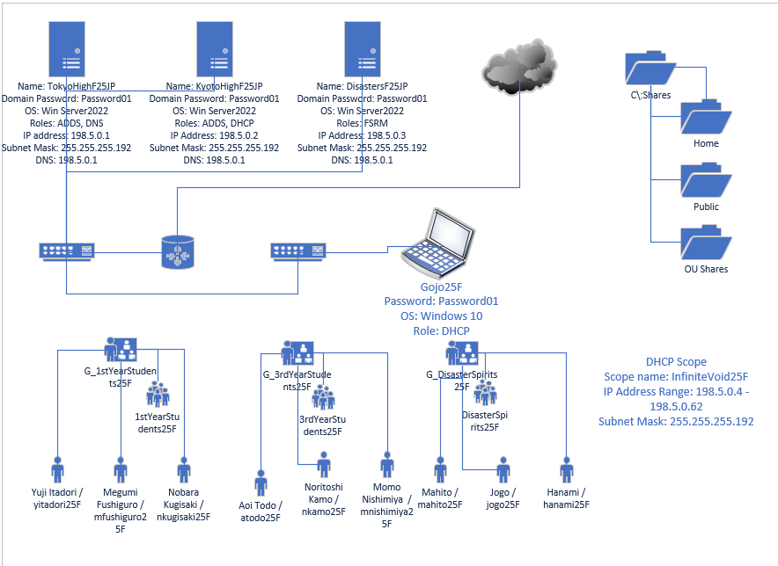
Figure 1 - Network Diagram

ADDS Diagram

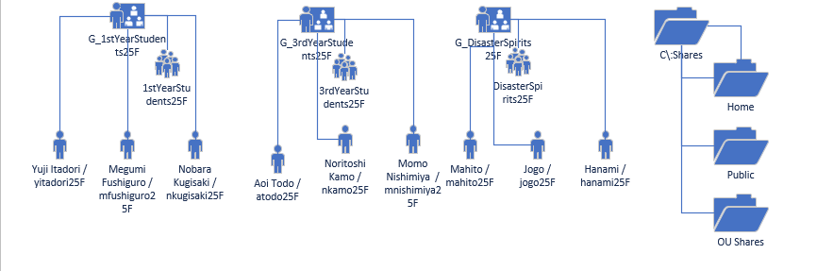
Figure 2 ADDS Diagram

Server #1 Screenshots
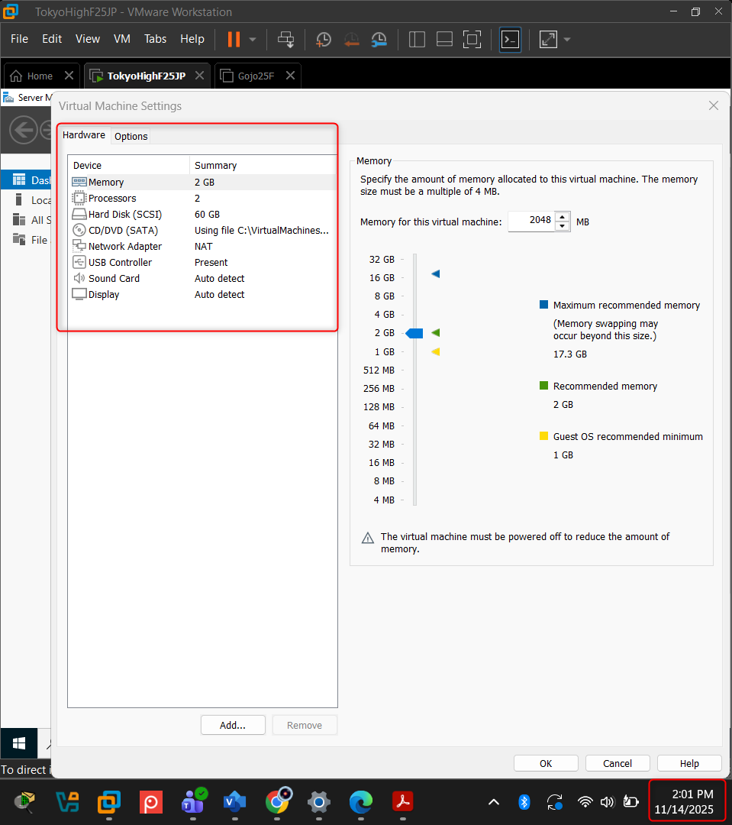
Figure 3 - Server 1 Hardware - Settings and Timestamps Included
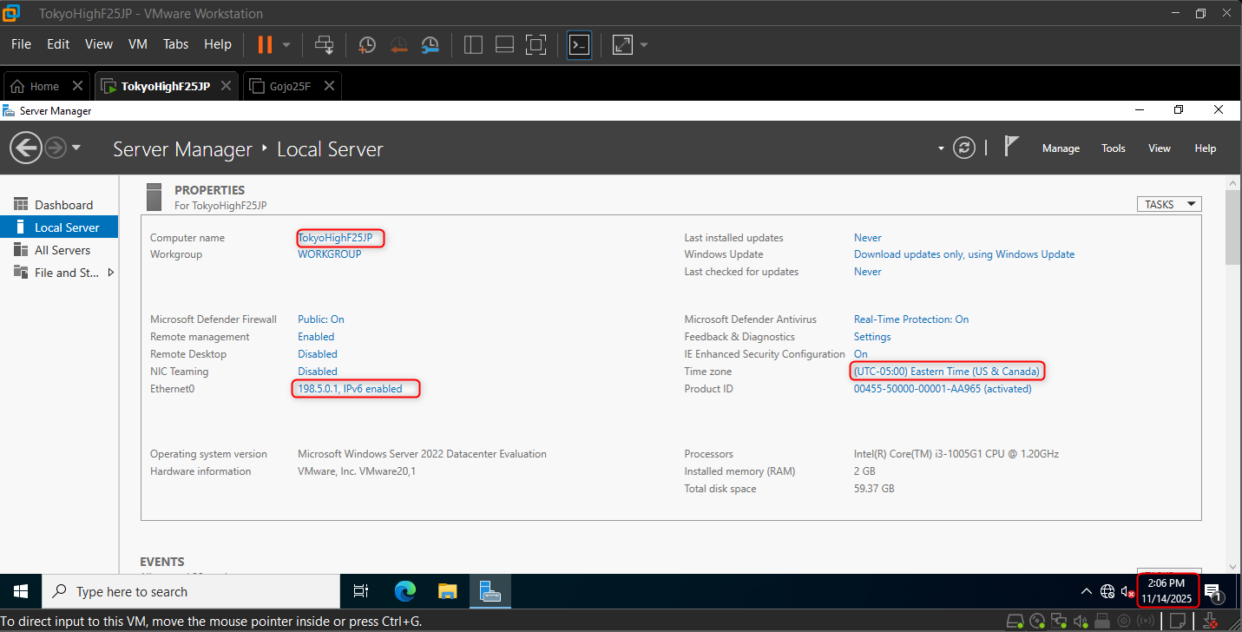
Figure 4 - Server 1 Configuration
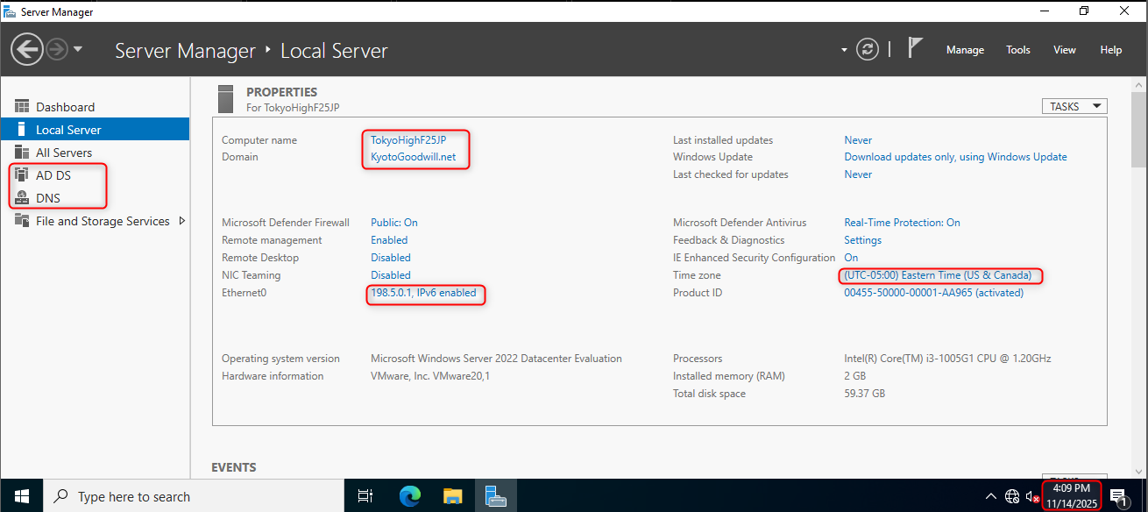
Figure 5 - Local Server Information Showing the server promoted to a Domain Controller

Server #2 Screenshots
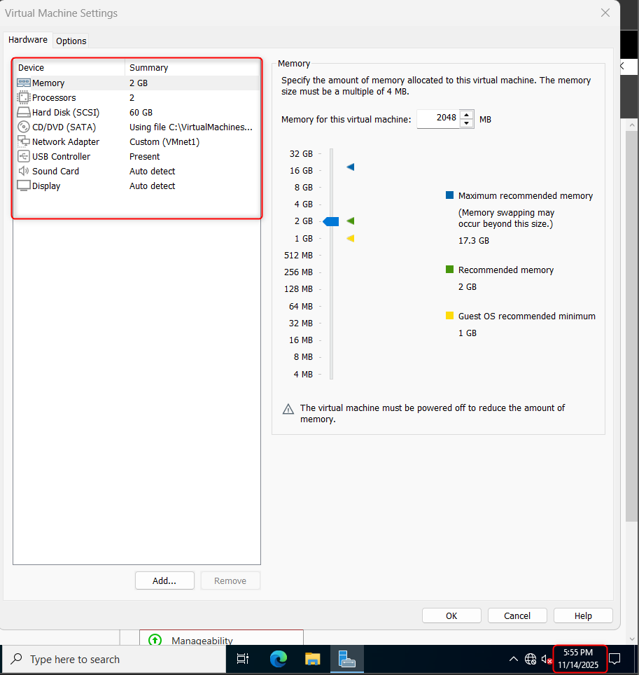
Figure 6 - Server 2 Hardware Settings
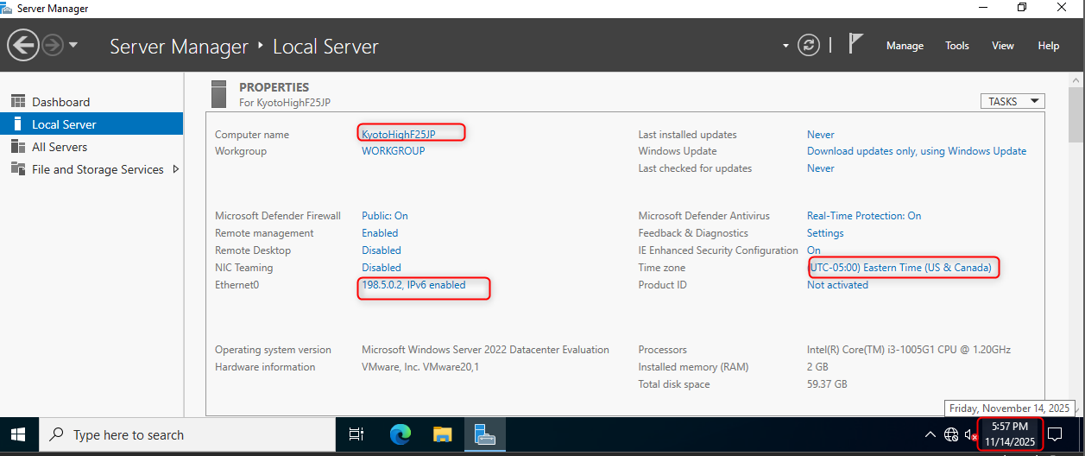
Figure 7 - Server 2 Configuration
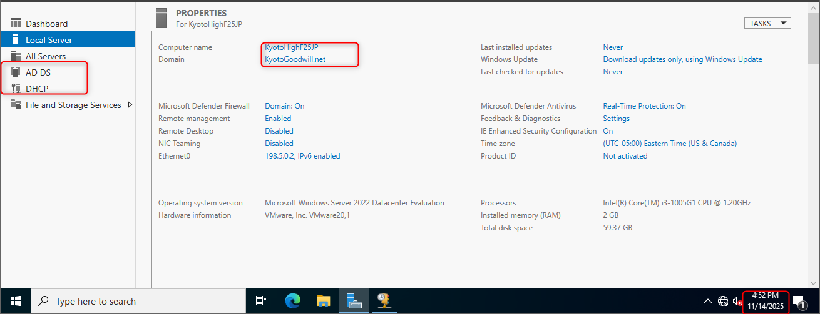
Figure 8 - Server 2 Configuration and Roles
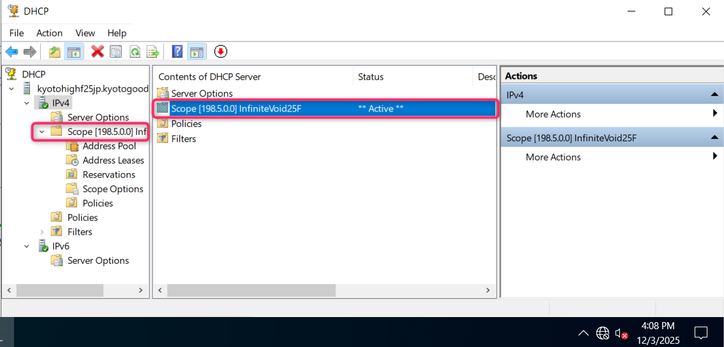
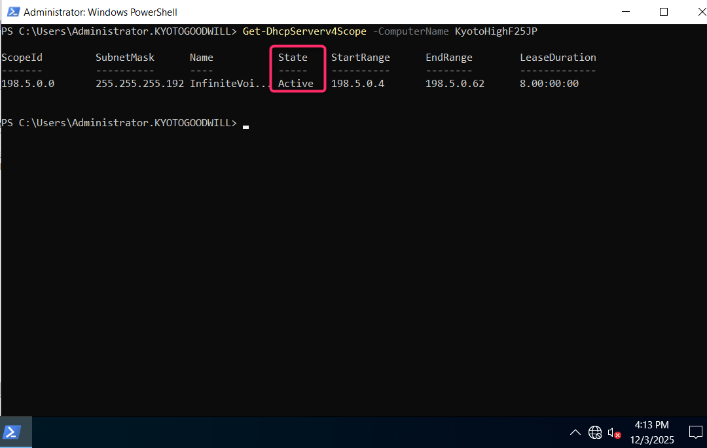
Figure 9 - Screenshot of the DHCP console Showing the scope range
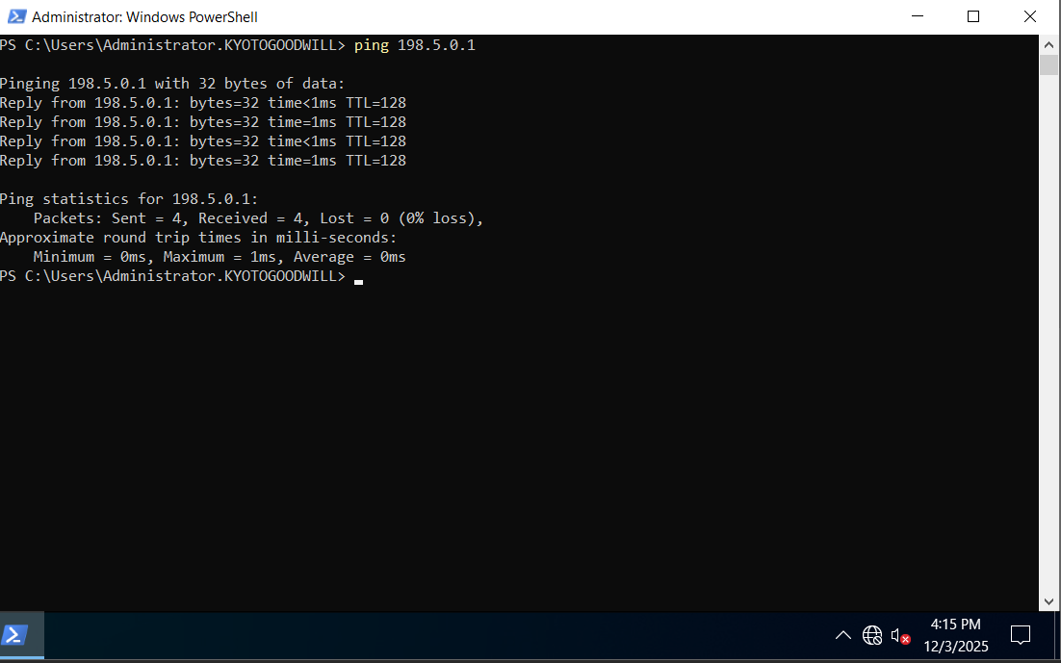
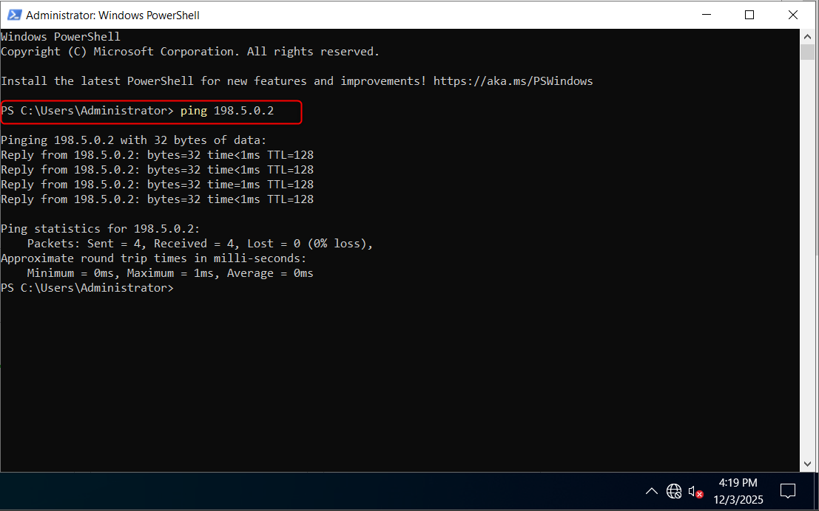
Figure 10 - Command Prompt showing the servers can ping each other

Server #3 Screenshots
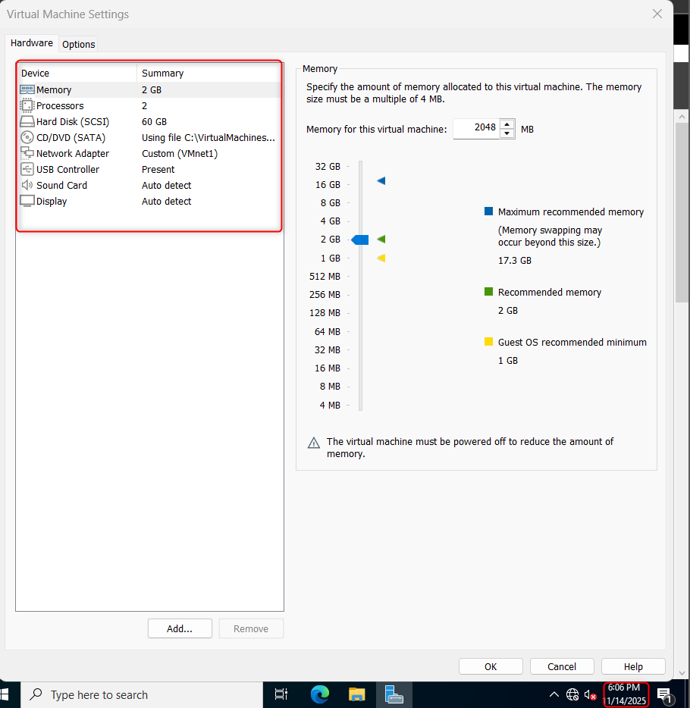
Figure 11 - Server 3 Hardware
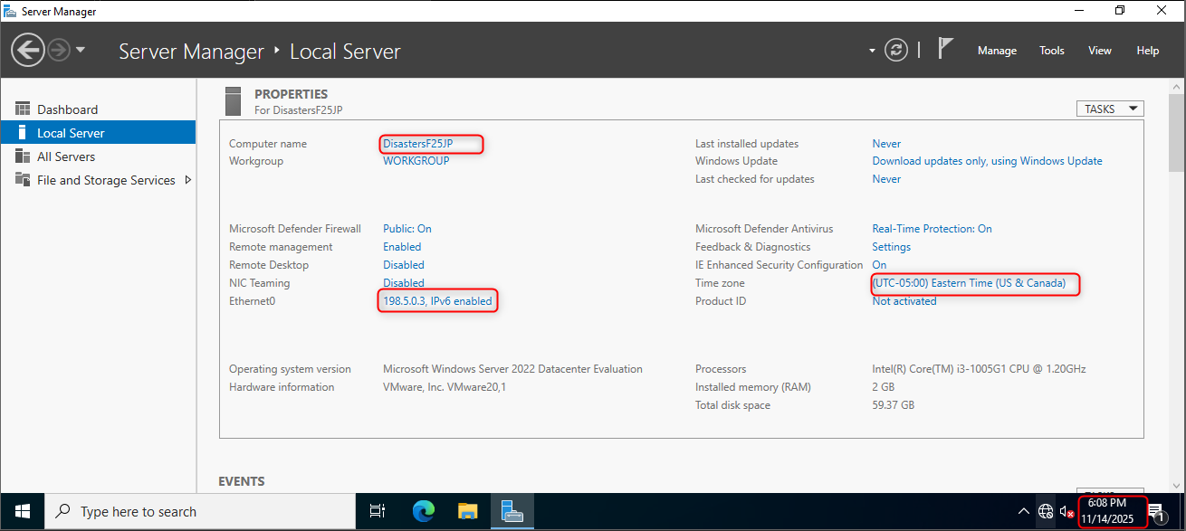
Figure 12 - Server 3 Configuration

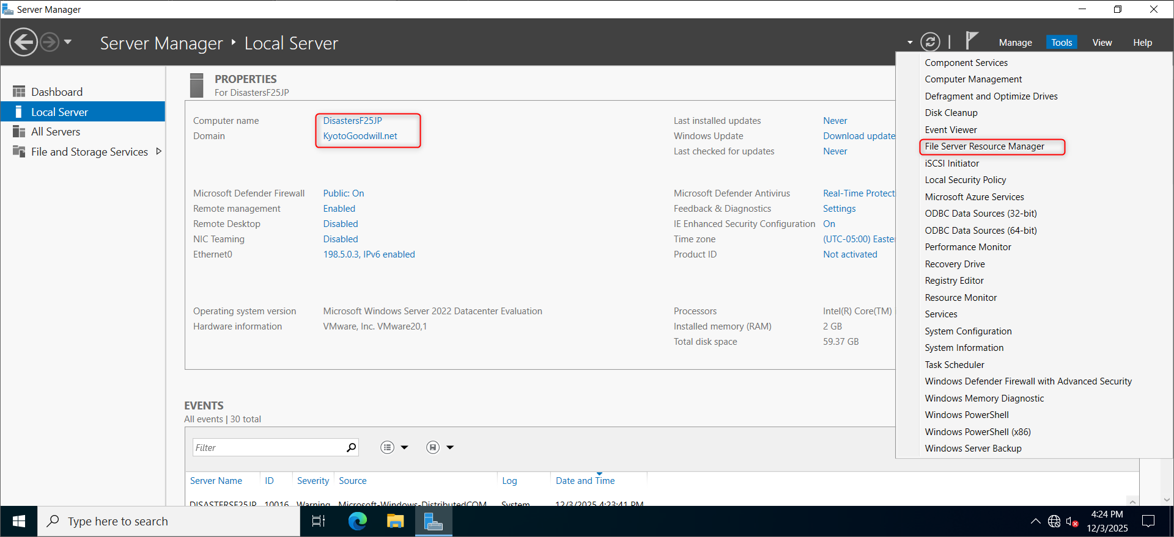
Figure 13 - File Server has FSRM installed

OU Screenshots
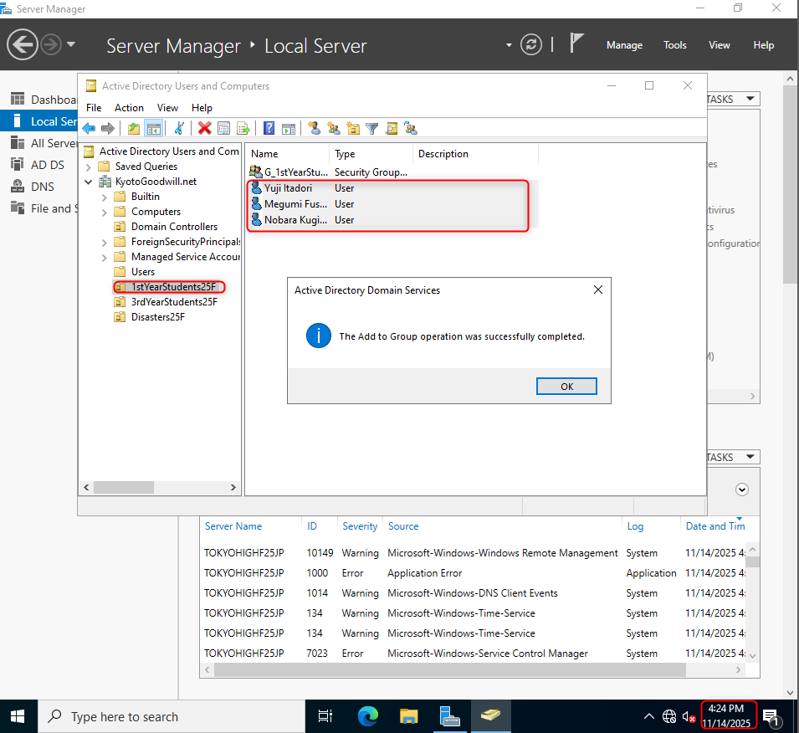
Figure 14 - OU #1
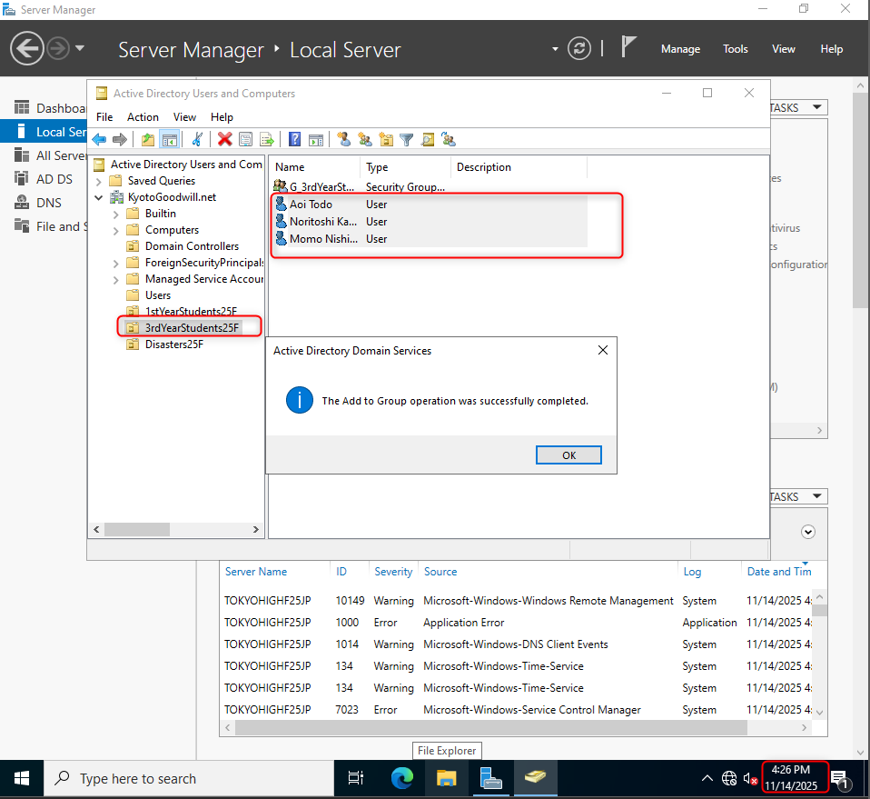
Figure 15 - OU #2
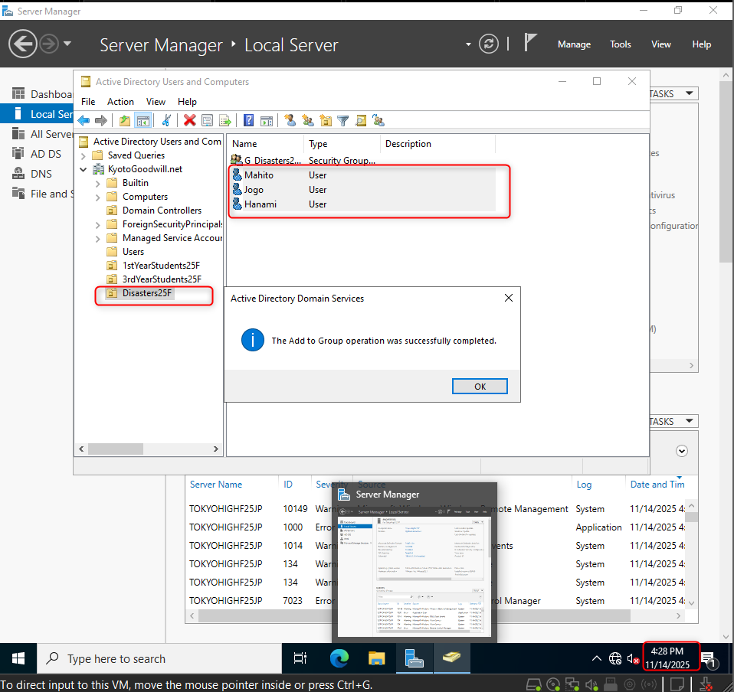
Figure 16 - OU #3

Shared Folder Screenshots

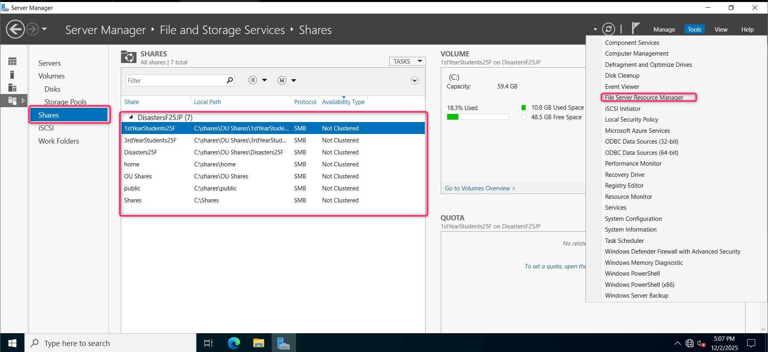
Figure 17 - Proof of FSRM Role Installation and list of folders on file server
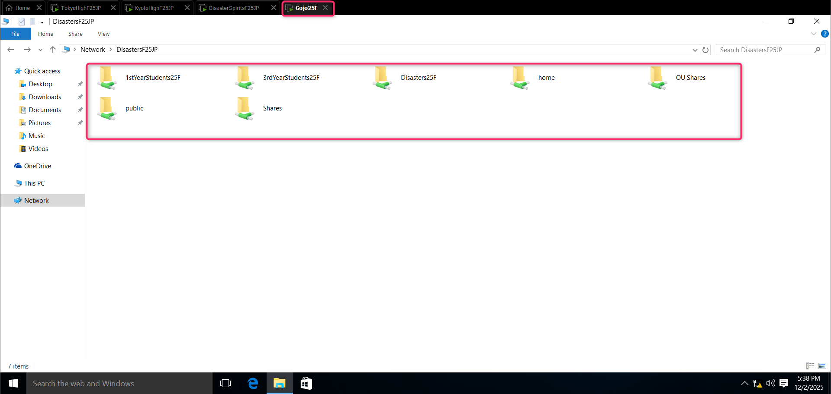
Figure 18 - List of folders on the client machine
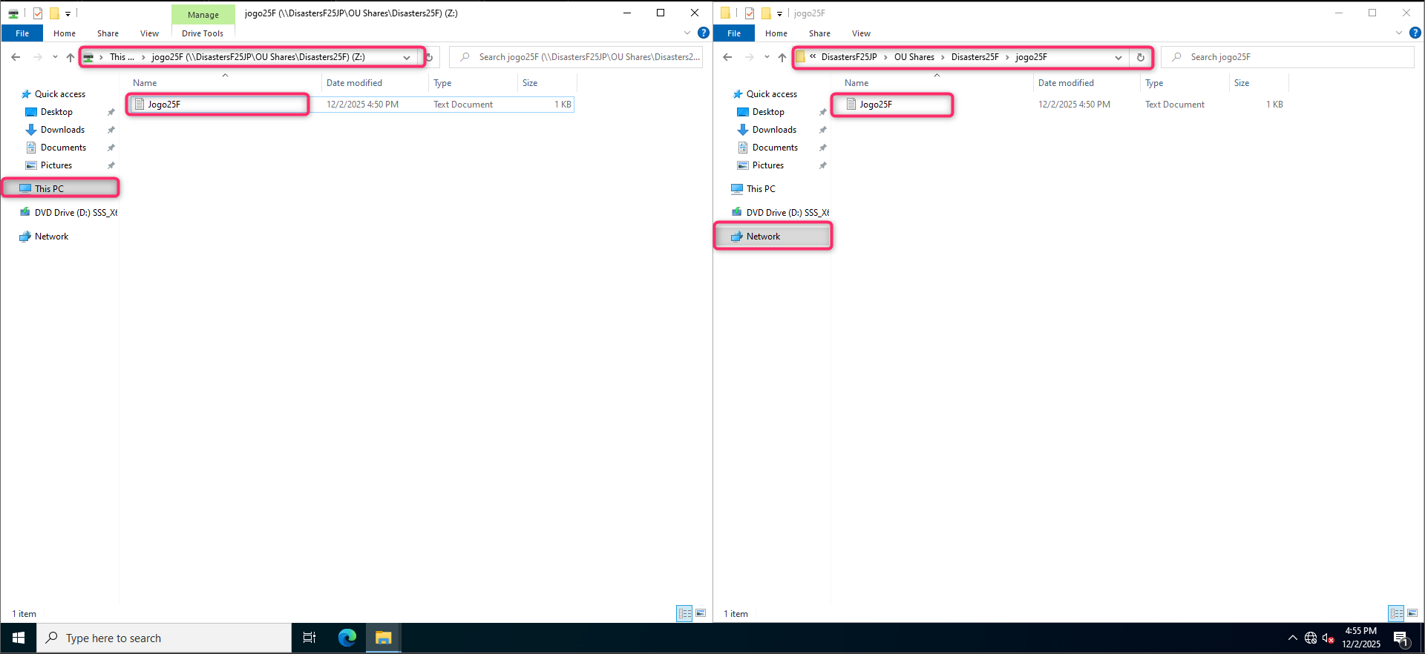
Figure 19 - Document Created on client machine opened on file server
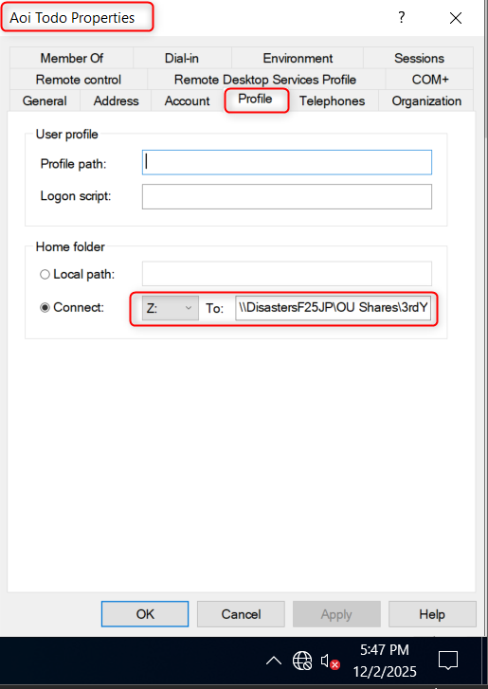
Figure 20 - Profile settings showing the drive letter and the path of the shared folder

Client Machine
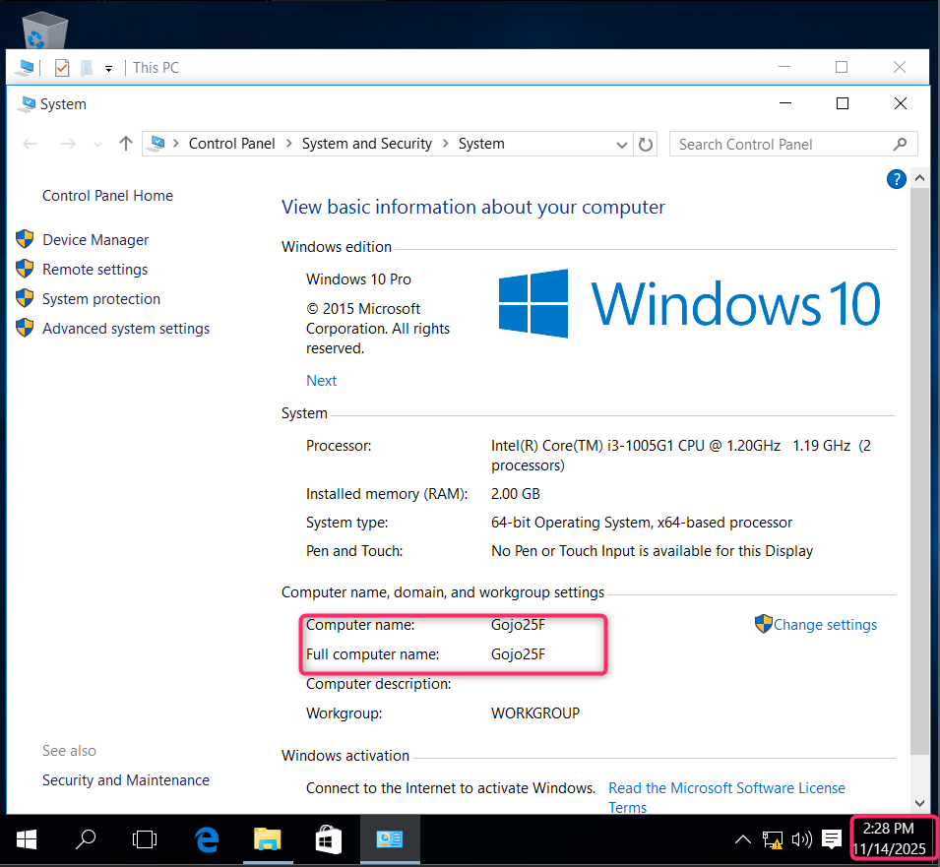
Figure 21 - Windows 10 Machine
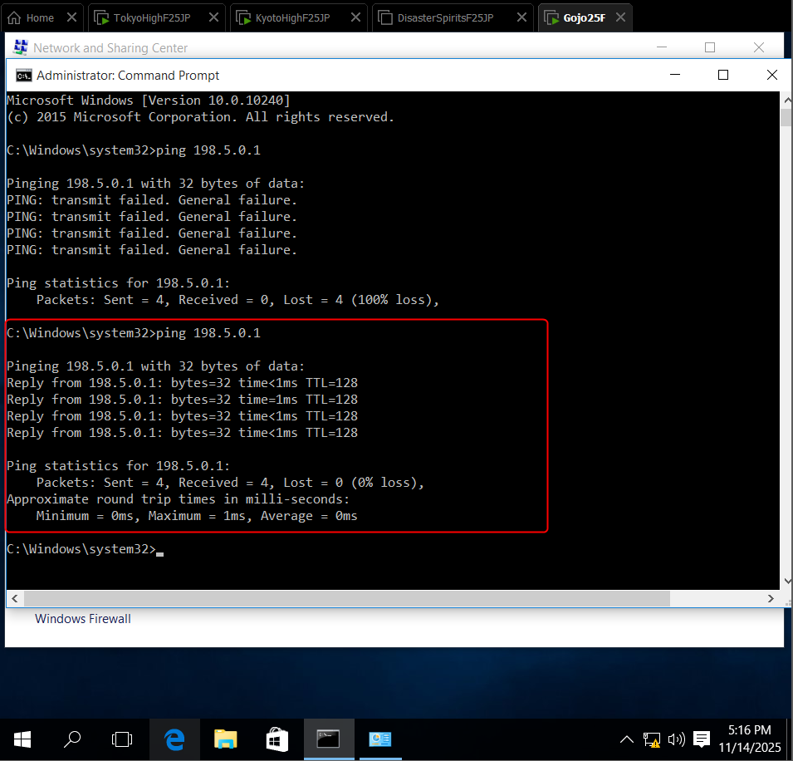
Figure 22 - Connectivity
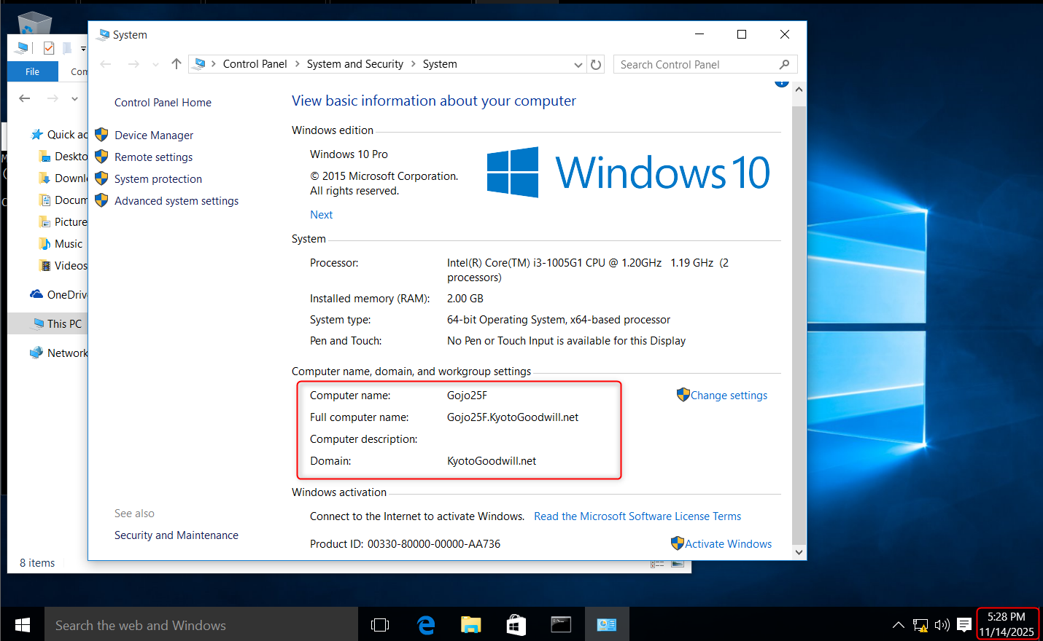
Figure 23 - Client joined to the Network
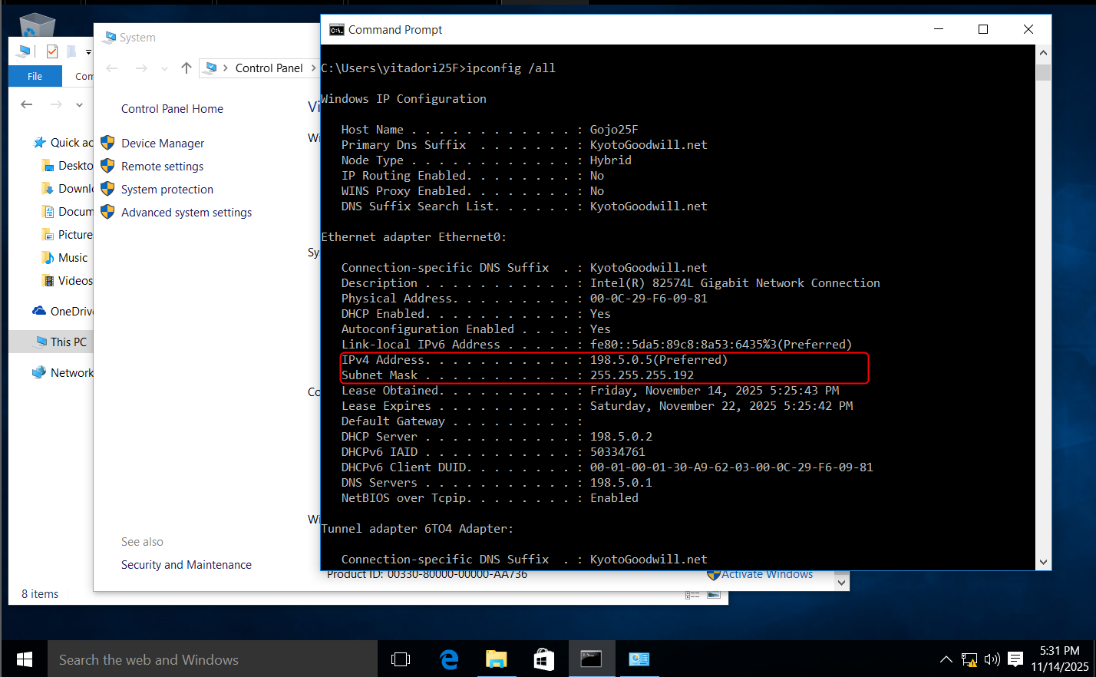
Figure 24 - DHCP console
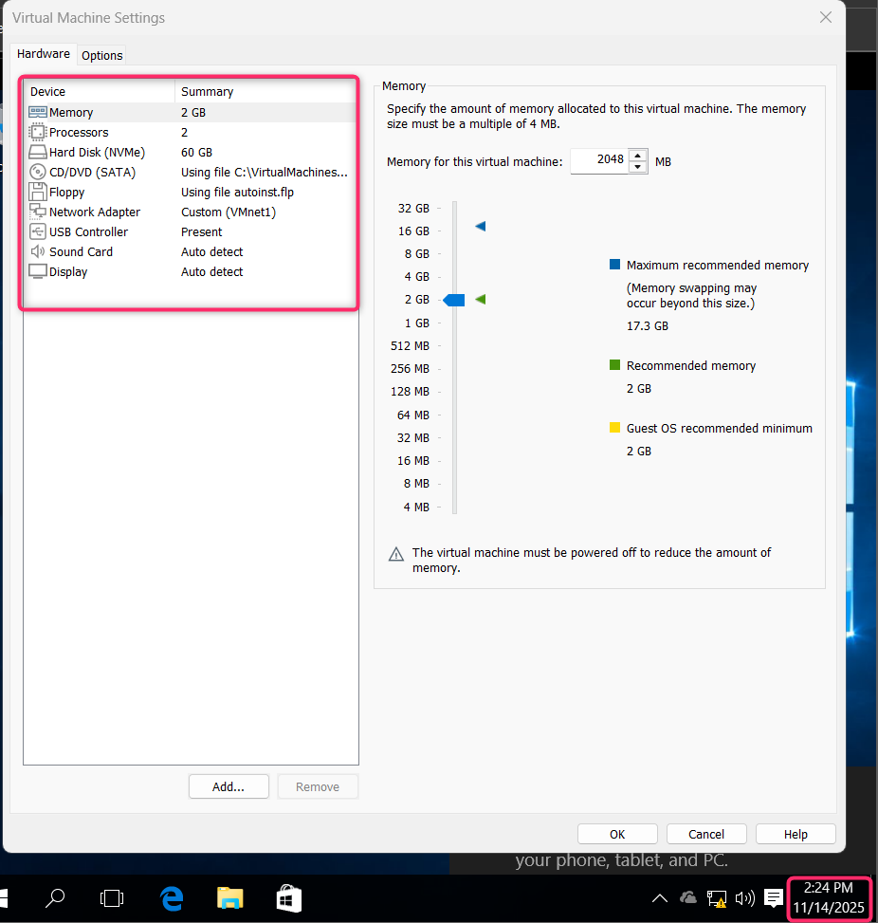
Figure 25 - Client Hardware

