**Introduction**

WordPress is a leading Content Management System which allows individuals to come up with highly efficient websites without prior programming knowledge (WordPress.com, n.d.). Released in 2003, the initial version was tailored for individuals who wanted to create and host basic blogs. Over the years, the software has greatly evolved into a robust and powerful tool suitable for almost any site. The software exists as opensource, it’s distributed under the GNU General Public License hence it is not under any copyright laws that restrict download and modification (Glassman, 2022). Its dashboard has an administration tool that allows users to change its layout and functionality codeless using themes. The software also features a huge variety of plugins, they allow users to extend the normal functionality of websites by personalizing to suite specific needs. WordPress offers a place for every mobile application developer, it supports apps for both WebOS, BlackBerry, iOS, and Android. This article seeks to describe the entire process through which an individual can sell online course on WordPress.

**Package Subscription**

In this article we are going to utilize the Bluehost to sell online courses on WordPress, since Bluehost allows provides 24/7 WordPress Support, a single click WordPress installation, and a 30-day money back guarantee after signing up. To get started, click on the following [**Link**](https://www.bluehost.com/special/wpbeginner?clickid=2fJyhq2rexyNTOAVqs3wbUHyUkDRg1XYJ1JORQ0&irgwc=1&pb=affiliate_super&irpid=11535&source=IR&utm_medium=affiliate&utm_affiliate=mbalkhi&utm_affiliate_sys=IR&sharedid=wpbeginner&siteID=&iradid=1434313&utm_source=IR&utm_campaign=Awesome%20Motive%20Inc.), this will avail the **Getting Started** webpage, click on the **Get Started Now** button and proceed to choose your most favorable package. The available packages are as shown below;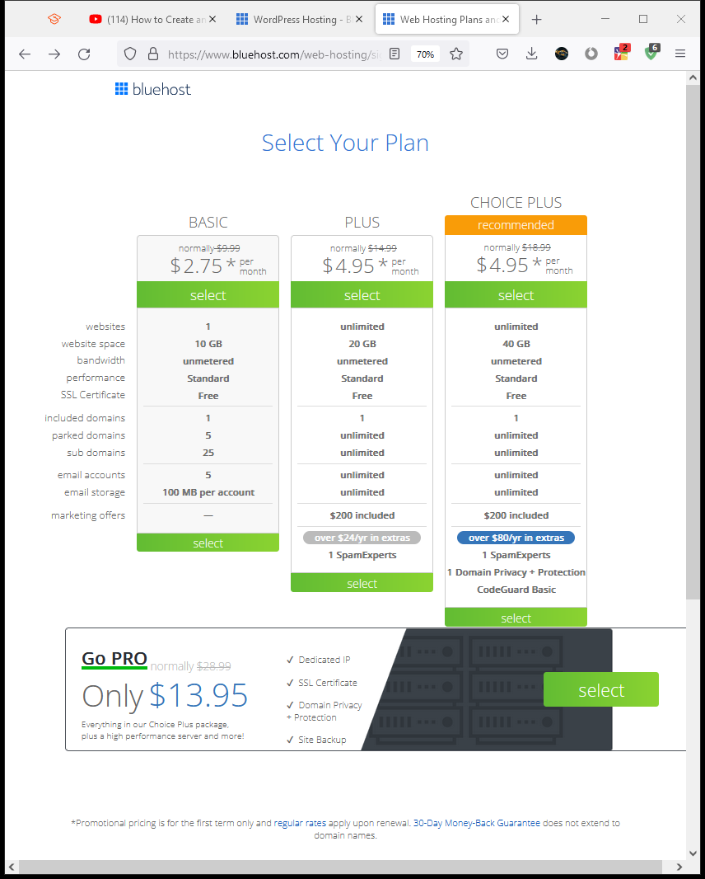

The **choice plus** package is most suitable for individuals who would like to set up a huge number of websites, the **basic** and **plus** option are most favorable for normal users. In this article, we shall utilize the **basic** package. Proceed to the domain set-up page by clicking on the **Select** button. In the provided text field, provide either your own existing domain or create a new one and click **Next.** Upon domain name verification, proceed to provide **Account Information, Package Information, Package Extras,** and **Payment Information.** Read the provided terms of service from Bluehost then clock the **Submit** button. This will install WordPress and will reroute you to the Bluehost **Dashboard** shown below. 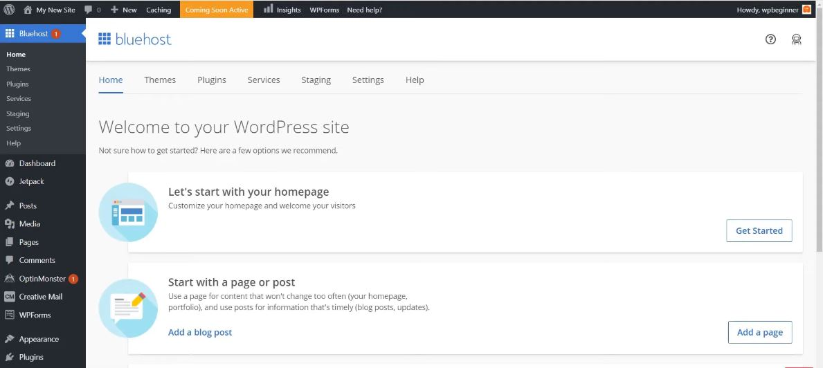

**Plugin Clean Up**

After the initial signup, the WordPress backend comes with plugins that may not be useful for our intention, we proceed to remove them by clicking on the **Plugins.** This will display the pre-installed plugins, select the **Deactivate** option in the availed combo box. Proceed to deselect all plugins that you wish to retain, (it is advisable that you deselect the following plugins; Google Analytics, Option Monster, and WPForms Lite.) then click **apply**. On the **Inactive** plugin section select all inactive plugins, select **delete** from the combo box then click **Apply** to delete them.

**New Theme Installation**

From the dashboard’s **Appearance** section, select **Themes,** this will avail any pre-installed themes. Click **Add New** to either install a custom theme or premium themes. Upon identifying the most suitable theme for your website from the list provided, click **Install** then **Activate.** The next step involves selecting a **Page Builder,** it’s important as it saves one extended hours of time that one would have used coding website pages as it provides prebuilt webpage designs. Select any of the available website templates then click **Import.**

**MemberPress LMS Plugin Installation**

MemberPress LMS is an addon that lets individuals to create course in WordPress. Visit the MemberPress website by clicking this [**link**](https://memberpress.com/?utm_medium=aff-syed&utm_content=%2Fwp-tutorials%2Fhow-to-create-online-course-in-wordpress%2F&utm_source=www.wpbeginner.com) . This will allow you to subscribe to MemberPress and download a MemberPress Plugin for installation in WordPress. From the **Plugin** Section in Dashboard, select **Upload Plugin** to upload the pre-downloaded MemberPress Plugin then click **Install Now.** Click the **Activation** button that appears after installation and add **License key** obtained after purchase of MemberPress subscription. We need to add a payment gateway to our website, we achieve this by visiting the **MemberPress** page from the dashboard. Under the Payment methods, click the **Gateway Drop down Box,** and select your most preferred payment gateway from the list provided.

**Course Creation**

To create the first course using the MemberPress Plugin, we need to install the **courses addon.** This can be achieved by visiting **MemberPress-Courses** page, then clicking the install and activate button shown in the figure below. 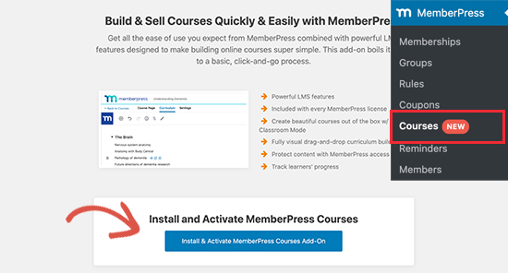

Successful creation and activation will redirect you to the **Courses Page,** click the **Add New** button to create the first course using the **MemberPress course Builder screen**. The **Course Page** will allow you to input the **Course Topic, Title and description.** The MemberPress Course Builder also allows one to input the **Course Categories, Course Excerpts, Course Tags, and Course Images** under the settings button displayed by the **gear icon**