2APPAI Shipping Challenge

The assignment

-> Create your own kubernetes stack with 1 worker
-> Containerized application for worker
-> When the surname changes in DB, it changes for the webpage automatically
-> When the layout changes, the worker will display the new layout automatically
-> Use the webstack which is assigned to you
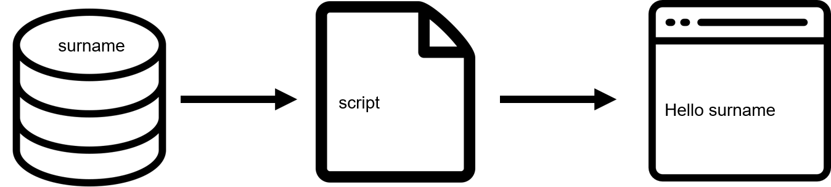

My webstack

Webserver | Script language | database
lighttpd | PHP | MariaDB

How to earn points

-> 0/20 Be a plant
->10/20 stack in Docker
-> 14/20 mk8s cluster with 1 worker

Extra points

-> Vagrant
-> Extra worker
-> Management webplatform for containers
-> Something else than mk8s with the same purpose
-> Be a funny guy

My setup

Dockerfile

FROM ubuntu:latest

#timezone
ENV TZ=Europe/Brussels
RUN ln -snf /usr/share/zoneinfo/$TZ /etc/localtime && echo $TZ > /etc/timezone

#updates
RUN apt-get update && apt-get upgrade -y

#install lighttpd, php, enable cgi
RUN apt-get install -y \
lighttpd \
php \
php-cgi \
php-mysql
RUN lighty-enable-mod fastcgi \
&& lighty-enable-mod fastcgi-php

#reload lighttpd
RUN service lighttpd restart

#copy test files
COPY test.php dbconnection.php dbfetch.php /var/www/html/

RUN chmod +x /var/www/html/test.php \
/var/www/html/dbconnection.php \
/var/www/html/dbfetch.php \
&& service lighttpd restart

#open port
EXPOSE 80

#run lighttpd server
CMD ["lighttpd", "-D", "-f","/etc/lighttpd/lighttpd.conf"]

Steps

-> Get the latest stable Ubuntu
-> Set the timezone(precaution just in case, heard some webservices hate being in the wrong time zone)
-> Update and upgrade everything
-> Install the essential software for my stack
-> Copy all the files needed
-> Make them executable
-> Open up port 80
-> run the lighttpd server

Kubernetes

Deployment

This downloads the image and creates 3 pods using the dockerfile. It also checks for the newest version on start.

apiVersion: apps/v1
kind: Deployment
metadata:
name:shippingchallenge-lighttpd
spec:
replicas: 3
selector:
matchLabels:
app: lighttpd
template:
metadata:
labels:
app: lighttpd
spec:
containers:
- name: lighttpd
image: tritsmansdylan/shippingchallenge
imagePullPolicy: Always
ports:
- containerPort: 80
name: lighttpd

Service

This makes sure the pods run on the correct port.

apiVersion: v1
kind: Service
metadata:
name: shippingchallenge-service
labels:
app: lighttpd
spec:
type: ClusterIP
ports:
- port: 80
selector:
app: lighttpd

Ingress

This is used to balance the load between the pods and make the application available to other devices.

apiVersion: networking.k8s.io/v1
kind: Ingress
metadata:
name: shippingchallenge-ingress
namespace: default
spec:
rules:
- host: shipping-challenge.local
http:
paths:
- path: /
pathtype: Prefix
backend:
service:
name: shippingchallenge-service
port:
number: 80

Dockerhub

I host my shipping challenge image on Dockerhub:
https://hub.docker.com/repository/docker/tritsmansdylan/shippingchallenge/

I have linked my github to dockerhub, when a git push is made this will automatically be built via automated builds in dockerhub.

Installation

Minikube

-> install Kubectl https://kubernetes.io/docs/tasks/tools/install-kubectl/
-> install minikkube https://minikube.sigs.k8s.io/docs/start/

-> Fire up Minikube with its add-on ingress.
minikube start
minikube addons enable ingress

Shipping challenge

-> install mariadb using these commands:
$ sudo apt-get install software-properties-common

$ sudo apt-key adv fetch-keys 'https://mariadb.org/mariadb_release_signing_key.asc'

$ sudo add-apt-repository 'deb [arch=amd64,arm64,ppc64el] http://mirrors.piconets.webwerks.in/mariadb-mirror/repo/10.5/ubuntu focal main'

$ sudo apt update

$ sudo apt install mariadb-server

-> secure installation with the script provided using:
$ sudo mysql_secure_installation

-> give yourself access to the database by following these steps:

-> find the database config file and add this to the [mysqld] tag:
port = 3306
bind_address = 0.0.0.0
skip_name_resolve

-> log in to the database on the machine running it and use this command:
GRANT ALL ON database_name.* TO ‘your_username’@’%’IDENTIFIED BY ‘your_password’;

-> apply the yaml files on the machine running minikube with:
kubectl apply -f deployment.yaml
kubectl apply -f service.yaml
kubectl apply-f ingress.yaml

-> get the ingress ip address:
kubectl get ingress

-> add this ip to your host file: example: 192.168.99.101 shippingchallenge.local

