'compare versions'

Calling the function with two inputs and printing the result

TestCase 1:

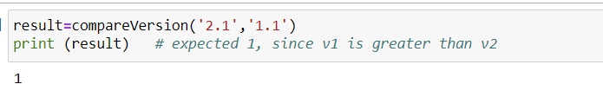

TestCase 2:

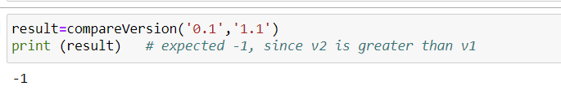

TestCase 3:

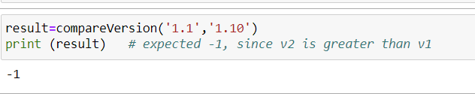

TestCase 4:

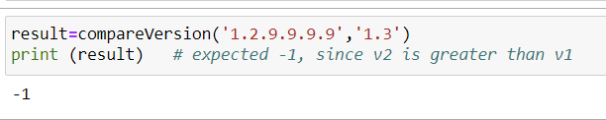

TestCase 5:

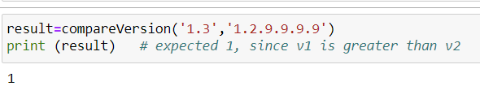

TestCase 6:

