|  |  |  |  |  |  |  |  |  |  |
| --- | --- | --- | --- | --- | --- | --- | --- | --- | --- |
| Mike Trivedi | |  |  | | --- | --- | | Tampa, Florida |  | | Will Relocate |  | | trivediahd@outlook.com |  | | www.linkedin.com/in/miketriv |  | |

Mike is a **Senior Data Scientist** with extensive industry experience as a **Lead/Principal Developer**.

SQL/NoSQL Databases **15+ years** Programming Languages **20+ years**

*(includes F#/Java/JavaScript/Perl/REXX/many others)*

Windows Programming **20+ years** Data Science **15+ years**

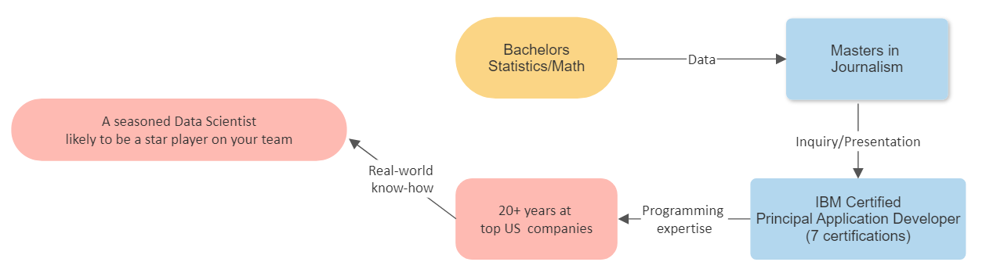

### **Mike has Built, Tested and Trained Machine Learning Models.**

### A 2018 Text-Classification and Tokenization project requirement needed the latest ML features,

### namely the then recent Google Research usage of *nGrams*.

### The toolkit being used (Java-based ML Toolkit *Mallet*) had not been updated for a while.

### Mike built, tested and deployed an independent module using Dependency Injection to add the features to the Machine Learning Toolkit *without touching* a single line of their code (licensing requirements)

### Mike has considerable experience with the Java-based **ML/NLP engines**, including *Mallet*, *Weka* and the *Stanford NLP Toolkit*.

### Mike understands tokenizing, stemming, lemmas, and model optimization techniques.

### If required **Mike could build you a ChatGPT clone from scratch**.

### The **variety** and **extent** of Mike's industry experience has ensured that he has always been current with the highest business standards and a wide wealth of technology stacks.

### Mike has been an Independent Contractor at foremost US Main Street firms including:

|  |  |  |  |  |
| --- | --- | --- | --- | --- |
| Pharmaceutical | Financial | Media | Manufacturing | Govt/Other |
| Merck & Co. | FannieMae | Comcast | Atlantic Richfield | US DoE |
| SmithKline Beecham | Chase Manhattan | Major League Baseball | Knoll Manufacturing | SWFWMD |
|  | Discover | Thomson Reuters | Elf Atochem | Temple Univ. |
|  | Vanguard Fin. |  |  |  |
|  | Pwc |  |  |  |
|  | Reliance Ins. |  |  |  |

*• Has developed and sold software in the US and Europe*  *• US Citizen*

*• Prefers IC status (1099/Corp-to-Corp) • US Govt. Security Clearance*

*• Recent resume updates @ https://trivedienterprisesinc.github.io/Mike2.docx*