**Week 6**

**React**

**Example 1:** Create a new React Application with the name “myfirstreact”, Run the application to print “welcome to the first session of React” as heading of that page.

1. Install Create-react-app by running the following command in the command prompt

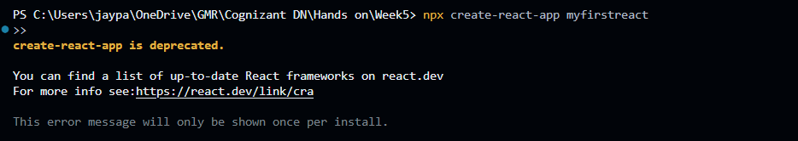

1. Once the App is created, navigate into the folder of myfirstreact by typing the following command:



1. Go to src/App.js . Delete all existing code . Replace it with:

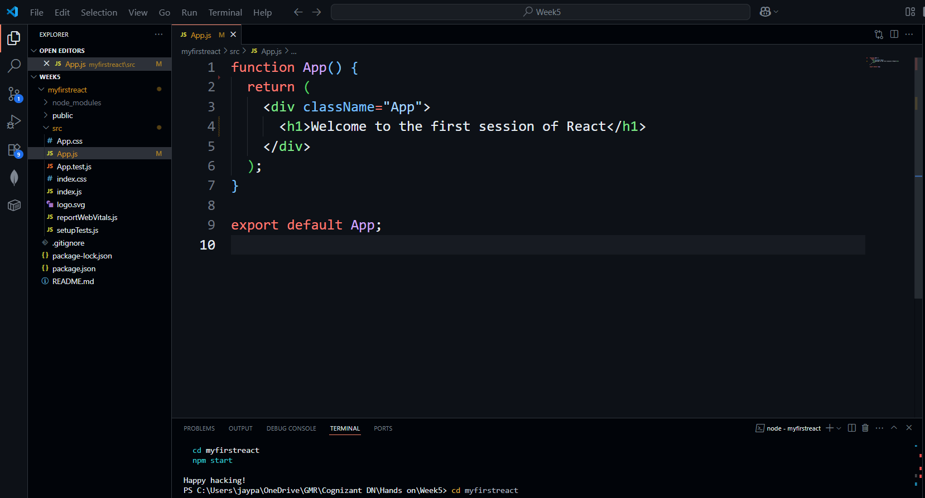

1. Run the following command to execute the React application:

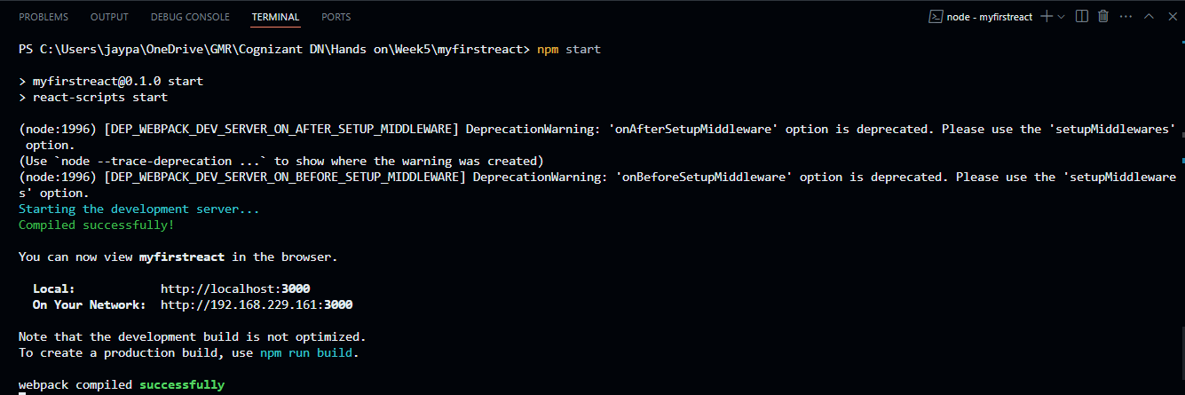

1. Open a new browser window and type “localhost:3000” in the address bar

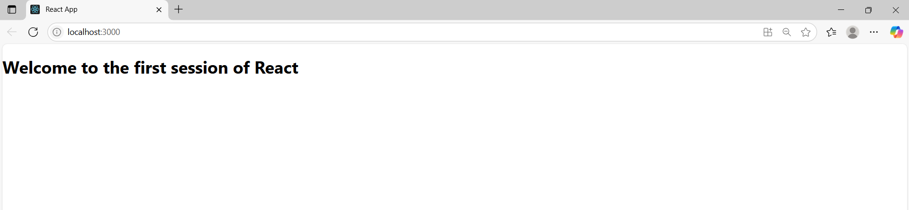

**Example 2:** Create a react app for Student Management Portal named StudentApp and create a component named Home which will display the Message “Welcome to the Home page of Student Management Portal”. Create another component named About and display the Message “Welcome to the About page of the Student Management Portal”. Create a third component named Contact and display the Message “Welcome to the Contact page of the Student Management Portal”. Call all the three components.

1. Create a React project named “StudentApp” type the following command in terminal of Visual studio:

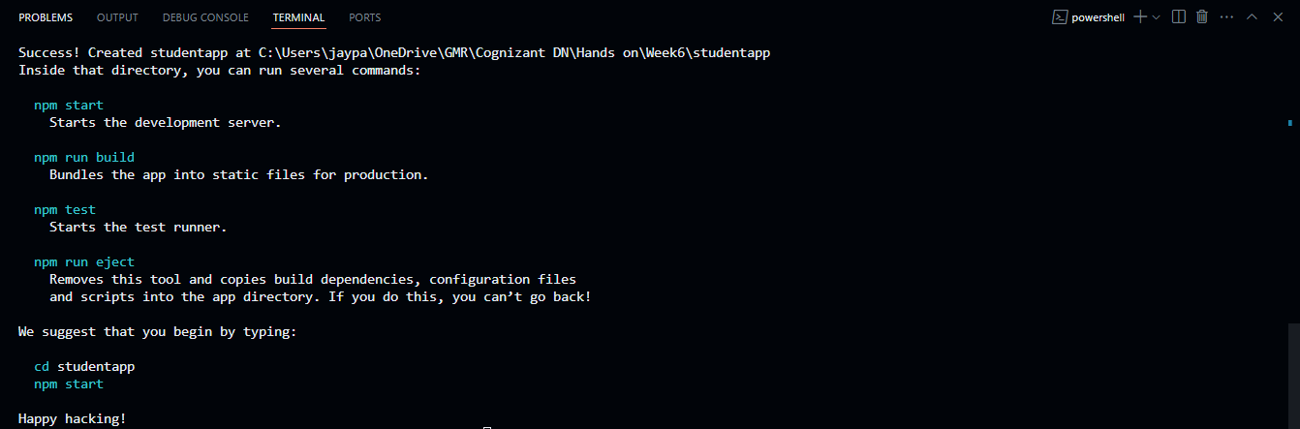

1. Create a new folder under Src folder with the name “Components”. Add a new file named “Home.js”

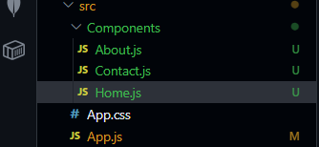

1. Type the following code in Home.js

import React, { Component } from 'react';

class Home extends Component {

render() {

return (

<h1>Welcome to the Home page of Student Management Portal</h1>

);

}

}

export default Home;

1. Type the following code in About.js

import React, { Component } from 'react';

class About extends Component {

render() {

return (

<h1>Welcome to the About page of Student Management Portal</h1>

);

}

}

export default About;

1. Type the following code in Contact.js

import React, { Component } from 'react';

class Contact extends Component {

render() {

return (

<h1>Welcome to the Contact page of Student Management Portal</h1>

);

}

}

export default Contact;

1. Open App.js nad type the below code.

import React, { Component } from 'react';

import Home from './Components/Home';

import About from './Components/About';

import Contact from './Components/Contact';

class App extends Component {

render() {

return (

<div>

<Home />

<About />

<Contact />

</div>

);

}

}

export default App;

1. In command Prompt, navigate into StudentApp and execute the code by typing the following command

npm start

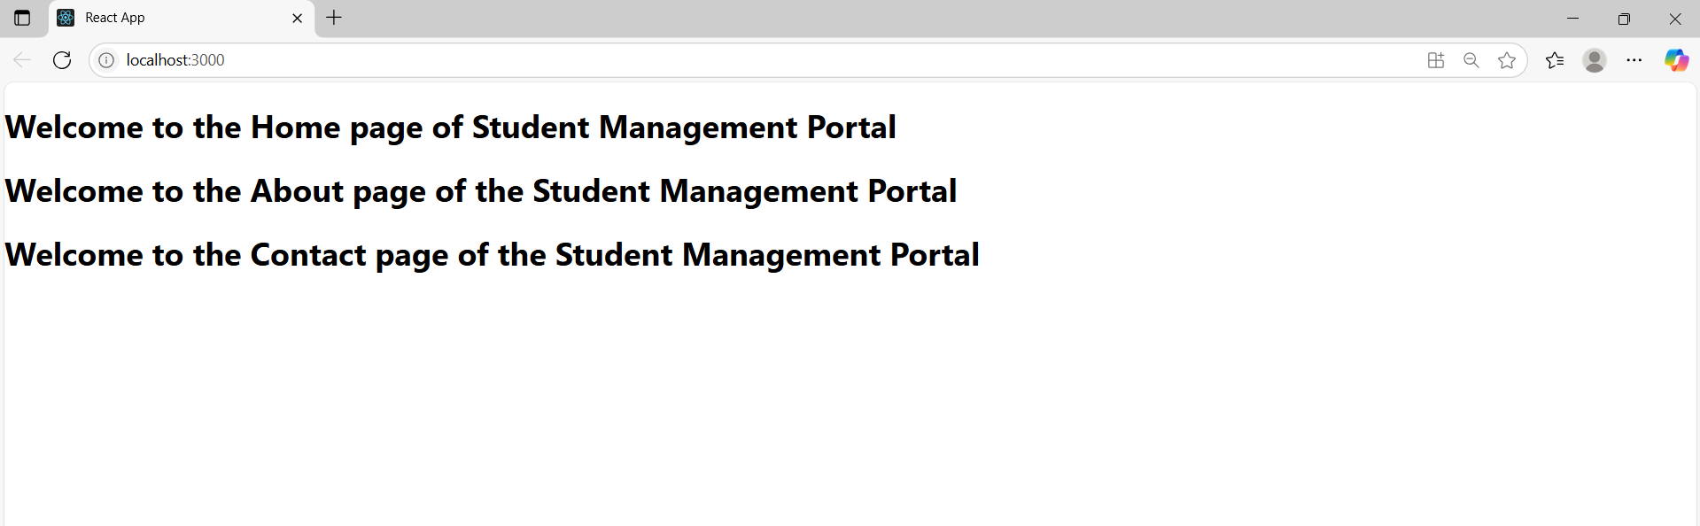

**Example 3:** Create a react app for Student Management Portal named scorecalculatorapp and create a function component named “CalculateScore” which will accept Name, School, Total and goal in order to calculate the average score of a student and display the same.

1. Create a React project named “scorecalculatorapp” type the following command in terminal of Visual studio:

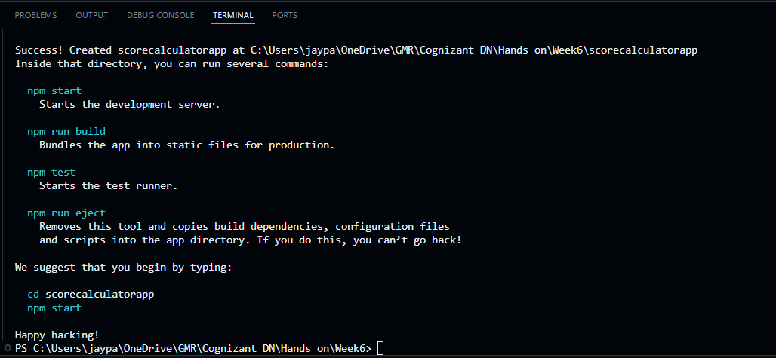

1. Create a new folder under Src folder with the name “Components”. Add a new file named “CalculateScore.js”

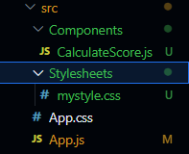

1. Type the following code in CalculateScore.js

import '../Stylesheets/mystyle.css'

const percentToDecimal=(decimal)=>{

return (decimal.toFixed(2) + '%')

}

const calcScore=(total,goal)=>{

return percentToDecimal(total/goal)

}

export const CalculateScore = ({Name, School, total, goal}) => (

<div className="formatstyle">

<h1><font color="Brown">Student Details:</font></h1>

<div className="Name">

<b> <span> Name: </span> </b>

<span>{Name}</span>

</div>

<div className="School">

<b> <span> School: </span> </b>

<span>{School}</span>

</div>

<div className="Total">

<b><span>Total:</span> </b>

<span>{total}</span>

Marks

</div>

<div className="Score">

<b>Score:</b>

{calcScore(

total,

goal

)}

</div>

</div>

);

1. Create a Folder named Stylesheets and add a file named “mystyle.css” in order to add some styles to the components

.Name{

font-weight: 300;

color:blue;

}

.School{

color: crimson;

}

.Total{

color: darkmagenta;

}

.formatstyle{

text-align: center;

font-size: large;

}

.Score{

color:forestgreen;

}

1. Edit the App.js to invoke the CalculateScore functional component as follows

import { CalculateScore } from "./Components/CalculateScore";

function App(){

return(

<div>

<CalculateScore Name={"Steeve"}

School={"DNV Public School"}

total={284}

goal={3}

/>

</div>

)

}

export default App;

1. In command Prompt, navigate into scorecalculatorapp and execute the code by typing the following command:

npm start

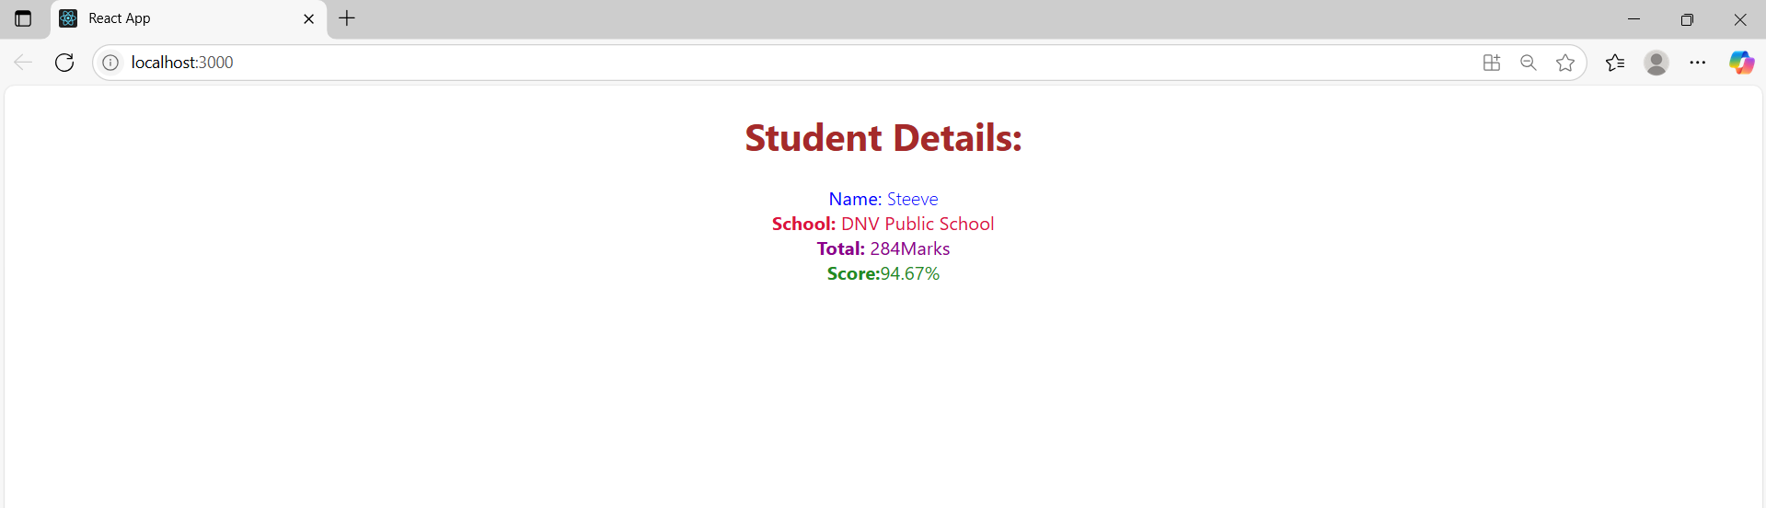

**Example 4:**

1. Create new react application using *create-react-app* tool with the name as “blogapp”

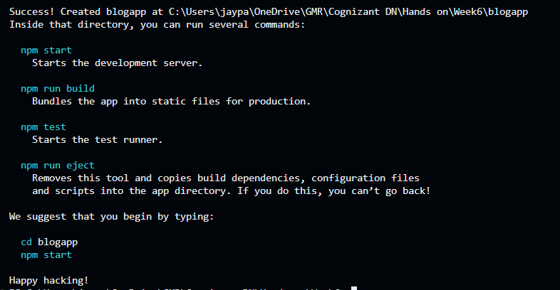

1. Open the application using VS Code
2. Create a new file named as **Post.js** in **src folder** with following properties

class Post{

    constructor(id,title,body){

        this.id = id;

        this.title= title;

        this.body = body;

    }

}

export default Post;

1. Create Posts.js file and add below code to that file.

import React, { Component } from 'react';

import Post from './Post';

class Posts extends Component {

constructor(props) {

super(props);

this.state = {

posts: [],

hasError: false

};

}

loadPosts = () => {

fetch('https://jsonplaceholder.typicode.com/posts')

.then(response => response.json())

.then(data => {

const postList = data.map(post => new Post(post.userId, post.id, post.title, post.body));

this.setState({ posts: postList });

})

.catch(error => {

console.error('Error fetching posts:', error);

this.setState({ hasError: true });

});

};

componentDidMount() {

this.loadPosts();

}

componentDidCatch(error, info) {

console.error('Error caught in component:', error, info);

alert('Something went wrong while rendering Posts!');

this.setState({ hasError: true });

}

render() {

if (this.state.hasError) {

return <h2>There was an error loading the posts.</h2>;

}

return (

<div>

<h1>Blog Posts</h1>

{this.state.posts.map(post => (

<div key={post.id}>

<h2>{post.title}</h2>

<p>{post.body}</p>

<hr />

</div>

))}

</div>

);

}

}

export default Posts;

1. Open App,js and add Posts to it

import React from 'react';

import './App.css';

import Posts from './Posts';

function App() {

return (

<div className="App">

<Posts />

</div>

);

}

export default App;

1. Open Run the application using the command npm start

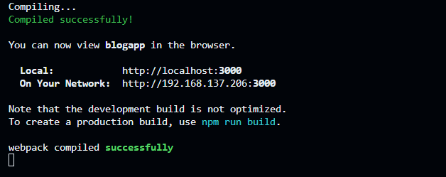

1. Open browser and see the output

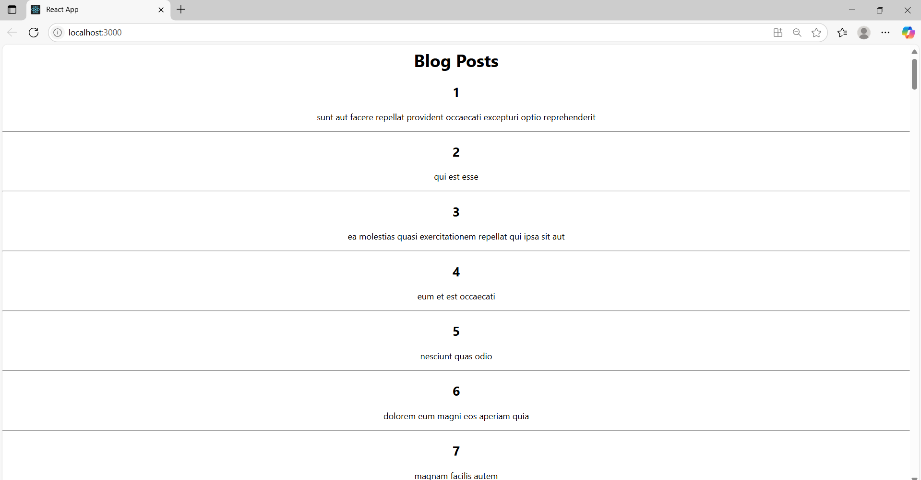

**Example 5:** My Academy team at Cognizant want to create a dashboard containing the details of ongoing and completed cohorts. A react application is created which displays the detail of the cohorts using react component. You are assigned the task of styling these react components.

1. Unzip the react application in a folder
2. Open command prompt and switch to the react application folder
3. Restore the node packages using the following commands
4. Open the application using VS Code
5. Create a new CSS Module in a file called “CohortDetails.module.css”
6. Define a css class with the name as “box” with following properties

.box {

width: 300px;

display: inline-block;

margin: 10px;

padding: 10px 20px;

border: 1px solid black;

border-radius: 10px;

}

1. Define a css style for html <dt> element using tag selector. Set the font weight to 500.

dt {

font-weight: 500;

}

1. Open the cohort details component and import the CSS Module

import styles from './CohortDetails.module.css';

1. Apply the box class to the container div

<div className={styles.box}>

//code

</div>

1. Define the style for <h3> element to use “green” color font when cohort status is “ongoing” and “blue” color in all other scenarios.

<h3 style={{ color: cohortStatus === 'ongoing' ? 'green' : 'blue' }}>

{props.cohort.cohortCode} -

<span>{props.cohort.technology}</span>

</h3>

1. CohortDetails.js:

import styles from './CohortDetails.module.css';

function CohortDetails(props) {

const cohortStatus = props.cohort.currentStatus;

return (

<div className={styles.box}>

<h3 style={{ color: cohortStatus === 'ongoing' ? 'green' : 'blue' }}>

{props.cohort.cohortCode} -

<span>{props.cohort.technology}</span>

</h3>

<dl>

<dt>Started On</dt>

<dd>{props.cohort.startDate}</dd>

<dt>Current Status</dt>

<dd>{props.cohort.currentStatus}</dd>

<dt>Coach</dt>

<dd>{props.cohort.coachName}</dd>

<dt>Trainer</dt>

<dd>{props.cohort.trainerName}</dd>

</dl>

</div>

);

}

export default CohortDetails;

1. App.js

import './App.css';

import { CohortsData} from './Cohort'

import CohortDetails from './CohortDetails';

function App() {

return (

<div>

<h1>Cohorts Details</h1>

{CohortsData.map(cohort => <CohortDetails cohort={cohort}/>)}

</div>

);

}

export default App;

1. CohortDetails.module.css

.box {

width: 300px;

display: inline-block;

margin: 10px;

padding: 10px 20px;

border: 1px solid black;

border-radius: 10px;

}

dt {

font-weight: 500;

}

1. Run the application using the command npm start and copy the url and paste it in browser

