**Week 7**

**React**

**Example 9:** Create a React Application named “cricketapp” with the following components

1. Open VS Code and create a react app
2. Now navigate to that app.
3. Under the src folder, Create a file called “ListofPlayers.js” and add below code to that file.

import React from 'react';

const ListofPlayers = () => {

const players = [

{ name: "Player1", score: 90 },

{ name: "Player2", score: 85 },

{ name: "Player3", score: 60 },

{ name: "Player4", score: 45 },

{ name: "Player5", score: 95 },

{ name: "Player6", score: 30 },

{ name: "Player7", score: 50 },

{ name: "Player8", score: 100 },

{ name: "Player9", score: 55 },

{ name: "Player10", score: 80 },

{ name: "Player11", score: 35 },

];

const below70 = players.filter(player => player.score < 70);

return (

<div>

<h2>All Players</h2>

<ul>

{players.map((player, index) => (

<li key={index}>{player.name} – {player.score}</li>

))}

</ul>

<h2>Players with Score Less Than 70</h2>

<ul>

{below70.map((player, index) => (

<li key={index}>{player.name} – {player.score}</li>

))}

</ul>

</div>

);

};

export default ListofPlayers;

1. Now craete another file named “IndianPlayers.js” and add below code to that file.

import React from 'react';

const IndianPlayers = () => {

const T20Players = ['Kohli', 'Rohit', 'Dhawan', 'Pant'];

const RanjiPlayers = ['Rahane', 'Pujara', 'Iyer', 'Jadeja'];

const AllPlayers = [...T20Players, ...RanjiPlayers];

const OddPlayers = AllPlayers.filter((_, index) => index % 2 === 0);

const EvenPlayers = AllPlayers.filter((_, index) => index % 2 !== 0);

return (

<div>

<h2>Odd Team Players</h2>

<ul>

{OddPlayers.map((player, index) => (

<li key={index}>{player}</li>

))}

</ul>

<h2>Even Team Players</h2>

<ul>

{EvenPlayers.map((player, index) => (

<li key={index}>{player}</li>

))}

</ul>

<h2>Merged Team Players</h2>

<ul>

{AllPlayers.map((player, index) => (

<li key={index}>{player}</li>

))}

</ul>

</div>

);

};

export default IndianPlayers;

1. Replace the below code in the ‘App.js’ file

import React from 'react';

import './App.css';

import ListofPlayers from './ListofPlayers';

import IndianPlayers from './IndianPlayers';

function App() {

const flag = false;

return (

<div className="App">

<h1>Cricket App</h1>

{flag ? <ListofPlayers /> : <IndianPlayers />}

</div>

);

}

export default App;

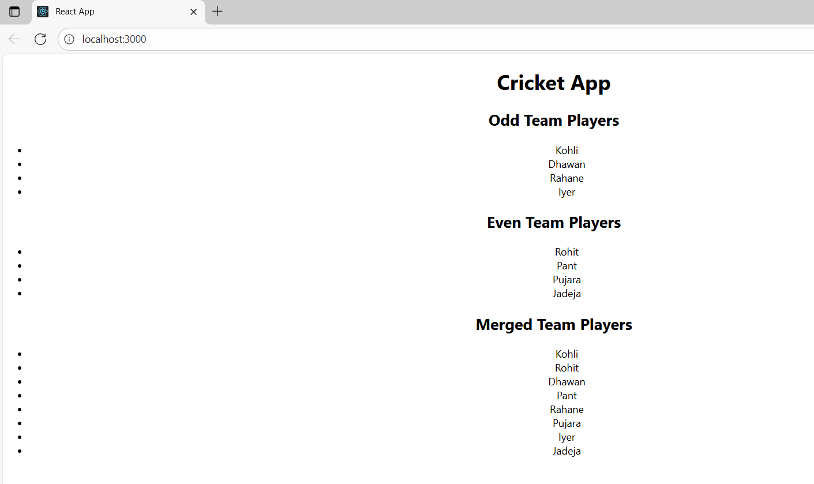

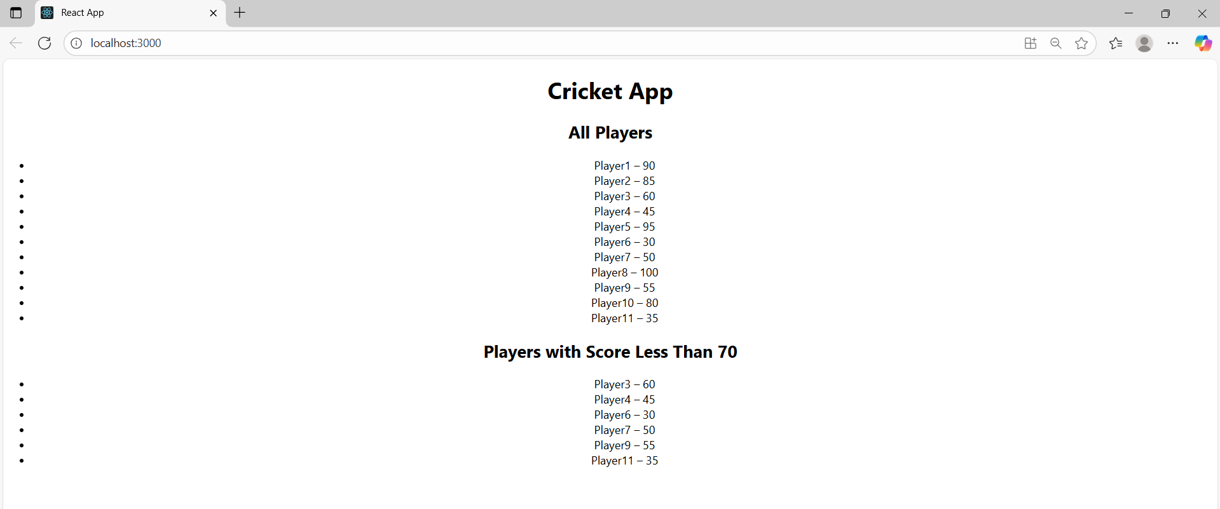

**Example 10:** Create a React Application named “officespacerentalapp” which uses React JSX to create elements, attributes and renders DOM to display the page.

1. Open VS Code and create a react app “officespacerentalapp”
2. Now navigate to that app.
3. Inside App.js add below code

import React from 'react';

import './App.css';

import sr from './office.jpeg';

function App() {

const heading = "Office Space Listings";

const imageElement = <img src={sr} width="25%" height="25%" alt="Office Space" />;

const officeList = [

{ Name: "Name1", Rent: 50000, Address: "Chennai" },

{ Name: "Name2", Rent: 65000, Address: "Hyderabad" },

{ Name: "Name3", Rent: 60000, Address: "Bangalore" },

{ Name: "Name4", Rent: 72000, Address: "Mumbai" },

];

return (

<div className="App">

<h1>{heading}</h1>

{imageElement}

{officeList.map((office, index) => (

<div key={index} className="office-card">

<h2>{office.Name}</h2>

<h3 className={office.Rent <= 60000 ? "textRed" : "textGreen"}>

Rent: Rs. {office.Rent}

</h3>

<h3>Address: {office.Address}</h3>

</div>

))}

</div>

);

}

export default App;

1. Inside “App.css”, add below code

.textRed {

color: red;

}

.textGreen {

color: green;

}

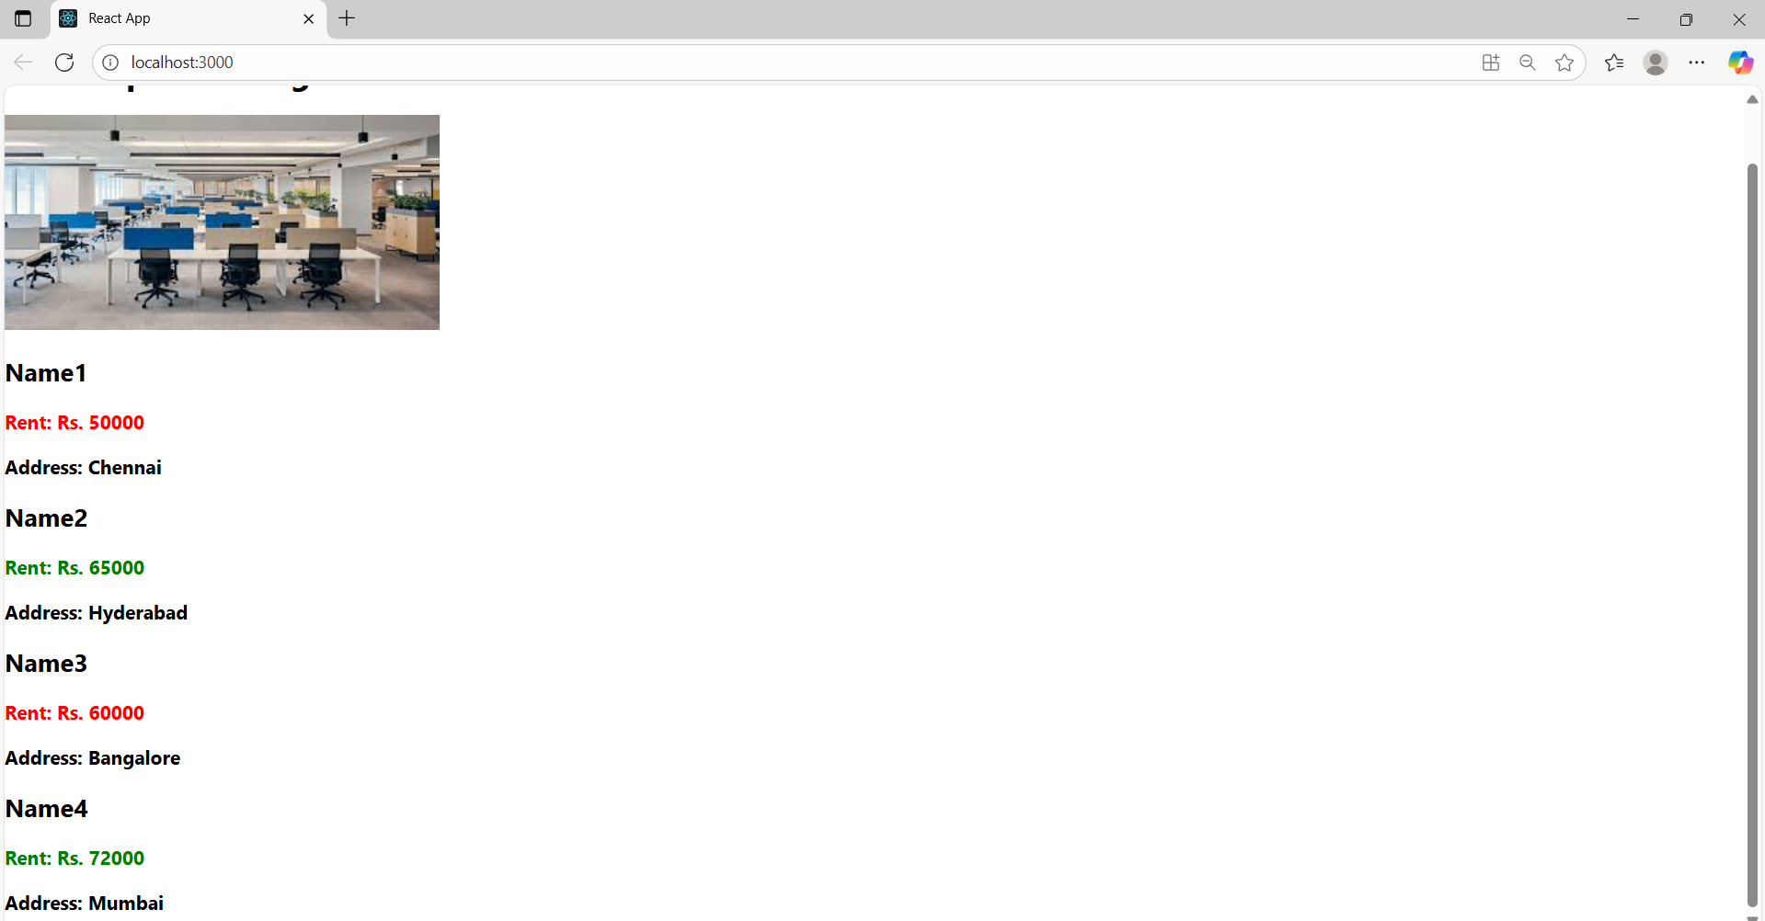

**Example 11:** Create a React Application “eventexamplesapp” to handle various events of the form elements in HTML.

1. Create “Increment” button to increase the value of the counter and “Decrement” button to decrease the value of the counter. The “Increase” button should invoke multiple methods.
   1. To increment the value
   2. Say Hello followed by a static message.

**WelcomeButton.js**

import React from 'react';

function WelcomeButton() {

  const handleWelcome = (msg) => {

    alert(msg);

  };

  return (

    <button onClick={() => handleWelcome("welcome")}>Say Welcome</button>

  );

}

export default WelcomeButton;

**Counter.js**

import React, { useState } from 'react';

function Counter() {

  const [count, setCount] = useState(5);

  const handleIncrement = () => {

    setCount(count + 1);

    alert("Hello! Madhu");

  };

  const handleDecrement = () => {

    setCount(count - 1);

  };

  return (

    <div>

      <h2>Counter: {count}</h2>

      <button onClick={handleIncrement}>Increment</button>

      <button onClick={handleDecrement}>Decrement</button>

    </div>

  );

}

export default Counter;

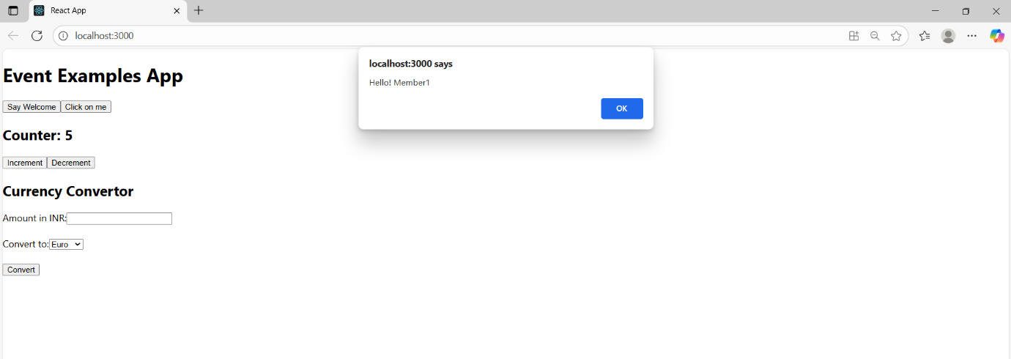

1. Create a button “Say Welcome” which invokes the function which takes “welcome” as an argument.

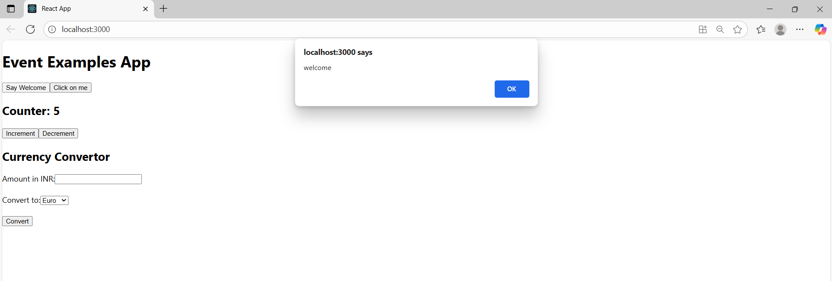

1. Create a button which invokes synthetic event “OnPress” which display “I was clicked”

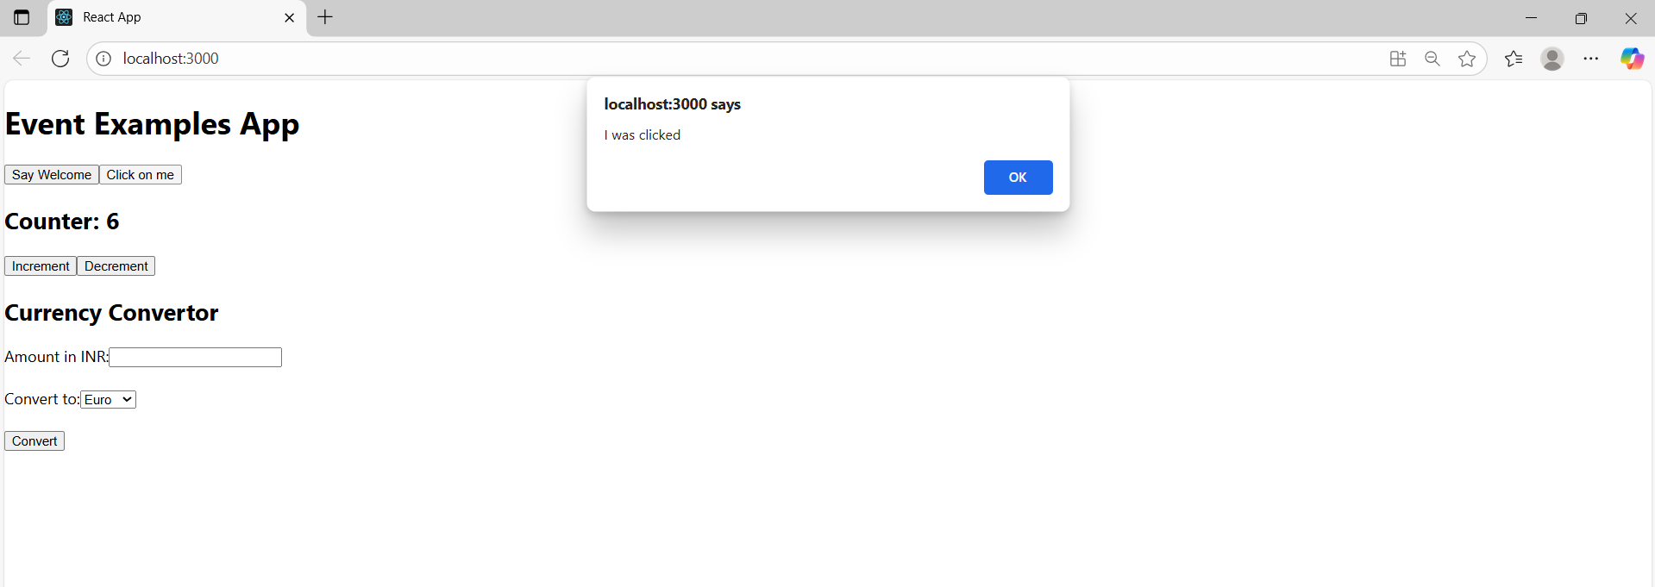

1. Create a “CurrencyConvertor” component which will convert the Indian Rupees to Euro when the Convert button is clicked.Handle the Click event of the button to invoke the handleSubmit event and handle the conversion of the euro to rupees.

**CurrencyConvertor.js**

import React, { useState } from 'react';

function CurrencyConvertor() {

  const [amountINR, setAmountINR] = useState('');

  const [currency, setCurrency] = useState('Euro');

  const conversionRates = {

    Euro: 90,

    Dollar: 75,

  };

  const handleSubmit = (e) => {

    e.preventDefault();

    const rate = conversionRates[currency];

    const converted = (parseFloat(amountINR) / rate).toFixed(2);

    const symbol = currency === 'Euro' ? '€' : '$';

    alert(`Converted Amount: ${symbol}${converted}`);

  };

  return (

    <div>

      <h2>Currency Convertor </h2>

      <form onSubmit={handleSubmit}>

        <label>

          Amount in INR:

          <input

            type="number"

            value={amountINR}

            onChange={(e) => setAmountINR(e.target.value)}

            required

          />

        </label>

        <br /><br />

        <label>

          Convert to:

          <select

            value={currency}

            onChange={(e) => setCurrency(e.target.value)}

          >

            <option value="Euro">Euro</option>

            <option value="Dollar">Dollar</option>

          </select>

        </label>

        <br /><br />

        <button type="submit">Convert</button>

      </form>

    </div>

  );

}

export default CurrencyConvertor;

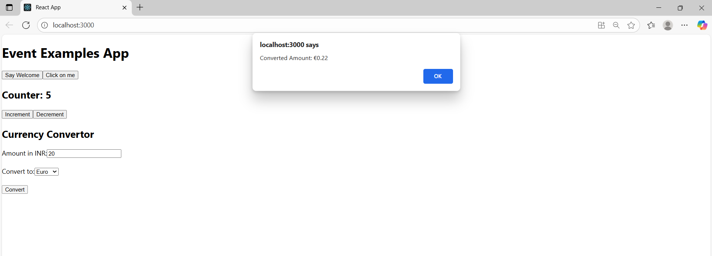

**Example 12:** Create a React Application named “ticketbookingapp” where the guest user can browse the page where the flight details are displayed whereas the logged in user only can book tickets.

The Login and Logout buttons should accordingly display different pages. Once the user is logged in the User page should be displayed. When the user clicks on Logout, the Guest page should be displayed.

1. **LoginButton.js**

import React from 'react';

function LoginButton(props) {

return (

<button onClick={props.onClick}>

Login

</button>

);

}

export default LoginButton;

1. **LogoutButton.js**

import React from 'react';

function LogoutButton(props) {

return (

<button onClick={props.onClick}>

Logout

</button>

);

}

export default LogoutButton;

1. **GuestGreeting.js**

import React from 'react';

function GuestGreeting() {

return <h1>Please sign up.</h1>;

}

export default GuestGreeting;

1. **UserGreeting.js**

import React from 'react';

function GuestGreeting() {

return <h1>Please sign up.</h1>;

}

export default GuestGreeting;

1. **Greeting.js**

import React from 'react';

import UserGreeting from './UserGreeting';

import GuestGreeting from './GuestGreeting';

function Greeting(props) {

const isLoggedIn = props.isLoggedIn;

if (isLoggedIn) {

return <UserGreeting />;

}

return <GuestGreeting />;

}

export default Greeting;

1. **App.js**

import React, { useState } from 'react';

import Greeting from './components/Greeting';

import LoginButton from './components/LoginButton';

import LogoutButton from './components/LogoutButton';

function App() {

const [isLoggedIn, setIsLoggedIn] = useState(false);

const handleLoginClick = () => {

setIsLoggedIn(true);

};

const handleLogoutClick = () => {

setIsLoggedIn(false);

};

return (

<div className="App">

<Greeting isLoggedIn={isLoggedIn} />

{isLoggedIn ? (

<LogoutButton onClick={handleLogoutClick} />

) : (

<LoginButton onClick={handleLoginClick} />

)}

</div>

);

}

export default App;

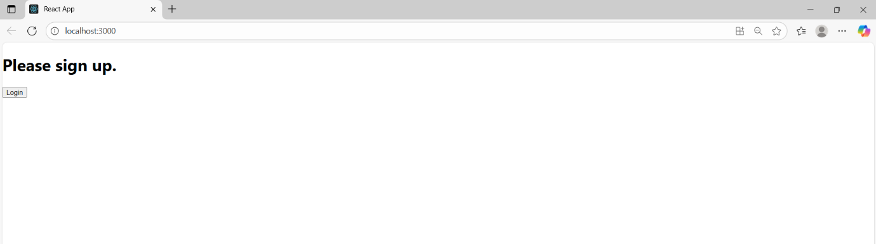

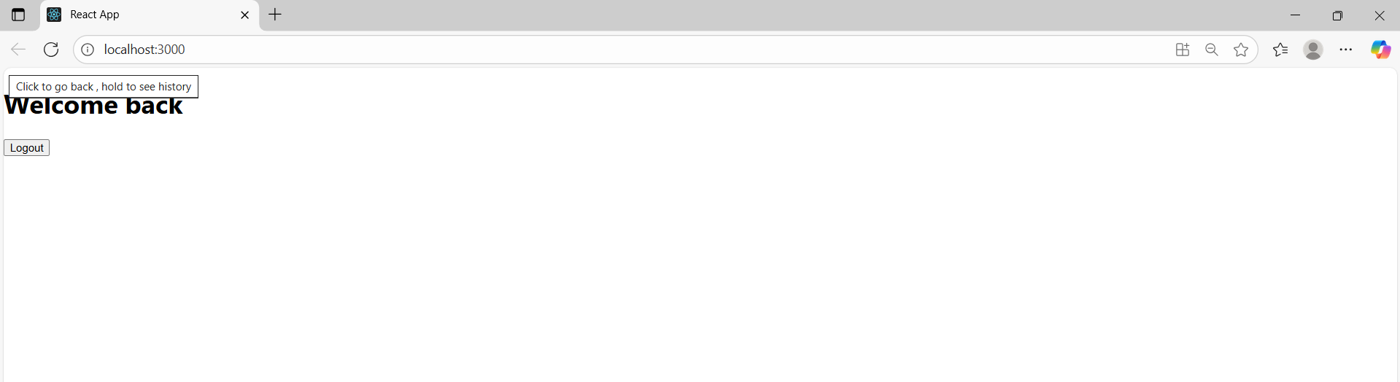

**Example 13:** Create a React App named “bloggerapp” in with 3 components.

1. Book Details
2. Blog Details
3. Course Details

**BookDetails.js**

import React from 'react';

export const books = [

  { id: 101, bname: 'Master React', price: 670 },

  { id: 102, bname: 'Deep Dive into Angular 11', price: 800 },

  { id: 103, bname: 'Mongo Essentials', price: 450 },

];

function BookDetails(props) {

  const showBooks = props.showBooks;

  if (!showBooks) {

    return <p>No book details available.</p>;

  }

  const bookdet = (

    <ul>

      {books.map((book) => (

        <div key={book.id}>

          <h3>{book.bname}</h3>

          <h4>₹{book.price}</h4>

        </div>

      ))}

    </ul>

  );

  return (

    <div className="st2">

      <h1>Book Details</h1>

      {bookdet}

    </div>

  );

}

export default BookDetails;

**BlogDetails.js**

import React from 'react';

function BlogDetails(props) {

  const isBlogVisible = props.isBlogVisible;

  return (

    <div className="v1">

      <h1>Blog Details</h1>

      {isBlogVisible ? (

        <p>React is a powerful library for building user interfaces.</p>

      ) : (

        <p>Blog content is hidden.</p>

      )}

    </div>

  );

}

export default BlogDetails;

**CourseDetails.js**

import React from 'react';

function CourseDetails(props) {

  const course = props.course;

  let coursedet;

  if (course === 'React') {

    coursedet = <p>React course covers hooks, components, and JSX.</p>;

  } else if (course === 'Angular') {

    coursedet = <p>Angular course includes TypeScript and RxJS.</p>;

  } else {

    coursedet = <p>No course selected.</p>;

  }

  return (

    <div className="mystyle1">

      <h1>Course Details</h1>

      {coursedet}

    </div>

  );

}

export default CourseDetails;

**App.js**

import React from 'react';

import './App.css';

function App() {

  return (

    <div className="row">

      <div className="box">

        <h2>Book Details</h2>

        <p>Master React - ₹670</p>

        <p>Angular 11 - ₹800</p>

        <p>Mongo Essentials - ₹450</p>

      </div>

      <div className="box">

        <h2>Blog Details</h2>

        <p>React is a powerful library for building user interfaces.</p>

      </div>

      <div className="box">

        <h2>Course Details</h2>

        <p>React course covers hooks, components, and JSX.</p>

      </div>

    </div>

  );

}

export default App;

**App.css**

.row {

  display: flex;

  justify-content: space-between;

  align-items: flex-start;

  padding: 20px;

}

