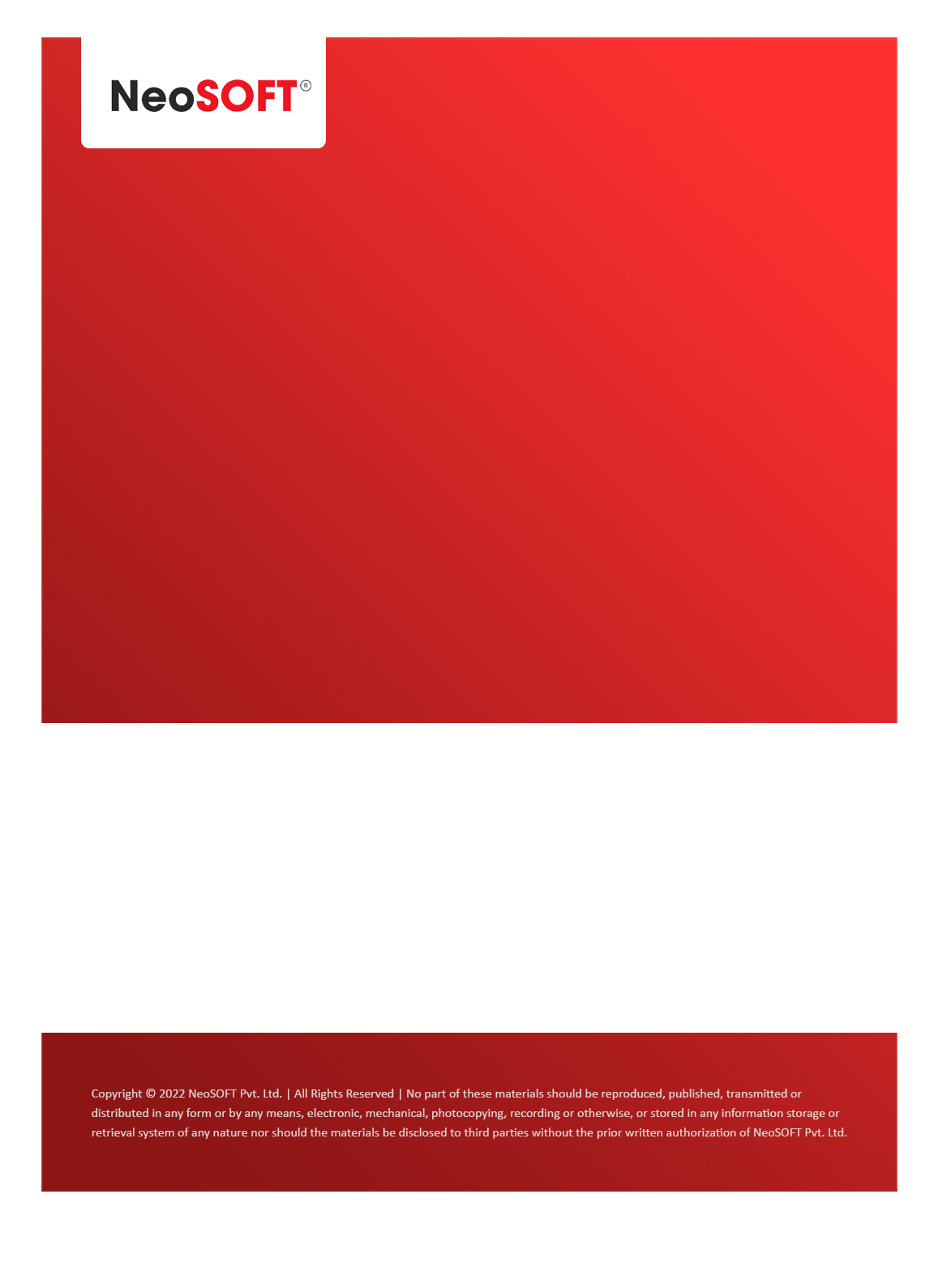`

**Weekly Status Report MOM**

**NeoSOFT** – A SEI-CMMI Level-5 Global IT Consulting & Software Solutions Provider

April 17, 2023

|  |  |
| --- | --- |
| **Meeting Date, Time and Attendee Details** | |
| **Date** | 17-April-2023 |
| **Venue** | MS Teams |
| **Time** | 12:00PM |
| **Meeting Type** | Emcure NPD - UAT Release |
| **Internal Attendees** | - Nilesh Jain  - Kuldip Wagh  - Supriya Patil |
| **Client Attendees** | - Rahul Patil |
| **MOM Prepared By** | Nilesh Jain |

|  |  |
| --- | --- |
| **Details of Meeting** | |
| **Sr.No** | **Description** |
| 1 | As discussed with Rahul, Emcure team would like to begin with Pre UAT phase for this week and from next week onwards they will begin with UAT phase. |
| 2 | As discussed with Rahul, NeoSOFT team is releasing NPD application for UAT phase. |

|  |  |  |  |  |  |
| --- | --- | --- | --- | --- | --- |
| **Actionable** | |  |  |  |  |
| **Sr.No** | **Action Item** | **Assigned to** | **Assigned Date** | **Expected Completion Date** | **Status** |
| 1 | NeoSOFT team will setup UAT environment on Emcure server | NeoSOFT Team | 17-Apr-2023 | 17-Apr-2023 | Completed |
| 2 | As discussed, Emcure team will share formula sheet for PBF & Finance module. | Rahul Patil | 17-Apr-2023 | 18-Apr-2023 | Pending |
| 3 | As Discussed, Emcure team will provide SMTP settings | Rahul Patil | 17-Apr-2023 | 18-Apr-2023 | Pending |
| 4 | As Discussed, Emcure team will setup meeting with business team for “Finance & PBF (Man Hour)” module. | Emcure Team | 17-Apr-2023 | 20-Apr-2023 | Pending |