**Tasks for Standard Sprint - Property Analysis - Part 5**

**Task 25**

**Given suburb and city, display median rental value, median yearly income, and value changes of the property within 1 km radius**

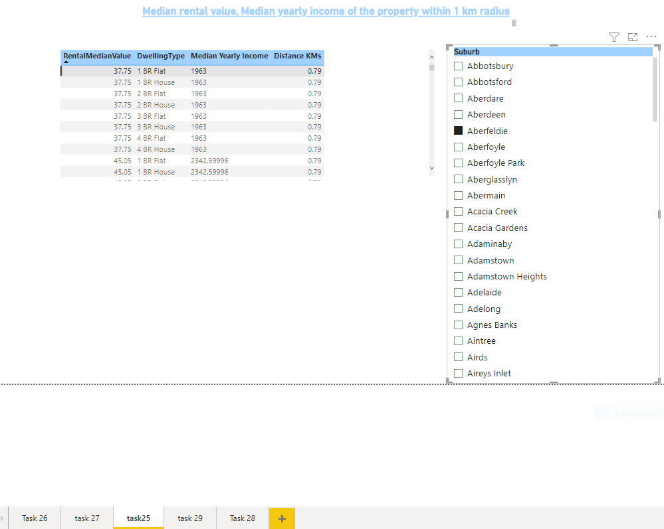

**Task 26**

**Given suburb and city, display local public transport within 1km radius**

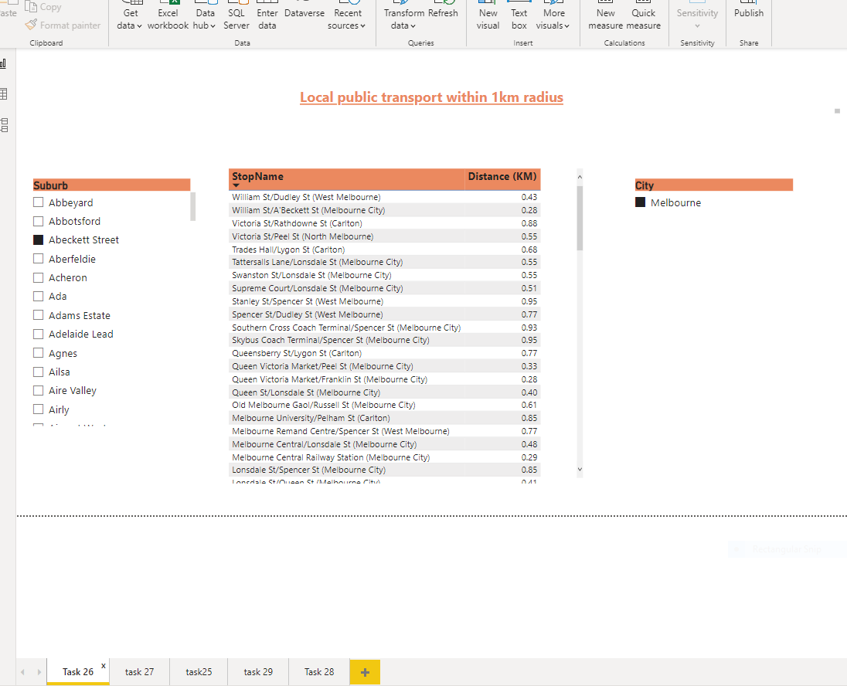

**Task 27**

**Given suburb and city, display local schools within 1km radius**

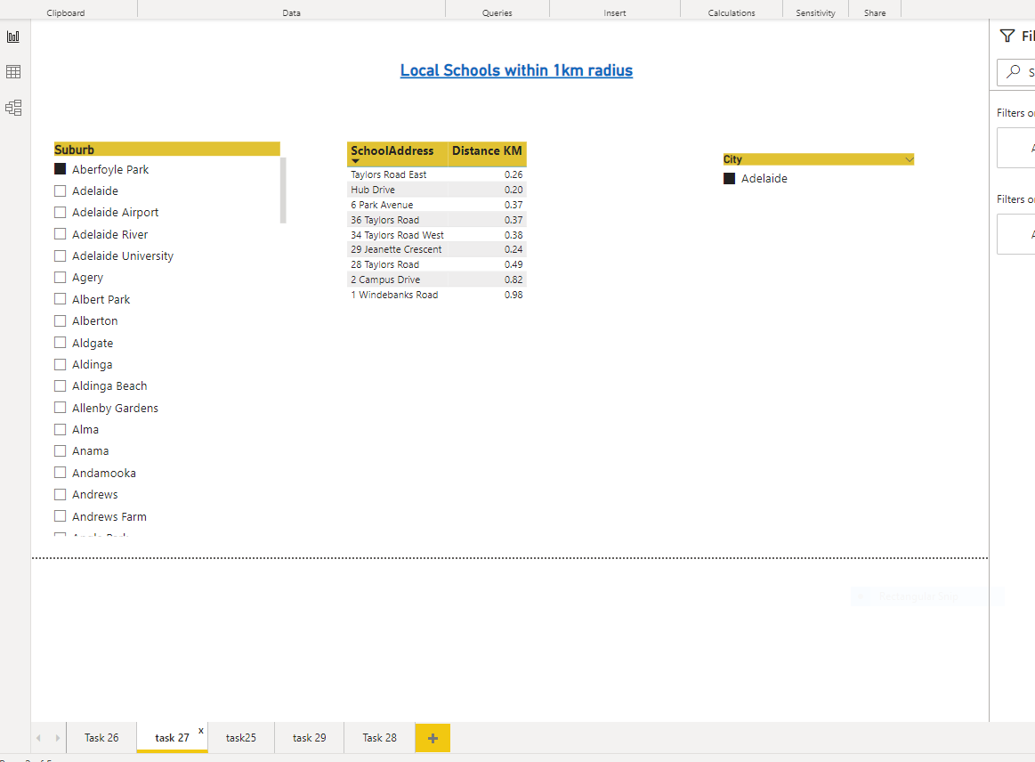

**Task 28**

**Given suburb and city, display crime rate within 1 km radius**

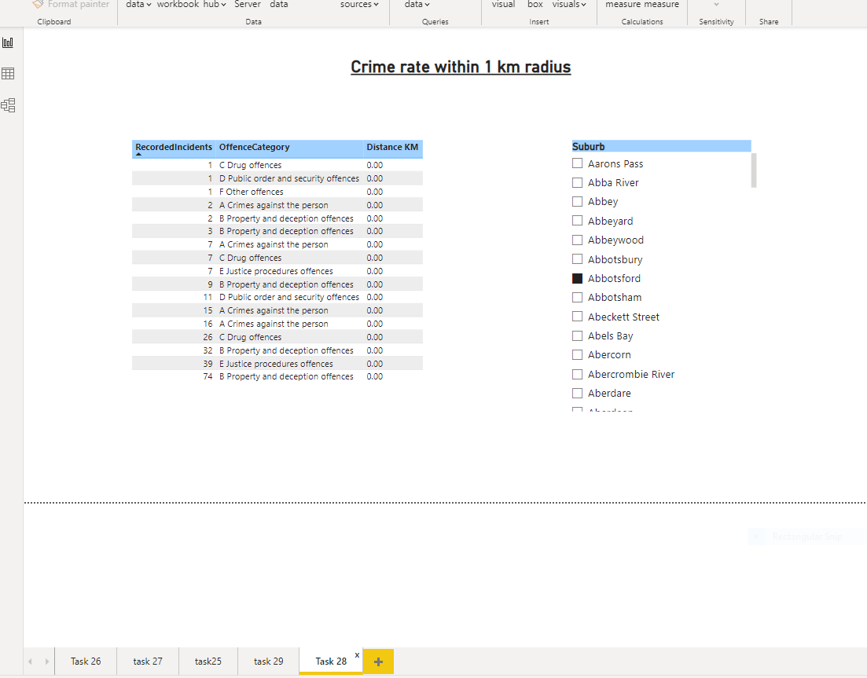

**Task 29**

**Given suburb and city, display property value of the area within 1km radius in Column chart and line chart of 1 year, 5 years and 10 years value**

