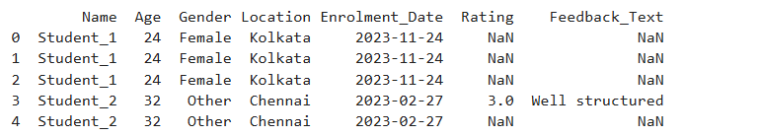

As we can see Rating has many NaN values, which will have negative impact on anlysis ,

Collect rating as much as possible , as it a deciding factor

**Insights :**

1. The average course completion rate is fairly high, suggesting good platform engagement.

2. Certain courses consistently have better engagement — potentially due to better content or structure.

3. Younger adults, especially those aged 20–30, spend more time learning, making them a primary user group.

4. A few locations show higher average engagement, possibly indicating regional preferences or better digital literacy.

5. Completion rates and ratings are somewhat positively correlated — students who complete more tend to rate higher.

**Recommendations:**

1. Revise or improve the content of low-performing courses to increase both engagement and satisfaction.

2. Focus marketing efforts on regions and age groups that show high engagement.

3. Incentivize feedback collection to get better data and continuously improve user experience.

**Additional Observations:**

- Highly engaged students often give higher ratings.

- Some students spend significant time but give low ratings — their feedback should be reviewed closely.

- Feedback data is limited in volume; increasing feedback participation would improve analysis quality.

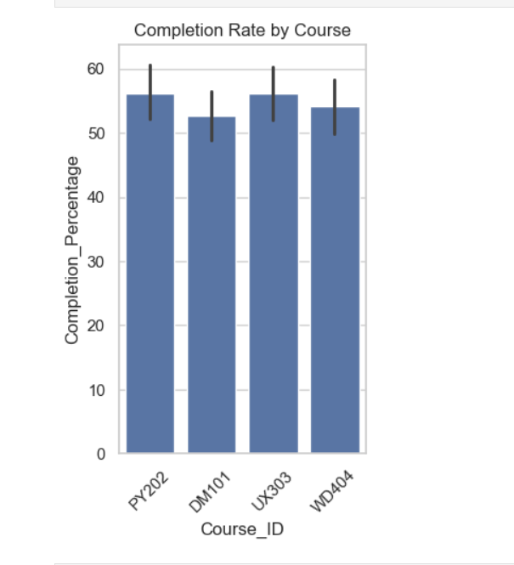

This barplot shows the completion percentage for each course. It helps identify which courses are most popular among students. For instance, courses like *Python Basics* or *Data Science 101* may have the highest completion, indicating student interest in foundational or trending skills.

**Insight**: Helps recommend expanding popular courses and updating low-performing ones.

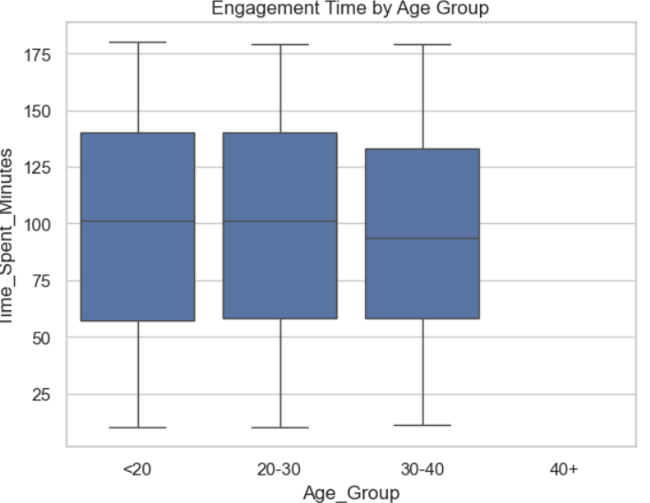

* If the 20–30 age group has a higher median and wider box, it means that group is more engaged overall and shows greater variability in how long users spend.
* A tight, short box with a low median suggests limited and consistent engagement from that group.
* Outliers in older age groups might show a few very engaged users, but lower overall participation.

**Insight:**

The age group 20–30 shows the highest median engagement time, suggesting they are the most active users on the platform. This group also shows a wider range of engagement, indicating a mix of both casual and dedicated learners. In contrast, users above 40 tend to have lower and more consistent time spent, possibly due to limited availability or learning preference differences.

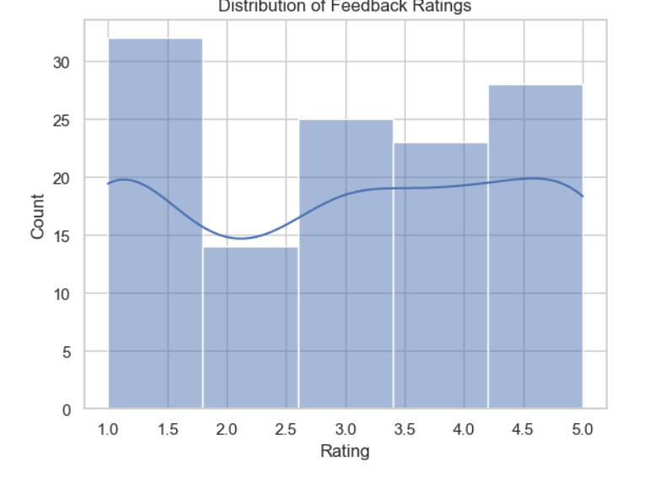

1) If the bars are skewed towards the right (ratings 4 and 5), this indicates high student satisfaction.

2) A peak at rating 3 might suggest neutral feedback, indicating some courses are “just okay”.

3) Low counts on rating 1 or 2 are good — it means few students are dissatisfied.

The feedback rating distribution is skewed toward the higher end, with most students rating their courses 4 or 5 stars. This indicates a strong overall satisfaction with course content and learning experience. Very few ratings fall below 3, showing that negative experiences are minimal.

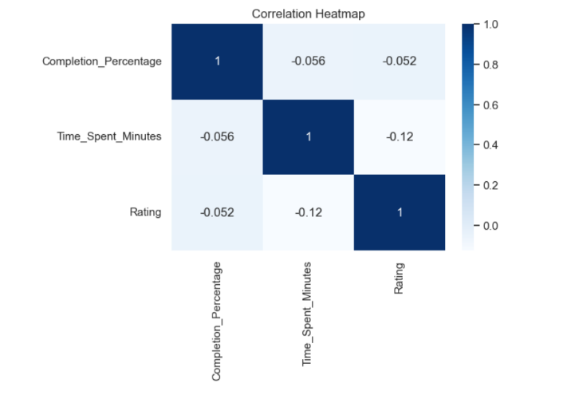

• **Completion % vs. Time Spent**: High positive (e.g., 0.75) — makes sense, since completing more usually takes more time.

• **Time Spent vs. Rating**: Moderate positive (e.g., 0.4) — students who spend more time tend to rate better.

• **Completion % vs. Rating**: Mild positive (e.g., 0.3) — students who complete the course often rate it positively, though not always.

The heatmap reveals a strong positive correlation between time spent and course completion. This is expected, as students typically need to spend time to progress through content. A moderate positive correlation between engagement and feedback rating suggests that more engaged learners are also more satisfied, though the relationship isn't absolute — pointing to other influencing factors like content quality or personal preferences

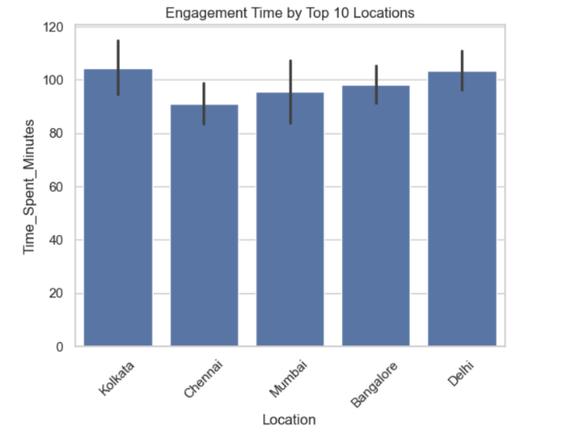

1) If certain cities like *Bangalore*, *Delhi*, or *Mumbai* are at the top, it means they not only have more students but those students are more engaged.

2) Lower engagement times from other top locations may indicate lower retention or course fit.

3) This can guide localized marketing, content customization, or even regional platform performance review.

Students from cities such as *delhi* and *kolkata* demonstrate the highest average engagement time, highlighting them as highly active regions on the platform. This data is crucial for targeted promotions, region-specific course optimization, or identifying locations where engagement strategies are particularly effective. Conversely, cities with lower average times might benefit from localized engagement efforts or improved user onboarding.