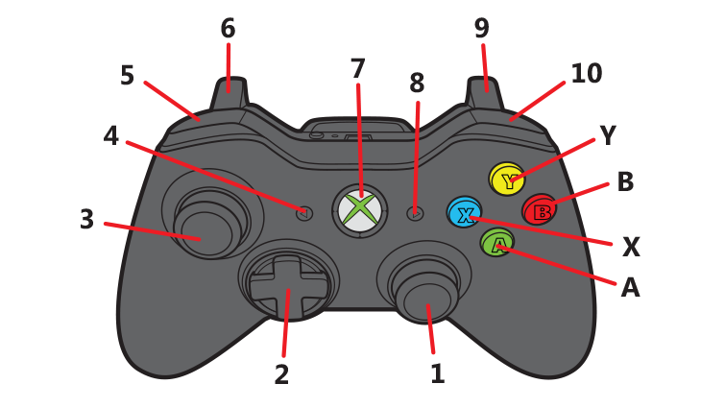
Layout SPYDER-CONTROLLER
Function | Button
Gas | 9
Left/Right | 2
Light | A
Music | B
Picture | Y
Volume + | 10
Volume - | 5

