Multi threaded programming and Lambda expressions

1) Thread Priorities
Problem Statement:
Write a Java program to create multiple threads and demonstrate different thread priorities using MIN_PRIORITY, NORM_PRIORITY, and MAX_PRIORITY.
Code:
class PriorityThread extends Thread {
public PriorityThread(String name) {
super(name);
}

public void run() {
System.out.println(getName() + " is running with priority " + getPriority());
}
}

public class ThreadPriorityDemo {
public static void main(String[] args) {
PriorityThread t1 = new PriorityThread("Low Priority Thread");
PriorityThread t2 = new PriorityThread("Normal Priority Thread");
PriorityThread t3 = new PriorityThread("High Priority Thread");

t1.setPriority(Thread.MIN_PRIORITY);
t2.setPriority(Thread.NORM_PRIORITY);
t3.setPriority(Thread.MAX_PRIORITY);

t1.start();
t2.start();
t3.start();
}
}
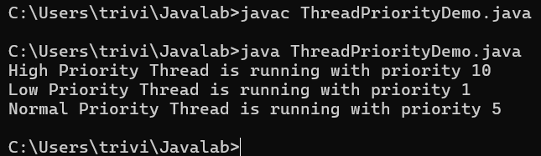

2) Execution Order of Threads
Problem Statement:
Write a Java program to create three threads with different priorities and observe their execution order.
Code:
class OrderThread extends Thread {
public OrderThread(String name) {
super(name);
}

public void run() {
for (int i = 1; i <= 5; i++) {
System.out.println(getName() + " - step " + i +
" - priority " + getPriority());
}
}
}

public class ThreadOrderDemo {
public static void main(String[] args) throws InterruptedException {
OrderThread low = new OrderThread("Low");
OrderThread normal = new OrderThread("Normal");
OrderThread high = new OrderThread("High");

low.setPriority(Thread.MIN_PRIORITY);
normal.setPriority(Thread.NORM_PRIORITY);
high.setPriority(Thread.MAX_PRIORITY);

low.start();
normal.start();
high.start();

low.join();
normal.join();
high.join();
System.out.println("All threads completed.");
}
}
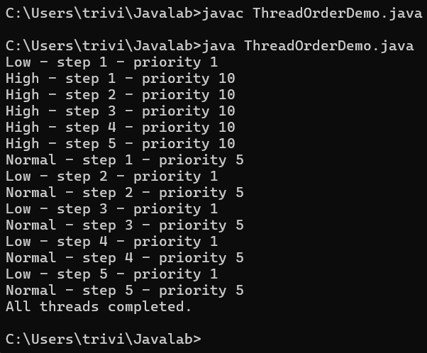

3) Synchronized Method
Problem Statement:
Write a Java program to demonstrate synchronization using a synchronized method for accessing a shared counter.
Code:
class SharedCounter {
private int count = 0;

public synchronized void increment() {
count++;
System.out.println(Thread.currentThread().getName()
+ " incremented counter to " + count);
}

public int getCount() {
return count;
}
}

public class SynchronizedMethodDemo {
public static void main(String[] args) throws InterruptedException {
SharedCounter counter = new SharedCounter();

Runnable task = () -> {
for (int i = 1; i <= 5; i++) {
counter.increment();
}
};

Thread t1 = new Thread(task, "Thread-1");
Thread t2 = new Thread(task, "Thread-2");
t1.start();
t2.start();
t1.join();
t2.join();

System.out.println("Final counter value: " + counter.getCount());
}
}
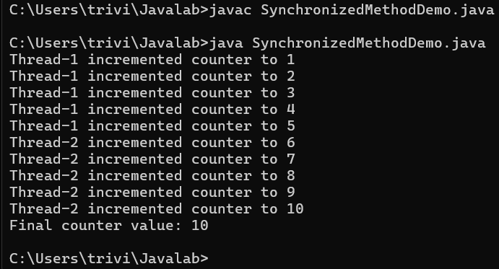

4) Synchronized Block
Problem Statement:
Write a Java program to demonstrate synchronization using a synchronized block.
Code:
class BlockCounter {
private int count = 0;

public void increment() {
synchronized (this) {
count++;
System.out.println(Thread.currentThread().getName()
+ " incremented counter to " + count);
}
}

public int getCount() {
return count;
}
}

public class SynchronizedBlockDemo {
public static void main(String[] args) throws InterruptedException {
BlockCounter counter = new BlockCounter();
Runnable task = () -> {
for (int i = 1; i <= 5; i++) {
counter.increment();
}
};

Thread t1 = new Thread(task, "Thread-1");
Thread t2 = new Thread(task, "Thread-2");
t1.start();
t2.start();
t1.join();
t2.join();

System.out.println("Final counter value: " + counter.getCount());
}
}

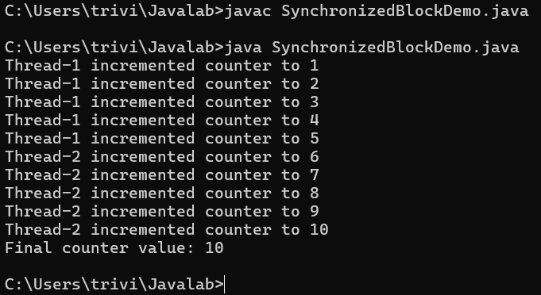

5) Race Condition and Synchronization
Problem Statement:
Write a Java program to demonstrate a race condition and eliminate it using synchronization.
Code:
class SafeCounter {
private int value = 0;

public synchronized void increment() {
value++;
}

public int getValue() {
return value;
}
}

public class RaceConditionDemo {
public static void main(String[] args) throws InterruptedException {
SafeCounter counter = new SafeCounter();
Runnable task = () -> {
for (int i = 1; i <= 1000; i++) {
counter.increment();
}
};

Thread t1 = new Thread(task);
Thread t2 = new Thread(task);
t1.start();
t2.start();
t1.join();
t2.join();

System.out.println("Expected value: 2000");
System.out.println("Actual value: " + counter.getValue());
System.out.println("Synchronization prevents lost updates.");
}
}
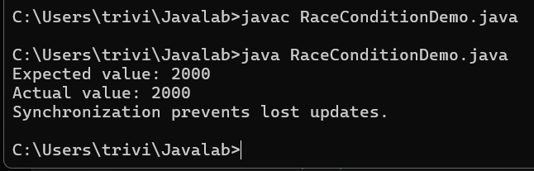

6) Synchronized Ticket Booking
Problem Statement:
Write a Java program to implement a synchronized ticket-booking system where multiple threads attempt to book tickets simultaneously.
Code:
class TicketBooking {
private int availableTickets = 5;

public synchronized void bookTicket(String passenger, int numberOfTickets) {
if (numberOfTickets <= availableTickets) {
System.out.println(passenger + " booked " + numberOfTickets + " ticket(s).");
availableTickets -= numberOfTickets;
System.out.println("Tickets remaining: " + availableTickets);
} else {
System.out.println(passenger + " could not book " + numberOfTickets
+ " ticket(s). Not enough tickets.");
}
}
}

public class TicketBookingDemo {
public static void main(String[] args) throws InterruptedException {
TicketBooking booking = new TicketBooking();

Thread t1 = new Thread(() -> booking.bookTicket("Alice", 2));
Thread t2 = new Thread(() -> booking.bookTicket("Bob", 2));
Thread t3 = new Thread(() -> booking.bookTicket("Charlie", 2));

t1.start();
t2.start();
t3.start();
t1.join();
t2.join();
t3.join();
}
}
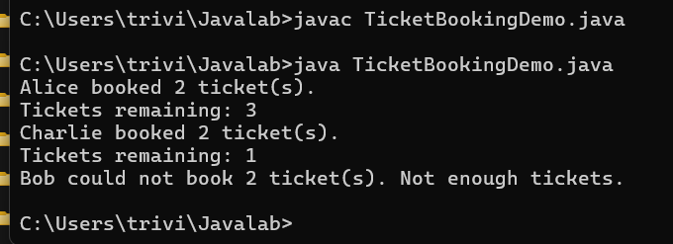

7) Functional Interface for Arithmetic
Problem Statement:
Write a Java program to introduce lambda expressions by implementing a functional interface for addition, subtraction, multiplication, and division.
Code:
@FunctionalInterface
interface ArithmeticOperation {
double calculate(double a, double b);
}

public class ArithmeticLambdaDemo {
public static void main(String[] args) {
ArithmeticOperation addition = (a, b) -> a + b;
ArithmeticOperation subtraction = (a, b) -> a - b;
ArithmeticOperation multiplication = (a, b) -> a * b;
ArithmeticOperation division = (a, b) -> a / b;

double x = 20;
double y = 5;

System.out.println("Addition: " + addition.calculate(x, y));
System.out.println("Subtraction: " + subtraction.calculate(x, y));
System.out.println("Multiplication: " + multiplication.calculate(x, y));
System.out.println("Division: " + division.calculate(x, y));
}
}
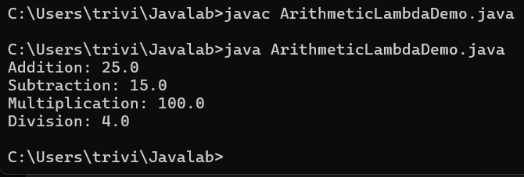

8) Single and Multiple Parameters
Problem Statement:
Write a Java program to demonstrate a lambda expression with a single parameter and multiple parameters.
Code:
@FunctionalInterface
interface SingleParameter {
int square(int number);
}

@FunctionalInterface
interface MultipleParameters {
int add(int a, int b);
}

public class LambdaParametersDemo {
public static void main(String[] args) {
SingleParameter square = number -> number * number;
MultipleParameters addition = (a, b) -> a + b;

System.out.println("Square of 6: " + square.square(6));
System.out.println("12 + 8: " + addition.add(12, 8));
}
}
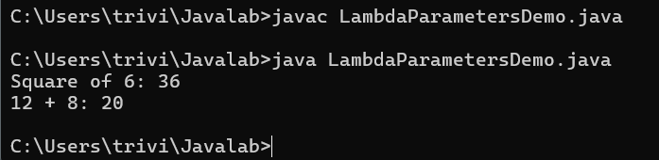

9) Block Lambda Expression
Problem Statement:
Write a Java program to demonstrate a block lambda expression containing multiple statements.
Code:
@FunctionalInterface
interface MessageProcessor {
String process(String message);
}

public class BlockLambdaDemo {
public static void main(String[] args) {
MessageProcessor processor = message -> {
String trimmed = message.trim();
String upperCase = trimmed.toUpperCase();
return "Processed message: " + upperCase;
};

System.out.println(processor.process(" hello lambda "));
}
}
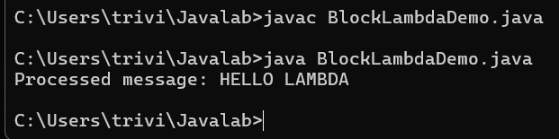

10) Largest of Two Numbers
Problem Statement:
Write a Java program using a block lambda expression to find the largest of two numbers and return the result.
Code:
@FunctionalInterface
interface LargestNumber {
int findLargest(int a, int b);
}

public class LargestNumberLambdaDemo {
public static void main(String[] args) {
LargestNumber largest = (a, b) -> {
if (a > b) {
return a;
} else {
return b;
}
};

System.out.println("Largest number: " + largest.findLargest(45, 72));
}
}
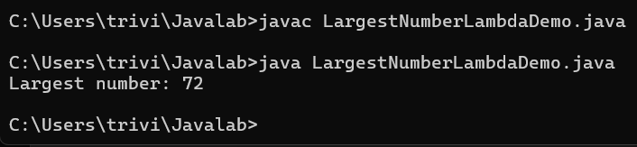

11) Generic Functional Interface
Problem Statement:
Write a Java program to create a generic functional interface and implement it using lambda expressions for different data types.
Code:
@FunctionalInterface
interface Display<T> {
void show(T value);
}

public class GenericLambdaDemo {
public static void main(String[] args) {
Display<Integer> integerDisplay = value ->
System.out.println("Integer value: " + value);
Display<String> stringDisplay = value ->
System.out.println("String value: " + value);
Display<Double> doubleDisplay = value ->
System.out.println("Double value: " + value);

integerDisplay.show(100);
stringDisplay.show("Java Lambda");
doubleDisplay.show(25.75);
}
}
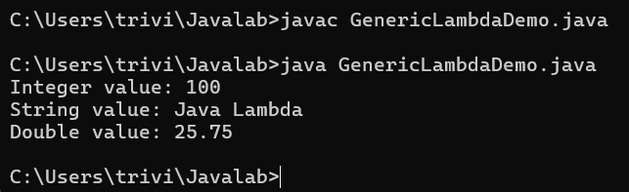

12) Generic Binary Operation
Problem Statement:
Write a Java program to create a generic functional interface that accepts two values and performs an operation using a lambda expression.
Code:
@FunctionalInterface
interface BinaryOperation<T> {
T operate(T first, T second);
}

public class GenericBinaryOperationDemo {
public static void main(String[] args) {
BinaryOperation<Integer> addition = (a, b) -> a + b;
BinaryOperation<String> joining = (a, b) -> a + " " + b;
BinaryOperation<Double> multiplication = (a, b) -> a * b;

System.out.println("Integer addition: " + addition.operate(10, 20));
System.out.println("String joining: " + joining.operate("Hello", "Java"));
System.out.println("Double multiplication: "
+ multiplication.operate(2.5, 4.0));
}
}
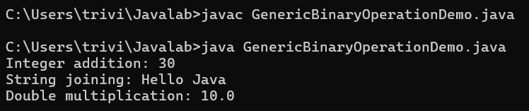

13) Display and Filter an ArrayList
Problem Statement:
Write a Java program to use lambda expressions to display and filter elements of an ArrayList.
Code:
import java.util.ArrayList;
import java.util.Arrays;

public class ArrayListLambdaDemo {
public static void main(String[] args) {
ArrayList<Integer> numbers = new ArrayList<>(
Arrays.asList(10, 15, 20, 25, 30, 35));

System.out.println("All numbers:");
numbers.forEach(number -> System.out.println(number));

System.out.println("Numbers greater than 20:");
numbers.forEach(number -> {
if (number > 20) {
System.out.println(number);
}
});
}
}
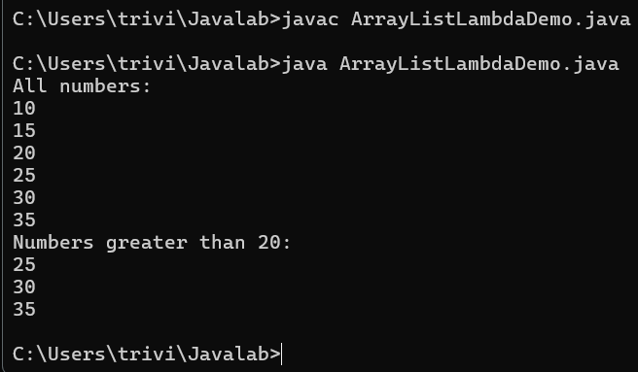

14) Sorting Lists Using Lambdas
Problem Statement:
Write a Java program to sort a list of integers and strings using lambda expressions.
Code:
import java.util.ArrayList;
import java.util.Arrays;
import java.util.List;

public class LambdaSortingDemo {
public static void main(String[] args) {
List<Integer> numbers = new ArrayList<>(
Arrays.asList(45, 12, 78, 3, 29));
List<String> names = new ArrayList<>(
Arrays.asList("Ravi", "Anita", "Kiran", "Bhavna"));

numbers.sort((a, b) -> a.compareTo(b));
names.sort((a, b) -> a.compareToIgnoreCase(b));

System.out.println("Sorted integers: " + numbers);
System.out.println("Sorted strings: " + names);
}
}

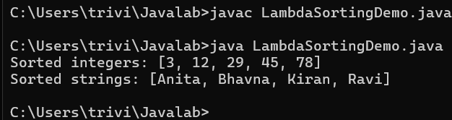

15) Thread Using Lambda Expression
Problem Statement:
Write a Java program to create and execute a thread using a lambda expression.
Code:
public class LambdaThreadDemo {
public static void main(String[] args) throws InterruptedException {
Runnable task = () -> {
for (int i = 1; i <= 5; i++) {
System.out.println("Lambda thread: " + i);
}
};

Thread thread = new Thread(task, "LambdaThread");
thread.start();
thread.join();

System.out.println("Main thread completed.");
}
}
