WEEK 7
Problem Statement:
Write a Java program to demonstrate different ways of creating and initializing String objects using various String constructors.
Code:
public class StringConstructor {
public static void main(String[] args) {
String s1 = "Hello Java";
String s2 = new String("Hello Java");
char[] charArray = {'J', 'a', 'v', 'a'};
String s3 = new String(charArray);
byte[] byteArray = {72, 101, 108, 108, 111};
String s4 = new String(byteArray);
System.out.println("s1 (literal): " + s1);
System.out.println("s2 (new String()): " + s2);
System.out.println("s3 (from char array): " + s3);
System.out.println("s4 (from byte array): " + s4);
System.out.println("\ns1 == s2: " + (s1 == s2));
System.out.println("s1.equals(s2): " + s1.equals(s2));
String s5 = "Hello Java";
System.out.println("s1 == s5: " + (s1 == s5));
}}
Output:

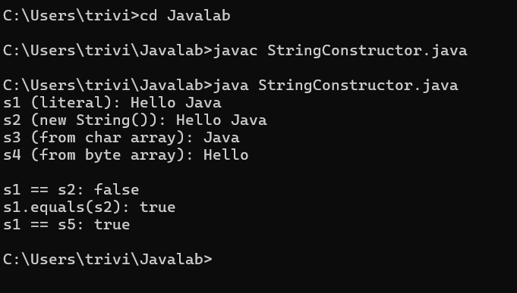
2) Problem Statement:
Write a Java program to demonstrate the functionality of the StringBuffer class by performing various mutable string operations.
Code:
public class StringBufferDemo {
public static void main(String[] args) {
StringBuffer sb = new StringBuffer("Hello");
System.out.println("Original: " + sb);
sb.append(" World");
System.out.println("After append: " + sb);
sb.insert(5, " Java");
System.out.println("After insert: " + sb);
sb.replace(0, 5, "Hi");
System.out.println("After replace: " + sb);
sb.delete(0, 3);
System.out.println("After delete: " + sb);
sb.reverse();
System.out.println("After reverse: " + sb);
System.out.println("Length: " + sb.length());
System.out.println("Capacity: " + sb.capacity());
}}
Output:
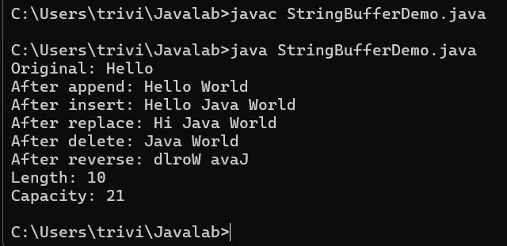
3)Write a Java program to tokenize a given sentence using the StringTokenizer class and display each individual token.
CODE:
import java.util.Scanner;
import java.util.StringTokenizer;

public class StringTokenizerDemo {
public static void main(String[] args) {
Scanner sc = new Scanner(System.in);

System.out.print("Enter a sentence: ");
String sentence = sc.nextLine();
StringTokenizer st = new StringTokenizer(sentence);
System.out.println("\n--- Tokens (default delimiter) ---");
int count = 0;
while (st.hasMoreTokens()) {
System.out.println(st.nextToken());
count++;
}
System.out.println("Total tokens: " + count);
System.out.print("\nEnter a custom delimiter (e.g. , or -): ");
String delimiter = sc.nextLine();
StringTokenizer st2 = new StringTokenizer(sentence, delimiter);
System.out.println("\n--- Tokens (custom delimiter) ---");
int count2 = 0;
while (st2.hasMoreTokens()) {
System.out.println(st2.nextToken());
count2++;
}
System.out.println("Total tokens: " + count2);
}
}
Output:
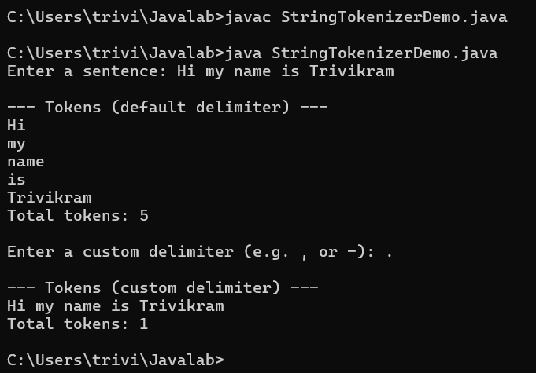
4) Problem Statement:
Write a Java program to demonstrate single inheritance by creating a superclass containing common properties and methods and a subclass that inherits and extends the functionality of the superclass.
CODE:
class Person {
String name;
int age;
void display() {
System.out.println("Name: " + name);
System.out.println("Age: " + age);
}}
class Student extends Person {
int rollNo;
String branch;
void displayStudent() {
display();
System.out.println("Roll Number: " + rollNo);
System.out.println("Branch: " + branch); }}
public class InheritanceDemo {
public static void main(String[] args) {
Student s1 = new Student();
s1.name = "Rahul";
s1.age = 20;
s1.rollNo = 101;
s1.branch = "CSE";s1.displayStudent();}}
Output:
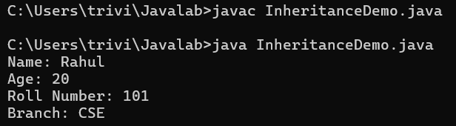
5)Using super Keyword Problem Statement: Write a Java program to demonstrate the use of the super keyword for accessing superclass variables, methods, and constructors. Requirements: · Create a superclass Employee with appropriate variables and methods. · Create a subclass Manager. · Use super to access a superclass variable. · Use super to invoke a superclass method. · Use super() to invoke the superclass constructor. · Display the complete employee and manager details.
CODE:
class Employee {
String name = "Unknown";
double salary;
Employee() {
System.out.println("Employee constructor called");
}
Employee(String name, double salary) {
this.name = name;
this.salary = salary;
System.out.println("Parameterized Employee constructor called");
}
void display() {
System.out.println("Name: " + name);
System.out.println("Salary: " + salary);
}}
class Manager extends Employee {
String name = Manager Name
double bonus;
Manager(String empName, double salary, double bonus) {
super(empName, salary);
this.bonus = bonus;
System.out.println("Manager constructor called"); }
void displayManager() {
System.out.println("Superclass name (via super): " + super.name);
super.display();
System.out.println("Bonus: " + bonus); }}
public class SuperKeywordDemo {
public static void main(String[] args) {
Manager m1 = new Manager("Trivikram", 100000, 10000);
System.out.println();
m1.displayManager();}}
Output:
