Hospital Readmission Risk Prediction Using MLP
Structured Error Analysis and Business Findings Report
Prepared from the Trivikram_Hospital_Readmission_MLP notebook

1. Summary
This project develops a Multi-Layer Perceptron (MLP) neural network using TensorFlow/Keras to estimate whether a diabetic patient encounter will be followed by a hospital readmission within 30 days. The model uses the Diabetes 130-US Hospitals dataset, with the <30 readmission category treated as the positive class.
- The cleaned modelling dataset contains 99,343 encounters and 41 selected input features.
- The held-out test set contains 19,870 encounters, including 2,263 readmissions (11.39%).
- At the validation-selected threshold of 0.536, test ROC-AUC is 0.6512 and recall is 0.4450.
- The model correctly identifies 1,007 readmissions but misses 1,256; it also generates 4,361 false-positive alerts.
- The high-risk tier has a 23.27% observed readmission rate, compared with 4.54% in the low-risk tier.
Important interpretation: the threshold was selected to maximize validation F1-score. On the untouched test set, this threshold produces lower recall than the default 0.50 threshold (44.50% versus 56.65%). The model therefore does not achieve a 60% recall target at the selected threshold.

2. Dataset Understanding and Preparation

Dataset overview
Item | Notebook result
Dataset | Diabetes 130-US Hospitals (1999–2008), diabetic_data.csv
Original shape | 101,766 rows × 50 columns
Original readmission labels | NO: 54,864 | >30: 35,545 | <30: 11,357
Target definition | 1 = <30; 0 = >30 or NO
Target distribution before filtering | Class 1: 11.16% | Class 0: 88.84%
Final modelling rows | 99,343 encounters
Selected input features | 41
Processed feature matrix | 114 columns after encoding

The dataset contains repeated encounters for some patients: 71,518 unique patient identifiers and 30,248 repeated patient records were observed. This makes patient-aware splitting important.

Missing values and cleaning
Column / issue | Observed missingness or action
weight | 98,569 values (96.86%) missing after converting '?' markers; column removed
max_glu_serum | 96,420 values (94.75%) missing
A1Cresult | 84,748 values (83.28%) missing
medical_specialty | 49,949 values (49.08%) missing
payer_code | 40,256 values (39.56%) missing
race | 2,273 values (2.23%) missing
Duplicate rows | 0 exact duplicate rows removed
Discharge disposition | 2,423 encounters excluded for codes 11, 13, 14, 19, 20 and 21

The '?' marker was converted to a missing value. The weight column was removed because of its very high missingness. Numerical features were median-imputed and scaled; categorical features were imputed with the value 'Unknown' and one-hot encoded.

3. Feature Preparation and Data Splitting
The target column readmitted was not used as an input feature. The encounter_id and patient_nbr identifiers were also excluded from the model inputs to avoid learning from row or patient identifiers.
The 41 selected features include demographics, admission and discharge information, length of stay, laboratory and procedure counts, medication counts, previous outpatient/emergency/inpatient visits, diagnoses, glucose and A1C categories, diabetes medications, and medication-change indicators.
Split | Encounters | Readmission prevalence
Training | 63,578 | 11.39%
Validation | 15,895 | 11.39%
Testing | 19,870 | 11.39%

StratifiedGroupKFold was used to keep all encounters belonging to one patient within a single split while maintaining a similar target distribution. The notebook verified zero patient overlap between training, validation and test sets.

Preprocessing pipeline
- Numerical variables: median imputation followed by StandardScaler.
- Categorical variables: constant imputation using 'Unknown', followed by OneHotEncoder with handle_unknown='ignore' and min_frequency=0.01.
- The ColumnTransformer was fitted only on the training set and then applied to validation and test data.
- The processed data was converted to float32 arrays for TensorFlow.
The resulting input dimensions were 114 encoded features for each encounter.

4. MLP Model Architecture
A feed-forward Multi-Layer Perceptron was built using the Keras Sequential API. It receives the 114-dimensional processed feature vector and outputs a probability between 0 and 1.
Layer | Configuration | Purpose
Input | 114 features | Accepts the preprocessed encounter data
Dense 1 | 64 neurons, ReLU | Learns first-level feature patterns
Dropout 1 | 0.30 | Reduces overfitting
Dense 2 | 32 neurons, ReLU | Learns higher-level combinations
Dropout 2 | 0.20 | Adds regularization
Output | 1 neuron, Sigmoid | Produces probability of readmission

Training setting | Value
Optimizer | Adam
Learning rate | 0.001 initially
Loss function | Binary crossentropy
Tracked metrics | Binary accuracy and AUC
Total parameters | 9,473 (all trainable)
Class weights | Class 0: 0.5643 | Class 1: 4.3907
Callbacks | EarlyStopping (validation AUC, patience 4); ReduceLROnPlateau (validation loss)

Class weights were calculated from the training labels to give greater importance to the minority readmission class. Early stopping restored the best weights based on validation AUC.

5. Training Experiments and Generalization
Two batch sizes were compared using the same model structure and training/validation splits. The batch size with the higher best validation AUC was selected.
Batch size | Best validation AUC | Epochs completed
128 | 0.6523 | 8
256 | 0.6519 | 7

Batch size 128 was selected because it achieved the slightly higher validation AUC. The final model was trained from scratch for a maximum of 30 epochs and early stopping ended training after 16 epochs.
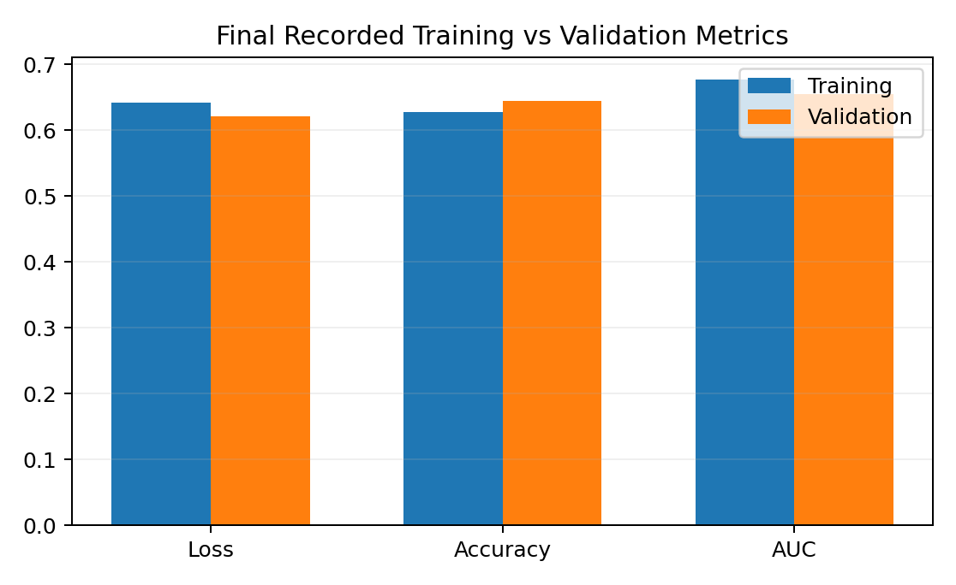
Figure 1: Final recorded training and validation loss, accuracy and AUC.
Metric | Training | Validation
Loss | 0.6422 | 0.6204
Accuracy | 0.6275 | 0.6445
AUC | 0.6764 | 0.6541

Training and validation AUC differ by approximately 0.0223. This is a relatively small gap, although the validation AUC is lower. The curves and values should be monitored in further experiments; they do not by themselves prove that the model will generalize to other hospitals or time periods.

6. Model Evaluation on Test Data
The test set was kept separate during model fitting and threshold selection. The notebook first evaluated the default probability threshold of 0.50, then selected a threshold of 0.536 by maximizing F1-score on the validation set.
Metric | Threshold 0.50 | Selected threshold 0.536
Accuracy | 0.6380 | 0.7173
Precision | 0.1711 | 0.1876
Recall | 0.5665 | 0.4450
F1-score | 0.2628 | 0.2639
ROC-AUC | 0.6512 | 0.6512
PR-AUC | 0.2016 | 0.2016

ROC-AUC and PR-AUC are calculated from the probability scores and therefore remain the same across classification thresholds. The selected threshold slightly improves F1-score and accuracy, but lowers recall. In a healthcare screening context, this trade-off matters because lower recall means more actual readmissions are missed.

7. Structured Error Analysis
At the selected threshold of 0.536, the test confusion matrix contains the following outcomes:
Actual outcome | Predicted: No | Predicted: Yes
No readmission | True Negative: 13,246 | False Positive: 4,361
Readmission | False Negative: 1,256 | True Positive: 1,007

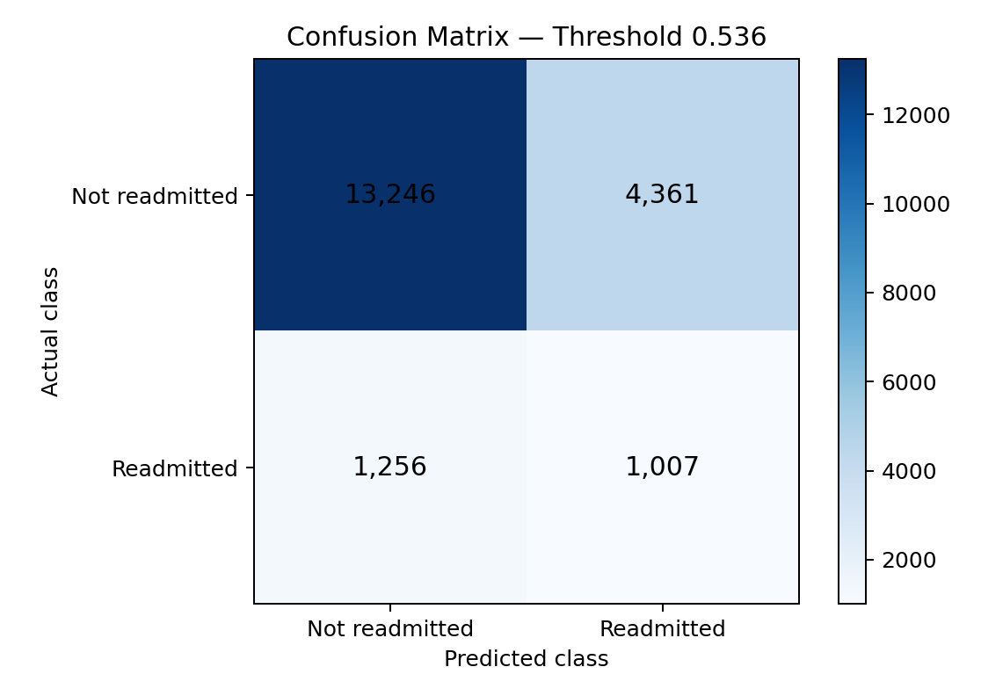
Figure 2: Confusion matrix for the selected threshold (0.536).
Error / outcome | Count | Meaning | Operational implication
True Positive | 1,007 | Readmission correctly flagged | Opportunity for planned follow-up
False Negative | 1,256 | Readmission missed by the model | Potentially high cost: patient receives no model-triggered extra follow-up
False Positive | 4,361 | Flagged, but no readmission observed | Additional calls or appointments may be unnecessary
True Negative | 13,246 | No readmission correctly predicted | Routine discharge pathway may be sufficient

A false negative can be more consequential than a false positive because a patient who is readmitted may have missed an opportunity for additional support. However, false-positive alerts also consume limited staff time.

Missed readmissions (FN) vs caught readmissions (TP)
The following averages compare encounters that were actually readmitted. They describe observed patterns and do not establish why the model made each prediction.
Feature average | False Negative | True Positive
Days in hospital | 4.54 | 5.12
Lab procedures | 44.00 | 44.71
Procedures | 1.36 | 1.12
Medications | 15.92 | 17.54
Outpatient visits | 0.35 | 0.49
Emergency visits | 0.11 | 0.69
Previous inpatient visits | 0.19 | 2.34
Number of diagnoses | 7.47 | 7.95

Missed readmissions had fewer previous inpatient and emergency visits on average than correctly detected readmissions. Their average stay and medication count were also somewhat lower. This suggests that encounters with less prior utilization may be harder for the model to identify.

False alarms (FP) vs correct negatives (TN)
Feature average | False Positive | True Negative
Days in hospital | 5.34 | 4.05
Lab procedures | 44.83 | 42.11
Procedures | 1.22 | 1.40
Medications | 18.31 | 15.17
Outpatient visits | 0.51 | 0.30
Emergency visits | 0.51 | 0.08
Previous inpatient visits | 1.81 | 0.16
Number of diagnoses | 8.03 | 7.15

False-positive encounters show higher average hospital utilization, medication counts and diagnosis counts than true negatives. These patterns may explain why the model assigns them higher risk scores, even though they were not readmitted in the observed target period.

8. Risk-Level Analysis
For operational reporting, each test encounter was assigned a risk tier using its predicted probability: Low up to and including 0.30, Medium above 0.30 through 0.60, and High above 0.60. These bands are separate from the 0.536 classification threshold used to produce the confusion matrix.
Risk tier | Probability range | Encounters | Observed readmissions | Readmission rate
Low | Up to 0.30 | 2,536 | 115 | 4.54%
Medium | >0.30 to 0.60 | 15,005 | 1,606 | 10.70%
High | Above 0.60 | 2,329 | 542 | 23.27%

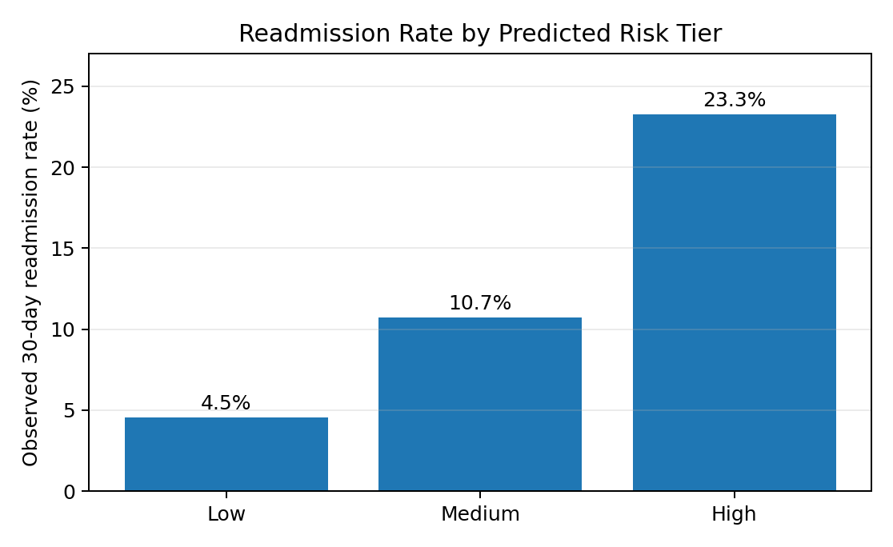
Figure 3: Observed readmission rate across the three probability-based risk tiers.
The observed readmission rate increases from Low to Medium to High. The High tier's rate is approximately 5.1 times the Low tier's rate (23.27% compared with 4.54%). This indicates useful risk separation, although most encounters fall into the Medium tier.

9. Business Findings

Business problem
Hospital readmissions soon after discharge can increase treatment costs, occupy limited beds and indicate that a patient may need additional support. A risk score can help care teams prioritize discharge planning and post-discharge contact.

Key findings
- Readmission is the minority outcome: 11.39% of the test encounters were readmitted within 30 days. Accuracy alone is not sufficient to judge performance.
- The test ROC-AUC is 0.6512, indicating moderate ranking ability rather than strong separation.
- At the selected 0.536 threshold, recall is 44.50%; the model misses 1,256 of 2,263 actual readmissions.
- The High risk tier has a 23.27% observed readmission rate, compared with 4.54% in the Low tier.
- Prior inpatient and emergency utilization is higher among true positives than false negatives, and higher among false positives than true negatives.
- The selected threshold maximizes validation F1-score, but the default 0.50 threshold provides higher test recall (56.65%). Threshold choice should reflect the hospital's capacity and the relative cost of missed cases.

Recommendations: prioritizing follow-up
Risk tier / group | Suggested operational action
High risk | Prioritize human review, medication reconciliation, clear discharge instructions and an early follow-up call or appointment.
Medium risk | Consider reminder calls, review of discharge instructions and routine outpatient follow-up scheduling.
Low risk | Continue standard discharge guidance and routine follow-up; do not treat the score as a guarantee of safety.
No previous utilization | Consider an additional checklist of social support, medication access and post-discharge needs because lower historical utilization may make readmissions harder to detect.

The recommendations are illustrative workflow suggestions, not clinical instructions. Clinical staff should determine the appropriate care plan for each patient.

10. Limitations
- The dataset represents US hospital encounters from 1999–2008 and may not reflect current patients, treatments or hospital practices.
- The target is based on the recorded readmission categories and may not capture readmissions outside the observed records.
- The target is imbalanced: approximately 11.4% of the final modelling encounters are positive.
- The selected threshold produces low precision (0.1876) and recall (0.4450) on the test set. Many alerts are false positives and many actual readmissions are missed.
- The model has moderate discrimination (ROC-AUC 0.6512) and has not been clinically validated.
- The notebook does not calculate age-wise recall or permutation feature importance; conclusions about those analyses are therefore not included in this report.
- A real deployment would require recent local data, prospective validation, privacy and fairness assessments, workflow review and clinical/regulatory approval.

11. Conclusion
The notebook demonstrates an end-to-end supervised deep learning workflow for predicting 30-day hospital readmission using a TensorFlow/Keras MLP. It includes data cleaning, patient-grouped splitting, categorical encoding, numerical scaling, class weighting, training experiments, threshold selection, test evaluation, error analysis and risk-tier reporting.
The model achieves a test ROC-AUC of 0.6512. Its risk tiers show increasing observed readmission rates from Low (4.54%) to High (23.27%), which may help prioritize human review. However, at the selected threshold of 0.536, recall is 44.50% and 1,256 readmissions are missed. The model should therefore be treated as an educational decision-support prototype, not a replacement for clinical judgement.
A useful next step is to evaluate alternative thresholds against an explicit recall or staff-capacity target, then validate the model on more recent and locally representative hospital data.

