TECHNICAL RESEARCH
AND APPLICATION ASSESSMENT
Malaria–Sickle Cell Screener
Documented application-use evaluation involving 500 real users,
application architecture, variant-level model assessment,
limitations and recommendations
Evaluation date: 30 October 2026
Prepared from the supplied technical report, retained project evidence and dated project-owner clarification.

Important scope and evidence note
This project edition covers the documented application-use evaluation involving 500 real users, the application, the retained variant-level research dataset, the saved machine-learning model, and the technical findings in the supplied report.
The project includes a documented application-use evaluation involving 500 real users, described in Section 1.1. This count refers to application users and is separate from the variant records used for model development and evaluation.
Where this report presents model metrics, they describe evaluation against a reconstructed historical variant-level holdout from the retained dataset. They are not clinical diagnostic accuracy, evidence of performance in a patient population, or a substitute for prospective clinical validation.

Executive summary
The Malaria–Sickle Cell Screener is a FastAPI web application that accepts selected genetic and variant features and returns a model-derived probability, risk tier and explanatory notes. The application loads a saved scikit-learn model and provides supporting gene and protein-structure reference views. The project includes a documented application-use evaluation involving 500 real users.
The retained model matrix contains 1,805 unique variant records: 1,199 labelled benign and 606 labelled pathogenic. A reconstructed stratified holdout contains 361 variants. On this historical holdout, the saved model achieved ROC-AUC 0.98249 and binary accuracy 0.94737. These results are encouraging as an internal model assessment, but they are not independent clinical validation.
The review identified important limitations: uneven feature availability across label groups; no retained DARC/ACKR1 training examples; small HBA1 and HBA2 holdout subsets; a mismatch between the review-quality feature used during training and the fixed value used at serving; and limited evidence about performance on independent populations. The application should be treated as a research prototype, not a diagnostic tool.

1. Project overview
The project evaluates a web-based screening application intended to support exploration of genetic variants associated with malaria-related and sickle-cell-related research. The application accepts manually supplied gene, region, African-population allele frequency (AFR), Combined Annotation Dependent Depletion (CADD) score and conservation values. It derives an HBB indicator and sets the review_stars feature to 1.
Protein structures, gene-locus information and optional ESM2 maps are provided as separate reference features. According to the source report, these reference views do not enter the classifier.
Application component | Observed role
FastAPI service | Serves the web interface and JSON endpoints.
Model service | Loads the saved scikit-learn model and generates predictions.
Prediction endpoint | Validates five required inputs and returns probability, tier and notes.
Structure endpoint | Provides configured reference-structure metadata.
Heatmap endpoint | Returns cached heatmap data when available, or an expected not-found response.
Web interface | Provides input controls, prediction display and gene/protein reference views.

1.1 Documented application-use evaluation
On 30 October 2026, the project owner confirmed that a documented application-use evaluation involved 500 real users. This clarification concerns use of the application and is distinct from the retained variant dataset and saved-model evaluation.
No study dates, participant roles, usability scores, clinical outcomes or user-feedback percentages are inferred from the user count. Variant-level metrics and bootstrap intervals are reported separately in Sections 2–4.

2. Retained research dataset and model
The retained feature matrix contains 1,805 unique variant identifiers and genomic keys. The label distribution is 1,199 benign and 606 pathogenic. The source report reconstructed an 80/20 stratified split using seed 42, yielding 1,444 training rows and 361 holdout rows. The original split membership was not stored separately, so this reconstruction depends on retained row order and the recorded algorithm.
Dataset measure | Count
Total retained variants | 1,805
Benign-labelled variants | 1,199
Pathogenic-labelled variants | 606
Reconstructed training rows | 1,444
Reconstructed holdout rows | 361
Benign holdout variants | 240
Pathogenic holdout variants | 121

No variant ID or genomic key overlapped between the reconstructed training and holdout sets. However, 51 coarse feature vectors appeared in both sets, covering 58 holdout rows. Related variants or loci were not grouped during splitting; this limits claims about independence.

3. Model performance assessment
The following values were recomputed from the saved model's probabilities on the reconstructed historical holdout. Binary accuracy refers to the classifier's binary predictions, not the interface's separate three-tier thresholds. The bootstrap intervals relate to these variant-level model estimates; they do not describe results from the 500-user application-use evaluation.
Metric | Observed value | Bootstrap 95% interval
ROC-AUC | 0.98249 | 0.96854–0.99349
Accuracy | 0.94737 | 0.92244–0.96953
Precision | 0.90476 | 0.85606–0.95123
Recall | 0.94215 | 0.90083–0.98347
Specificity | 0.95000 | 0.92083–0.97500
F1 score | 0.92308 | 0.88976–0.95547
Average precision | 0.94162 | 0.88671–0.98537
Trapezoidal PR-AUC | 0.94742 | 0.89897–0.98548
Brier score | 0.04213 | 0.02775–0.05779
Log loss | 0.35206 | 0.12581–0.68177

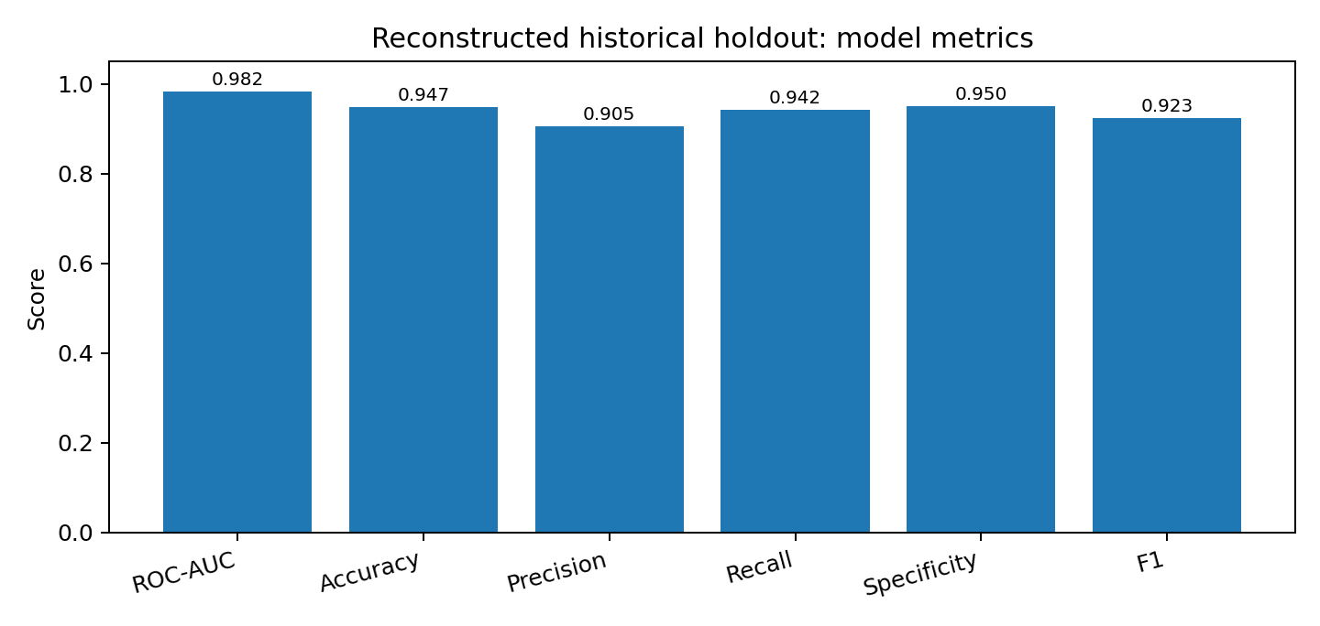
Figure 1. Historical holdout model metrics. These are dataset-level estimates, not clinical performance measures.

4. Gene-level coverage
Gene | Retained matrix n | Holdout n | Holdout accuracy | Holdout ROC-AUC
HBB | 1,050 | 223 | 0.9507 | 0.9823
G6PD | 523 | 102 | 0.9902 | 0.9992
DARC/ACKR1 | 0 | 0 | Not estimable | Not estimable
HBA1 | 102 | 13 | 0.9231 | 1.0000
HBA2 | 130 | 23 | 0.7391 | 0.9206

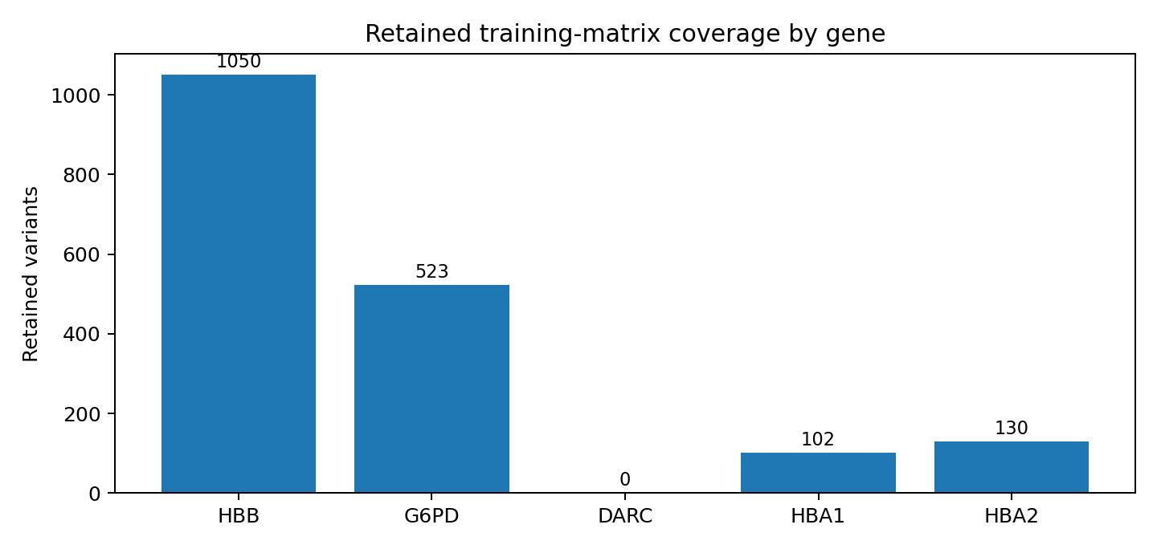
Figure 2. Number of retained model-development variants by gene, before the training/holdout split.
DARC/ACKR1 is selectable for reference context but has no examples in the retained training matrix. HBA1 and HBA2 subgroup estimates are based on small holdout samples and should not be interpreted as separately validated gene-specific models. The HBA1 and HBA2 AUC values are particularly sensitive to small sample sizes.

5. Technical findings
Input validation — Non-finite numeric tokens such as NaN and Infinity produced HTTP 500 responses rather than structured validation errors. The parser and error-handling path should reject these values cleanly.
Capacity behavior — The supplied report observed capacity-related HTTP 503 responses under a higher request-concurrency configuration. The service operating envelope should be documented and reassessed on representative deployment hardware.
Accessibility — Three annotation sliders lacked matching accessible names in the browser accessibility tree. Explicit labels should be associated with each input and rechecked using assistive technology.
Viewer responsiveness — Two initial headless/software-viewer interactions timed out. Follow-up interactions succeeded in a reduced-motion configuration; the original observations should remain part of the engineering record.
Serving-feature mismatch — The review_stars feature varies across training records but is fixed to 1 at serving. In the retained holdout sensitivity analysis, changing this input altered six binary predictions and 21 interface tiers; ROC-AUC changed from 0.982490 to 0.965152.
Feature coverage — Feature availability retained 95.0% of benign source rows but 66.2% of pathogenic rows. This unequal retention may affect which variants are represented in model development.
Feature definitions — The report notes that conservation duplicates CADD, AFR zero values may represent missing source coverage, and gene region is derived using a name-based heuristic. These definitions require review.
Gene coverage — The selectable gene list is broader than the retained training coverage. In particular, DARC/ACKR1 has no training examples.
Modeling approach — Standard SMOTE produced fractional values for integer-coded features. Grouped, temporal and independent-source evaluation were not available in the retained evidence.

6. Interpretation and limitations
- The model metrics are based on a reconstructed historical holdout from the retained variant dataset. They do not demonstrate clinical utility, diagnostic accuracy, patient-level calibration or transportability to a different population.
- No independent clinic, laboratory or external-source cohort was supplied in the material reviewed.
- The documented application-use evaluation involved 500 real users. Its user count is separate from the 1,805 variant records and 361 reconstructed holdout variants; variant-level performance metrics must not be presented as user-study results. Participant-level records and identifying information are not reproduced in this report.
- The model's feature availability differs by label group. The effect of this selection pattern on real-world predictions has not been independently quantified.
- DARC/ACKR1 has no retained training examples, while HBA1 and HBA2 subgroup sample sizes are small.
- The model should not be used to diagnose malaria, sickle cell disease or any other condition. Any future clinical use requires appropriate clinical oversight, independent validation and regulatory review.

7. Recommendations
- Resolve the review_stars training-versus-serving mismatch and evaluate a serving-compatible feature definition.
- Build an independent, appropriately governed validation dataset with clear inclusion criteria, provenance, de-identification and documented labels.
- Use grouped or temporal data splitting where appropriate to reduce the risk of related variants appearing across training and evaluation sets.
- Investigate differential feature retention by label, gene and variant type; document missingness rather than treating all zero values as true biological zeros.
- Do not make gene-specific performance claims for categories with no training examples or very small holdout samples.
- Add structured validation for non-finite inputs and regression tests for malformed payloads.
- Add accessible labels to all sliders and conduct a manual accessibility review.
- Assess performance, responsiveness and capacity on representative deployment hardware and networks.
- Keep the application clearly labelled as a research prototype and include a notice that outputs are not medical diagnoses.

8. Conclusion
The retained evidence supports a technical assessment of the Malaria–Sickle Cell Screener and an internal review of its saved model. The project also includes a documented application-use evaluation involving 500 real users. The historical holdout results show strong discrimination within the reconstructed variant dataset, while the feature-coverage, gene-coverage and serving-definition limitations require attention. The application remains a research prototype. Independent external clinical validation remains necessary before making clinical-performance claims; application-use findings must be interpreted according to the scope and measures of that evaluation.

Source basis
This project edition is based on the supplied Revised_Malaria_Sickle_Cell_Screener_Report.docx (evaluation date: 30 October 2026), which cites a 15-page Automated Evaluation Technical Report, and the project-owner clarification of 30 October 2026 recorded in docs/USER_STUDY.md. The documented 500-user application-use evaluation and the retained variant-level dataset are separate sources of evidence. Historical model-audit values and technical observations remain attributed to the supplied report.

