VERSION 1
Scope and Launch Report
Multi-tenant K-12 school ERP with LMS | 30 September 2026 | Branch v1-launch
Summary
V1 is the school-operations core for Admin, Teacher and Student users. 239 previously open API routes now require a login, 117 broken sidebar links are fixed (0 remain), and PAL, H5P and AI modules are hidden. Plaintext web login, open WhatsApp webhooks and leftover debug scripts remain to be decided before launch.

API routes closed | Dead menu links | Security tests passing | Roles in V1
239 | 117 to 0 | 23 | 3
Figures: route/method pairs under api/*, sidebar links checked against the real pages, Laravel tests in tests/Feature/Security.

Step 1. Understanding the existing product
The product is a multi-tenant K-12 school ERP with an LMS and an adaptive-learning layer. One deployment serves many schools; each school is a tenant identified by sub_institute_id.
Area | Finding
Purpose | Run a school: admissions, students, attendance, fees, exams, teaching, communication
Backend | Laravel 12, PHP 8.2, MySQL/MariaDB; 835 controllers, 41 route files, about 5,300 routes, 914 tables
Frontend | Next.js 16 (App Router), React 19, Tailwind 4; 677 pages across about 54 top-level modules
Auth | Email login; API login issues a signed JWT; web login uses PHP sessions; rights from menu and rights tables
Roles | Free-text profile names per school; is_admin 1 or 2 for multi-school admins
Workflows | Admission to student, attendance, fee collection, exam to report card, homework, circulars
Reusable parts | Shared UI set, dynamic menu tree, per-module API helpers, rights middleware, token hydration
Integrations | S3, payment gateways, SMS/WhatsApp/email, Neo4j, AI providers (Gemini, DeepSeek, Anthropic)
Tests | About 124 Laravel tests and 41 frontend unit files; almost none for attendance, marks entry or login

Step 2. V1 scope
V1 is the smallest loop a school can run on: people in, the school runs daily, results and money out. Decisions taken: roles are Admin, Teacher and Student; PAL, H5P and AI are hidden; security comes first.
# | Area | V1 decision
1 | Core functionality | Admissions, students, attendance, fees, exams and results, teaching, circulars
2 | Essential modules | School setup, admissions, students, attendance, fees, exam/result, teaching, communication, dashboards; optional hostel, transport, inventory, library, front desk
3 | User roles | Admin (incl. Super Admin, Principal), Teacher (incl. Class Teacher, HOD), Student; no Parent
4 | Screens | 287 sidebar links shown; every one resolves to a real page
5 | Main workflows | Six, listed in Step 3
6 | Database | Existing core tables (Step 6); no new tables
7 | API/backend | Existing api/* routes; each is guarded, authenticated or deliberately public
8 | Auth and authorization | JWT for the frontend, sessions for Blade; menu rights per profile; new tenant and staff rules
9 | Basic security | Token guard, tenant check, staff-only actions, login throttling, production env defaults
10 | Validation and errors | Existing validation kept; JSON error envelope (401, 403) from the guard
11 | Integrations | Email, SMS/WhatsApp, payment gateways, S3 as configured; AI and Neo4j off
12 | Reports and dashboards | Admin, Teacher, Student dashboards; fee, attendance, admission and result reports
13 | System configuration | Documented .env keys; config/api_guard.php; school onboarding journey
14 | Deployment | PHP-FPM and nginx, HTTPS, production env, CORS origins, queue and scheduler as configured

Not in V1: parent portal, HR leave and payroll screens (API exists), LMS Message placeholder, Learning-Outcome masters, and the hidden modules (PAL, H5P, AI, Enterprise Brain, talent, career, SQAA). Hiding changes what menus show, not what the backend allows.

Step 3. V1 structure
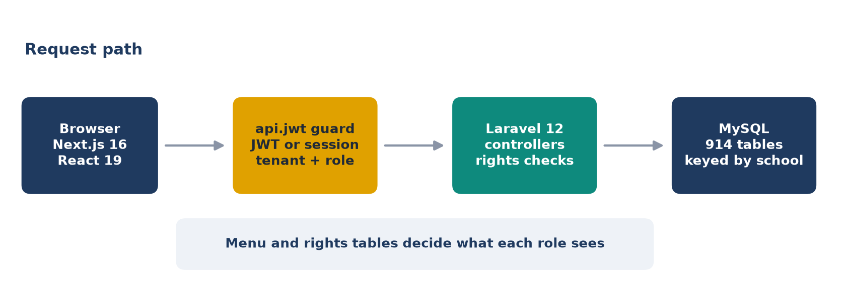
Figure 1. Request path: every call passes the guard before reaching a controller.

Modules, sub-modules and pages
Module | Sub-modules and screens | Main routes
Access | Login, forgot password, group rights, individual rights, user profiles | /login, /general/groupwise_rights
School setup | Standard-division mapping, subject mapping, periods, batches, capacity, users, onboarding | /academic_setup/*, /user
Admissions | Enquiry, registration, follow-up, confirmation, reports, dashboard | /admissions/*
Students | Add, search, bulk update, documents, health, certificates, ID cards, houses | /student/*, /students/*
Attendance | Mark attendance, day/month/year reports, dashboard | /attendance/*
Fees | Masters, collect, other fees, cancel and refund, circulars, reports, online payment | /fees/*
Exam and result | Exam and grade masters, marks entry, co-scholastic, report cards, consolidated reports | /exam/*, /result/*
Teaching | Courses, chapters, lesson plans, homework, assignments, LMS exams, question papers | /course-master/*, /lms/*
Communication | Circulars, SMS, email, WhatsApp | /front_desk/circular, /easy_com/*
Dashboards | Admin, Teacher, Student landing pages | /dashboard
Add-ons | Hostel, transport, inventory, library, front desk, visitors | /hostel, /Transportation, /library

User roles
Role | Responsibility
Super Admin / client admin | All schools, or all schools of one client; rights and setup
Admin, School Admin, Principal | Run one school: setup, admissions, fees, results
Teacher, Class Teacher, HOD | Attendance, homework, marks and circulars for own classes
Student | Dashboard, homework, courses, exams

Main workflows
- Admission to student: enquiry, follow-up, registration, confirmation, student record.
- Daily attendance: teacher marks a class; dashboards and reports update.
- Fee collection: set heads, collect per student, issue receipt, report defaulters.
- Exam to report card: create exam, enter marks, approve, print report card.
- Homework: teacher assigns, student submits, teacher reviews.
- Circular: staff posts, families are notified by SMS, email or WhatsApp.
APIs, database and components. APIs are the existing api/* routes (routes/api.php, resultapi.php, easycomapi.php); tables are listed in Step 6. Major components: Next.js frontend, Laravel API, the api.jwt guard and rights middleware, menu and rights tables, MySQL, and optional S3, queue and gateways.

Step 4. What was built
Existing code was reused. The footprint is 10 backend files and 11 frontend files; nothing was rewritten and no dependency was added.
Area | Change | Where
Auth guard | New api.jwt middleware and one config of protected, staff-only and public URLs | RequireApiJwt.php, config/api_guard.php
Token minting | api/testkey registered only in local and testing | routes/api.php
Login protection | 10 to 20 requests per minute per IP on login and OTP | routes/api.php
Injection hardening | Table names must be plain identifiers | Helper.php, CustomModuleController.php
Config | Production-safe defaults, documented keys | .env.example
Token on requests | Bearer token added to requests to the school API that lacked it | lib/erp-client.ts
Scope | Hidden modules filtered from sidebar and profile menu; admin-only platform setup | menuMappers.ts, Header.tsx
Broken links | Result links mapped to real pages; dead rows hidden; quick actions fixed | routeMapper.ts, AdminDashboard.tsx
Roles | Class Teacher and HOD reach the teacher dashboard | resolveDashboardRole.ts
Tests and tools | 12 guard tests, 9 frontend tests, menu link checker | ApiGuardTest.php, check-menu-links.ts
Work is on branch v1-launch in both repositories and is not committed.

Step 5. Quality check
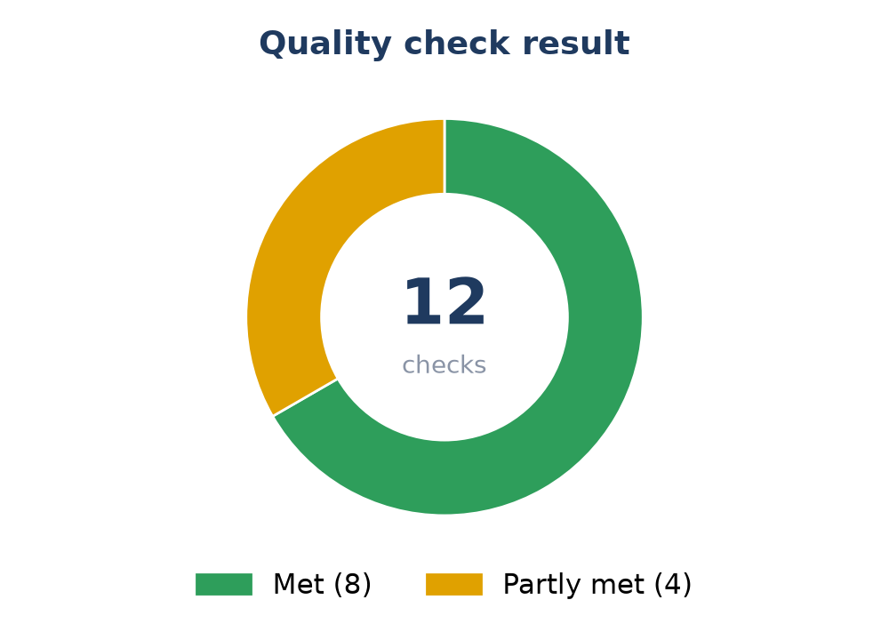
Figure 2. Result of the twelve checks from the brief.
Check | Status | Evidence
Main journeys end to end | Partly | Dashboards and key screens load with real data for all three roles; fee collection, marks entry and admission submit were not exercised end to end
Authentication | Yes | Protected URLs return 401 without a token; forged tokens rejected; login and OTP throttled
Role and permission handling | Yes | Student tokens get 403 on staff URLs; teacher and student tokens get 403 for another school
CRUD operations | Partly | Existing controllers untouched; not re-tested one by one
Database operations | Yes | No schema change; table-name inputs restricted to plain identifiers
Validation | Partly | Existing controller validation kept; guard adds token, school and role checks
Error handling | Yes | Guard returns a JSON envelope with 401 or 403
UI usable and consistent | Yes | Existing design system reused; hidden modules and dead rows removed
API responses correct | Yes | Live HTTP matrix: protected, public, staff-only and cross-school cases behave as designed
No broken links or blank screens | Yes | 287 sidebar links shown, 0 lead to a missing page (117 before)
No obvious security issues | Partly | 239 open route/method pairs closed; plaintext web login, webhook secrets and debug scripts remain
Existing functionality not broken | Yes, with notes | Fees 17, PAL 141, mobile builder 14, security 23 pass; remaining failures also occur on the original code

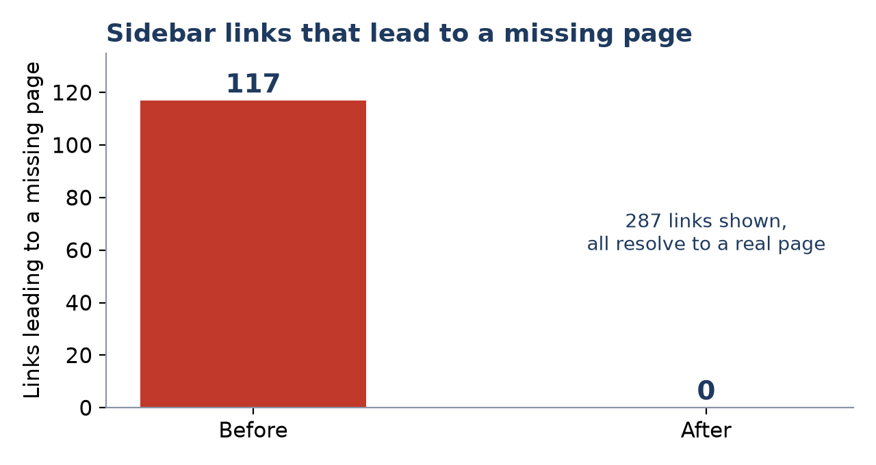
Figure 3. Sidebar links that led to a missing page, before and after.
Found in review and fixed
A URL-encoded path such as /api/get%2Dexam%2Dlist skipped the first version of the guard and returned 200 with no token. An array-valued school id was read as school 1. Both are fixed and covered by tests.

Step 6. Final documentation

1. Product overview
A multi-tenant K-12 school ERP with a learning layer, for school administrators, teachers and students. One deployment serves many schools; each is a tenant.

2. V1 scope
Admissions, students, attendance, fees, exams and report cards, teaching, circulars, role dashboards and reports; optional hostel, transport, inventory, library and front desk. PAL, H5P, AI, talent and career modules are hidden, not deleted. Parent portal and HR leave and payroll screens are out.

3. Modules and features
See the module table in Step 3. Key features: setup of classes and subjects; enquiry to enrolment; daily attendance with reports; fee heads, collection, receipts, refunds and defaulters; exam masters, marks entry and report cards; courses, homework and LMS exams; circulars by SMS, email and WhatsApp.

4. User roles
Role | Identity | Responsibilities
Super Admin / client admin | is_admin 2 or 1 | Manage schools, rights and setup; may act across schools of the client
Admin, School Admin, Principal | Profile name | Run one school
Teacher, Class Teacher, HOD | Name contains teacher, hod or faculty | Classes, attendance, homework, marks
Student | is_student flag | Learning screens

5. Main workflows
Admission to student; daily attendance; fee collection; exam to report card; homework; circular. The steps are listed in Step 3.

6. Technical architecture
The browser runs Next.js and calls the Laravel API over HTTPS with a bearer token. Laravel reads and writes MySQL. Login returns a signed token carrying user, school, profile, admin and student flags. The sidebar comes from the menu tables and each profile's rights. Older Blade screens still run on web sessions. Each query filters by school itself; there is no global tenant scope.

7. Database structure
914 tables exist on the development server; the V1 core is below. Everything keys on sub_institute_id.
Domain | Key tables
Identity and rights | tbluser, tbluserprofilemaster, tblmenumaster, tblindividual_rights, tblgroupwise_rights
Tenancy | school_setup, tblclient, academic_year
Academic setup | standard, division, subject, sub_std_map, class_teacher, timetable
Students | tblstudent, tblstudent_enrollment, tblstudent_document
Admissions | admission_enquiry, admission_registration, admission_form
Attendance | attendance_student
Fees | fees_title, fees_breackoff, fees_collect, fees_receipt, fees_cancel, fees_refund
Exam and result | result_create_exam, result_marks, result_exam_master, result_reportcard_marks, grade_master
Teaching | homework, lms_assignment, lms_online_exam, lms_question_master, lms_lesson_plan
Communication | circular, sms_sent_parents, email_sent_parents
A student's class is stored in tblstudent_enrollment, joined by student and year. Staff roles come from tbluser.user_profile_id. Teacher to class linkage is through timetable and class_teacher.

8. API structure
Group | Purpose
routes/api.php | Main JSON API used by the frontend and mobile apps
resultapi.php | Exam and result
easycomapi.php | Communication
Legacy Blade files | web.php, student.php, fees.php, result.php for the older screens
Every api/* route is guarded by config/api_guard.php, behind an auth middleware, served by a controller that checks the token itself, or on a short public list (login, OTP, webhooks, certificate check, public admission submit). A test fails if a new route is none of these.
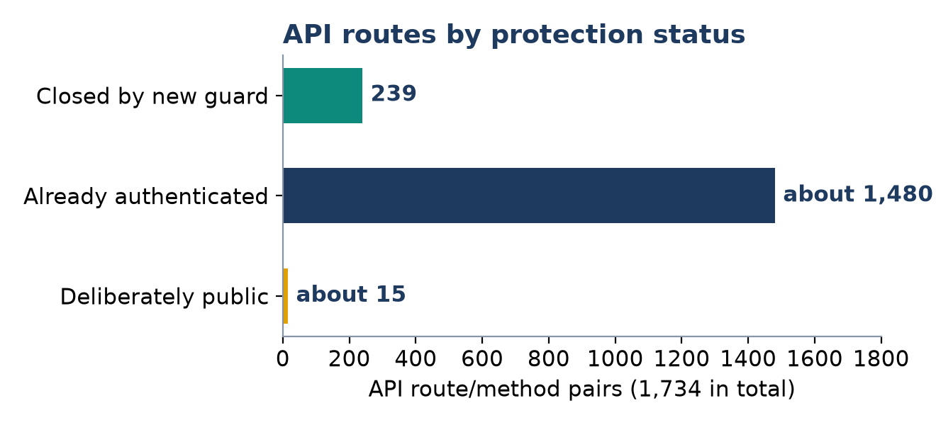
Figure 4. API route/method pairs by protection status.

9. Security
Control | State
Authentication | Verified token or web session required on 239 previously open route/method pairs
Authorization | Menu rights per profile; staff-only URLs refuse students and parents
Tenant isolation | A caller may only name its own school; multi-school admins limited to their client
Validation | Existing controller validation; table names must be plain identifiers
Brute force | Login and OTP limited to 10 to 20 requests a minute per IP
Token minting | api/testkey exists only in local and testing
Data protection | Set APP_DEBUG=false, strong JWT_SECRET, CORS origins, empty CAPTCHA, HTTPS only
Known gaps | Plaintext or md5 web login, open WhatsApp webhooks, tokens in browser storage, about 38 debug scripts in the backend root

Open items before launch
Set on the server. APP_ENV=production, APP_DEBUG=false, a long random JWT_SECRET, CORS_ALLOWED_ORIGINS (unset means any origin), an empty CAPTCHA, API_GUARD_ENFORCE=true, HTTPS only, PHP-FPM with nginx rather than artisan serve.

Decisions needed
- Web login passwords. Move off plaintext and md5; needs a password migration for every school.
- WhatsApp webhooks. Add a shared secret so only the provider can call them.
- Debug scripts. Remove about 38 files from the backend root (test_*.php, debug_*.php, tmp_*.php, check_*.php).
- HR screens. Build leave, payroll and staff attendance screens, or keep them out of V1.
- Parent portal. Build it, or keep it out of V1.
Testing gaps. Attendance, marks entry, fee collection screens and login have almost no automated tests. Failures that already existed before this work: 4 Laravel unit tests (one is a Neo4j login problem), 1 menu-category test that depends on shared data, and 2 frontend AI registry tests. The ESO feature tests did not finish in this environment.

