Smart Campus – Project Report
Supervisor: Mayya Lihovodov
Students: • Shira Vainer 206533184 • Menalu chekol 328858071
• Trngo Abawa 332565050 • Zohar Shalom 212512032

Project Objective
The objective of the Smart Campus project is to develop a machine learning–based system that predicts, in real time, whether a classroom is occupied (1) or unoccupied (0) using environmental sensor data such as Temperature, Humidity, CO₂ concentration, Light intensity, and Humidity Ratio.
By leveraging these IoT sensor readings, the project aims to:
- Improve energy efficiency by automatically controlling lighting, heating, and air conditioning only when rooms are occupied.
- Enable smarter space management through accurate occupancy detection for classrooms and offices.
- Support sustainability goals by reducing unnecessary energy consumption and associated carbon emissions.
- Enhance the campus experience by providing students and faculty with real-time room availability information.

Data Insights
The exploration of data analysis performed in the project revealed several key insights into the relationship between sensor readings and room occupancy:
- Light intensity is the strongest predictor of occupancy. Occupied rooms consistently show significantly higher light values, creating a clear separation from empty rooms.
- CO₂ levels rise when people are present, confirming it as a reliable secondary indicator of occupancy.
- Temperature tends to be slightly higher in occupied rooms, reflecting the natural effect of human presence.
- Humidity Ratio shows moderate correlation with occupancy, while Humidity itself has little direct impact.
The dataset is imbalanced, with rooms being empty about 77% of the time and occupied only 23%.
Visual analysis (distributions, averages, and correlation heatmaps) confirmed that combining multiple features provides a more robust signal than relying on a single sensor.
Conclusion from the data analysis:
While light intensity alone can almost perfectly separate occupied from unoccupied states, relying only on light can be misleading in edge cases (For example, daylight entering or lights left on). A machine learning model that integrates Light, CO₂, Temperature, and Humidity Ratio achieves much greater robustness and accuracy.

Project Overview
A Smart Campus integrates IoT (temperature, motion, light sensors), AI algorithms, and Big Data analytics to optimize campus operations, improve energy efficiency, and enhance user comfort.
Key Technologies:
- IoT sensors for environmental monitoring
- AI models for occupancy detection and prediction
- Cloud/Edge computing for real-time data processing
Benefits:
Energy savings, improved resource allocation, enhanced comfort
Challenges:
Data privacy, integration complexity, and cost.

In this project, we analyze real sensor data (temperature, CO₂, humidity, light) from a campus room to detect occupancy patterns and build predictive models using Python.
Data Preparation
The dataset contains 20,560 samples collected over several days from a single classroom, including timestamped sensor readings of temperature, humidity, light, and CO₂.
Step 1 – Loading and Previewing the Dataset
Step 2 – Dataset Overview: Checking dataset size, column names, missing values, duplicates.
Step 3 – Exploratory Data Analysis (EDA): Identifying data distribution, variability, and relationships.

Variable Analysis
Based on the data insights, we continued to analyze each environmental variable separately to understand how it affects room occupancy:
• Temperature: showed a modest increase during occupancy (around +1.3°C).
This rise reflects the natural heat produced by people and reduced ventilation when the room is occupied.
Although it helps distinguish between states, temperature alone is not a strong enough indicator.
• CO₂: demonstrated a sharp and consistent increase from 605 ppm (unoccupied) to 975 ppm (occupied).
This pattern confirms that CO₂ is a strong indicator of occupancy, directly linked to human respiration.
• Humidity: remained almost unchanged (~27.5% → ~28%).
This minimal variation indicates that humidity provides very limited value for predicting occupancy.
• Light: showed a very strong increase from 25 lux to 482 lux.
Light intensity offered a clear separation between occupied and unoccupied states,
confirming it as the most powerful single predictor of room occupancy.
These analyses confirmed that Light and CO₂ are the strongest predictors of occupancy,
while Temperature has a moderate effect and Humidity is almost irrelevant.
These findings match what we saw in the EDA — Light and CO₂ clearly separated occupied from unoccupied states, showing again that they are the most important indicators.
Sample Graphs:
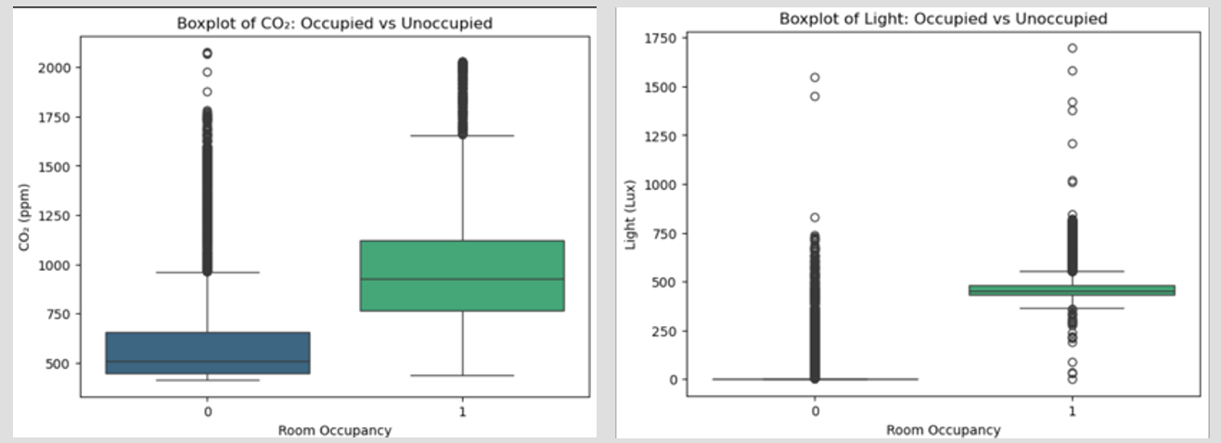

Correlation Analysis
Visualizations confirmed that Light and CO₂ values were much higher when rooms were occupied.

Correlation Analysis:
A correlation matrix and heatmap revealed:
• Light (0.91) → the strongest correlation with occupancy, showing almost perfect separation.
Light (~0.9), CO₂ (~0.5), Temperature (~0.55), and Humidity (~0.05) showed similar relationships to occupancy as in the code analysis
• CO₂ (0.50) → moderate correlation; reliable secondary indicator of human presence.
• Temperature (0.56) → moderate correlation; warmer rooms tend to be occupied.
• Humidity (0.05) → very weak correlation, minimal predictive value.
These results confirm that combining multiple features — especially Light and CO₂ —
provides a more robust and reliable model than relying on a single variable.
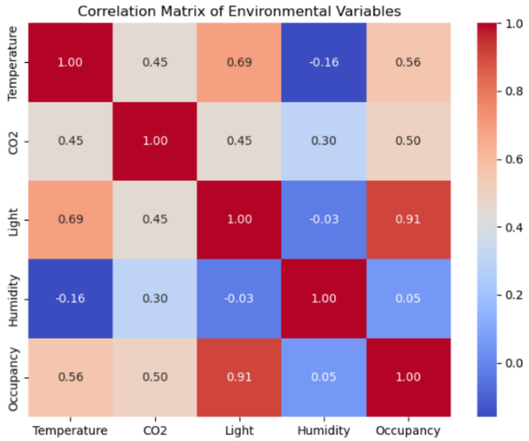

Modeling
The strong correlations observed, especially for Light and CO₂, motivated the next step — training predictive models to quantify their impact on occupancy.
After understanding the variable behavior, we proceeded to build and evaluate predictive models to classify room occupancy.
We applied two supervised learning models to predict room occupancy:
The dataset was split into 70% for training and 30% for testing, just like in our code and presentation. This ensures the models are trained and evaluated fairly
- Logistic Regression – Accuracy: 98.8%, F1 Score: 0.974
• Served as a clear, interpretable baseline model.
• Easily explains feature contributions and confirms that Light and CO₂ drive predictions.
- Random Forest – Accuracy: 99.1%, F1 Score: 0.982
• Slightly outperformed Logistic Regression.
• Captured non-linear interactions between features and handled variability effectively.
Both models performed extremely well (~99%), showing that the chosen features
are highly predictive of occupancy behavior.
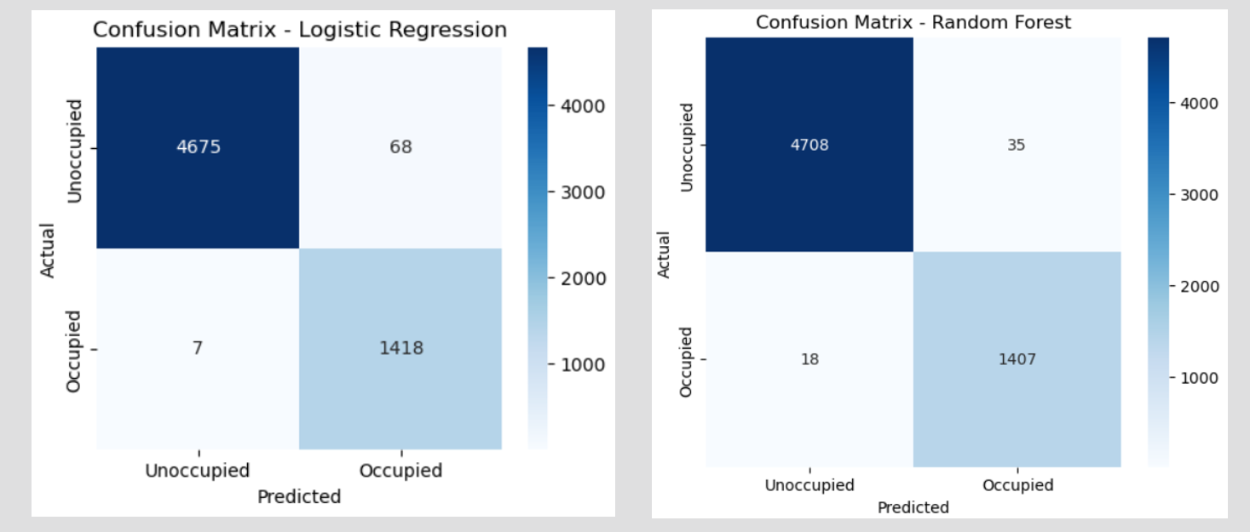

Model Comparison
The following section compares both models to highlight their strengths and practical differences.
While Random Forest achieved slightly higher accuracy (99.1%) and F1 score (0.982), Logistic Regression also performed very strongly with 98.8% accuracy and 0.974 F1.
Logistic Regression is simpler, faster, and easier to interpret, making it ideal when model transparency is important.
Random Forest, on the other hand, is more powerful and captures complex patterns in the data, which explains its slightly better performance.
Model | Accuracy | F1 score | Precision/ Recall
Logistic Regression: | 98.8% | 97.4% | Precision: 95-100%  Recall: 99-100%
Random Forest | 99.1% | 98.2% | Precision: 98-100%  Recall: 99-100%
Recommendation:
- Use Random Forest for maximum predictive power.
- Use Logistic Regression when transparency and simplicity are important.

Limitations
This section outlines the main limitations of the study and potential areas for improvement.
- The dataset is limited to a single room, which may restrict generalization to other spaces.
- Environmental conditions (e.g., HVAC operation, natural light, and ventilation) may influence results.
- Only Logistic Regression and Random Forest were tested; other models could provide different insights.
- Sensor noise and calibration inaccuracies could slightly affect model precision.
- The dataset is imbalanced (77% unoccupied vs. 23% occupied), meaning that accuracy alone may be misleading — hence the use of Precision, Recall, and F1 metrics.
These limitations highlight possible directions for improvement and future work.
Because the data came from one classroom, we recommend testing the model in additional rooms to confirm whether it maintains the same level of accuracy under different conditions.
Additionally, time of day or class schedules could influence occupancy patterns, but these factors were not explicitly modeled in this study.
Despite these limitations, the models achieved very high accuracy and demonstrated strong reliability within the tested environment, supporting their potential use in Smart Campus systems.

Modeling Conclusions
Findings from EDA:
- Light and CO₂ are the strongest indicators of occupancy.
- Temperature has a moderate effect.
- Humidity shows the weakest relationship.

Modeling Results:
Logistic Regression- strong, interpretable baseline (Accuracy 98.8%).
Random Forest- slightly better performance (Accuracy 99.1%), captures non-linear patterns.
It is important to note that the dataset is imbalanced (77% unoccupied vs. 23% occupied). Therefore, Accuracy alone may be misleading, and metrics such as Precision, Recall, and F1 were essential to ensure a fair assessment of model performance.
Overall Insight:
- Both models accurately predict room occupancy.
- Use Random Forest for maximum performance.
- Use Logistic Regression for simplicity and interpretability.
- After completing the modeling and evaluation phase, we compared our results with previous academic studies to validate the reliability and consistency of our findings.

Review of Previous Research
Introduction:
Occupancy detection has been widely studied in recent years due to its crucial role in energy efficiency, smart buildings, and indoor environmental management.
The ability to detect whether a room is occupied in real time allows for automatic control of lighting, heating, ventilation, and air conditioning systems — reducing unnecessary energy use and improving user comfort.
Many researchers have demonstrated that reliable occupancy detection can be achieved using simple environmental sensors such as Temperature, Humidity, Light, and CO₂ concentration.
When combined with machine learning algorithms, these sensor readings can produce accurate and non-intrusive models for real-time room monitoring, making them ideal for smart campus and smart building applications.

Findings from Previous Studies:
Candanedo & Feldheim (2016)
(Candanedo, L. M., & Feldheim, V. (2016). Accurate occupancy detection of an office room from light, temperature, humidity and CO₂ measurements. Energy and Buildings, 112, 28–39.)
This well-known study is one of the foundational works in the field.
The researchers used the same four environmental variables: Temperature, Humidity, Light, and CO₂ — to predict room occupancy.
Their main findings were:
- Light and CO₂ are the most reliable and consistent predictors of occupancy.
- Temperature has a moderate effect.
- Humidity plays only a minor role.
Using Logistic Regression and Random Forest, they achieved very high accuracy levels of 98%–99%, confirming that environmental data alone can effectively indicate occupancy without using cameras or motion sensors.

UCI Occupancy Dataset Studies
Several other studies used the same UCI Occupancy dataset to compare different machine learning models, including Support Vector Machine (SVM), Random Forest, and Logistic Regression.
Their results were highly consistent across works:
- SVM achieved up to 99.3% accuracy.
- Random Forest achieved about 99.2% accuracy.
- Logistic Regression performed slightly lower but still above 98% accuracy.
Across all studies, a clear and recurring pattern was observed:
Light intensity and CO₂ concentration show the strongest correlation with occupancy, while Temperature and Humidity have weaker and less consistent effects.
This pattern held true even in different environments and times, demonstrating the stability and reliability of these variables as universal indicators of human presence.

Our Position in Relation to Literature:
The results of our Smart Campus project are highly consistent with the findings of previous studies.
- Our Random Forest model achieved 99.1% accuracy, nearly identical to the ~99.2% reported in another research.
- Our Logistic Regression model achieved 98.8% accuracy, also matching previously published results.
- Our correlation analysis revealed the same pattern of variable importance:
  - Light – 0.91 (very strong correlation)
  - CO₂ – 0.50 (moderate-strong)
  - Temperature – 0.56 (moderate)
  - Humidity – 0.05 (very weak)
These outcomes confirm that even when applied to real sensor data collected in a campus environment, the same relationships hold true:
Light and CO₂ remain the dominant features for predicting occupancy, while Temperature contributes moderately and Humidity only slightly.
Thus, our project not only reproduces earlier findings but also validates them using real-world data.

Conclusion:
The review of previous research clearly shows that our project’s findings are fully aligned with existing literature.
Both our accuracy levels and our variable importance analysis replicate the trends observed by earlier studies.
In all cases, Light and CO₂ were the primary indicators of occupancy, while Temperature provided secondary support and Humidity had minimal influence.
Our project not only confirms these results but also demonstrates their validity in a practical, real-world setting within an actual campus environment — strengthening the evidence that simple IoT sensor data can serve as an effective, accurate, and scalable basis for smart building systems.

Summary of Previous Research vs. Our Results:
Source | Models Tested | Reported Accuracy | Main Variables | Comparison to Our Results
Candanedo & Feldheim (2016) | Logistic Regression, Random Forest | 98–99% | Light and CO₂ strongest; Humidity weak | Perfect match identical trends and variable importance
UCI Benchmark Studies | SVM, Random Forest, Logistic Regression | up to 99.3% | Light and CO₂ consistent; Temperature moderate | Fully consistent our Random Forest achieved 99.1%
Our Project (Smart Campus) | Random Forest, Logistic Regression | 99.1% / 98.8% | Light and CO₂ dominant; Temperature moderate; Humidity weak | Confirms and reproduces existing literature in a real campus setting

Overall Conclusion
When compared with previous studies, our project demonstrates complete consistency with the scientific literature.
Both of our models — Random Forest and Logistic Regression — achieved nearly identical accuracy to prior research, and the order of variable importance remained unchanged:
Light and CO₂ are the key features, Temperature contributes moderately, and Humidity has minimal effect.
In summary, our study does not only align with prior research but also validates it in a real-world context, proving that machine learning models based on simple environmental sensors can reliably detect occupancy.
These findings reinforce the feasibility of applying such systems for Smart Campus and Smart Building energy-management applications, achieving both accuracy and sustainability.
In the future, this model can be expanded to more classrooms and connected to real-time systems that control lighting or air conditioning automatically, to improve energy use even more. Overall, this study highlights how data-driven machine learning models can transform traditional classrooms into intelligent, energy-efficient environments, paving the way for future Smart Campus innovations.

