|  |  |
| --- | --- |
| CS33 Project  Supervisor: Eng. Suhaila Mohamed | Names  Abdelrahman Mustafa El-Feky 19102270 Amr Ibrahim Soliman 19101476 Wednesday 12:30 |

# Declaration

I certify that this assignment/report is my own work, based on my personal study and/or research and that I have acknowledged all material and sources used in its preparation, whether they be books, articles, reports, lecture notes, and any other kind of document, electronic or personal communication

# Table of Contents

Declaration I

Table of Contents II

Table of Figures III

About Project & Client 1

1.1 The Client 1

1.2 Client Contact Information 2

1.3 Project Overview 3

1.3.1 The Problem 3

1.3.2 The Required Features 4

1.3.3 The Activities Needed by Students 5

1.3.4 Revenue Scheme 6

1.3.5 The Website Current Limitations & Features to Come 6

1.4 The Website Code Overview & Documentation 7

1.5 Project Prototype 24

1.6 Competitors Survey 26

1.6.1 Chegg 27

1.6.2 CourseHero 29

1.6.3 Slader (Now Quizlet) 30

1.6.4 Differences 31

References 32

# Table of Figures

Figure 1 – Stylesheet Code Snippet 1 7

Figure 2 - Stylesheet Code Snippet 2 8

Figure 3 - Index Page 9

Figure 4 - Index Page Code Snippet 1 10

Figure 5 - Index Page Code Snippet 2 11

Figure 6 - Main Footer 11

Figure 7 - Index Page Code Snippet 3 11

Figure 8 - Registration Page 12

Figure 9 - Registration Page Code Snippet 1 13

Figure 10 - Login Page 15

Figure 11 - Login Page Code Snippet 1 15

Figure 12 - FAQ Page 16

Figure 13 - FAQ Page Code Snippet 1 17

Figure 14 - Reviews Page 19

Figure 15 - Reviews Code Snippet 1 19

Figure 16 - Math Subject Forum 20

Figure 17 - Math Subject Code Snippet 1 20

Figure 18 - Math Question One 21

Figure 19 - Math Question One Code Snippet 1 21

Figure 20 - Network Subject Forum 22

Figure 21 - Network Question One 22

Figure 22 - Index Homepage Prototype 24

Figure 23 - Subjects Page Prototype 25

Figure 24 - Forum Page Prototype 25

# About Project & Client

We will start off our report by discussing our project, discussing its distinct features in details and discussing the clients’ needs.

## The Client

Our chosen client of choice is Eng. Mark Tharwat, who is a very experienced academic tutor and instructor, with many courses on famous course websites including Coursera and Udemy, and has been providing online resources for students in different universities in a number of countries including Saudi Arabia and Kuwait.

Eng. Mark Tharwat has proficiencies in the following academic subjects:

* Network and Data Communication
* Ethical Hacking
* Linux System Administration
* Information Technology
* Operating System Concepts and Principles
* Computer Architecture and Design

Mr. Mark Tharwat has focused more of his work as an employee working for different platforms that provide these courses and has decided that he wants to start his own business endeavor in order to be able to provide the work of his own to students all around the world and especially in Egypt and the MENA region, as students in this region have struggled to find a platform of their own that they can use to communicate information with one another and have access to top-of-the-line instructors and tutors in order to assist them, especially for students who study online, remotely or at their own pace, who might also face language barriers when trying to find help online on other famous websites.

This endeavor would not be a successful one if it was not led by a website that allows Eng. Mark to regularly post his own content and have a suitable platform that Arab students can easily use in order to connect with Eng. Mark.

## Client Contact Information

* Client Name: Mark Tharwat Antonio
* Email: ihackprojectsmm@gmail.com
* Tel.: +20 100 422 2114
* Links:
  + LinkedIn: <https://eg.linkedin.com/in/mark-antonio-b2777310a>
  + Udemy Profile: <https://www.udemy.com/user/markantonio2/>
  + Facebook: <https://www.facebook.com/manovinrecords>

## Project Overview

As we have mentioned previously, the project is a website that serves as a platform to allow students, especially in Egypt and the Arab world, to be able to connect with proficient tutors and instructors so that they can receive the help they need on their study, homework and general questions regarding different courses and subjects.

The website will allow the students to register and login with their personal information that they supply during their register on the first visit to the website and then they will be allowed to visit and browser the different number of courses and subjects on the website. The website courses and subjects page will be based on forum-like webpages, whereby the students can post their questions and then the instructors that are tasked with the maintenance and ongoing of the platform will answer these questions as thread replies, making it available for other students on the website so that they can have the ability to find previously-answered questions that other students might have encountered during their study.



### The Problem

Our client has requested the website as a solution for the following problems that he encountered during his work:

* Not having a personal website where he can post his own content rather and have a personal following rather than working for other brand names and websites.
* Not having a proper platform that serves only the MENA region, as other alternatives are based in other countries, mainly in the United Sates, and are only available in English language, this poses both a threat and an opportunity for the region.

### The Required Features

The following features are those that were requested by the client in the website and have been implemented or will yet to be implemented:

* The website will act as a platform where students can post their questions and have them answered by professionals in the field, namely the tutors working on the website.
* The ability for students to both register and login on the website safely and securely, whilst providing the client with the information they need for statistics later on, such as the country and university of the student.
* The website must prevent students that are not signed in from browsing the questions and answers of a certain topic.
* The website must allow the students that are logged in but not subscribed to only view 2 answers per month.
* The website must allow students to be able to pay online for subscriptions, with both monthly and yearly options, and only allow subscribed students to post up to 10 questions per month and view as many answers as they would like.

### The Activities Needed by Students

In order to make the most out of our website and use it effectively, the students will have to do the following steps:

* The students will firstly have to navigate to our website or find it through the its URL.
* Having found the website, the student will then have to register using the register button as he will be limited to only browsing the website pages without having signed in.
* After clicking on the register button, the student will then have to fill the following information in order to create an account for himself on the website:
  + Username
  + Password
  + Email
  + Gender
  + Country
  + University
* Having confirmed registration, the student will be redirected to the home page where he can now press on the login button to sign in.
* The student will be asked to supply his previously-entered username and password in order to login on the platform.
* When the student is logged in, he can then choose his subject of choice in order to browse its questions and answers as well as post questions.

### Revenue Scheme

The website will follow a subscription-based revenue scheme, where the students have to pay for a subscription, that can be monthly or yearly depending on his choice, in order to have full privileges on viewing all the posted questions and answers on the platform, as the free students will only have the following privileges:

* The ability to view 2 answers only per monthly visit.
* The inability to post new questions.

This scheme, as requested by the client, will make the website cleaner and have less spam and have higher quality posts so that it is moderated and regulated, moreover, it will ensure that students are provided with high-quality service.

### The Website Current Limitations & Features to Come

We will now discuss the current limitations as of the current phase of development of the website, as these will be handled as time goes by whilst adding more features as requested by the client:

* The website now is only in English, which defeats the purpose of development for the MENA region specifically, a full Arabic translation might be added later on *(Date: TBD).*
* The website dark mode is only functional in the index page and will still be migrated and integrated into the other pages *(Date: TBD).*
* The website forum pages where the students can post questions to be answered needs further work and improvements *(Date: TBD).*
* The website must have a secure payment page with several payment methods to ease the process for the students that are willing to subscribe *(Date: TBD).*

## The Website Code Overview & Documentation

In this section, we will go over the current website state and explain the pages’ structure, code and the features they offer, starting with the CSS style sheet that we used for the pages, that is “stylesheet.css”.

We have used a variety of CSS selectors depending on the context needed; hence, for the unique elements we have used id selectors and for the elements that are present in most pages, such as the containers as <main>, <header> and <footer> tags, we have used the class selector.

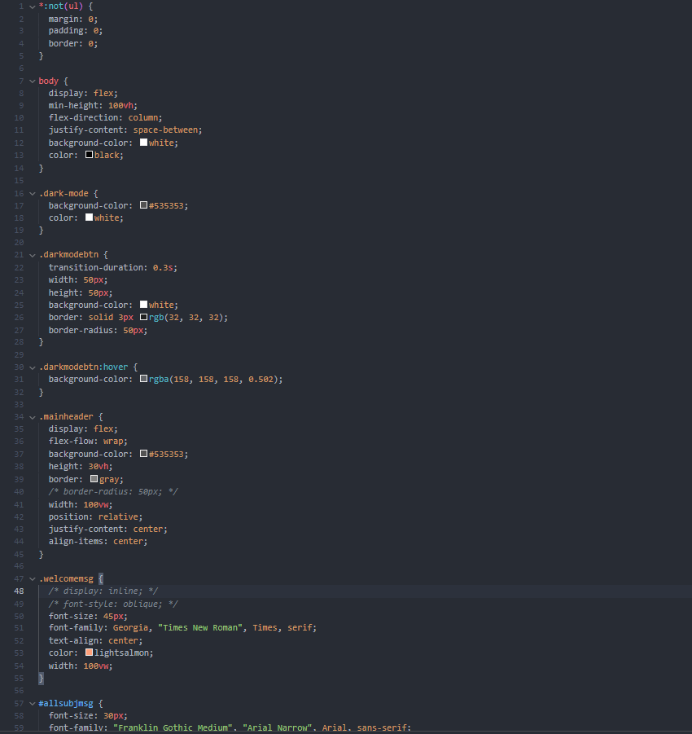

Figure 1 – Stylesheet Code Snippet 1

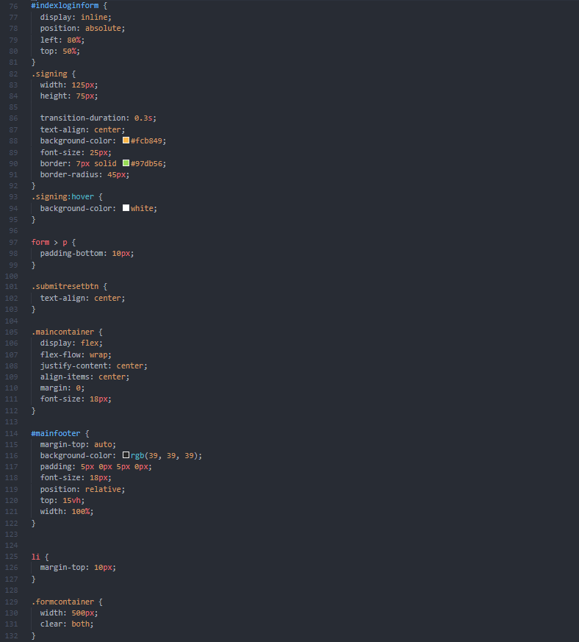

Figure 2 - Stylesheet Code Snippet 2

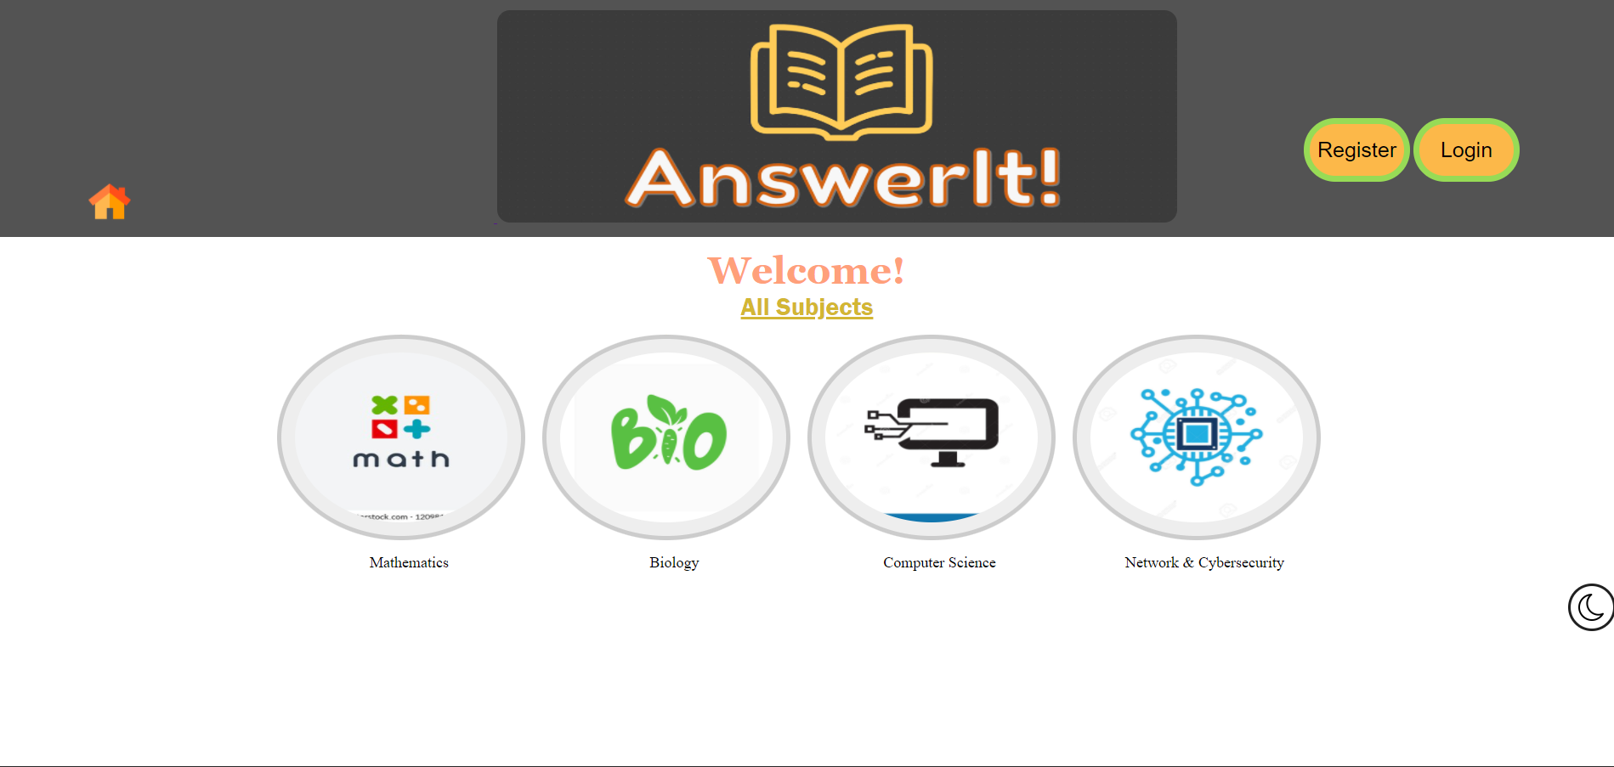

Figure 3 - Index Page

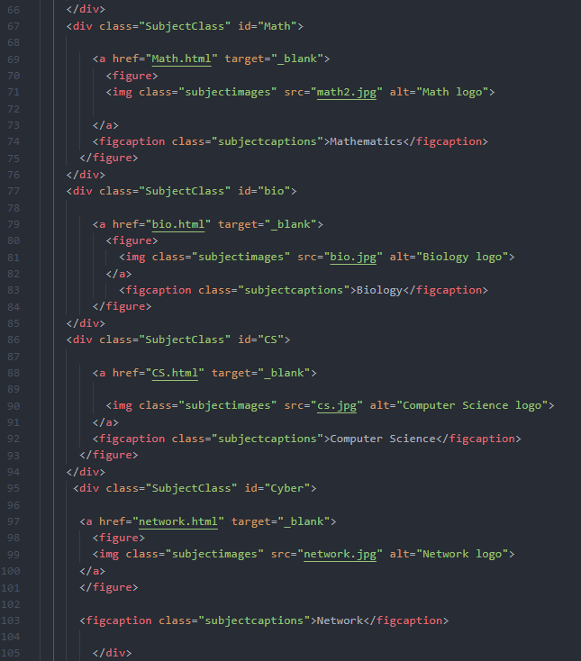

Figure 4 - Index Page Code Snippet 1

The current index page is mostly concerned with the display of subjects’ forum pages, each with a hyperlinked image and a text explaining the subject name, which then links the user to the appropriate HTML page of the chosen subject.

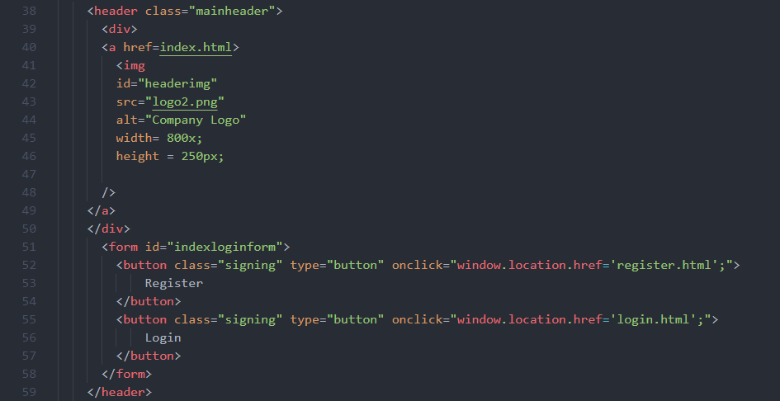

Figure 5 - Index Page Code Snippet 2

The <header> tags in the index page and the following pages represents the logo of the website AnswerIt! at the top, which the user can click at any time to return to the index page, whilst also displaying the register and login buttons that allow the student to register or login.



Figure 6 - Main Footer

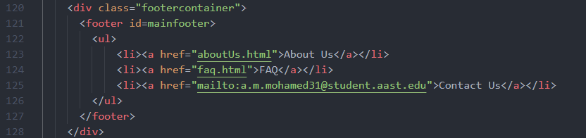

Figure 7 - Index Page Code Snippet 3

Our main <footer> tag with the id *“mainfooter”* represents the footer that is present at the end of each page on the website and carries relevant hyperlinks about the website like the About us, FAQ, testimonials and a hyperlink with a *“mailto”* source that opens a new email for users to send to the website support and contact email.

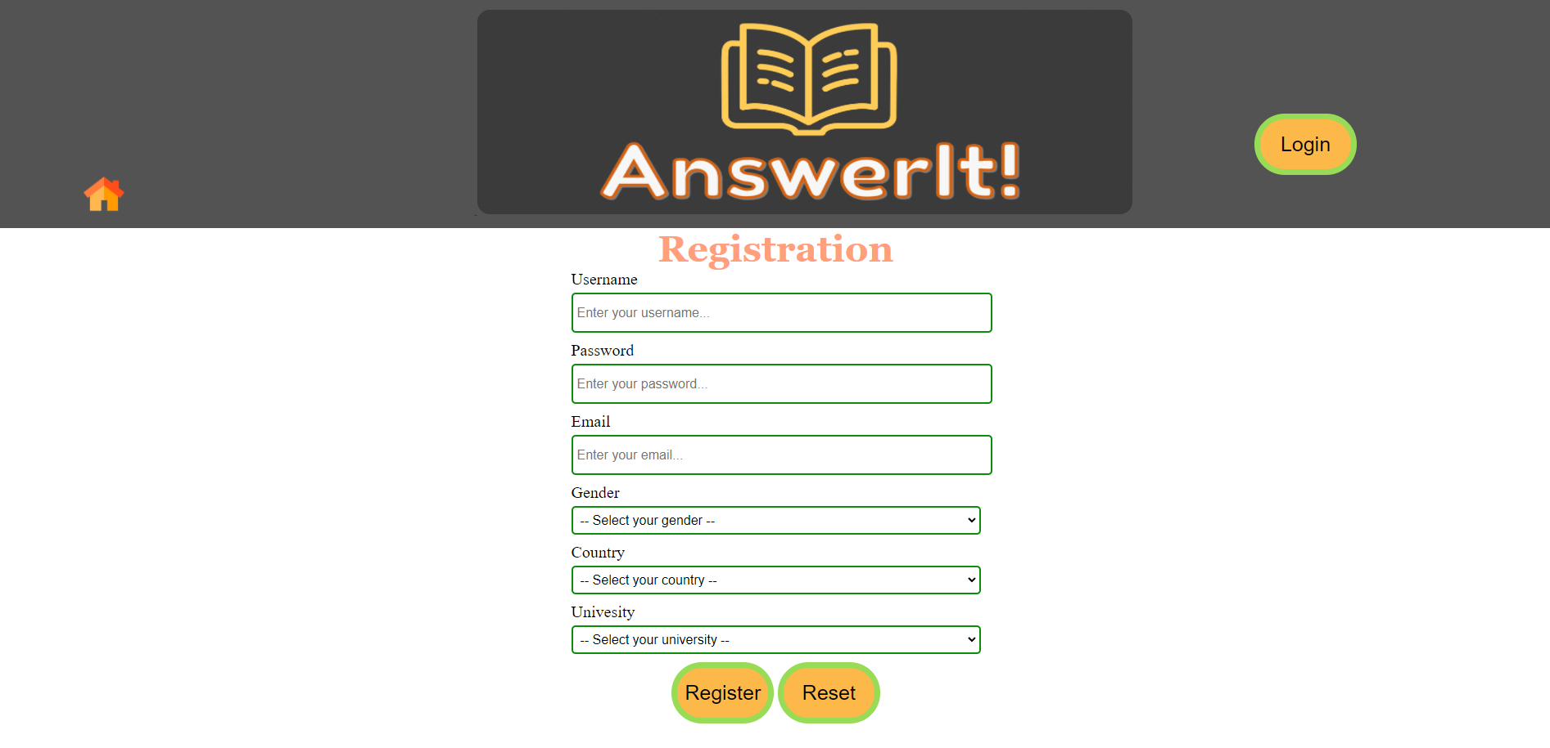

Figure 8 - Registration Page

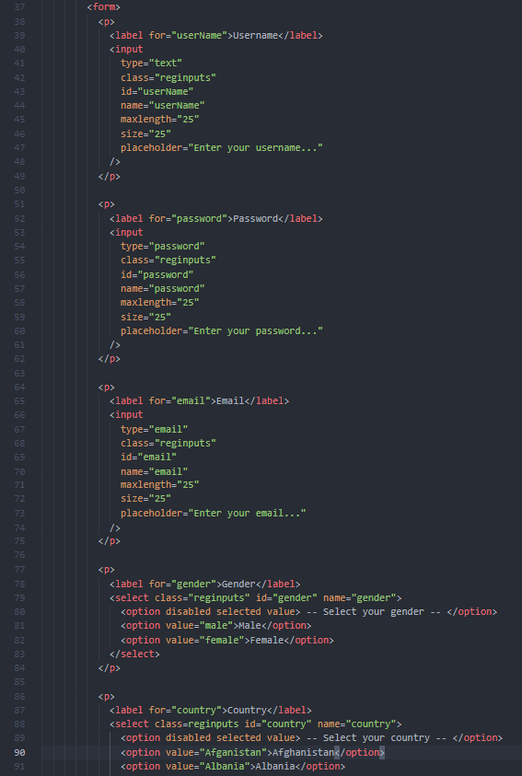

Figure 9 - Registration Page Code Snippet 1

In the registration page, both the header and footer tags remain the same, with the only difference that the register button is no longer visible as the user is already in the registration page, instead they can go to the login page have the student been registered before.

The code for the registration page shows a <form> tag in which we have added the appropriate <input> tags with the appropriate types for each input.

In the list menus, we have used the <select> tag with the first option being *disabled* to prevent the user from forgetting to select an input from the list menu, we have also limited all of the lengths of the entries to 25 characters. Finally, a <select> tag with all of the countries also is present in the form, this information will be later used by the client in data statistics.

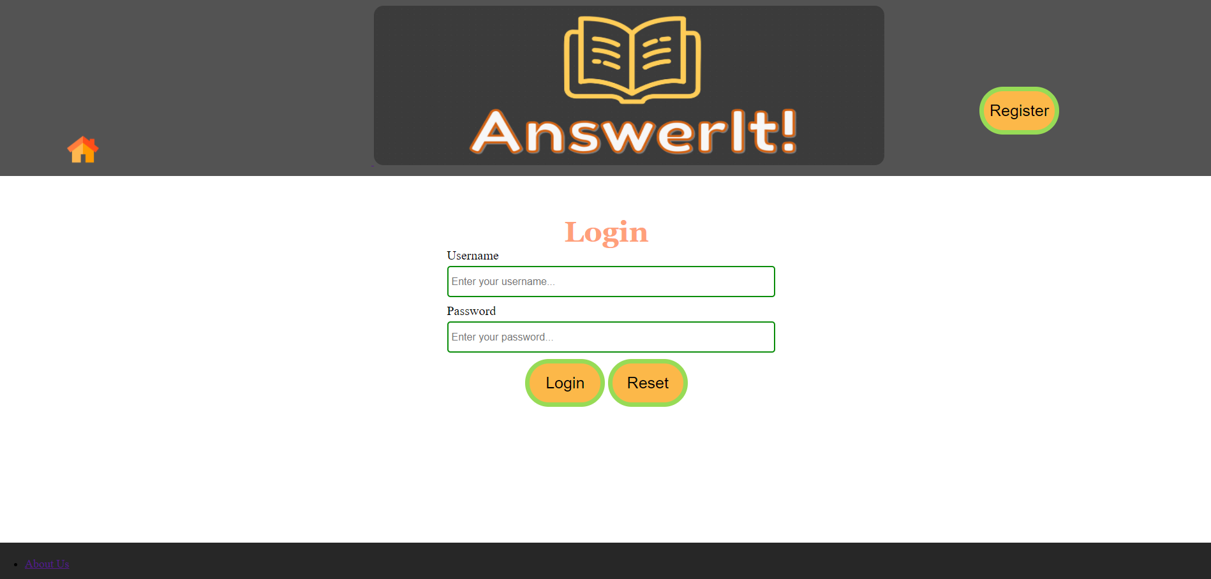

Figure 10 - Login Page

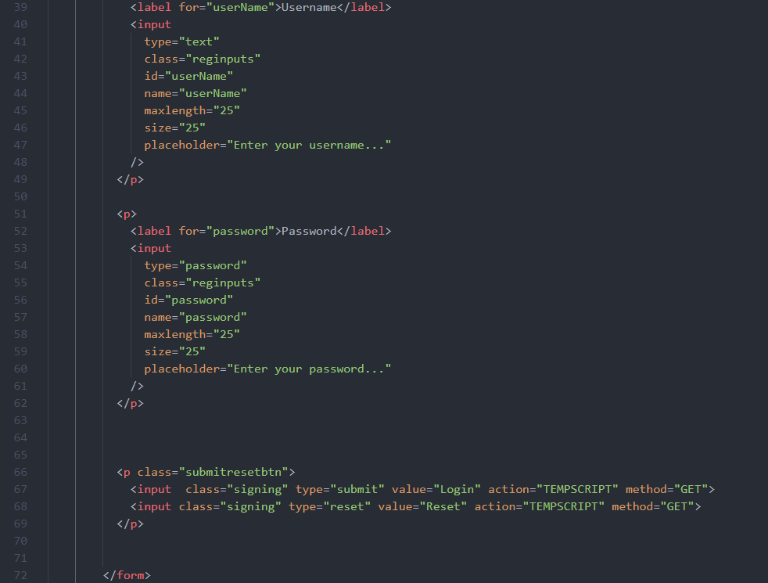

Figure 11 - Login Page Code Snippet 1

The login page shows very similar characteristics and code to the registration page with the only differences being the different header button; from login to register.

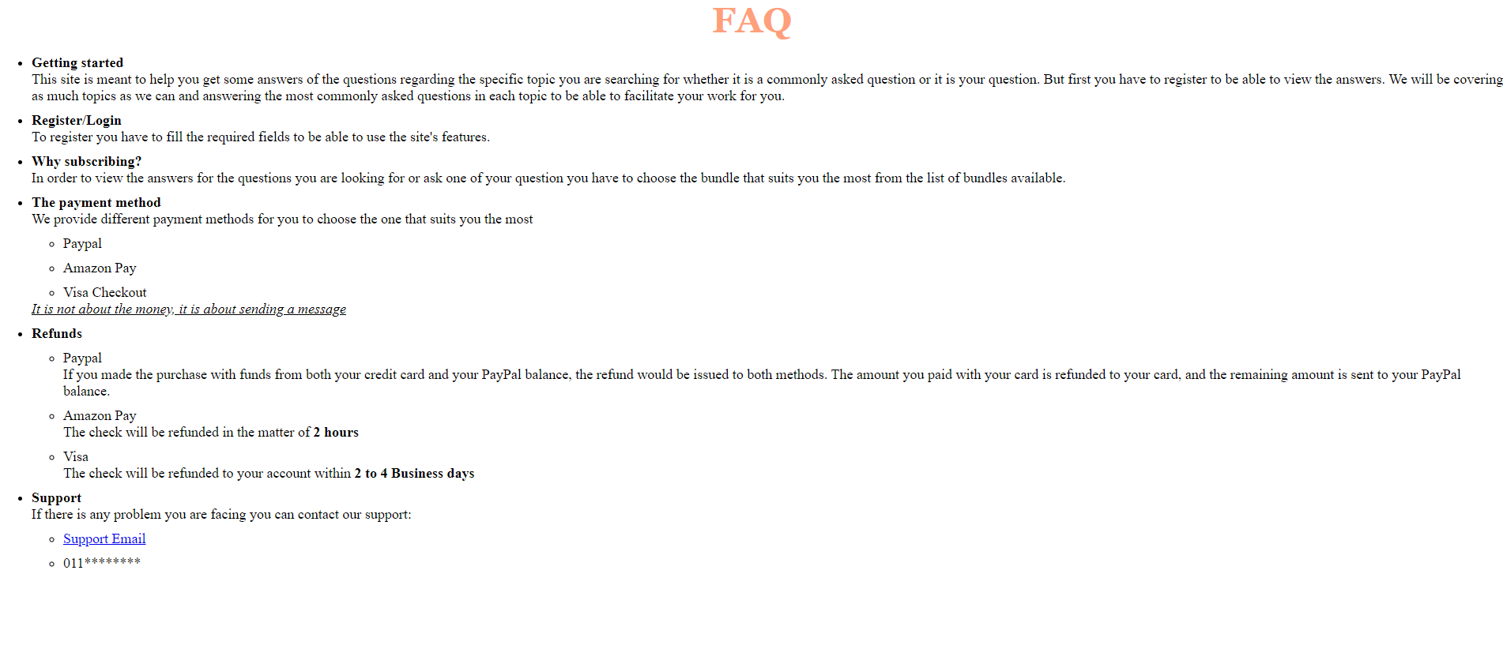

Figure 12 - FAQ Page

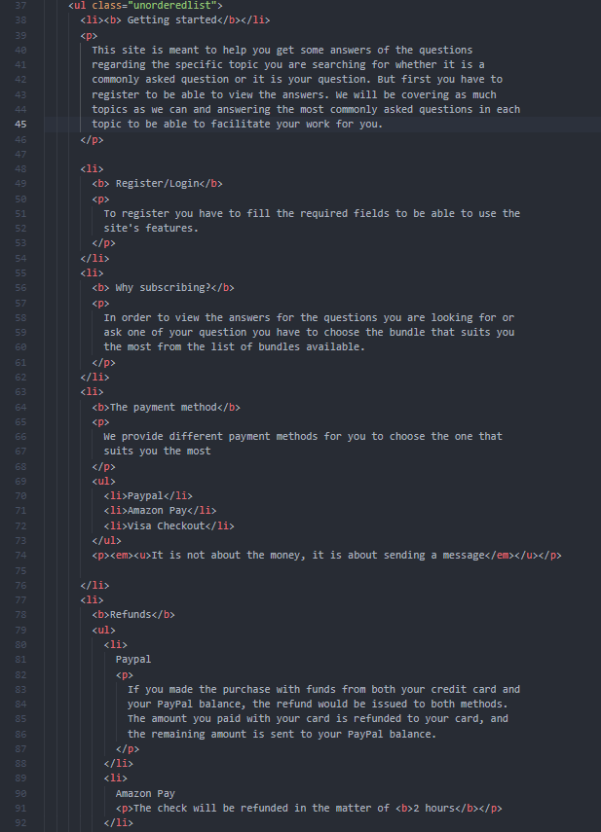

Figure 13 - FAQ Page Code Snippet 1

The FAQ page makes use of <ul> tag to make a number of questions that each are separated with a bullet and an answer below them in order to differentiate between them and add further support to the students, moreover, the <ul> tags are all styled by the class *“unorderedlist”* in the rest of the pages that utilize the <ul> tag.

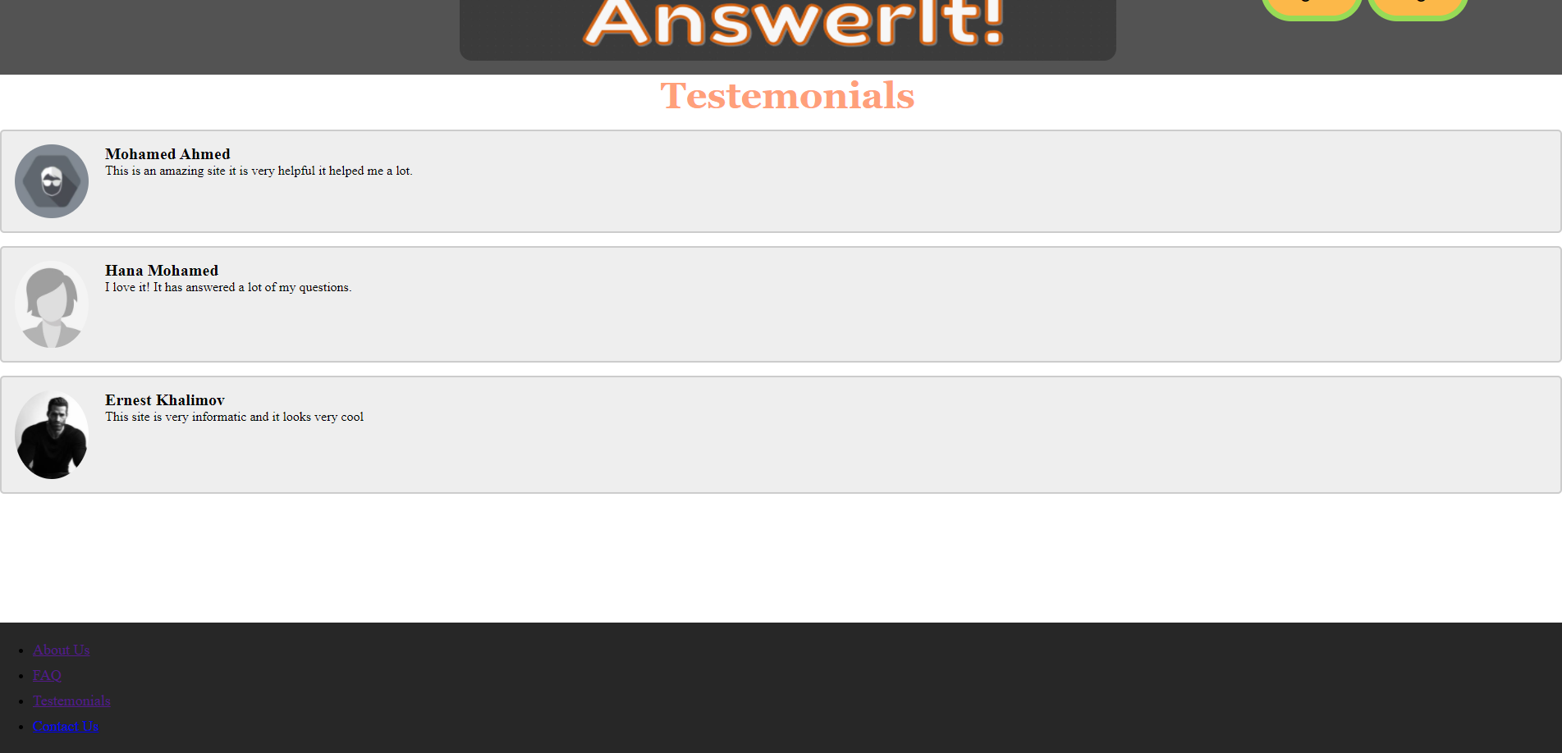

Figure 14 - Reviews Page

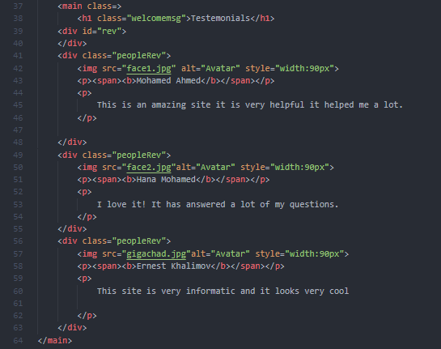

Figure 15 - Reviews Code Snippet 1

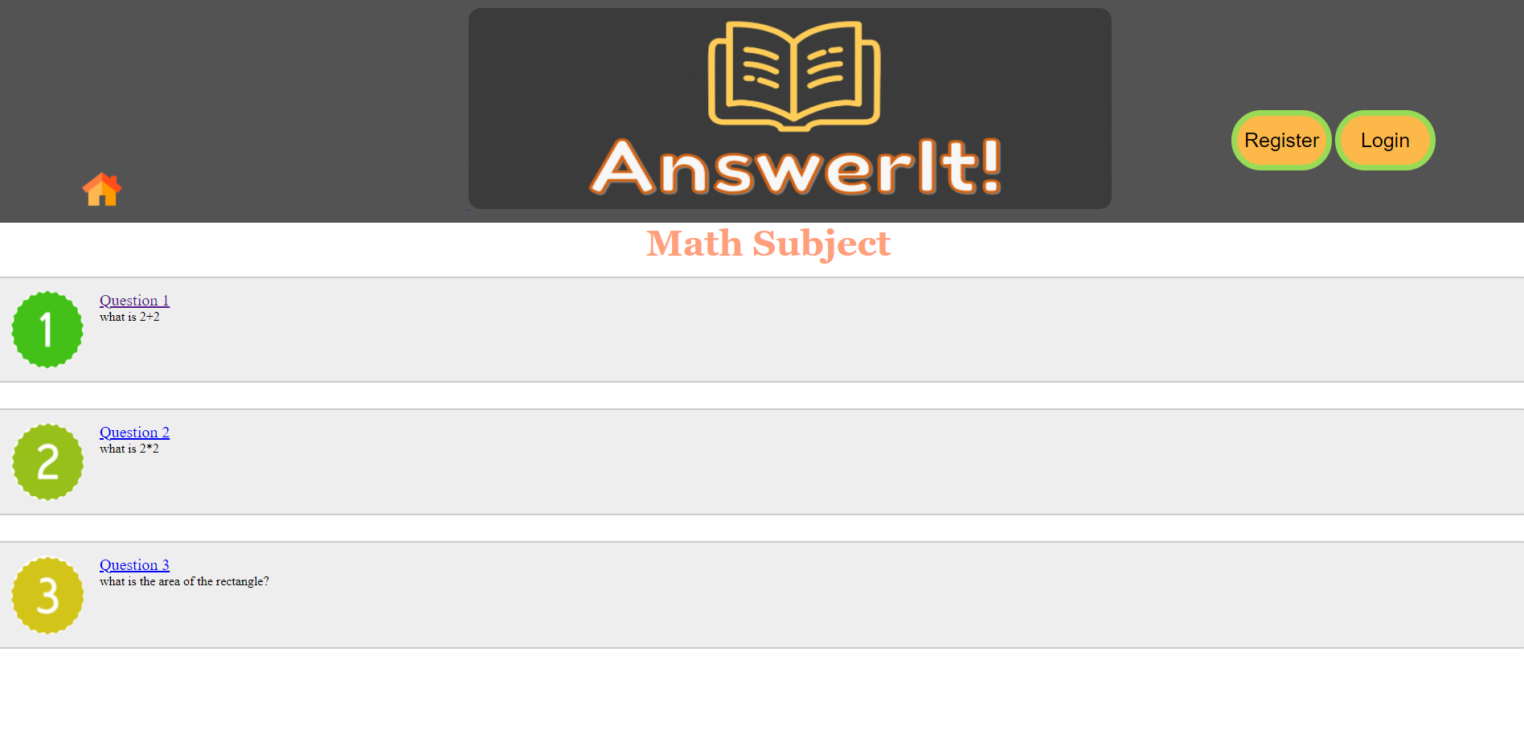

Figure 16 - Math Subject Forum

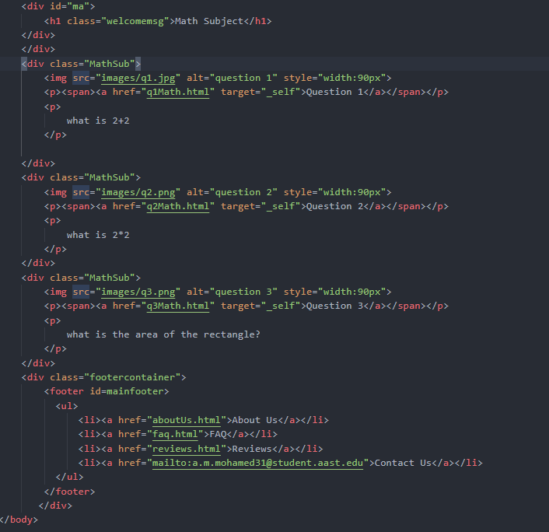

Figure 17 - Math Subject Code Snippet 1

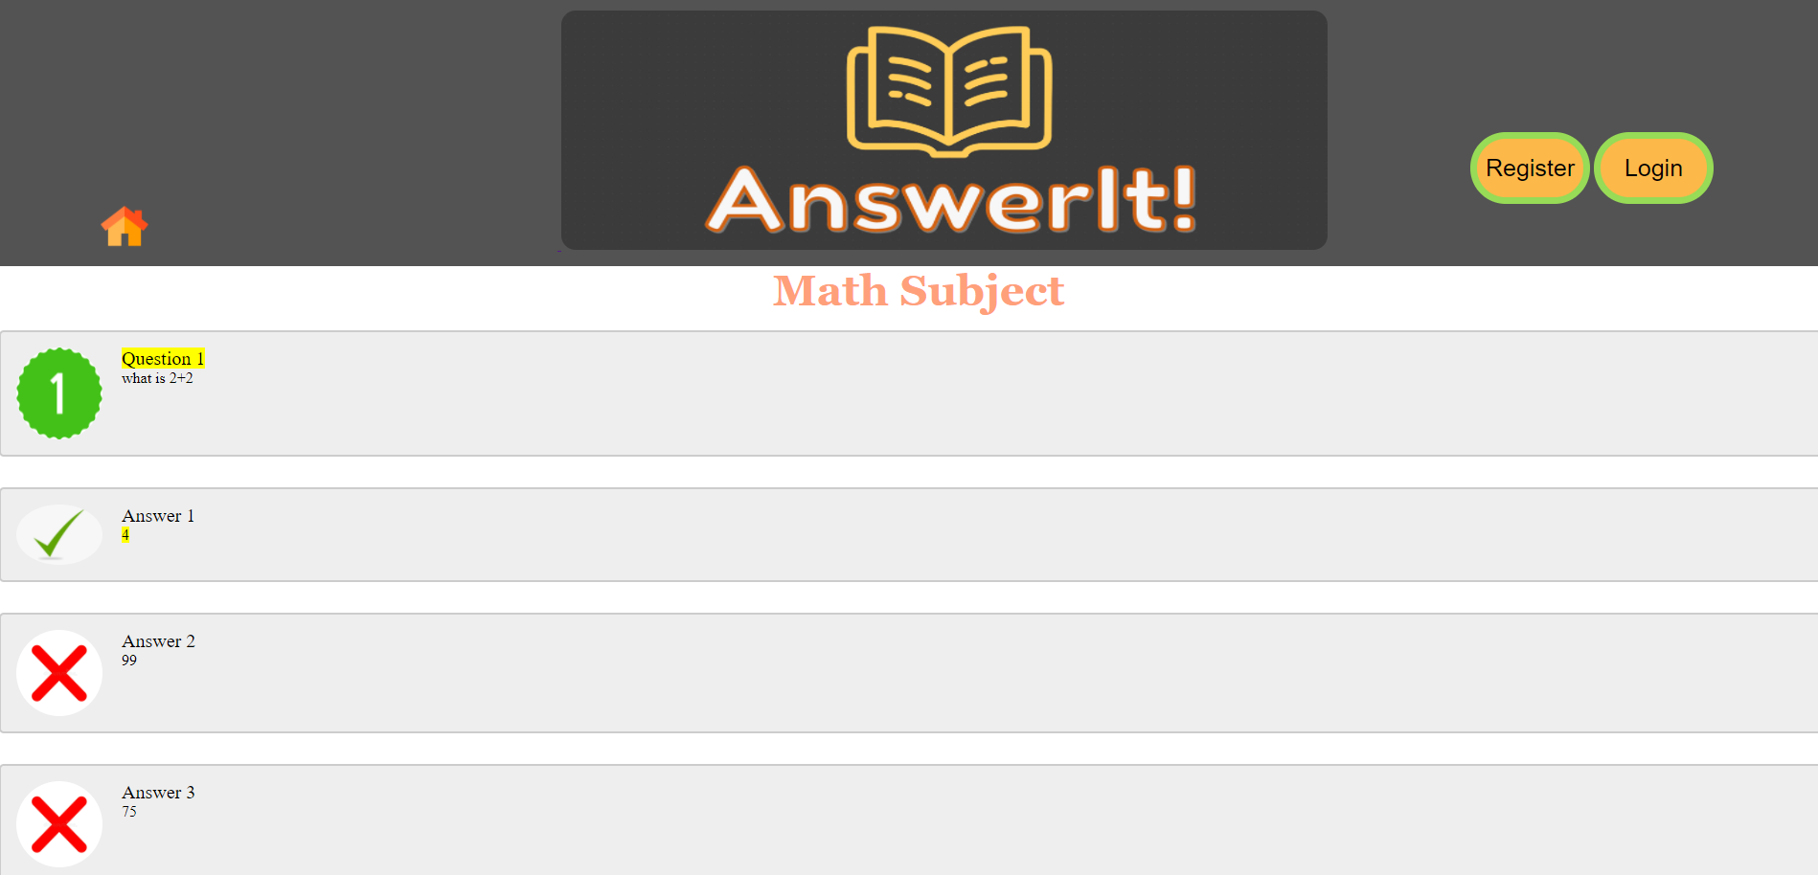

Figure 18 - Math Question One

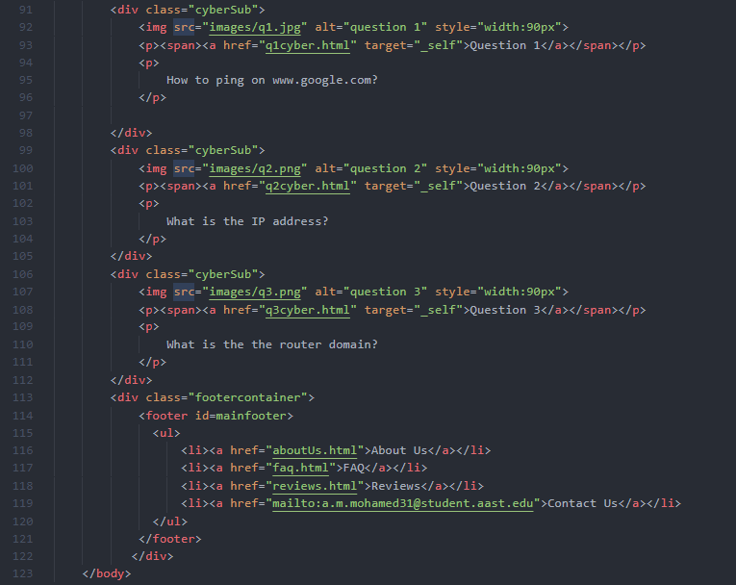

Figure 19 - Math Question One Code Snippet 1

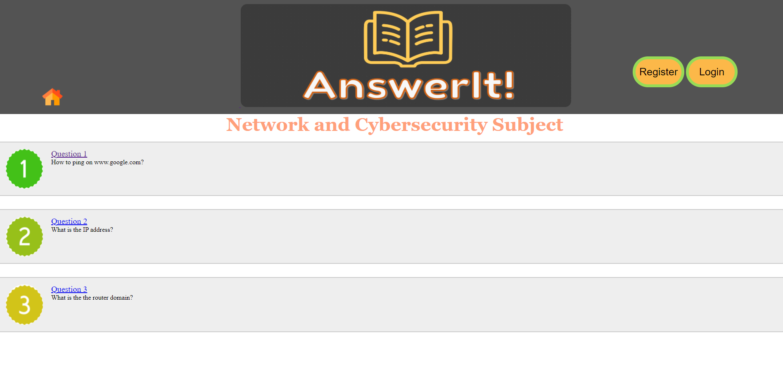

Figure 20 - Network Subject Forum

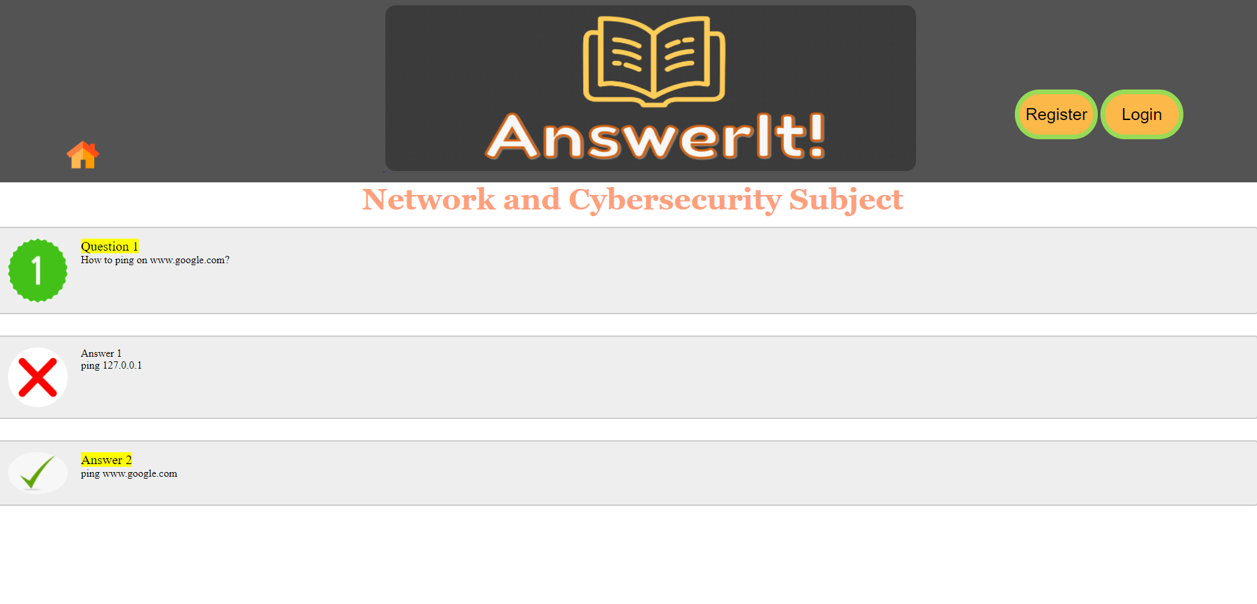

Figure 21 - Network Question One

In both subject forums and questions, we make use of several tags to highlight the importance of the correct answer, using <img> to add an image denoting the correct answer as well as the <mark> tag to highlight the correct answer. Moreover, we make use of the CSS id selector and have added embedded style options inside the <style> tag to further decorate the webpages more than the external style sheet.

## Project Prototype

In this section, we will outline our vision that we aspire to have achieved by the end of the website development, with further improvements being added incrementally as every phase of the development is concluded. To further elaborate, we look to decorate the index webpage further and make it more user friendly, moreover, we aim to add better forum and thread systems to further increase the look-and-feel of the website.

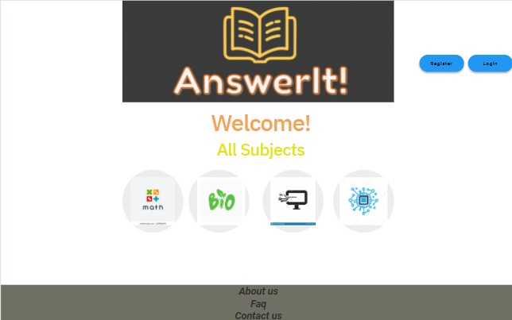

Figure 22 - Index Homepage Prototype

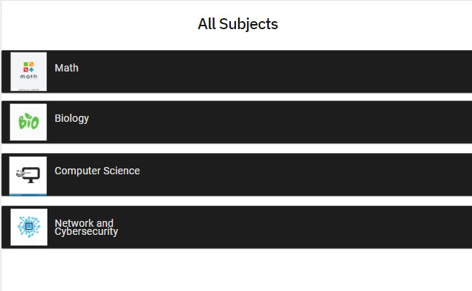

Figure 23 - Subjects Page Prototype

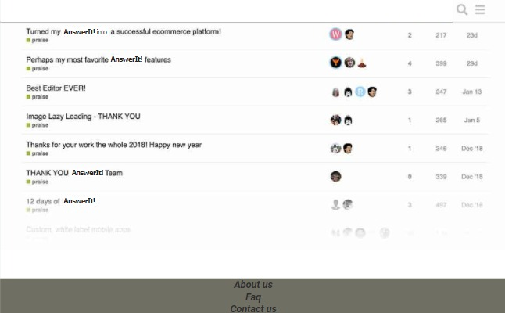

Figure 24 - Forum Page Prototype

## Competitors Survey

In this chapter, we will delve deeper into the current market and analyze the different competitors that are already in the field, compare and contrast them in order to come up with a final survey result that will allow us to compare our current stance in the website with the other competitors in order to differentiate ourselves and further draw attention to ourselves. We will discuss the following known competitors:

1. Chegg
2. CourseHero
3. Quizlet (Acquired Slader)

### Chegg

Starting with one of the largest and most known names in the field that is Chegg. Chegg is a very known website that provides educational support and help for students, such as digital and physical textbook rentals, textbook solutions, online tutoring and so on. For a very long time, Chegg has been the leading educational platform made for students, with a large number of users that are constantly networking together in order to help one another.

Chegg launched in 2005 and is based in America. Chegg currently has over 3 million subscribers as of 2020. Being such a fierce competitor with large exponential growth, Chegg has opted for a **horizontal** **growth** strategy, whereby they focused on strong acquisition of other competitors in order to dominate the market, namely CourseRank, Cramster and Notehall. Finally, Chegg also offers a textbook rentals service as well as internship and scholarship chances on their child website Chegg Internships.

|  |  |
| --- | --- |
| Pros | Cons |
| * The website is very user-friendly and attractive, with easy-to-find and search functionalities to limit the confusion problems. * Chegg has a very large number of users which ensures that most of the questions posted are both relevant and will also receive a timely answer in any subject you think of. * Chegg provides more features and services than other competitors such as the textbook rentals and the internships services. * Chegg website have a parent website, Chegg Life, that focuses on money, health and wellness for students with a number of articles on it. | * Chegg website could use more figures and a better color palette for more attractiveness. * Chegg is mainly based in the US and in Europe, with all the questions and answers being in English, which might make the language a barrier for many Arab students. * Chegg is disliked by many universities for its regularly reported academic dishonesty. * Chegg does not provide any of its features and services if you are not subscribed, totally limiting the students that may not have the funds to spare. * The answers provided on Chegg are often wrong as they are provided by anyone registered on the website, typically Indians, and not limited to professionals on the subject. * Chegg subscription is costly. |

### CourseHero

Another known name in the field is CourseHero, also based in America, CourseHero was founded in 2006 by a college student originally to share lectures, notes, exams and assignments, but has then directed its work to be more global. It is a total online learning platform for students depending on course-specific study resources, ranging from simple homework, essays and to lab reports, videos and textbooks. CourseHero has also increased its dominance by acquiring other fierce competitors in the market such as Symbolab, however, with much less horizontal growth than other mentioned alternatives.

CourseHero also has an array of features in order to provide differentiation to their website, such as their 24/7 access to tutors and having the guarantee of a question-answered within 3 days only. They also have a number of courses on their website, currently over 22 courses, as well as video lectures.

|  |  |
| --- | --- |
| Pros | Cons |
| * CourseHero website is more polished, has an easier-looking color palette and less parent websites, making it more focused on their objectives to provide student aid. * CourseHero has a more holistic approach for when it comes to education and student-aid as it provides more than just questions and answers, with video lectures and courses on their website. * CourseHero has full textbook solutions unlike other competitors. * CourseHero answers on the website are mainly provided by tutors rather than random users. | * The website is not user friendly; it comes with a confusing layout. * CourseHero is also mainly based in the US and in Europe, and is only available in English similar to other websites. * CourseHero is also based on a subscription scheme and provides nearly no features for free students, not even a trial period! * The number of users on the website is way lower than on other competitors, so your questions take more time to be answered. |

### Slader (Now Quizlet)

Slader previously, and now merged with Quizlet, is an educational website that is mainly concerned with only providing textbook solutions, explanations and study sets/problems, without any question-and-answer type of service, however, it makes our list for having a very large database of textbook solutions that are verified and provided by professionals.

Quizlet was also founded in 2005 in America, and has been more concerned with providing digital flash cards as question/answers study sets and now has the whole database of Slader’s textbook answers, making it a very strong contender in the list.

|  |  |
| --- | --- |
| Pros | Cons |
| * Quizlet website is the best among the previously mentioned websites, it is very interactive, colorful and different, with a very attractive color scheme and a user-friendly layout, especially the **flash cards** interactive questions and answers. * Quizlet provides a very pleasant looking night mode. * Quizlet offers a free 7-day trial, differentiating it from other competitors. * Quizlet has focused its efforts in one direction, that is the textbook solutions and interactive flash cards, they have successfully been able to be one their kind in these features and services. | * Quizlet website hyperlinks are not working well, there is no footer at the end of the HOME page to ease navigation! * Quizlet is advertised more as a *game* website rather than student-aid, which might deter many serious students. * Quizlet does not allow any user to solve textbook answers; but rather only certified teachers and tutors on the platform. * The website allows anyone to add study sets (flash cards), which might make the website filled with spam. |

### Differences

Following our survey of similar websites, we now turn our attention to making the best use out of this survey to further strengthen and differentiate our website in the following points:

* We will pay attention to provide better navigation through footer hyperlinks and maybe even website breadcrumbs.
* We will pay attention to providing a strong thread infrastructure to power the question-and-answer posts.
* We will allow only tutors to answer questions, making the website better moderated and worth the subscription.
* We will offer free features for unsubscribed students to further attract new customers.
* We will focus the efforts on one particular target in order to dominate the market.
* We will add Arabic translation to target the MENA region and provide a platform for students in the Arab world.

# References

Course Hero - About Us. (n.d.). Retrieved from

<https://www.coursehero.com/about-us/>

Help and Feedback. (n.d.). Retrieved from

<https://help.quizlet.com/hc/en-us/>

Home. (2021, October 19). Retrieved from

<https://www.chegg.com/about/>