**Review (Lecture 1): Time series modelling and forecasting**  
1. Plot the time series.  
Look for trends, seasonal components, step changes, outliers.  
2. Transform data so that residuals are**stationary**.  
(a) Remove trend and seasonal components.  
(b) Differencing.  
(c) Nonlinear transformations (log,√· ).  
3.Fit model to residuals.  
4. Forecast time series by forecasting residuals and inverting any transformations.

**Parameter estimation**  
We want to estimate the parameters of an ARMA(p,q) model.  
We will assume (for now) that:  
1. The model order (p and q) is known, and  
2. The data has zero mean.  
If (2) is not a reasonable assumption, we can subtract the sample meany¯ ,  
fit a **zero-mean** ARMA model,  
φ(B)Xt=θ(B)Wt,  
to the mean-corrected time seriesXt=Yt− y¯ ,  
and then useXt+ ¯yas the model forYt

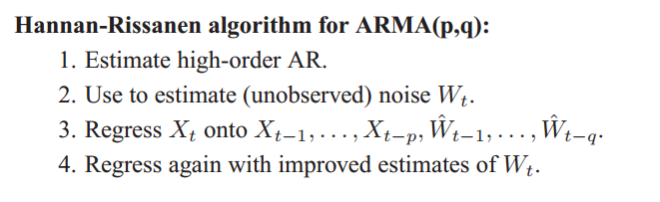

2. ARMA(p,q)模型的自回归逼近法

1) 首先建“独立的”AR模型

由(零均值), 取, 用AIC定阶方法得和;

2) 计算残差,

视数据 和

近似满足ARMA(p,q)模型≈回归模型

,

这里;

3) 作二次目标函数



另记 



则 



极小化: 



和 .