# Exercise 3 – Inverse Dynamics

## Chapter 1 – Data Preprocessing

The purpose of this exercise is to provide a video analysis to describe an inverse dynamics problem of a gymnast performing a knee squat. The ultimate goal is to provide full mechanical description of body parts including forces, moments and torques.

Ein Bild, das Screenshot, Multimedia-Software, Text, Software enthält.

Figure 1 Still frame of knee_squat_raw.mkv

A video (knee_squat_raw.mkv) was provided to track motion during a knee squat performed by a gymnast. Horizontal and vertical positions of multiple tracking points on ankle, knee, hip and shoulder were exported as a function of time using the *Kinovea* software. By using python code nested in a *Jupyter* *Notebook*, a more profound motion analysis tracking, calculation of forces and moments as well as plotting of those calculations could be done.

In the following shown *table 1* shows the first 17 tracked points of PositionData.xlsx extracted from *Kinovea*:

Ein Bild, das Text, Screenshot, Zahl, Schrift enthält.

Table 1 Extracted Coordinates of the knee squat video

Note, that these values are in pixel coordinates directly retrieved from the video. The center of origin was assumed on the front left corner of the blue mat.  
For further processing, all values need to be converted to real life (SI) units with a conversion factor. The shank length was provided as 44cm real life, therefore after import of the .xlsx and conversion of data to a *pandas* dataframe, a scaling factor was calculated from the distance between knee and ankle for each frame.   
As a check, it was determined whether this provides a constant scaling factor over time. However, it was seen that due to errors in tracking the shank length in pixel is not perfectly consistent, therefore the scaling factor was assumed to be the average of all determined scaling factors, which was ~0.39 pixels/cm.   
Another possible option would be to manually research the most accurately tracked frame within *Kinovea* and use the distance in that frame as scaling factor.

With this, the dataframe was adapted to centimeters instead of pixel units and allocated to “df_cm”.

In chapter 1.3 it was now possible to plot all points in the dataframe to give a representation of the knee squat within the *Jupyter* notebook. In figure 2 a all available variables are presented over time, whereas in figure 3 a more useful x-y representation of tracked body positions is rendered.  
  
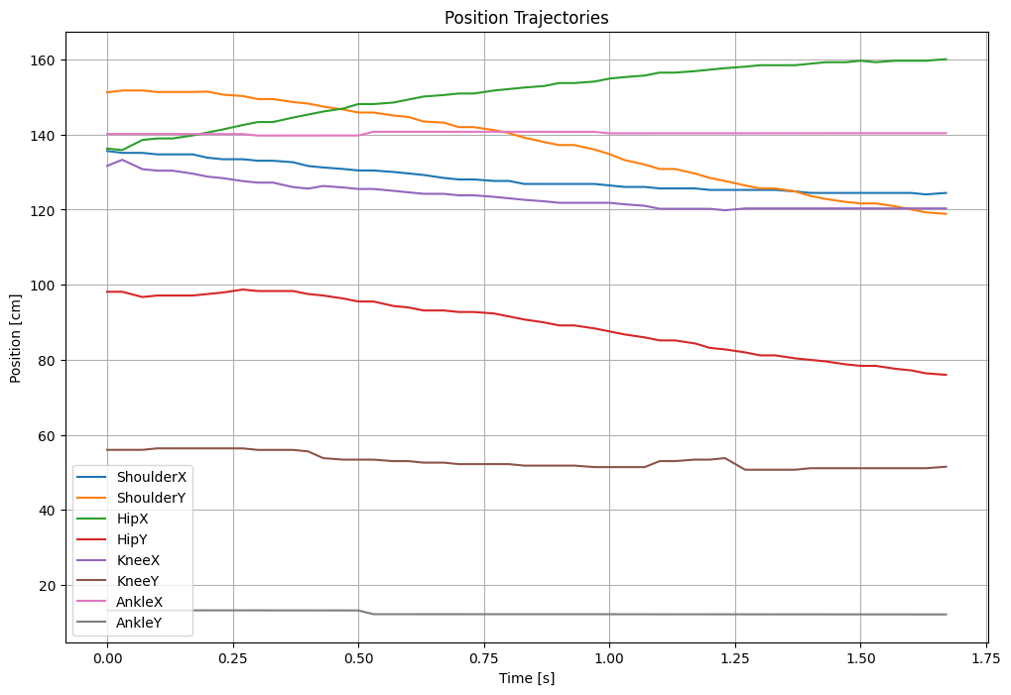

Figure 2 Horizontal & Vertical Position of tracked body points

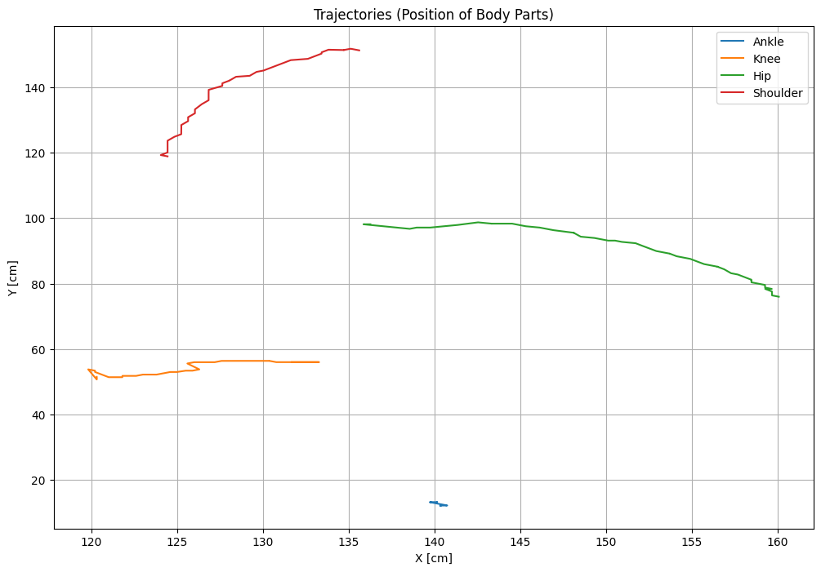

Figure 3 X-Y represenation of tracked points

It can be noted that small jagged movements in the plot might be caused by tracking errors within the video edition software. Especially the ankle position can be observed steady in the video, however, the tracking point shows a lateral variation of about 2 centimeters.

## Chapter 2 – Inverse Dynamics

Within this chapter of the notebook further calculations and interactive plotting was targeted. To achieve this, ankle, knee, hip & shoulder coordinates were intermittently stored in their respective *numpy* array including x and y coordinates.

These numpy arrays were further used as inputs for a general custom function that visualizes the planar model and returns an interactive plot. Additionally, the center of mass for each segment was to be plotted at each point in time.

To achieve this the function was set up to initialize subplots from the matplotlib library as well as a FuncAnimation.   
  
The subroutine init() makes sure to clear the figure for each call of the function, set the actual grid size according to minima and maxima of the read in data, as well as setting up axis, labels, legend and titles.

The subroutine update(i) is responsible for all calculations and plotting depending on row “i” of the read in data corresponding to a point in time.   
Each segment is plotted as a line from proximal to distal point, depending on i. The centers of mass are calculated by using common values given in *exercise 2* (see *Deleva* dataframe). The lines and center markers are then appended to the lines array, which is returned to the be plotted using the *FuncAnimation* *matplotlib* function. The final state of the output figure is shown in figure 4.

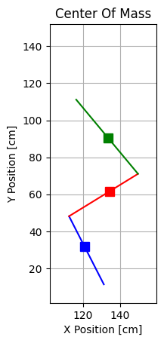

Figure 4 Segment lines and Center of Masses plotted interactively

In the following a custom function was defined to calculate the forces in x and y direction of the proximal joint as well as the proximal moment with the input given as:

def torque_calc(F_distal_x, F_distal_y, M_distal, weight, x_distal, x_proximal, weight_factor, roh_factor, rotation_direction)

Ein Bild, das Text, Schrift, weiß, Zahl enthält.

Similarly, the instantaneous acceleration gives change of instantaneous velocities for the smallest timestep available.

Ein Bild, das Text, Schrift, Reihe, weiß enthält.

The combined data of “video units” in pixel and frames, as well as real life SI units was stored in the “CoM” dataframe using the functionality of python *pandas* library:  
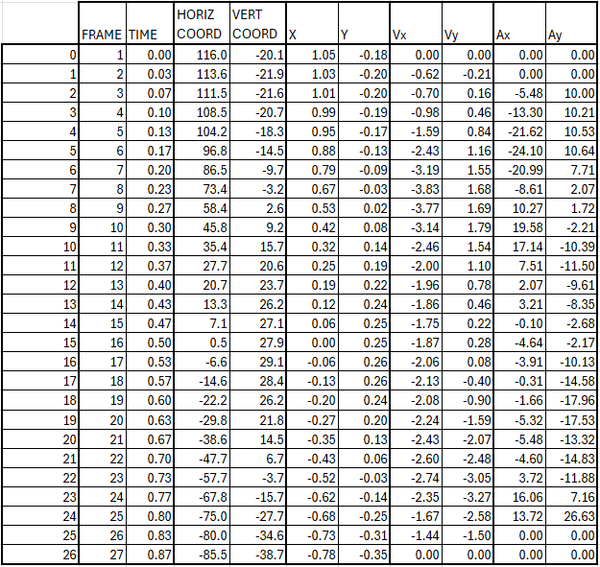

Table 2 Center of Mass DataFrame

With all the calculations stored, the *matplotlib.pyplot* library was used to plot position [m], velocity [$\frac{m}{s}$] and acceleration [$\frac{m}{s^{2}}$] in a figure. The results are shown in *figure 3*.

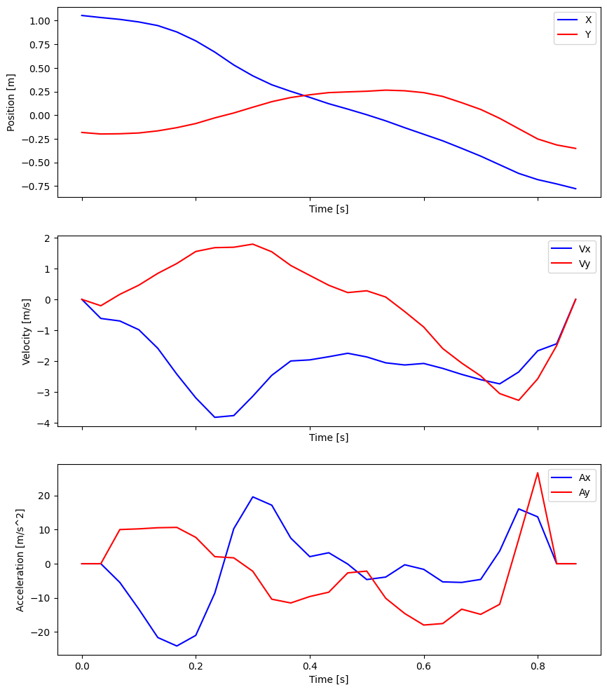

Figure 5 Center of Mass: Position, Velocity & Acceleration over Time

### Discussion & Questions

As observed, the horizontal position of the jump vaguely follows a linear motion, whereas the vertical position follows a vaguely sinus motion. The vertical velocity can be observed to increase for a certain amount of time, if a force provided by the jumping motion of the feet is applied. *Vy* flattens and starts decreasing before the peak jump position is achieved, due to gravity taking the upper hand. The vertical acceleration *Ay* approaches -9.81 $\frac{m}{s^{2}}$ as gravity becomes the main contributing force to the motion. Of course there is a lot of “noise” in these observations, as will be discussed later. At the end of the jump a feathering motion of the feet can be observed in *Vy* and *Ay*. The horizontal velocity *Vx* stays almost constant after the initial acceleration of the jumping motion. Further, in *Vx* and *Ax* a softer feathering can be observed as the jump comes to an end. Paradoxically the horizontal acceleration shows a deceleration peak after the initial acceleration of the jumping motion, before approaching zero in undisturbed flight, due to the first Newtonian law of motion. As a preliminary hypothesis the “deceleration” peak in Ax can be explained by inertia. The jumpers’ trousers with the center of mass point marking attached, are only loosely attached to his body, therefore the trousers and reference point “overtake” the jumper after the initial acceleration.

General improvements could be made by either low-pass filtering both velocities and accelerations, retrieving more datapoints by filming in a higher frame rate or in a higher resolution to give qualitatively better tracking and therefore more accurate calculations.

### Question 1

* In which frames was the jumper in flight, without contacting the ground?

This question can not be answered with the extracted center of mass data, but by analysing the video itself. The jumpers feet leave the ground in frame 10 and touch the ground again appr. at frame 23. Therefore, arguably, the jump duration is from frame 10 to 22 🡪 13 frames = 0.43 seconds

### Question 2

* In which direction, forward or upward, did the jumper accelerate with the largest peak magnitude before take-off?

The forward acceleration was stronger than the vertical acceleration (approx. 2.5x)

* In which direction, forward or upward, was the jumper travelling faster at the instant of take-off from the ground?

After lift-off the jumper was faster in horizontal direction than in the vertical direction (approx. 4 m/s and 2 m/s)

* In what way does the magnitude of the acceleration before take-off appear to influence the velocity at take-off?

The acceleration in both axis increases the take-off velocity, before becoming constant for a short period.

* Why would you expect this, or not expect this, based on the equations relating acceleration and velocity?

As velocity is the integral of acceleration for a given period of time, thus being the summation, it meets the expectations that a positive acceleration increases the velocity over time. In a more general observation, it makes sense that the jumper is accelerating in both axes right up to the point of actual take-off, as this is the very definition of a jump.

### Question 3

* According to the material presented in lecture, what should the horizontal and vertical acceleration components look like for the center of mass of a body in flight?

The horizontal acceleration should be 0, as there is no force applied during flight time (First Newtonian law of motion). The vertical acceleration starts at 0 after lift-off and slowly approaches -9.81 $\frac{m}{s^{2}}$ as expected, when the gravity takes over the motion. Horizontal velocity should largely stay constant after take-off, but will increase slightly due to drag and air resistance. The vertical velocity will be positive after take-off and will slowly approach zero at the peak position of the jump, before gaining negative velocity due to gravity.

* How does this compare to the actual horizontal and vertical acceleration of the hip in your results? *🡪 see below*
* What are the main reasons for the differences between the actual acceleration and what one would expect for the center of mass?

The expected behaviour and the observations of center of mass in the video are largely congruent. There are certain differences in the acceleration due to side effects, as described earlier:   
Paradoxically the horizontal acceleration shows a deceleration peak after the initial acceleration of the jumping motion, before approaching zero in undisturbed flight, due to the first Newtonian law of motion. As a preliminary hypothesis the “deceleration” peak in Ax can be explained by inertia. The jumpers’ trousers with the center of mass point marking are not tightly fixed to his body, therefore the trousers and reference point “overtake” the jumper after the initial acceleration.

General improvements could be made by low-pass filtering both velocities and accelerations, retrieving more datapoints by filming in a higher frame rate or in a higher resolution to give qualitatively better tracking and therefore more accurate calculations.

### Question 4

* In frame 14 *(=frame 24 in data)*, during landing, was the jumper propelling or braking in the horizontal direction and what was he doing in the vertical direction?
* How were you able to determine this from your results?

The jumper was of course breaking in both axes, due to the nature of direction of the examined jump in the moment of touchdown (negative x and negative y direction), the acceleration (actually deceleration) forces appear positive in our frame of reference. The deceleration in the vertical direction is stronger than breaking in the horizontal direction as at then end both velocities approach zero again.

### Question 5

* Using a single point on the hip to characterize jumping mechanics was a simplification that made analysis of this jump easier to complete. How could the whole body motion be determined more accurately for describing jumping mechanics?

To give a full representative kinematic description of the jump it would be vital to examine the behaviour of feet (toes) and knees to estimate the propelling motion. Secondarily, a point on the shoulders would help to estimate the counteraction of angular momentum induced by the jump. The moment of inertia could be calculated with the center of mass as a reference point. Similarly to weight & balance calculations in aircrafts, these problems in 2D could be solved around a single axis.   
By attributing more tracking points and assigning a mass to the tracked area, a more complete description of a jump could be given.

## Exercise 1B

In the previous exercise, we have focused on analyzing linear motion. However, many movements of interest involve angular motion (rotation). Examples include the giant swing in gymnastics, the motion of the pedals during stationary cycling, and the motion distal to the elbow during a biceps curl. To analyze the kinematics of tasks involving angular motion, video analysis techniques similar to those from previous labs were used. The purpose of this is to apply video and image analysis to a task that involves angular motion, specifically, a giant swing.

The motion of a gymnast was recorded using high speed film during a gymnastics competition. From this film, a series of images during one revolution about the bar have been extracted and combined into a single picture. The 11 frames included in *figure 4* were uniformly separated in time: 0.15 seconds between each position. The scaling of the images can be determined by the meter stick that is included in *figure 4*.

Ein Bild, das Zeichnung, Entwurf, Kunst enthält.

Figure 6 Swing Motion of a Gymnast, calibration included

The analysis involved determination of the gymnast's angular position, angular velocity, and linear velocity as a function of time. The reference for the angular measures is the upward vertical direction (+Y axis). As per convention, rotation in the counterclockwise direction is assumed positive.

To determine the gymnast's angular position in each of the 11 frames shown, the hip marker was used as an estimation of the center of mass position. Methods used were similar to previous *Exercise 1A* (*Kinovea* video analysis app) to determine the coordinates of both, hip marker in each frame and also the bar position.  
  
For easier usage, the origin of the coordinate system was set exactly to the position of the gymnasts bar, thus reducing the complexity of calculations, as this position is also the rotational symmetry axis.

Similarly to Exercise 1A the hip positions in cartesian pixel values as well as the frame index were extracted using the *Kinovea* software. In *Jupyter* *Notebook* the values were then read in and stored in a *pandas* library dataframe for easier usage. With the calibration factors at hand (Δt = 0.15 s) as well as the length of the 1 m bar in pixel values (= 98.78 pixel), the conversions to SI units could be easily exercised.   
  
With the +Y axis of rotation as zero degrees and the rotational center, the gymnasts bar, set to (0,0) the rotational displacement of the hip could the calculated for angle Θ

Ein Bild, das Schrift, Text, Reihe, Diagramm enthält.

The issue with calculating angles in degrees from cartesian coordinate systems to polar coordinate systems is the behaviour of the arctan function with absolute values. Doing the calculation this way, will have increasing angles up to 90° (-X axis), which will then decrease again, as they approach the -Y axis and vice versa for positive X values. Therefore, only values in the first quadrant of rotations will be given correctly, in our case as +Y is the origin, it is the quadrant where x = negative and y = positive.  
An approach has to be made to adjust the output angle per quadrant. As can be seen in *figure 5*, quadrant II is calculated by 180° - angle, quadrant III by angle - 180° and quadrant IV by 360° - angle.  
 Ein Bild, das Diagramm, Reihe, Schrift, Text enthält.

Figure 7 Angle adjustment for Quadrants II, III, IV

Calculations for the radius of the hip positions from cartesian to polar coordinates are, fortunately, easier:  


As Xbar and Ybar are set a priori to the origin of reference, the calculation reduces to a simple Euclidian distance. Computations were made and the results stored within the dataframe.  
  
Consecutively, the angular velocity ω, defined as the change in angle per change in time and given in [$\frac{rad}{s}$] , was calculated in the same manner as the instantaneous velocity in Exercise 1A:  
Ein Bild, das Schrift, Reihe, Diagramm, Design enthält.

As radians are per definition a dimensionless SI unit of [ $\frac{m}{m}$], no deduction about actual speed of the gymnasts’ hip point can be made. Angular velocity per definition is equal at all radii. To obtain the actual cross-radial velocity v⊥ , the angular velocity ω must be multiplied by the radius [m]



With these calculations ready, everything was stored in a pandas dataframe shown in *table 3* and ready for the next step. The matplotlib.pyplot library was used to plot all useful variables over the angle [rad]. Ein Bild, das Text, Screenshot, Zahl, parallel enthält.

Table 3 Dataframe of Gymnasts Swing Rotation

The created plots are shown in *figure 6*:

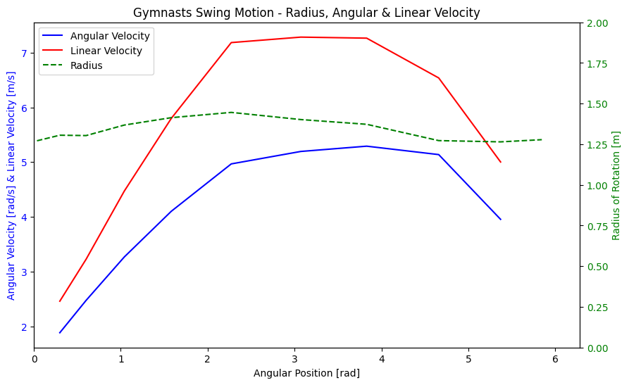

Figure 8 Angular & Linear Velocities for Gymnast's Swing

### Discussion & Questions

### Question 1

* Describe the kinematic characteristics of the giant swing.

As shown in figure 6, the angular velocity as well as the linear velocity increase as the gymnast proceeds with their rotation. The velocities approach their peak approximately at the bottom of the swing, helped by gravity before then proceeding to decrease again, as the gravity works against the rotation on the upward swing. The radius, more precisely the distance of the gymnast’s hip to the bar, stays very constant throughout the swing, however, slight variations occur. It is greatest close to the bottom of the rotation, where velocities and therefore centrifugal forces are highest, and decreases slightly on higher angles.

### Question 2

* When during the giant swing did the greatest angular velocity occur, and when did the greatest linear velocity occur?

As the angular velocity is not affected by the radius, the highest velocity was reached slightly after PI radians, meaning shortly after the low point of the swing. This is largely congruent with expectations. The linear velocity however, peaks slightly before the low point of the swing, where the radius, the distance between hip and bar, is the highest. As gravity and centrifugal forces are highest, this is the angle of peak radius. The gymnast proceeded to move the hip close to the bar at apogee, reducing the linear velocity, but increasing the angular velocity to its peak.

### Question 3

* Over what part of the giant swing was the greatest radial acceleration and associated force needed? How did you come to this conclusion?

The radial acceleration or centripetal acceleration ac is highest at apogee (= -Y = 180° position). It can be calculated as:   
Ein Bild, das Schrift, weiß, Handschrift, Typografie enthält.

This is derived from the Centripetal Force



which has the same magnitude but opposite direction of the Centrifugal Force (Newton’s third law of motion). As Centrifugal Forces are highest at the low point of the rotation (due to gravity) in turn the centripetal acceleration must be highest, assuming constant mass.

### Question 4

* If the gymnast had let go of the bar in frame 8, how fast and at what angle would her center of mass have been projected into the air (i.e. what would her projection speed and projection angle have been)? Explain how you determined this.

In the moment a gymnast lets go of the bar, the centripetal force = 0, thus also the centrifugal force = 0, as it is an inertial “pseudo” force. No longer is the gymnast in a rotational frame of reference, therefore only the current linear velocity will be applied (Newton’s first law of motion).   
To sum up, in the moment the gymnast lets go of the bar, only the tangential velocity v⊥ in a perpendicular direction, 90° in front of the current hip angle is applied.   
In our case: frame 8 🡪 hip angle = 219.45° 🡪 the motion of the body will proceed in direction 309.45° with a (linear) velocity of 7.26 m/s. This angle represents an angle in the +X and +Y direction, therefore upwards (39.45° upwards). From this a jump distance can be calculated, because only gravity with acceleration -9.81 $\frac{m}{s^{2}}$ has to be attributed for in a cartesian coordinate system.   
To sum up, if the gymnast would have let go of the bar in frame 8, they would be in an initially linear motion 39.45° upwards in the +X direction with a velocity of 7.26 m/s. As gravity (acceleration in -Y direction) is applied, they would land 0.94 seconds later at a jump distance of 5.27 m.   
*No air resistance or drag forces have been taken into consideration. The height of the gymnast has been assumed 1cm above ground level. The real jump distance therefore might be shorter.*

The *Jupyter* Notebook containing all python plots and stored calculations, has been attached to the lab report upload.