Documentation

Soldier Way

Thank you for purchasing my game.

If you have any questions that are beyond the scope of this help file,

please feel free to email me at matijabna@hotmail.com​. Thanks so much!

How to open the project

How to edit the project details

How to edit Admob configuration

How to publish on Android using Intel XDK

How to quickly deploy the game on your website

# How to open the project

The game is made with ​**Construct 2 ( r 239 ).** The project file is soldier_way.capx.

To open the​.capx file you need a personal license of Construct 2. <http://www.scirra.com>

Before you can open the project in Construct 2 , you will need to install the ​**_iFrame&insertHTML**and **spritefontplus.c2addon** plugins.Here is how you do it:

1. Open the ​**plugins** folder (provided with the game) then copy the folder​**_iFrame&insertHTMl**and paste it into this folder: **C:\Program Files\Construct2\exporters\html5\plugins**

You shoud have this:

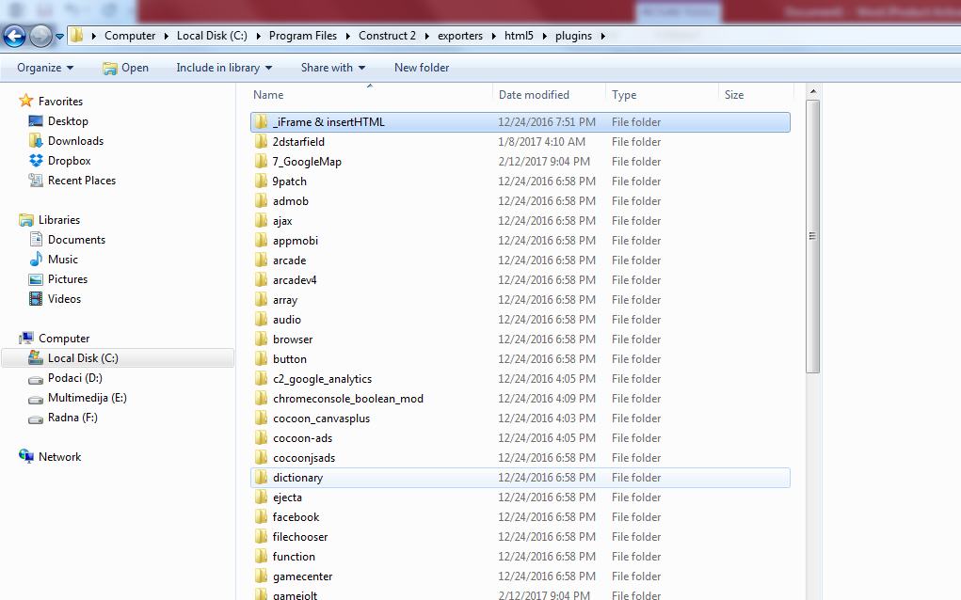

2. Open Construct 2, then open the **plugins** folder (provided with the game).

Drag and drop **spritefontplus.c2addon**in Construct 2 editor.

Close and reopen Construct2.

You shoud have this:

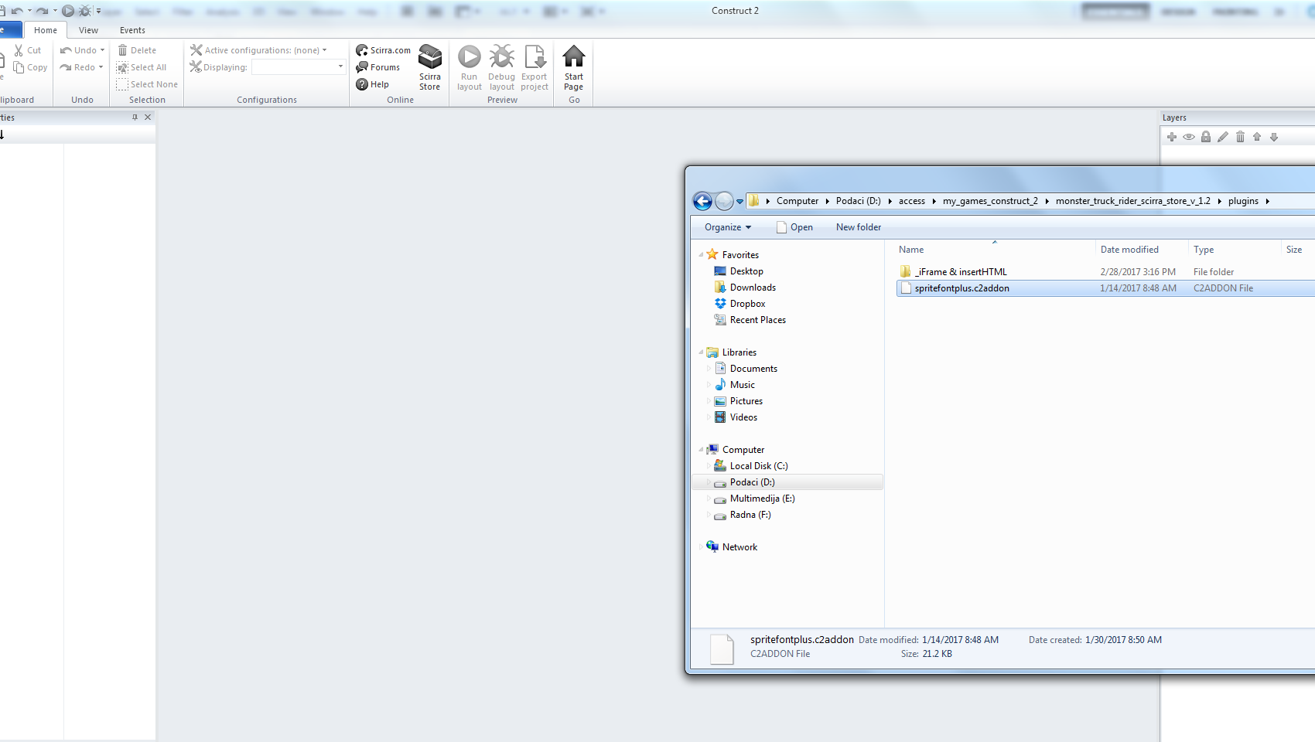

# How to edit the project details

Before you can export the project to various platforms, it is recommended to update the project details; Here is how you can do it:

1. In the ​**Properties**​ left panel, click on **View,** ​ ​like shown in the image below :

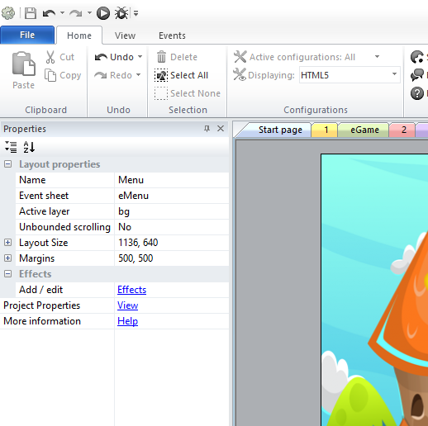

2.Fill the ​**About**​ section with your own details:

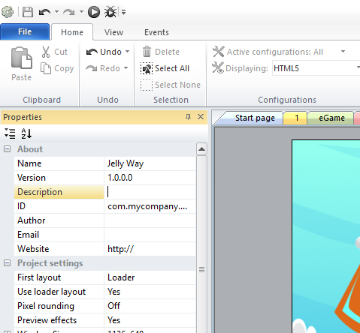

# How to edit Admob configuration

In the ​**Projects**​right panel, find the **AdmobAds**​ object, like shown below:​

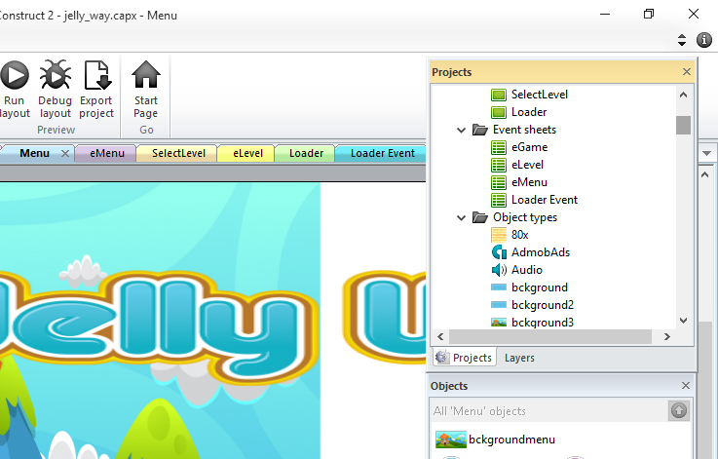

Click on it, then in the properties panel, fill the Interstitial ID (you find those ID on your admob account, after you have created the ad units; Also, make sure you don't copy/paste any space) :

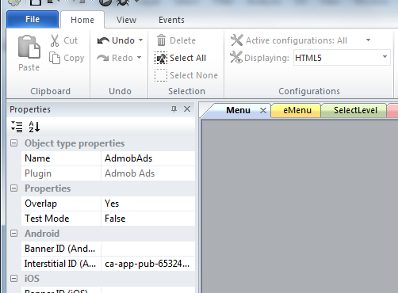

# How to publish on Android using Intel XDK

1. Make sure that the “Fullscreen in browser” property is set to **“Scale outer”**​

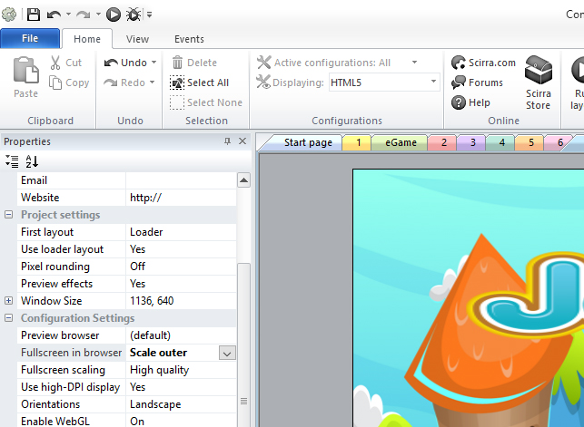

1. Export the project by going to File menu and then choose **Export project.**​ Then choose the ​**Cordova**​ option:

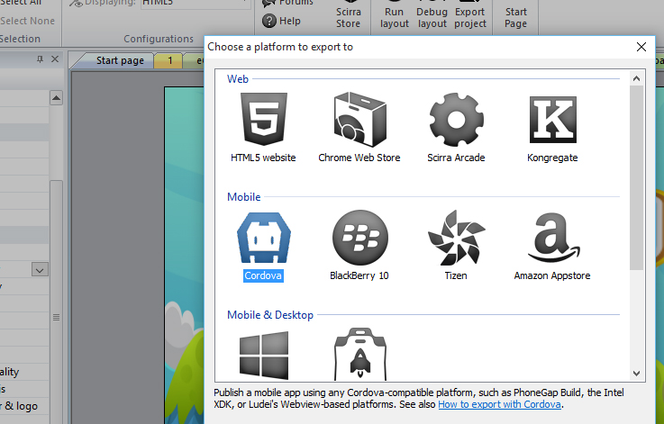

1. Go to <https://software.intel.com/en-us/intel-xdk>

Download the XDK and install it.

Once installed, run the Intel XDK. Register a new account if you need to, and log in.

4. In the Intel XDK, open the Projects tab:

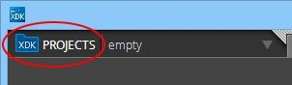

1. Click Start A New Project.

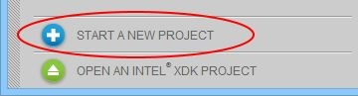

1. Choose Import an Existing HTML5 Project.

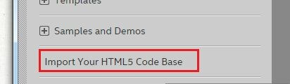

Choose the folder you exported from Construct 2 as the Import Project from location. Enter a name for the XDK project and click Create.



1. Choose these options:

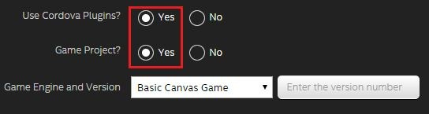

Then click continue

1. All your app settings will be done within this section:

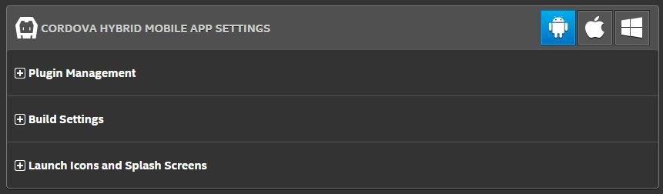

1. Let’s install the Cordova plugins needed by your game by clicking here:



First the social­sharingplugin :

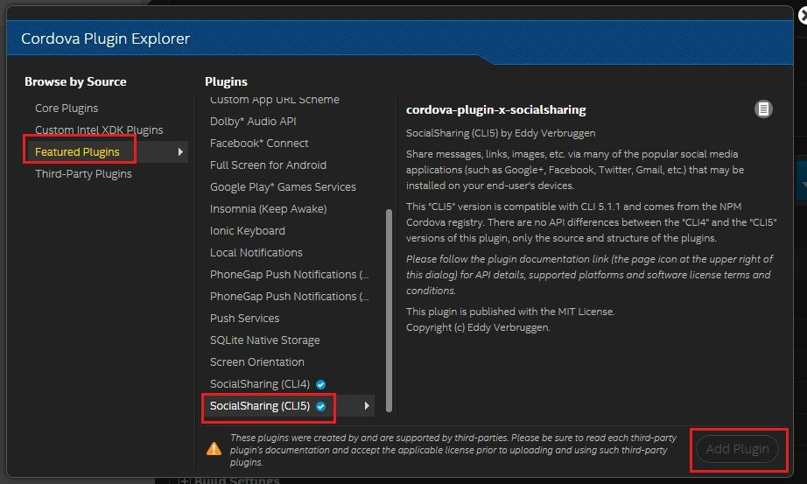

Second the admob plugin:

Copy­paste :​**cordova­plugin­ad­admob**​ in the Plugin Id field.

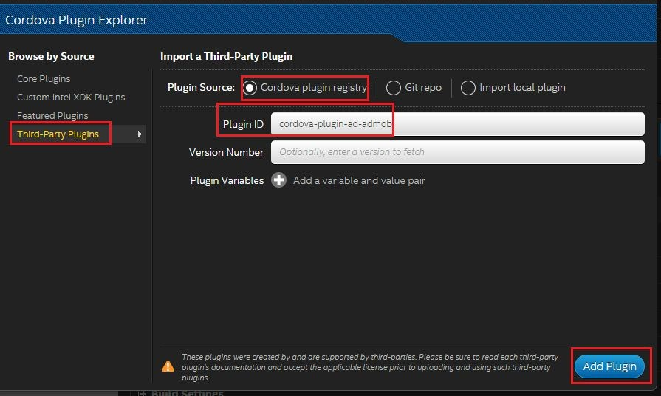

1. Next, let’s specify the ​**build settings**

­ First you need to choose whether to use **Crosswalk** ​ ​(for better performance.) or no Crosswalk (Android webview).

­ Then specify your app Id , name, description and version.

­ Then choose the latest version of Cordova.

­ In the ​**WhiteList**​ section, check the ​**Cordova whitelist**​ and add these 2 entries under **Intent** ​ ​by clicking on the ​**Add another entry:**

http://*/*

market://*/*

Basically these 2 rules will allow your application to request external webpages ( like a facebook page, rate us page, etc...) using the browser.

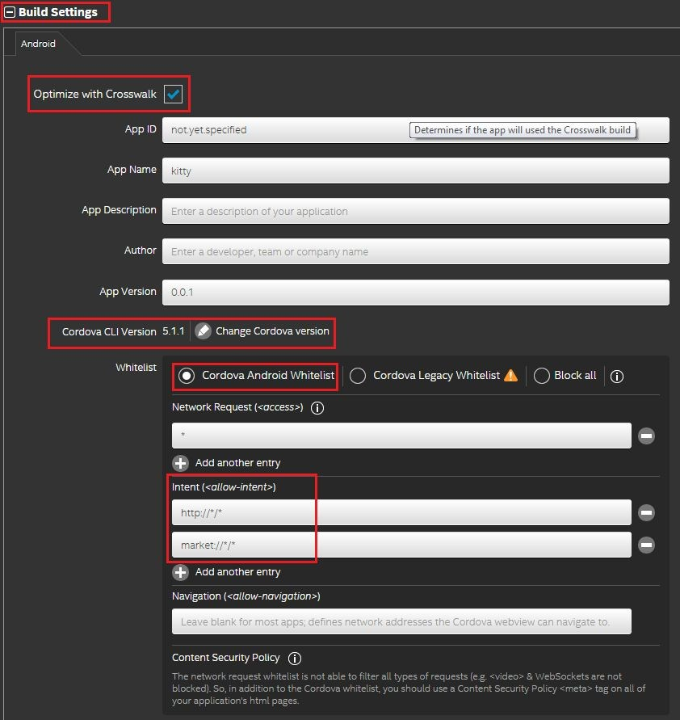

1. Next, you specify that your app need to run in full screen (hiding the status bar) and that it should be in Landscape, because the game is in landscape.

You will also need to provide a Developer Certificate, If you have never created a certificate,

XDK will notice that and guide you to create a keystore.

Finally check the Signed option so your apk will be ready to be published on Google Play or other stores.

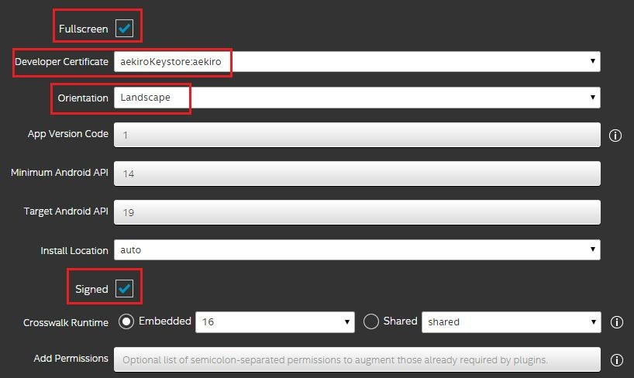

1. Now, let’s specify the icon of your app by clicking on the **“Launch icons and splash Screens”**​ tab, And then upload your icons

You can also upload a ​**splash screen** , or leave them empty if you don't want to.​

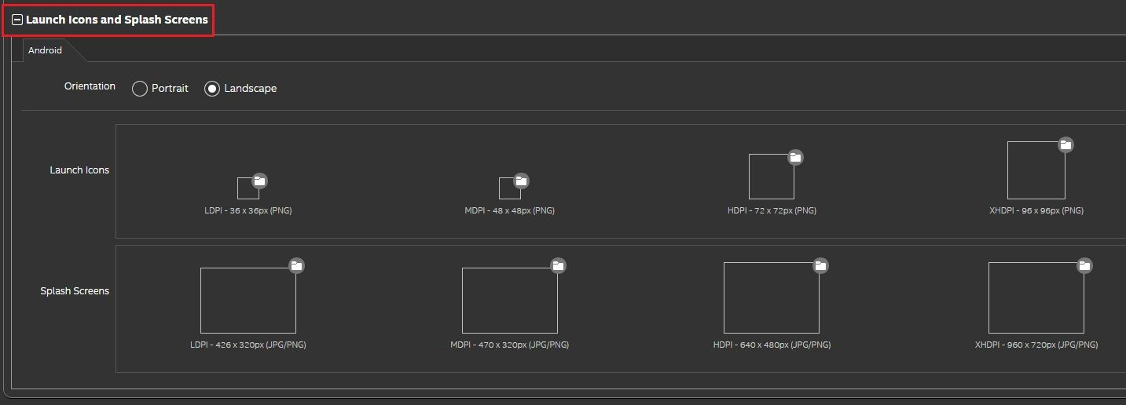

1. Finally, click on the ​**BUILD** ​tab

Then click on build:

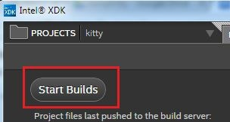

Before XDK start building your app, you will be asked to unlock the certificate.

Your project will be zipped and then uploaded to intel’s cloud compilation service. The compilation process might take several minutes.When it will be done, you will receive an email with the link to the APK.

For more details: https://www.scirra.com/tutorials/809/how­to­export­to­android­with­crosswalk

# How to quickly deploy the game on your website

1. First, make sure you select fullscreen in browser to letterbox scale.



1. Export the project by going to File menu and then choose **Export project.**​ Then choose the ​**HTML5 website**​ option:

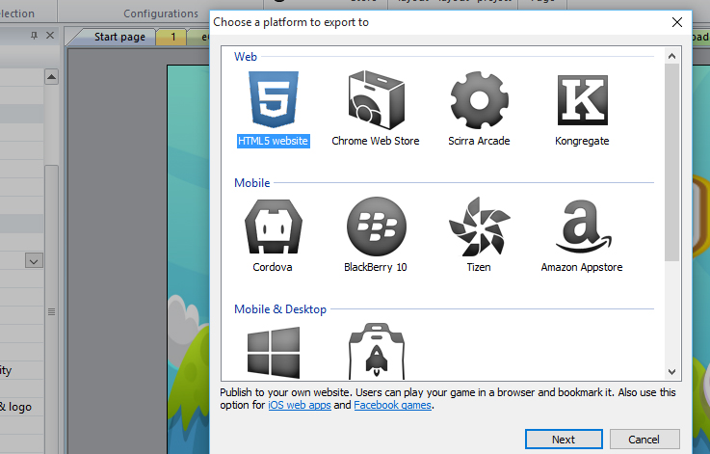

Usually to publish on the web, you would have a page of your website and you want to embed the game inside that page. To do that you need to have an iframe on your page that points to your game like this:

<iframe src="link to game.html "allowfullscreen="true" width="1136" height="640" />

The “link to game.html” depends on where you have put the HTML5 project in your website directory.

More details can be found here: https://www.scirra.com/tutorials/655/tips­on­publishing­html5­games­to­the­web

About:

License:

Permits Royalty Free usage for one single commercial project. You are permitted to use the asset on unlimited non-commercial projects. For more info see [https://www.scirra.com/store/licensing#license3](https://www.scirra.com/store/licensing%23license3)

Extra (free) plugins and behaviors used in the template:

- TextProperties byRex.Rainbow[download](https://www.scirra.com/forum/behavior-text-properties-for-text-plugin_t74208)

- SpriteFontPlus by Chris Kentsee [tutorial](https://www.scirra.com/tutorials/716/using-the-spritefont-plugin)

- _iFrame&insertHTMLby Nandynho[download](https://www.scirra.com/forum/plugin-html-iframe_t149647)

Requirements:

The project file needs Construct 2 version 239 or better (personal license or better). For smooth game play, a medium gamer computer (or better) is recommended. The project file uses some extra free plugins and behaviors. These are included in the pack.

License:

Permits Royalty Free usage for one single commercial project. You are permitted to use the asset on unlimited non-commercial projects. For more info see https://www.scirra.com/store/licensing#license3

Documentation last updated:

18. 04. 2017.

# How to use the project file

Just load the capx into Construct 2. The project file will contain layouts, event sheets, game objects and a few other common elements.

All the graphics are kind of placeholder. Use the graphics to build your own game style .If you find the animation a bit rough then just add smoother graphics (hire an artist if you do not have the art skills yourself). Adding a few more frames will also make the animation look better. It is best practice that animation has under 10 frames.

# Layers

Each level layout contains a range of layers. Here is a short explanation of each of them:

## Popup

This is a very special and handy layer. It contains level complete/gameover page.

This is global layer, also contain html5 ad which is implemented by iFrame&insertHTML plugin.

You can add your ads by uploading to your server 300x250 banner and put link to that page.

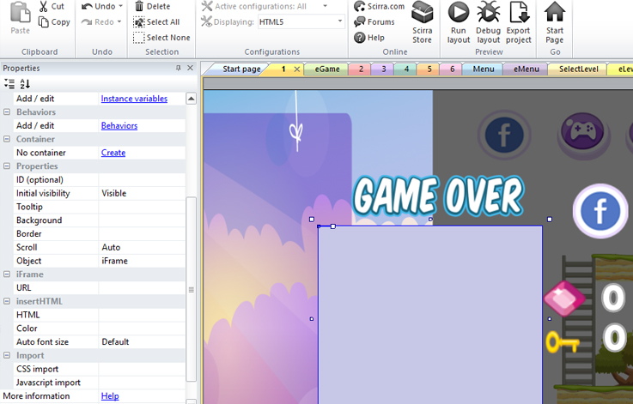

I prefer to lock this layer and set him invisible for easier work.

## HUD

This is also a very special layer and also global. It contains buttons, level number and dollar count.

Also here is “op” sprite which I used for automatic zoom.

## Control

Yet another special layer. Used for mobile control buttons. Also global.

## Game

Non global layer. Used for positioned player and other ingame objects. You can reposition player and other objects on this layer how ever you like.

## TileMap

Used for drawing tracks and grounds. See [tutorial](https://www.youtube.com/watch?v=nwdUj2bSlVo&t=132s)

## Ground

Used for objects that is in back of normal game object.

## Background

This is layer used for background image. It has parallax 0,0 which set image fixed.

Thanks for reading this and good luck with your game!

Have fun,

BNAgames

[matijabna@hotmail.com](mailto:atlasplus@gamezastar.com)