KIRBY’S FIGHT MANUAL

Welcome to Kirby’s fight, this will be the user manual for the game. To start off this game you will be introduced with this screen, you have three options here: play the game, instructions and quit. I recommend choosing the Instruction to start off to learn about the game. This game will also have music so it is best to put on headphones or earphones for the best experience.

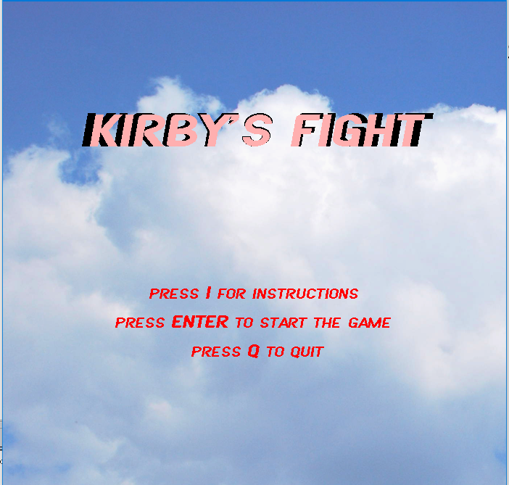

In the instructions screen you will learn how to play the game and the objective of the game, press I to go to the next page of the instructions.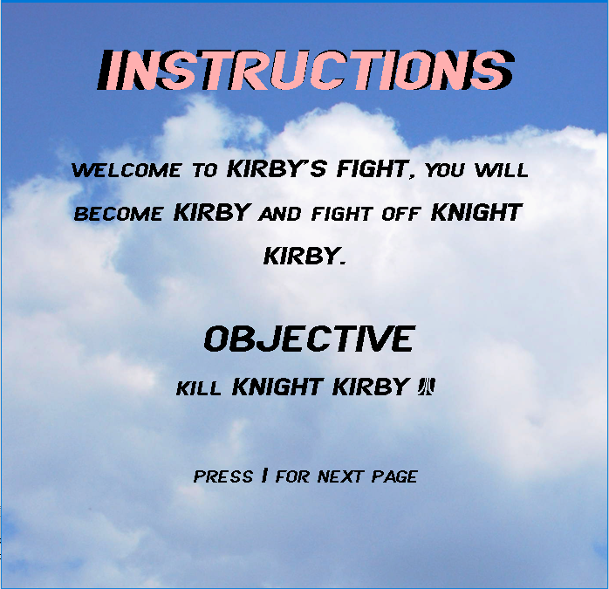

For this page of the instructions you will learn how to play the game. Use A, and D to move left and right, use W,S to jump up and slam down, T for attack, Y to dash, U to taunt, and ESC to pause the game. You will also learn the rules of the games which you can take damage when you go off the screen, you can deal damage using attack or slam, you can dash once while airborne, you can use slam to block attack on the ground and the first one to kill the other one wins the game. Press I to go back to the main menu. 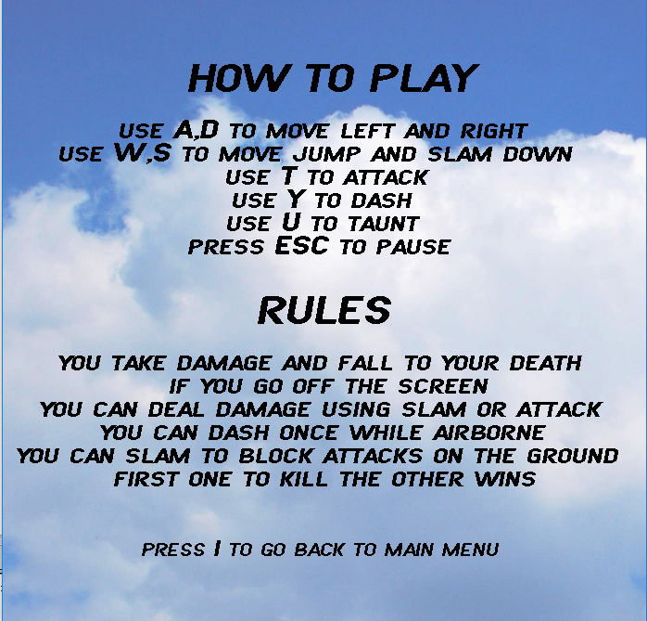

When the game start you will be on the left and the enemy on the right, the health bar will be full and your goal is to damage you enemy and make their healthbar go black. Do not die yourself.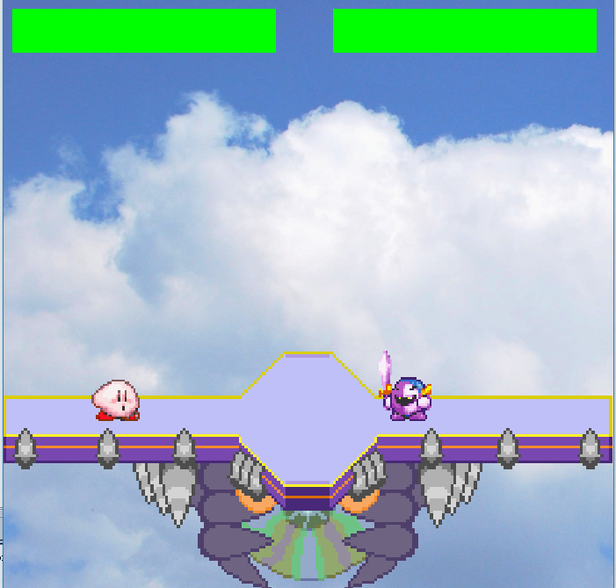

Try no to get damage like this picture below. 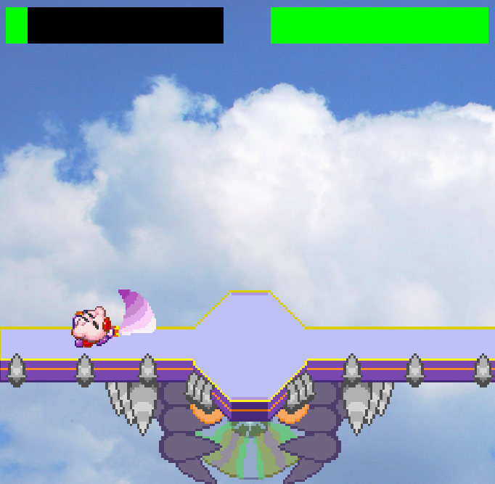

You can also pause the game if you want to using the ESC key, and this is where you get options to return to the main menu using ENTER, ESC to return to game or Q to quit.

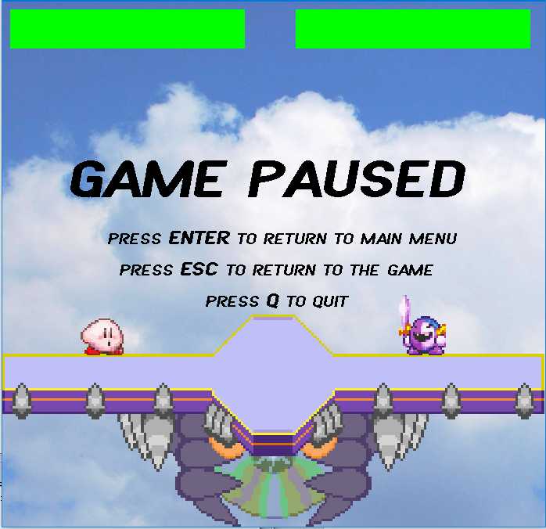

If you die before the enemy you will see this screen and you have the option to press ENTER to return to the main menu, press R to play again or press Q to quit the program.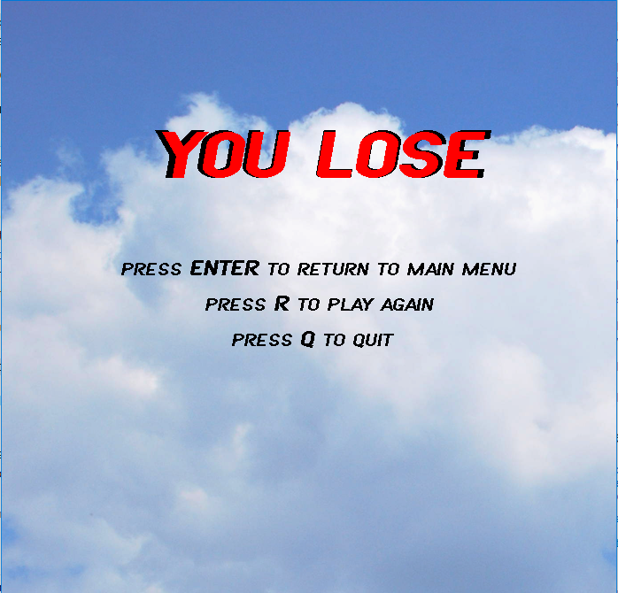

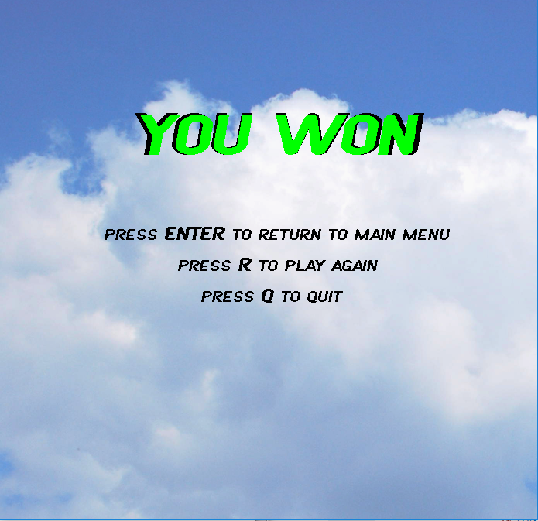If you kill the enemy before you die will see this screen and you have the option to press ENTER to return to the main menu, press R to play again or press Q to quit the program.

That is it for the user manual, I hope you like the game!