云南大学数学与与统计学院
上机实践报告

课程名称：计算机网络实验 | 年级：2013 | 上机实践成绩：
指导教师：陆正福 | 姓名：金洋
上机实践名称：基于UDP/IP协议与Socket接口的可靠通信编程实验 | 学号：20131910023 | 上机实践日期：2015/12/31
上机实践编号：No.5 | 组号： | 上机实践时间： 19:52

一、实验目的
1.熟悉基于UDP-IP协议与Socket接口的网络通信编程实验
2.熟悉教材第三章的基本概念
3.理解并掌握可靠数据传输的基本机制

- 实验内容
- 在前期实验（计算机网络实验4）的基础上，编程实现主讲教材第3章（Chapter 3 Transport Layer）rdt协议的各个版本。
- 剖析消息处理与消息交换在rdt协议的可靠性增强中的作用。

三、实验平台
个人计算机;
Oracle/Sun Java 7 SE or later versions
Python 2.x or 3.x
Android 2.x，3.x， 4.x
Windows，Linux，虚拟机等不限制。

四、实验记录与实验结果分析
（注意记录实验中遇到的问题。实验报告的评分依据之一是实验记录的细致程度、实验过程的真实性、实验结果的解释和分析。如果涉及实验结果截屏，应选择白底黑字。）

- rdt1.0
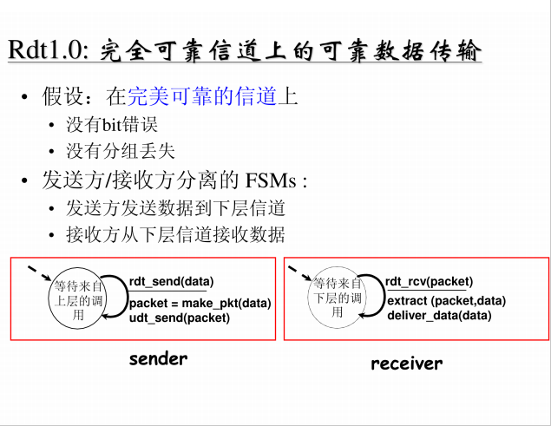
- . rdt1.0: 发送端

Sender_rdt_1_0.java
package CN5;
import java.io.*;
import java.net.*;
import java.util.zip.CheckedOutputStream;

public class Sender_rdt_1_0 {
protected static int packetSize=20;//每次传送的分组中数据的长度
protected int packetNum;//分组的个数
protected byte [ ] receiveData;//保存发送的数据
protected byte [ ] sendData; //保存接收的数据
protected FileReader f;//从文件中读取数据
protected byte[] bufferText;
protected int size;

protected BufferedReader inFromUser;
protected DatagramSocket sendSocket;
protected int port;//端口号
InetAddress IPAddress;

/*构造方法*/
public Sender_rdt_1_0() throws Exception {
receiveData = new byte [packetSize + 3];
sendData = new byte [packetSize + 3];
inFromUser=new BufferedReader(new InputStreamReader(System.in));
sendSocket=new DatagramSocket();
port=9999;
IPAddress=InetAddress.getByName("localhost");

f = new FileReader("E:/Computer/Java/Project/Networking/src/CN5/HappyNewYear.txt");

}

/**
* 读入文本
* @throws Exception
*/
public void readText() throws IOException {
BufferedReader buffer = new BufferedReader(f);
String tempStr = buffer.readLine();
size = tempStr.length();
bufferText= new byte[size];
bufferText= tempStr.getBytes();

packetNum=size/packetSize+1;

System.out.println("已完成向缓存中读入文本,文本大小:"+size);
System.out.println("文本内容:" + tempStr);
}

public DatagramPacket make_pkt(int j) {

int i,k;
byte buf[] = new byte [packetSize];

for (k=0,i=(j-1)*packetSize;i<Math.min(j*packetSize,size);i++,k++)
{
buf[k] = bufferText[i];
}

System.out.println(new String(buf));
/*构造一个分组sendPacket，包含数据、数据长度、服务器IP、端口号*/
DatagramPacket sendPacket=new DatagramPacket(buf,Math.min(packetSize,k),IPAddress,port);
return sendPacket;

}

/*不可靠传输*/
public void udt_send(DatagramPacket packet) throws IOException {

sendSocket.send(packet);
}

public void start() throws IOException {
System.out.println("开始发送");
int sentNum=0;//已发送的分组,也即序号
while (sentNum<packetNum) {
sentNum++;
/*将构造好的分组通过UDP Socket送入网络*/
System.out.print("第"+sentNum+"个分组:");
udt_send(make_pkt(sentNum));
}
}
}

TestSender_rdt_1_0.java

package CN5;

import java.io.*;

public class TestSender_rdt_1_0 {

public static void main(String args [ ] ) throws Exception {
System.out.println("等待来自上层的调用...");
System.out.println("输入send即可开始发送...");

BufferedReader inFromUser = new BufferedReader(new InputStreamReader(System.in));
String sentence = inFromUser.readLine(); // 从键盘等待"send"命令
while (!sentence.equals("send")) sentence = inFromUser.readLine();
Sender_rdt_1_0 Sender1_0=new Sender_rdt_1_0();
/*读入文本*/
Sender1_0.readText();
Sender1_0.start();
}
}
发送端运行结果：
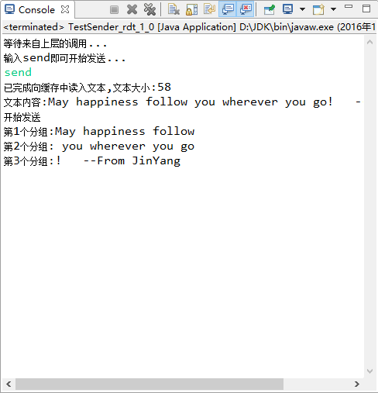
b)rtd1.0: 接收端
Receiver_rdt_1_0.java

package CN5;

import java.io.IOException;
import java.net.*;

public class Receiver_rdt_1_0 {
//protected static int packetSize=20;//每次传送的分组中数据的长度
protected byte[] sendData;
protected byte[] receiveData;
protected int receivedNum;//已收到的分组个数
protected DatagramSocket receiverSocket;
protected String data;
protected int port;

public Receiver_rdt_1_0() throws Exception{
port=9999;
receiverSocket=new DatagramSocket(port);
receivedNum=0;
}

public String extract(DatagramPacket pkt) {

return new String(pkt.getData());
}

public void deliver_data(String data,int i){
System.out.println("接收到第"+i+"个分组:"+data);

}

public void start() throws Exception {
while (true) {
//byte[] sendData=new byte[1024];//保存发送的数据
byte[] receiveData=new byte[1024];//保存接收的数据

DatagramPacket receivePacket=new DatagramPacket(receiveData,receiveData.length);
receiverSocket.receive(receivePacket);
data=new String(extract(receivePacket));
deliver_data(data,++receivedNum);
}
}
}

TestReceiver_rdt_1_0.java
package CN5;

public class TestReceiver_rdt_1_0 {

public static void main(String[] args) throws Exception {
System.out.println("等待接收数据...");
Receiver_rdt_1_0 Receiver1_0=new Receiver_rdt_1_0();

Receiver1_0.start();
}
}
接收方运行结果：
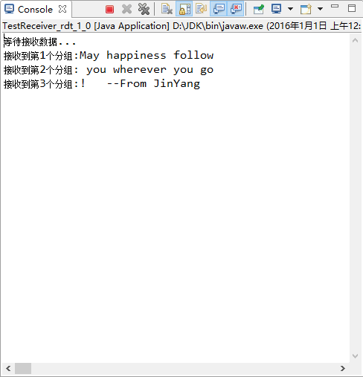
- rdt2.0
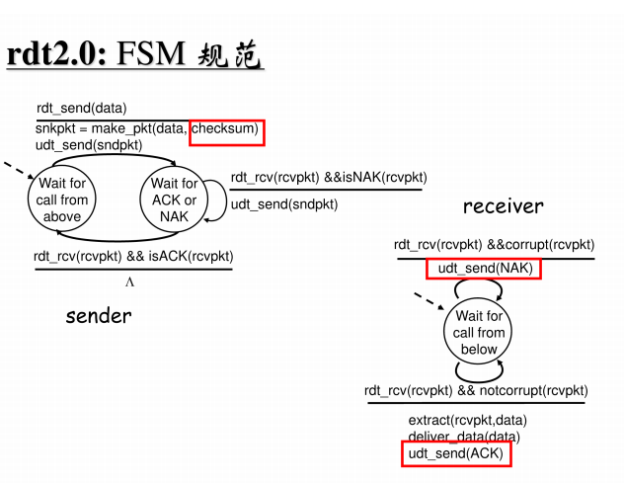
2.0版本相对于1.0版本，假设是经具有比特差错信道的可靠数据传输，在1.0基础上，多了checksum检测是否出现比特出错，并返回ACK或NAK，以使发送方决定是否重发。
对于checksum的计算，实际上java已经提供了checksum的软件包 ：
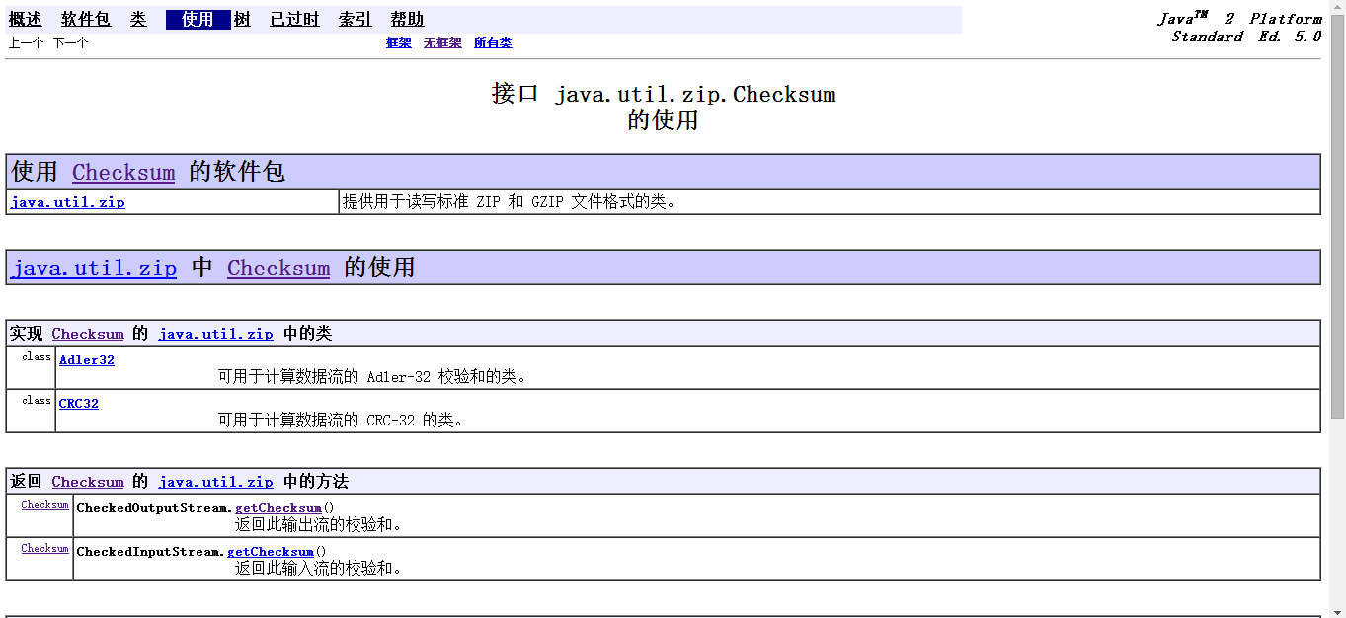
但其检测机制似乎不同于课本的介绍，其提供了另外的检测机制——MD5或者SHA，以下根据其介绍进行实际测试：
checksum 的这一特性通常用于校验文件下载。如果文件的提供者创建了一个MD5或者SHA 的Checksum文件, 使用者计算得出自己的checksum 文件，与提供者的checksum文件进行比较，就可以知道文件是否完整。
通过CheckedInputStream来计算IOTest.zip文件的checksum：
package CN5;

import java.io.*;
import java.util.zip.*;

public class TestCheckSum {

public static void main(String argv[]) throws IOException {
FileInputStream in = new FileInputStream("E:/Computer/Java/Project/Networking/src/CN5/HappyNewYear.txt");
CheckedInputStream checked = new CheckedInputStream(in, new Adler32());
byte[] b = new byte[4096];
while ((checked.read(b)) != -1) {
}
in.close();
checked.close();
System.out.println("checksum: " + checked.getChecksum().getValue());
}

}
运行结果：
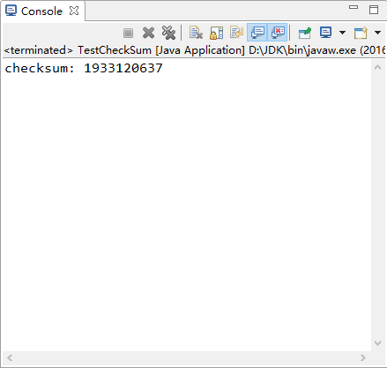
模拟下载过程，把文件复制一份，修改文件名为HappyNewYear1.txt，再计算它的checksum，打印结果一致：
对于checksum的计算，以课本的介绍，对于01比特组成的流，通过求和、回卷、累加和、变反得到校验和，可以检测出部分出错情况，对于本实验中的文本，若要计算checksum，则需将其转换为比特流，在通过特定的算法对其计算并加入到发送的分组中，接收方也需要进行同样的工作来检验checksum。通过java已有的方法也需要将每一个分组实现到CheckedInputStream的转化，最后加入到发送的分组中。由于精力时间有限，我不再在实验中加入生成checksum的算法，想了一种办法来模拟具有比特差错的信道——我们事先规定一个合理的出现比特差错界限p，当接收方每接到一个分组，便生成一个随机数，若该随机数大于等于p，则我们认为出现比特差错、checkSum不一致。

- . rdt2.0: 发送端

Sender_rdt_2_0.java

package CN5;
import java.io.*;
import java.net.*;
import java.util.zip.CheckedOutputStream;

/**
*
* @author 金洋
*
*/
public class Sender_rdt_2_0 {
protected static int packetSize=20;//每次传送的分组中数据的长度
protected int packetNum;//分组的个数
protected byte [ ] receiveData;//保存发送的数据
protected byte [ ] sendData; //保存接收的数据
protected FileReader f;//从文件中读取数据
protected byte[] bufferText;
protected int size;

protected BufferedReader inFromUser;
protected DatagramSocket sendSocket;
//protected DatagramSocket receiveSocket;
protected int sendPort;//发送过去的端口号
//protected int receivePort;//本地接收端口号
InetAddress IPAddress;

/*构造方法*/
public Sender_rdt_2_0() throws Exception {
receiveData = new byte [packetSize + 3];
sendData = new byte [packetSize + 3];
inFromUser=new BufferedReader(new InputStreamReader(System.in));
sendSocket=new DatagramSocket();
sendPort=9999;
IPAddress=InetAddress.getByName("localhost");

//receivePort=10000;
//receiveSocket=new DatagramSocket(receivePort);

f = new FileReader("E:/Computer/Java/Project/Networking/src/CN5/HappyNewYear.txt");

}

/**
* 读入文本
* @throws Exception
*/
public void readText() throws IOException {
BufferedReader buffer = new BufferedReader(f);
String tempStr = buffer.readLine();
size = tempStr.length();
bufferText= new byte[size];
bufferText= tempStr.getBytes();

packetNum=size/packetSize+1;

System.out.println("已完成向缓存中读入文本,文本大小:"+size);
System.out.println("文本内容:" + tempStr);
}

public DatagramPacket make_pkt(int j) {

int i,k;
byte buf[] = new byte [packetSize];

for (k=0,i=(j-1)*packetSize;i<Math.min(j*packetSize,size);i++,k++)
{
buf[k] = bufferText[i];
}

System.out.println(new String(buf));
/*构造一个分组sendPacket，包含数据、数据长度、服务器IP、端口号*/
DatagramPacket sendPacket=new DatagramPacket(buf,Math.min(packetSize,k),IPAddress,sendPort);
return sendPacket;

}

/*不可靠传输*/
public void udt_send(DatagramPacket packet) throws Exception {

sendSocket.send(packet);
}

/*从分组中提取ACK或NAK*/
public byte[] extract(DatagramPacket pkt) {
return pkt.getData();
}

public void start() throws Exception {
System.out.println("开始发送");
int sentNum=0;//已发送的分组,也即序号
while (sentNum<packetNum) {
sentNum++;
/*将构造好的分组通过UDP Socket送入网络*/
System.out.print("发送第"+sentNum+"个分组:");

DatagramPacket sendPacket=make_pkt(sentNum);
udt_send(sendPacket);

while (true) {
/*等待ACK或NAK*/
DatagramPacket receivePacket=new DatagramPacket(receiveData,receiveData.length);
/*rdt_rcv*/
sendSocket.receive(receivePacket);
byte[] AN=extract(receivePacket);

if (AN[0]==1) {
System.out.println("接收到第"+sentNum+"个分组的ACK");
break;
}

else {
System.out.println("接收到第"+sentNum+"个分组的NAK,重传");
udt_send(sendPacket);
}

}

}
}
}

TestSender_rdt_2_0.java
package CN5;

import java.io.*;

public class TestSender_rdt_2_0 {

public static void main(String args [ ] ) throws Exception {
System.out.println("等待来自上层的调用...");
System.out.println("输入send即可开始发送...");

BufferedReader inFromUser = new BufferedReader(new InputStreamReader(System.in));
String sentence = inFromUser.readLine(); // 从键盘等待"send"命令
while (!sentence.equals("send")) sentence = inFromUser.readLine();

Sender_rdt_2_0 Sender1_0=new Sender_rdt_2_0();
/*读入文本*/
Sender1_0.readText();
Sender1_0.start();

}

}

- . rdt2.0: 接收端

Receiver_rdt_2_0.java

package CN5;

import java.io.IOException;
import java.net.*;

/**
*
* @author 金洋
*
*/
public class Receiver_rdt_2_0 {
//protected static int packetSize=20;//每次传送的分组中数据的长度
protected byte[] sendDataACKNAK;
protected byte[] receiveData;
protected int receivedNum;//已收到的分组个数
protected DatagramSocket receiverSocket;
protected String data;
protected int port;
protected static double p=0.6;//事先规定一个合理的出现比特差错界限p

public Receiver_rdt_2_0() throws Exception{
port=9999;
receiverSocket=new DatagramSocket(port);
receivedNum=0;
}

/*从分组中提取data*/
public String extract(DatagramPacket pkt) {

return new String(pkt.getData());
}

/*向本地上层发送data*/
public void deliver_data(String data,int i){
System.out.println("接收到第"+i+"个分组:"+data);
}

public DatagramPacket make_pkt(DatagramPacket rcvPacket, byte AN) {

byte[] buf = new byte[1];
buf[0]=AN;

/*抽取客户端IP地址和端口号*/
InetAddress IPAddress=rcvPacket.getAddress();
int port=rcvPacket.getPort();

/*构造一个分组sendPacket，包含数据、数据长度、服务器IP、端口号*/
DatagramPacket sendPacket=new DatagramPacket(buf,1,IPAddress,port);
return sendPacket;

}

/*不可靠传输*/
public void udt_send(DatagramPacket packet) throws IOException {

receiverSocket.send(packet);
}

public void start() throws Exception {
while (true) {
//byte[] sendDataACKNAK=new byte[1];//保存发送的数据，储存ACK 1或NAK 0
byte[] receiveData=new byte[1024];//保存接收的数据

DatagramPacket receivePacket=new DatagramPacket(receiveData,receiveData.length);
receiverSocket.receive(receivePacket);

++receivedNum;

while (true) {
double randomP = Math.random();//通过随机数来模拟是否出现别错误
/*未出现比特错误*/
if (randomP>p) {
data=new String(extract(receivePacket));
deliver_data(data,receivedNum);
System.out.println("未出现比特错误，返回ACK.");
udt_send(make_pkt(receivePacket,(byte) 1));
break;
}

/*出现比特错误*/
else {
System.out.println("接收到第"+receivedNum+"个分组:");
System.out.println("出现比特错误,返回NAK.");
udt_send(make_pkt(receivePacket,(byte) 0));
}

/*如果重传则接收下一个分组*/
receiverSocket.receive(receivePacket);

}

}
}

}

TestReceiver_rdt_2_0.java
package CN5;

public class TestReceiver_rdt_2_0 {

public static void main(String[] args) throws Exception {
System.out.println("等待接收数据...");
Receiver_rdt_2_0 Receiver2_0=new Receiver_rdt_2_0();

Receiver2_0.start();
}

}

运行结果①：
发送端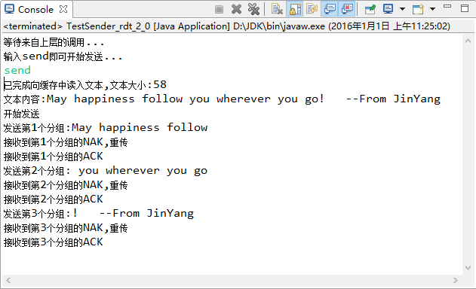
接收端
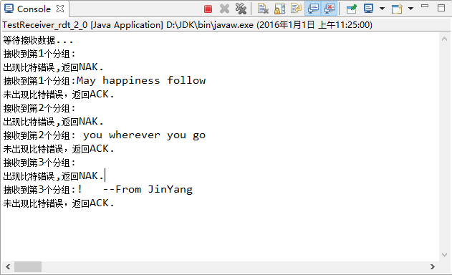

运行结果②
发送端
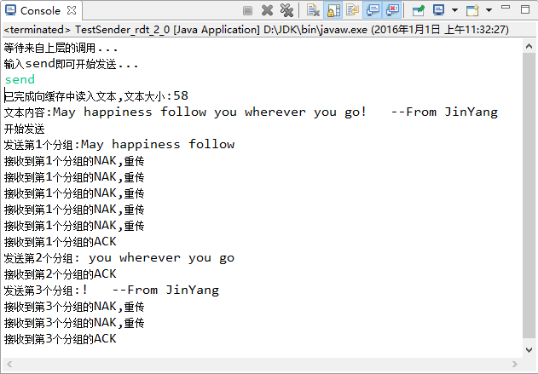
接收端
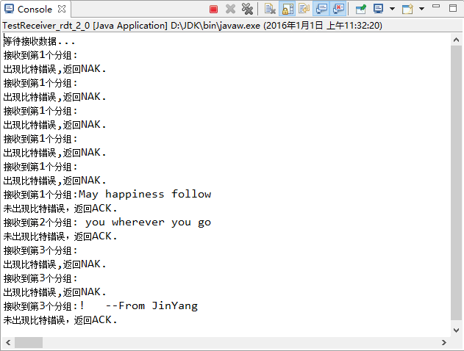

- rdt2.1
rdt2.1即在2.0的基础上增加一比特序号来判断是否丢包，为了模拟丢包的情况，我们也像2中一样设定一个丢包界限q，当产生的随机数小于等于q时表示丢包
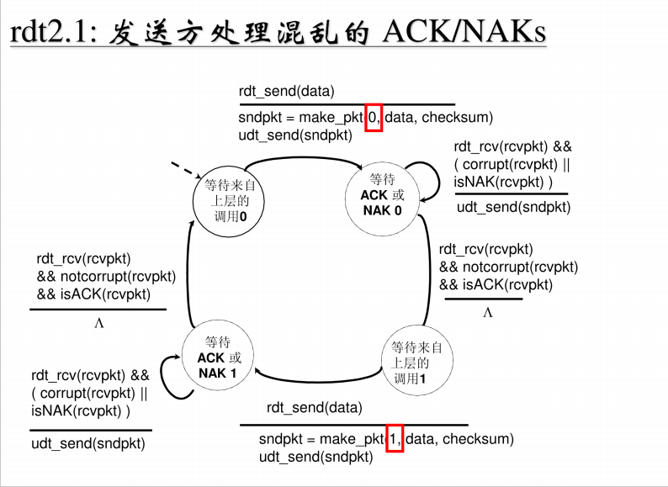
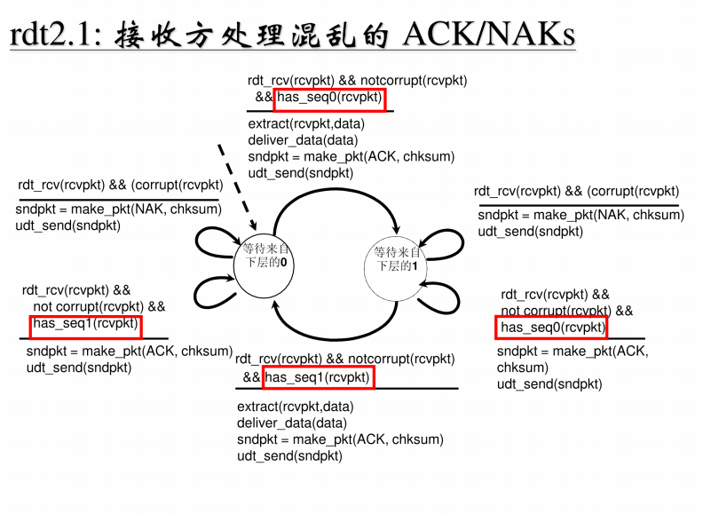
- .rdt2.1: 发送端

Sender_rdt_2_1.java

package CN5;
import java.io.*;
import java.net.*;
import java.util.zip.CheckedOutputStream;

/**
*
* @author 金洋
*
*/
public class Sender_rdt_2_1 {
protected static int packetSize=20;//每次传送的分组中数据的长度
protected int packetNum;//分组的个数
protected byte [ ] receiveData;//保存发送的数据
protected byte [ ] sendData; //保存接收的数据
protected FileReader f;//从文件中读取数据
protected byte[] bufferText;
protected int size;

protected BufferedReader inFromUser;
protected DatagramSocket sendSocket;
//protected DatagramSocket receiveSocket;
protected int sendPort;//发送过去的端口号
//protected int receivePort;//本地接收端口号
InetAddress IPAddress;

/*构造方法*/
public Sender_rdt_2_1() throws Exception {
receiveData = new byte [packetSize + 3];
sendData = new byte [packetSize + 3];
inFromUser=new BufferedReader(new InputStreamReader(System.in));
sendSocket=new DatagramSocket();
sendPort=9999;
IPAddress=InetAddress.getByName("localhost");

//receivePort=10000;
//receiveSocket=new DatagramSocket(receivePort);

f = new FileReader("E:/Computer/Java/Project/Networking/src/CN5/HappyNewYear.txt");

}

/**
* 读入文本
* @throws Exception
*/
public void readText() throws IOException {
BufferedReader buffer = new BufferedReader(f);
String tempStr = buffer.readLine();
size = tempStr.length();
bufferText= new byte[size];
bufferText= tempStr.getBytes();

packetNum=size/packetSize+1;

System.out.println("已完成向缓存中读入文本,文本大小:"+size);
System.out.println("文本内容:" + tempStr);
}

public DatagramPacket make_pkt(int j) {

int i,k;
byte buf[] = new byte [packetSize];

for (k=0,i=(j-1)*packetSize;i<Math.min(j*packetSize,size);i++,k++)
{
buf[k] = bufferText[i];
}

System.out.println(new String(buf));
/*构造一个分组sendPacket，包含数据、数据长度、服务器IP、端口号*/
DatagramPacket sendPacket=new DatagramPacket(buf,Math.min(packetSize,k),IPAddress,sendPort);
return sendPacket;

}

/*不可靠传输*/
public void udt_send(DatagramPacket packet) throws Exception {

sendSocket.send(packet);
}

/*从分组中提取ACK或NAK*/
public byte[] extract(DatagramPacket pkt) {
return pkt.getData();
}

public void start() throws Exception {
System.out.println("开始发送");
int sentNum=0;//已发送的分组,也即序号
while (sentNum<packetNum) {
sentNum++;
/*将构造好的分组通过UDP Socket送入网络*/
System.out.print("发送第"+sentNum+"个分组:");

DatagramPacket sendPacket=make_pkt(sentNum);
udt_send(sendPacket);

/*等待接收方发来的反馈*/
while (true) {
DatagramPacket receivePacket=new DatagramPacket(receiveData,receiveData.length);
/*rdt_rcv*/
sendSocket.receive(receivePacket);
byte[] AN=extract(receivePacket);

if (AN[0]==1 && AN[1]==sentNum%2) {
System.out.println("接收到第"+sentNum+"个分组的ACK"+AN[1]+",传送下一分组");
break;
}

else if (AN[0]==1){
System.out.println("接收到第"+sentNum+"个分组的ACK"+AN[1]+",重传");
udt_send(sendPacket);
}
else {
System.out.println("接收到第"+sentNum+"个分组的NAK"+AN[1]+",重传");
udt_send(sendPacket);
}

}

}
System.out.println("传输完毕");
sendSocket.close();
}
}

b).rdt2.1: 接收端

Receiver_rdt_2_1.java

package CN5;

import java.io.IOException;
import java.net.*;

/**
*
* @author 金洋
*
*/
public class Receiver_rdt_2_1 {
//protected static int packetSize=20;//每次传送的分组中数据的长度
protected byte[] sendDataACKNAK;
protected byte[] receiveData;
protected int receivedNum;//已收到的分组个数
protected DatagramSocket receiverSocket;
protected String data;
protected int port;
protected static double p=0.4;//事先规定一个合理的出现比特差错的界限p
protected static double q=0.3;//事先规定一个合理的出现丢包界限q

public Receiver_rdt_2_1() throws Exception{
port=9999;
receiverSocket=new DatagramSocket(port);
receivedNum=0;
}

/*从分组中提取data*/
public String extract(DatagramPacket pkt) {

return new String(pkt.getData());
}

/*向本地上层发送data*/
public void deliver_data(String data,int i){
System.out.println("接收到第"+i+"个分组:"+data);
}

public DatagramPacket make_pkt(DatagramPacket rcvPacket, byte AN,byte ord) {

byte[] buf = new byte[2];
buf[0]=AN;
buf[1]=ord;

/*抽取客户端IP地址和端口号*/
InetAddress IPAddress=rcvPacket.getAddress();
int port=rcvPacket.getPort();

/*构造一个分组sendPacket，包含数据、数据长度、服务器IP、端口号*/
DatagramPacket sendPacket=new DatagramPacket(buf,2,IPAddress,port);
return sendPacket;

}

/*不可靠传输*/
public void udt_send(DatagramPacket packet) throws IOException {

receiverSocket.send(packet);
}

public void start() throws Exception {
while (true) {
//byte[] sendDataACKNAK=new byte[1];//保存发送的数据，储存ACK 1或NAK 0
byte[] receiveData=new byte[1024];//保存接收的数据

DatagramPacket receivePacket=new DatagramPacket(receiveData,receiveData.length);
receiverSocket.receive(receivePacket);

++receivedNum;

while (true) {
double randomP = Math.random();//通过随机数来模拟是否出现比特错误
double randomQ = Math.random();//通过随机数来模拟是否出现丢包

data=new String(extract(receivePacket));

/*未出现比特错误*/
if (randomP>p) {

/*且未丢包*/
if (randomQ>q) {
deliver_data(data,receivedNum);
System.out.println("未出现比特错误,未丢包，返回ACK"+receivedNum % 2+".");
udt_send(make_pkt(receivePacket,(byte) 1,(byte)(receivedNum % 2 ) ));
break;//继续传下一个
}

/*但丢包*/
else {
System.out.println("接收到第"+receivedNum+"个分组:");
System.out.println("未出现比特错误,但丢包,返回ACK"+(receivedNum+1)%2+".");
udt_send(make_pkt(receivePacket,(byte) 1,(byte)((receivedNum+1 )% 2 ) ));
}
}

/*出现比特错误*/
else {
/*未丢包*/
if (randomQ>q) {
deliver_data(data,receivedNum);
System.out.println("出现比特错误,未丢包，返回NAK"+receivedNum % 2+".");
udt_send(make_pkt(receivePacket,(byte) 0,(byte)(receivedNum % 2 ) ));

}

/*丢包*/
else {
System.out.println("接收到第"+receivedNum+"个分组:");
System.out.println("未出现比特错误,但丢包,返回ACK"+(receivedNum+1)%2+".");
udt_send(make_pkt(receivePacket,(byte) 0,(byte)((receivedNum+1 )% 2 ) ));
}
}
/*如果重传则接收下一个分组*/
receiverSocket.receive(receivePacket);
}
}
}

}

运行结果：

发送端：
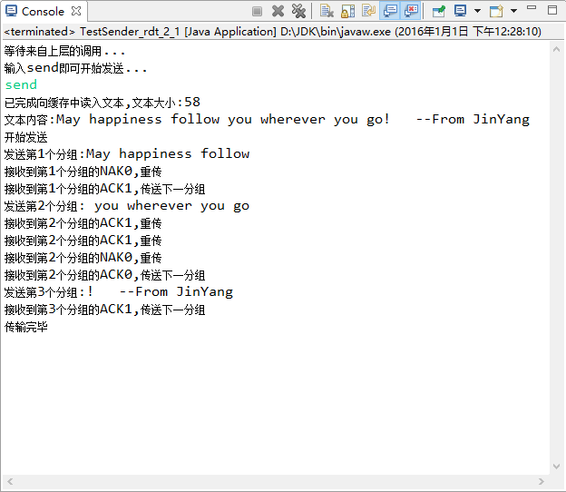
接收端：
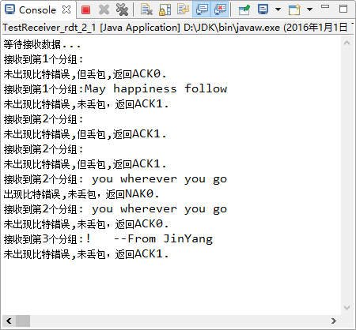

- rdt2.2
2.2版本与2.1版本的细微省略了NAK，只由ACK来确认是否出现比特错误。同时加上一个序号来表明收到的包的顺序。
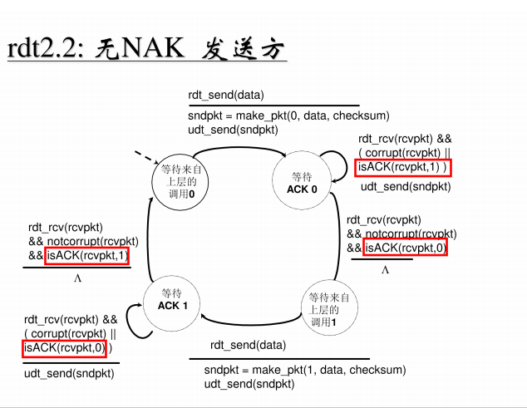
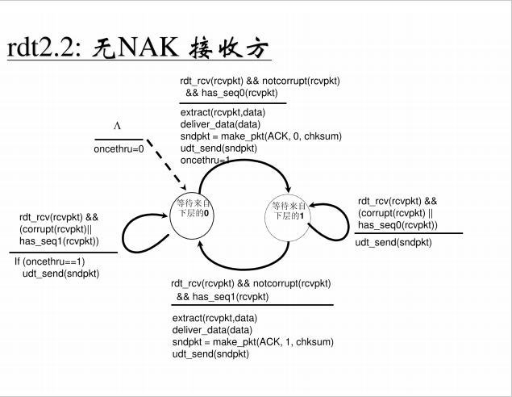
- rdt2.2发送端
Sender_rdt_2_2.java

package CN5;
import java.io.*;
import java.net.*;
import java.util.zip.CheckedOutputStream;

/**
*
* @author 金洋
*
*/
public class Sender_rdt_2_2 {
protected static int packetSize=20;//每次传送的分组中数据的长度
protected int packetNum;//分组的个数
protected byte [ ] receiveData;//保存发送的数据
protected byte [ ] sendData; //保存接收的数据
protected FileReader f;//从文件中读取数据
protected byte[] bufferText;
protected int size;

protected BufferedReader inFromUser;
protected DatagramSocket sendSocket;
//protected DatagramSocket receiveSocket;
protected int sendPort;//发送过去的端口号
//protected int receivePort;//本地接收端口号
InetAddress IPAddress;

/*构造方法*/
public Sender_rdt_2_2() throws Exception {
receiveData = new byte [packetSize + 3];
sendData = new byte [packetSize + 3];
inFromUser=new BufferedReader(new InputStreamReader(System.in));
sendSocket=new DatagramSocket();
sendPort=9999;
IPAddress=InetAddress.getByName("localhost");

//receivePort=10000;
//receiveSocket=new DatagramSocket(receivePort);

f = new FileReader("E:/Computer/Java/Project/Networking/src/CN5/HappyNewYear.txt");

}

/**
* 读入文本
* @throws Exception
*/
public void readText() throws IOException {
BufferedReader buffer = new BufferedReader(f);
String tempStr = buffer.readLine();
size = tempStr.length();
bufferText= new byte[size];
bufferText= tempStr.getBytes();

packetNum=size/packetSize+1;

System.out.println("已完成向缓存中读入文本,文本大小:"+size);
System.out.println("文本内容:" + tempStr);
}

/*传送的数据中第0位为序号*/
public DatagramPacket make_pkt(byte order,int j) {

int i,k;
byte buf[] = new byte [packetSize+1];
buf[0]=(byte)(order+48);//为了便于在控制台显示序号值，将其转为字符

for (k=1,i=(j-1)*packetSize;i<Math.min(j*packetSize,size);i++,k++)
{
buf[k] = bufferText[i];
}

System.out.println(new String(buf));
/*构造一个分组sendPacket，包含数据、数据长度（由于多了序号，便需要长度加一）、服务器IP、端口号*/
DatagramPacket sendPacket=new DatagramPacket(buf,Math.min(packetSize,k)+1,IPAddress,sendPort);
return sendPacket;

}

/*不可靠传输*/
public void udt_send(DatagramPacket packet) throws Exception {

sendSocket.send(packet);
}

/*从分组中提取ACK或NAK*/
public byte[] extract(DatagramPacket pkt) {
return pkt.getData();
}

public void start() throws Exception {
System.out.println("开始发送");
int sentNum=0;//已发送的分组

int reACK,reord;//接收到的ACK和序号
while (sentNum<packetNum) {
sentNum++;
/*将构造好的分组通过UDP Socket送入网络*/
System.out.print("发送第"+sentNum+"个分组:");

DatagramPacket sendPacket=make_pkt((byte) (sentNum%2),sentNum);
udt_send(sendPacket);

/*等待接收方发来的反馈*/
while (true) {
DatagramPacket receivePacket=new DatagramPacket(receiveData,receiveData.length);
/*rdt_rcv*/
sendSocket.receive(receivePacket);
byte[] rP=extract(receivePacket);
reACK=rP[0];
reord=rP[1];

if (reACK==1 && reord==sentNum%2) {
System.out.println("接收到第"+sentNum+"个分组的ACK=1,序号="+reord+",传送下一分组");
break;
}

else {
System.out.println("接收到第"+sentNum+"个分组的ACK="+reACK+",序号="+reord+",重传");
udt_send(sendPacket);
}

}
}
System.out.println("传输完毕");
sendSocket.close();
}
}

- rdt2.2接收端
Receiver_rdt_2_2.java

package CN5;

import java.io.IOException;
import java.net.*;

/**
*
* @author 金洋
*
*/
public class Receiver_rdt_2_2 {
//protected static int packetSize=20;//每次传送的分组中数据的长度
protected byte[] sendDataACKNAK;
protected byte[] receiveData;
protected int receivedNum;//已收到的分组个数
protected DatagramSocket receiverSocket;
protected String data;
protected int port;
protected static double p=0.4;//事先规定一个合理的出现比特差错的界限p
protected static double q=0.3;//事先规定一个合理的出现丢包界限q

public Receiver_rdt_2_2() throws Exception{
port=9999;
receiverSocket=new DatagramSocket(port);
receivedNum=0;
}

/*从分组中提取data*/
public String extract(DatagramPacket pkt) {

return new String(pkt.getData());
}

/*向本地上层发送data*/
public void deliver_data(String data,int i){
System.out.println("接收到第"+i+"个分组:"+data);
}

public DatagramPacket make_pkt(DatagramPacket rcvPacket, byte ACK,byte ord) {

byte[] buf = new byte[2];
buf[0]=ACK;
buf[1]=ord;

/*抽取客户端IP地址和端口号*/
InetAddress IPAddress=rcvPacket.getAddress();
int port=rcvPacket.getPort();

/*构造一个分组sendPacket，包含数据、数据长度、服务器IP、端口号*/
DatagramPacket sendPacket=new DatagramPacket(buf,2,IPAddress,port);
return sendPacket;

}

/*不可靠传输*/
public void udt_send(DatagramPacket packet) throws IOException {

receiverSocket.send(packet);
}

public void start() throws Exception {
while (true) {
//byte[] sendDataACKNAK=new byte[1];//保存发送的数据，储存ACK 1或NAK 0
byte[] receiveData=new byte[1024];//保存接收的数据

DatagramPacket receivePacket=new DatagramPacket(receiveData,receiveData.length);
receiverSocket.receive(receivePacket);

++receivedNum;

while (true) {
double randomP = Math.random();//通过随机数来模拟是否出现比特错误
double randomQ = Math.random();//通过随机数来模拟是否出现丢包

data=new String(extract(receivePacket));
byte ord;//接收的分组中的序号
byte ACK=1;//反馈的ACK值,默认未出错为1
ord=(byte) (data.charAt(0)-48);

/*未出现比特错误*/
if (randomP>p) {
/*且序号正确*/
if (randomQ>q) {
deliver_data(data,receivedNum);
System.out.println("未出现比特错误,序号正确,返回ACK=1,ord="+ord+".");
udt_send(make_pkt(receivePacket,(byte) 1,ord));
break;//继续传下一个
}
}

/*模拟比特出错*/
if (randomP<=p) ACK=0;
/*模拟序号出错*/
if (randomQ<=q) ord=(byte) ((ord+1)%2);

System.out.println("接收到的分组有误,需重传,返回ACK="+ACK+",ord="+ord+".");
udt_send(make_pkt(receivePacket,ACK,ord));
/*如果重传则接收下一个分组*/
receiverSocket.receive(receivePacket);
}
}
}

}

运行结果
发送端：
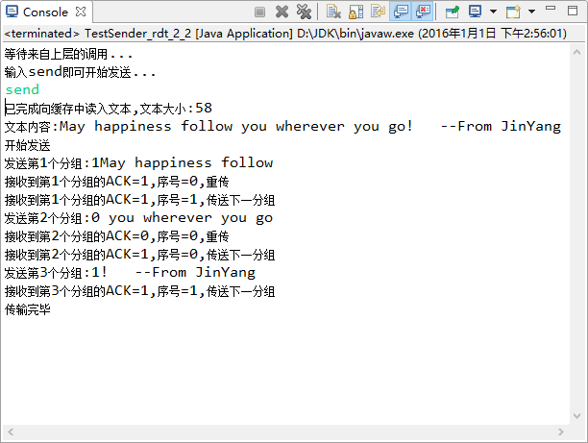
接收端：
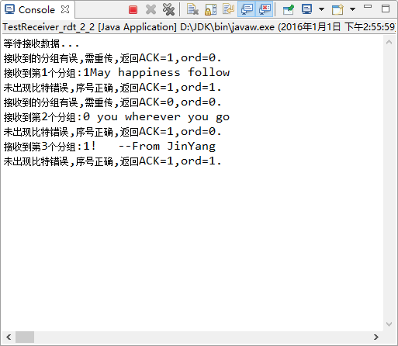

- rdt3.0
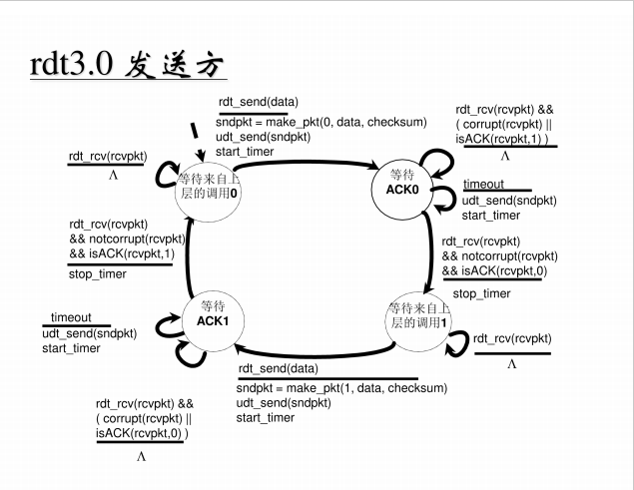
接收方：
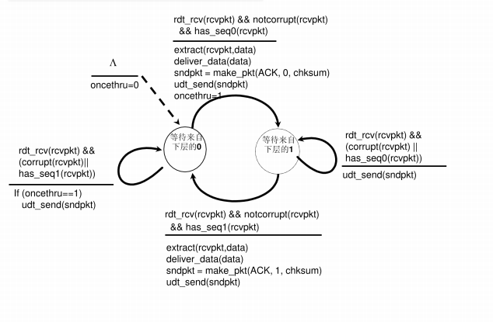

- rdt3.0发送端
Sender_rdt_3_0.java

package CN5;
import java.io.*;
import java.net.*;
import java.util.Timer;

/*UDP连接的发送端实现可靠数据传输
* 使用GBN算法，实现了：
* 1.随即丢包(随机数产生器Math.random())
* 2.丢包后遇冗余ack重传
* 3.超时重传 (DatagramSocket和Socket都有成员函数setSoTimeout(delay),通过捕获超时时抛出的IO异常来实现超时重传)
*/

public class Sender_rdt_3_0 {
static int packetsize = 20;
static int n = 10; // 服务器将向客户端发送的packet数
static byte [ ] receiveData = new byte [packetsize + 3];
static byte [ ] sendData = new byte [packetsize + 3];
static int listeningPort = 10001;
static double p = 0.5; // probability of dropping packets
static int delay = 1000; // 延时

public static void main(String args [ ] ) throws Exception {
DatagramSocket serverSocket = new DatagramSocket (listeningPort);
int base = 1;
int nextseqnum = 1;
System.out.println("Listening on port" + listeningPort);

FileReader f = new FileReader("E:/Computer/Java/Project/Networking/src/CN5/HappyNewYear.txt");
BufferedReader buffer = new BufferedReader(f);
String tempStr = buffer.readLine();
int size = tempStr.length();
byte bufferArray[] = new byte[size];
bufferArray = tempStr.getBytes();

System.out.println("已完成向缓存中读入文本,文本大小:" + size);
System.out.println("文本内容:" + tempStr);

DatagramPacket receivePacket = new DatagramPacket ( receiveData , receiveData.length );
serverSocket.receive (receivePacket);
String sentence = new String ( receivePacket.getData ( ) );
System.out.println("已收到发送请求");

InetAddress IPAddress = receivePacket.getAddress ( );
int port = receivePacket.getPort();

serverSocket.setSoTimeout(delay);
int i;
System.out.println("开始传输:");
byte buf1[] = new byte [packetsize];
byte buf2[] = new byte [packetsize];
// 初始化buf1和buf2，即读入前两个包直接发送
for ( i = (nextseqnum - 1) * packetsize ; i < nextseqnum * packetsize; i++) {
buf1[i] = bufferArray[i];
}
nextseqnum++;
String str = "1#" + new String (buf1);
System.out.println("发送分组:" + str);
sendData = str.getBytes( );
DatagramPacket sendPacket = new DatagramPacket ( sendData, sendData.length ,IPAddress, port);
sendPacket(serverSocket, sendPacket );

int j;
for (j=0, i = (nextseqnum - 1) * packetsize; i < nextseqnum * packetsize; i++) {
buf2[j++] = bufferArray[i];
}
nextseqnum++;
str = "2#" + new String (buf2);;
System.out.println("");
System.out.println("发送分组:" + str);
sendData = str.getBytes( );
sendPacket = new DatagramPacket ( sendData, sendData.length ,IPAddress, port);
sendPacket(serverSocket, sendPacket );

String strACKNum;
while ( true ) {
try {
receivePacket = new DatagramPacket ( receiveData, receiveData.length );
serverSocket.receive (receivePacket );

strACKNum = new String ( receivePacket.getData ( ) );
System.out.println("");
System.out.println("接收ACK:" + strACKNum.substring(0, strACKNum.indexOf('#') + 1));
if (strACKNum.substring(0, strACKNum.indexOf('#')).equals(String.valueOf(base))) {// 接收到正确的Ack
base++;
// 已经发出n个包并且都收到确认Ack了
if (base == n + 1) {
break;
}

// 收到Ack，继续发送后面的包，但是当base==n-1时，没有文件可发送了，只要等待最后窗口长度个Ack就行了
else if (base <= n - 1) {
buf1 = buf2;
for (j = 0, i = (nextseqnum - 1) * packetsize ; i < nextseqnum * packetsize; i++) {
buf2[j++] = bufferArray[i];
}
str = String.valueOf(nextseqnum) + "#" + new String (buf2);
System.out.println("");
System.out.println("发送分组:" + str);
sendData = str.getBytes( );
sendPacket = new DatagramPacket ( sendData, sendData.length ,IPAddress, port);
sendPacket(serverSocket, sendPacket );
nextseqnum++;
}
}
// 冗余Ack, 重传
else {
System.out.println("");
System.out.println("收到冗余ACK.");
Resend(serverSocket, base, buf1, buf2, IPAddress, port);
}
}
catch (IOException e) {// 捕获超时抛出的异常，重传
System.out.println("");
System.out.println("超时，重传.");
Resend(serverSocket, base, buf1, buf2, IPAddress, port);
}
}
serverSocket.close();
System.out.println("传输完毕");
}

public static void sendPacket(DatagramSocket serverSocket, DatagramPacket packet)
{
try
{// randomly dropping packet
double i = Math.random();
if (i > p)
{
serverSocket.send ( packet );
}
else
{
System.out.println("丢包!");
//System.out.println( "packet content:" + new String(packet.getData()) );
}
}
catch (Exception e)
{
System.out.println("发送分组异常!");
}
}

public static void Resend(DatagramSocket serverSocket, int base, byte[] buf1, byte[]buf2,
InetAddress IPAddress, int port)
{
if (base < n)
{
String str = String.valueOf(base) + "#" + new String(buf1);
System.out.println("重传分组:" + str);
sendData = str.getBytes( );
DatagramPacket sendPack = new DatagramPacket ( sendData, sendData.length ,IPAddress, port);
sendPacket(serverSocket, sendPack );
str = String.valueOf(base + 1) + "#" + new String(buf2);
System.out.println("重传分组:" + str);
sendData = str.getBytes( );
sendPack = new DatagramPacket ( sendData, sendData.length, IPAddress, port);
sendPacket(serverSocket, sendPack );
}
else
{ // 当只有最后一个包未确认时，重传也只要传最后一个包了
String str = String.valueOf(base) + "#" + new String(buf2);
System.out.println("重传分组:" + str);
sendData = str.getBytes( );
DatagramPacket sendPack = new DatagramPacket ( sendData, sendData.length, IPAddress, port);
sendPacket(serverSocket, sendPack );
}
}
}

b) rdt3.0接收端

Receiver_rdt_3_0.java

package CN5;

import java.io.*;
import java.net.*;
public class Receiver_rdt_3_0 {
public static void main( String args[ ] ) throws Exception
{
int packetsize = 20;
int expectednum = 1; // 客户端期待的packet的序号
int n = 10; // 客户端将接收的packet数
DatagramSocket clientSocket = new DatagramSocket ( );
InetAddress IPAddress = InetAddress.getByName ( "localhost" );
byte [ ] sendData =new byte [packetsize + 3];
byte [ ] receiveData =new byte [packetsize + 3];

String sentence = "request";
sendData = sentence.getBytes ( );
DatagramPacket sendPacket = new DatagramPacket ( sendData,sendData.length,IPAddress,10001);
clientSocket.send ( sendPacket );

System.out.println("等待接收数据：");
while (expectednum <= n)
{
DatagramPacket receivePacket = new DatagramPacket ( receiveData,receiveData.length );
clientSocket.receive ( receivePacket );
String strRec = new String ( receivePacket.getData () );
System.out.println ( "收到的packet: " + strRec );
String strNum = strRec.substring(0, strRec.indexOf('#'));
System.out.println ( "收到的packet序号为: " + strNum );
System.out.println ( "期待的序号为:" + expectednum );
if (strNum.equals(String.valueOf(expectednum)))
{
String packetCon = strRec.substring(strRec.indexOf('#') + 1);
System.out.println( "序号正确！分组内容为：" + packetCon);
// 发送确认信息给服务器
sentence = String.valueOf(expectednum) + "#";
// for (i = 0; )
expectednum++;
}
else
{
System.out.println("失序！丢弃该包并发送冗余Ack");
// 发送冗余Ack
sentence = String.valueOf(expectednum - 1) + "#";
}
System.out.println("发送ACK: " + sentence);
System.out.println("");
sendData = sentence.getBytes ( );
sendPacket = new DatagramPacket ( sendData,sendData.length,IPAddress,9999 );
clientSocket.send ( sendPacket );
}
System.out.println("接收完毕");
clientSocket.close ( );
}
}

运行结果：
发送端：
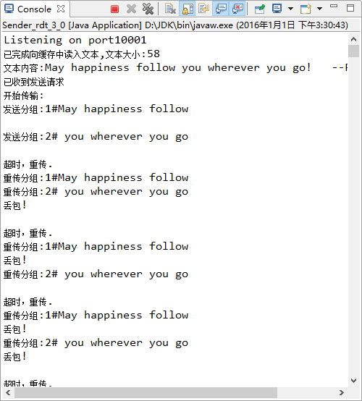
接收端：
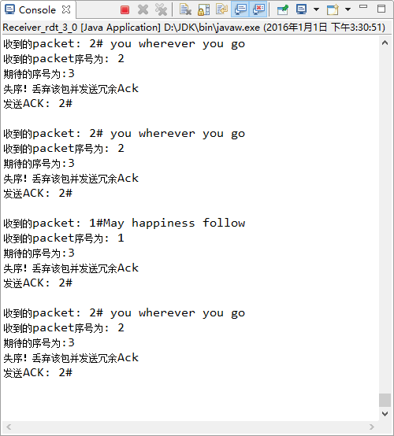

6.剖析消息处理与消息交换在rdt协议的可靠性增强中的作用。

在rdt1.0中，由于拥有完全可靠的信道，接收端就不需要提供任何反馈信息给发送方，因为不必担心出现差错。

而底层信道更为实际的模型是分组中的比特可能出现受损，通过类比人类交流的情形，在通常情况下，报文接受者在听到、理解并记下每句话后可能会说OK。如果报文接受者听到一句含糊不清的话时，他可能会要求发送方重复刚才那句话。这种口述报文协议使用了肯定确认与否定确认。

这些控制报文史的接收方可以让发送方知道哪些内容被正确接收，哪些内容接收有误的并因此需要重复。在计算机网络环境中，基于这样重传机制的可靠传输协议称为自动重传请求ARQ。

差错控制检测、接收方反馈、重传使得ARQ能够很好地处理比特差错问题。

差错检测：检验和技术使接收方可以检测，并可能纠正分组中的比特差错。实现这些技术要求有额外的比特从发送方发送到接收方。

接收方反馈:因为发送方和接收方通常在不同的端系统上执行，可能相隔很远，发送方要了解接受方情况唯一途径就是让接收方提供明确的反馈信息给发送方。在rtd2协议中，使用NAK或ACK由接收方返回给发送方

重传:接收方收到有差错的分组时，发送方将重传该分组文 。

3.0：如果发现丢包，对于发送方来说，重传是一种万能药，为了实现基于时间的重传机制，需要一个倒计时定时器，在一个给定的时间量过期后，可中断发送方。因此发送方需要做到:①每次发送一个分组，便启动一个定时器;②响应定时器中断(采取适当的动作)③终止定时器。

这几个版本都在“停止等待”前提下，rdt2.0对付位差错——采用检查和, 使用反馈ACK/NAK，出错时发送方重传分组；rdt2.1和2.2对付ACK/NAK的位差错——采用序号(0/1号)机制。 rdt3.0对付分组丢失——采用超时重传机制。

综上，检验和、序号、定时器、肯定和否认确认分组，这些消息处理与消息交换在rdt协议的可靠性增强中起到了必不可少的作用

五、实验体会
（请认真填写自己的真实体会）
- 目前UDP在因特网中的主要应用有：远程文件服务（NFS）；流式多媒体（专用协议）； IP电话（专用协议）；网络管理（SNMP）；路由选择协议（RIP）；和名址转换（DNS）等。 其特征是要求快捷、可以不必考虑在传输中的可靠服务等场合。

- 对于checksum的计算，以课本的介绍，对于01比特组成的流，通过求和、回卷、累加和、变反得到校验和，可以检测出部分出错情况，对于本实验中的文本，若要计算checksum，则需将其转换为比特流，在通过特定的算法对其计算并加入到发送的分组中，接收方也需要进行同样的工作来检验checksum。通过java已有的方法也需要将每一个分组实现到CheckedInputStream的转化，最后加入到发送的分组中。由于精力时间有限，目前对流的概念了解也不是很多，我不再在实验中加入生成checksum的算法，想了一种办法来模拟具有比特差错的信道——我们事先规定一个合理的出现比特差错界限p，当接收方每接到一个分组，便生成一个随机数，若该随机数小于等于p，则我们认为出现比特差错、checkSum不一致。

- rdt2.0之后的版本都在“停止等待”前提下，rdt2.0对付位差错——采用检查和, 使用反馈ACK/NAK，出错时发送方重传分组；rdt2.1和2.2对付ACK/NAK的位差错——采用序号(0/1号)机制。 rdt3.0对付分组丢失——采用超时重传机制。

4. 因为发送方和接收方通常在不同的端系统上执行，可能相隔很远，发送方要了解接受方情况唯一途径就是让接收方提供明确的反馈信息给发送方。

六、参考文献
1. 主讲课英文教材 chapter 3
2. 汪晓平，俞俊，李功 著. Java网络编程[M]. 北京：清华大学出版社.2005.9；
3. 蒙红楼. Java IO之 CheckedInputStream和CheckedOutputStream [EB/OL]. [2011-09-08]. http://blog.csdn.net/mhl29/article/details/6759267

