1. **Business requirement:**

Design a head unit system on vehicle.

This system has 5 applications running in parallel: AppMain, Audio, Phone, Climate and Settings.

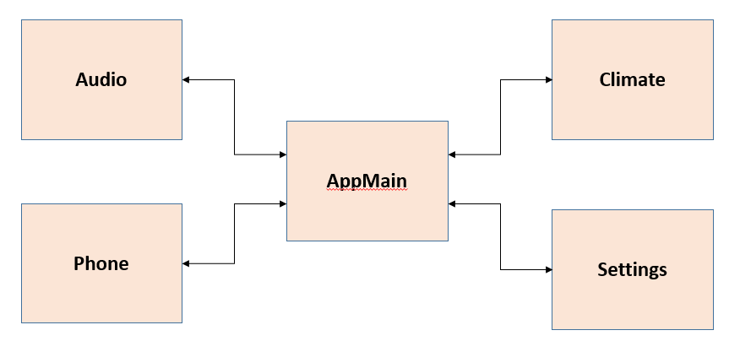

The AppMain can communicate with other applications to control them and get their status.

1. AppMain: Manage all screens and screen transitions.

* Home screen:
  + Contain icons to open application screens.
  + User can re-arrange these icons to desired position.
  + There is a tray that contains information about date/time, climate…
  + There is a Home button on the tray to return home screen from any application.

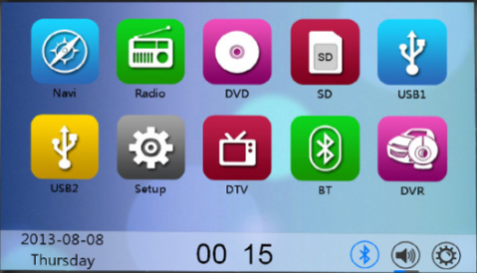

* Audio screen:
* Display song now playing
  + There is a song list which is loaded from a folder in hard disk.
  + There are buttons to control playing a song such as: Pause/Play, Rewind, Fast-forward.
  + There are some buttons to change source (AM, FM, USB…)
  + Direct Tune screen to go any frequency
* Phone screen: There are 3 tabs on the screen:
  + Phone book list tab: List contacts. When use click on a contact, the detail screen is show.
  + There is a call button on the detail screen to make a phone call to the contact.
  + Recent tab: List of call history.
  + Active call screen: Display active call information
* Climate screen: Show information about climate.
* Settings screen: User can change date/time, language (Vietnamese or English), valet mode

1. Audio application:

Manage song list and playing song.

Receive commands from AppMain to control playing song.

Send back its go previous screen.

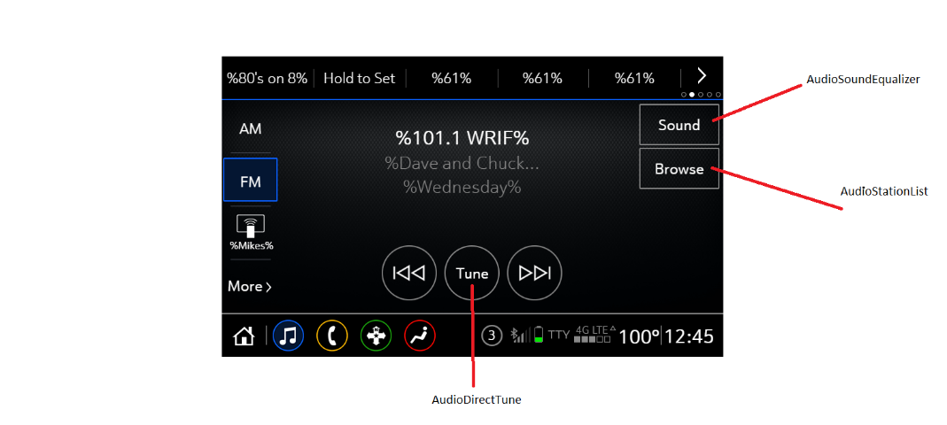

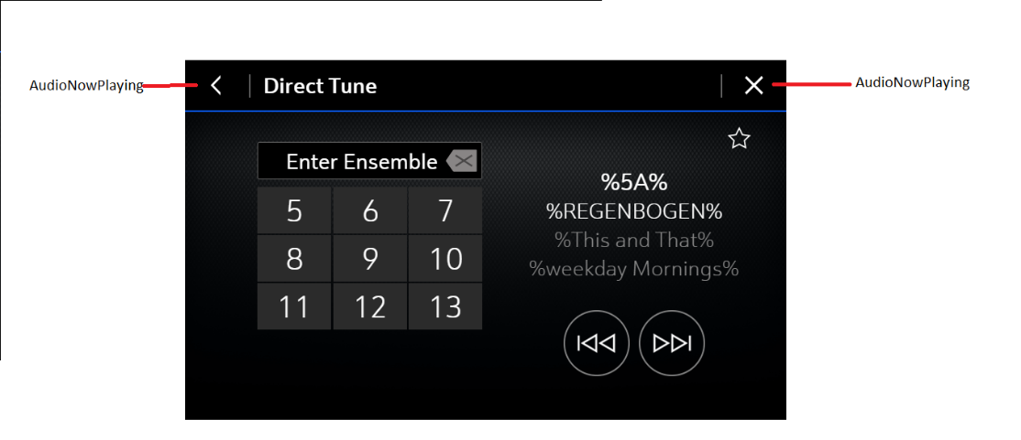

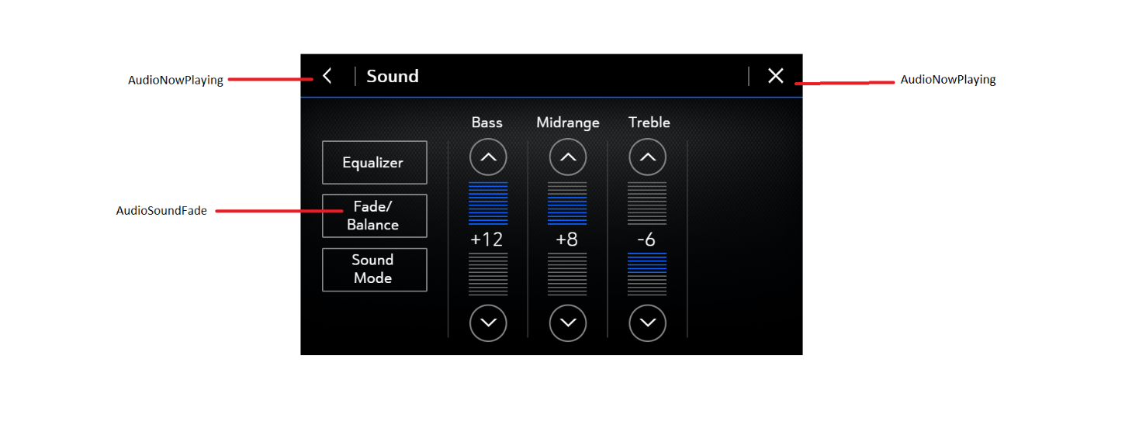

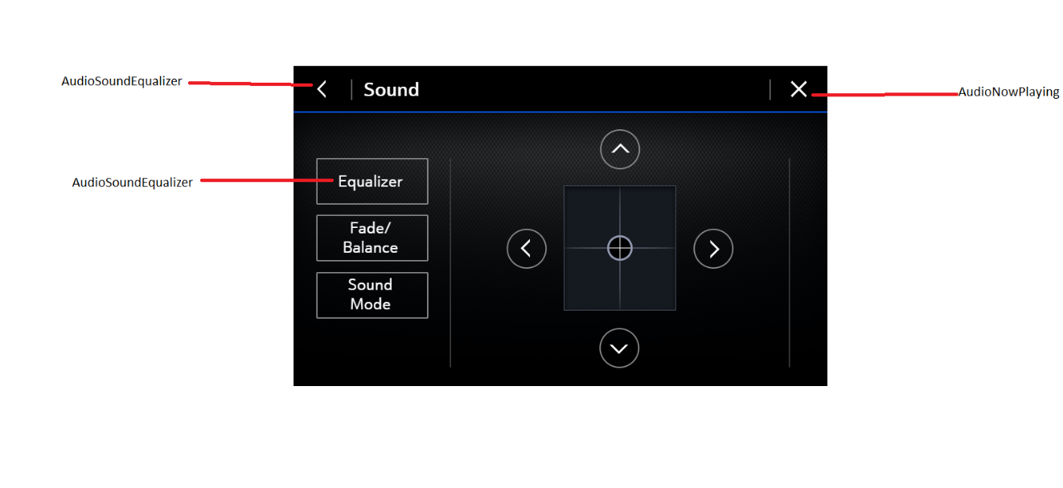

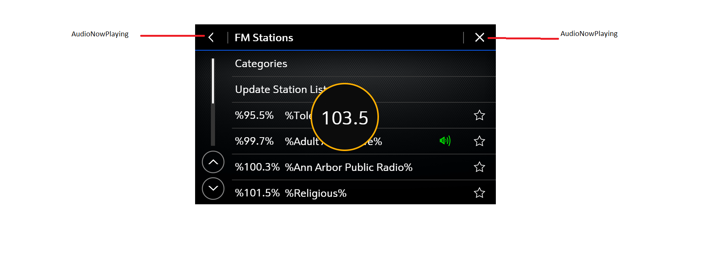

1. Phone application:

Manage phonebook list and calls.

There is no real phone so a call can be simulated in this application.

The phonebook list is stored in a database file.

Receive commands from AppMain to send a phonebook list or control a call.

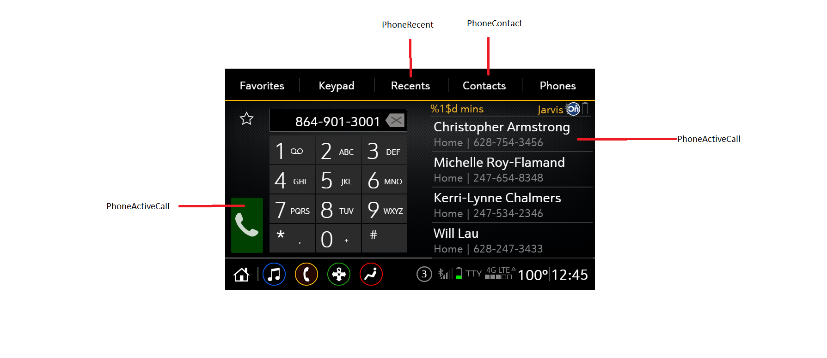

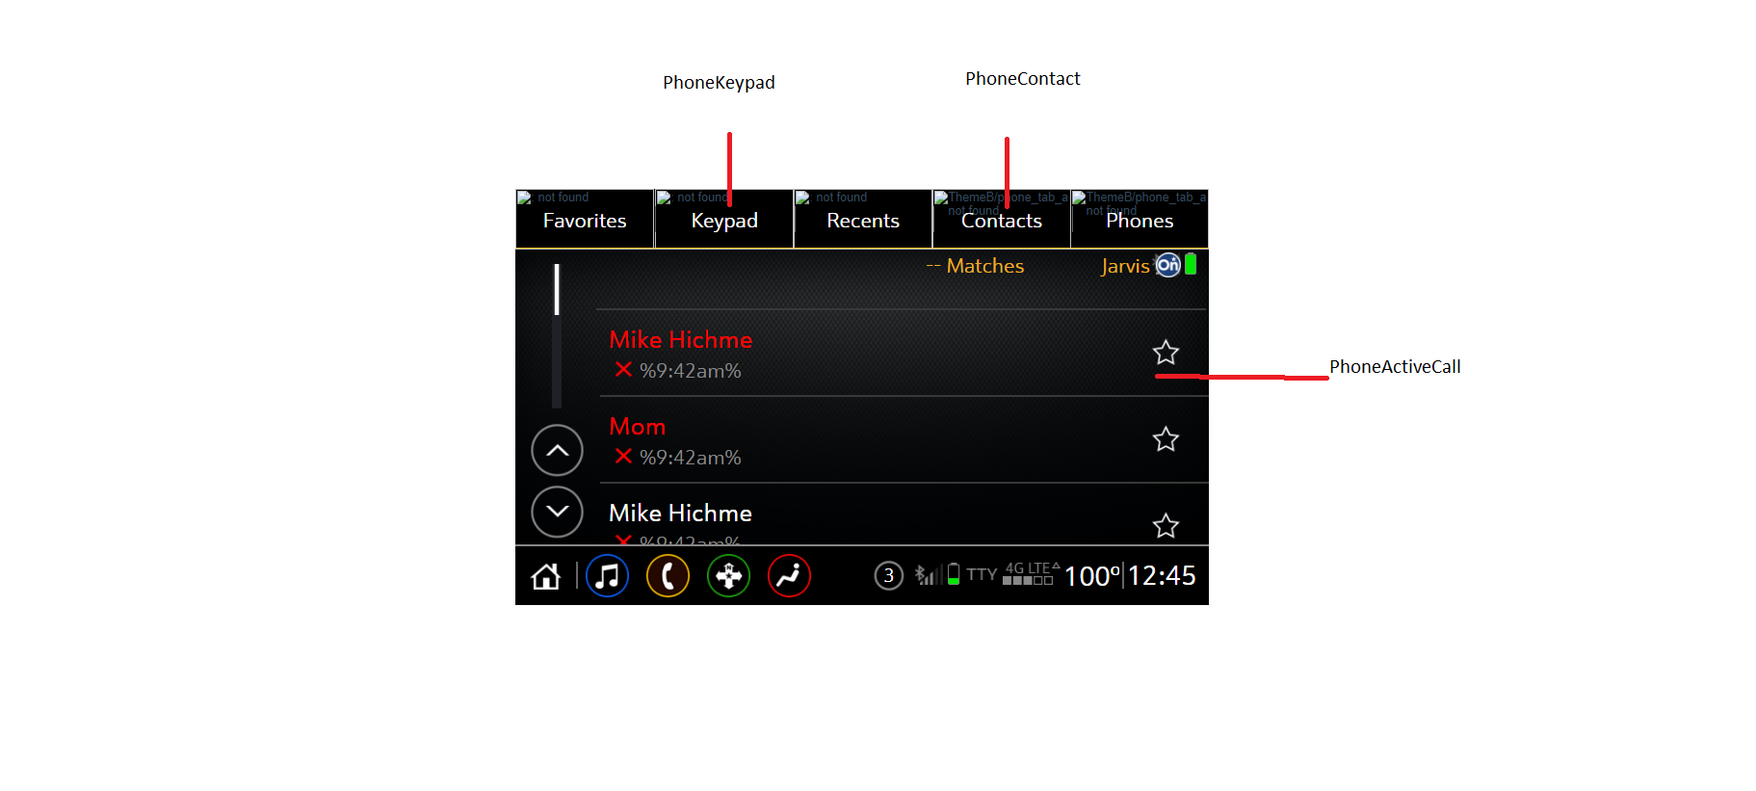

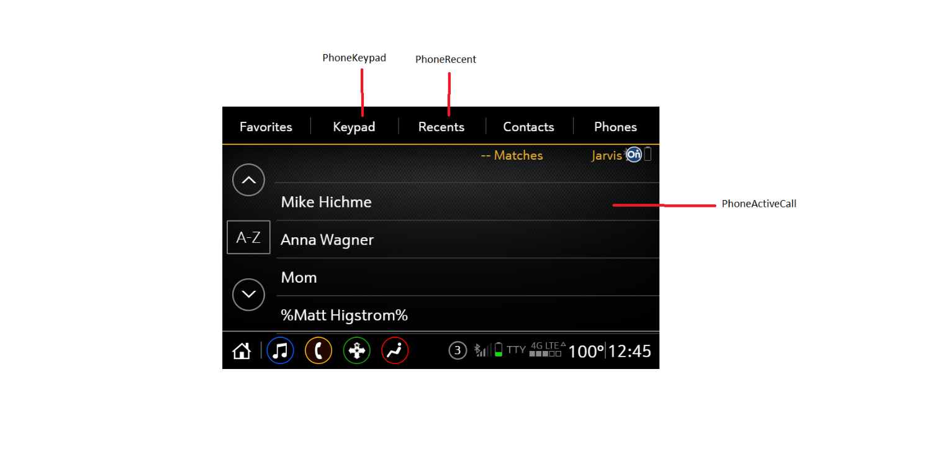

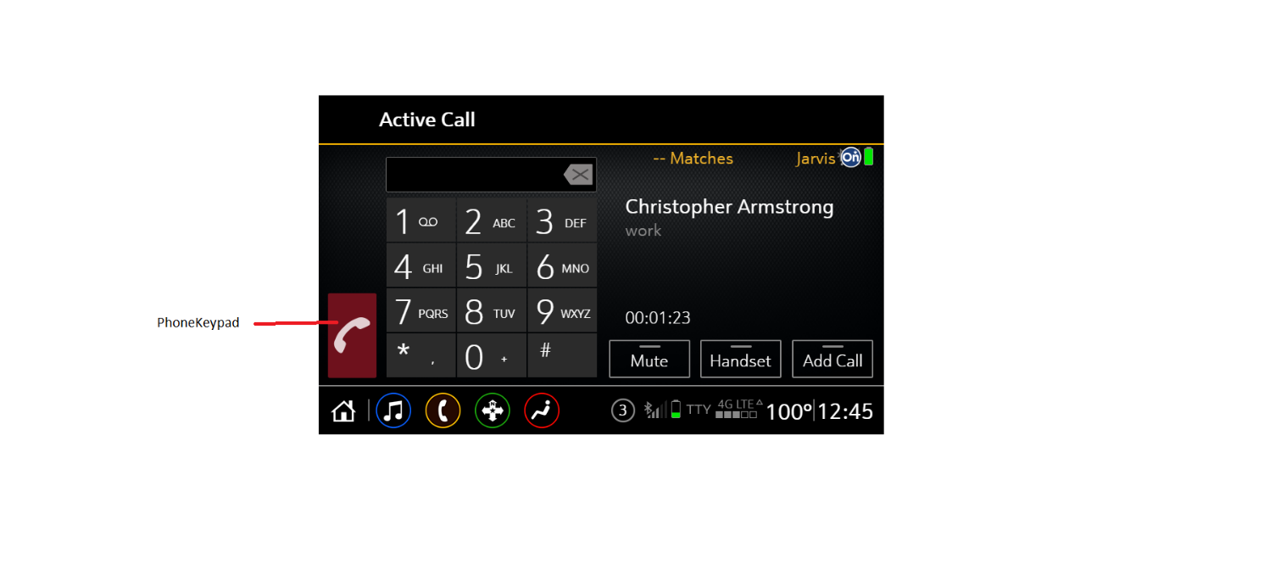

1. Climate application:

Manage climate information.

Receive commands from AppMain to send a climate information.

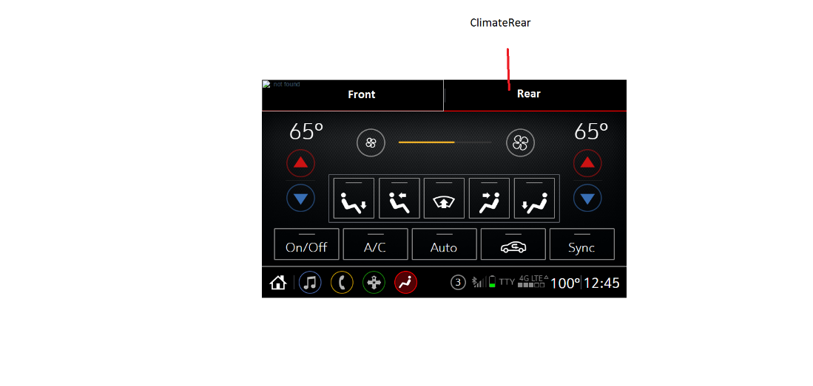

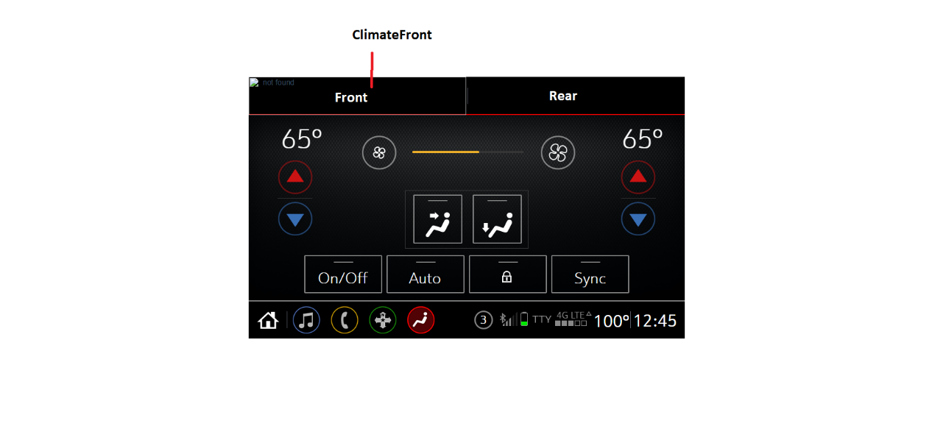

1. Settings:

Manage settings information of date/time, language.

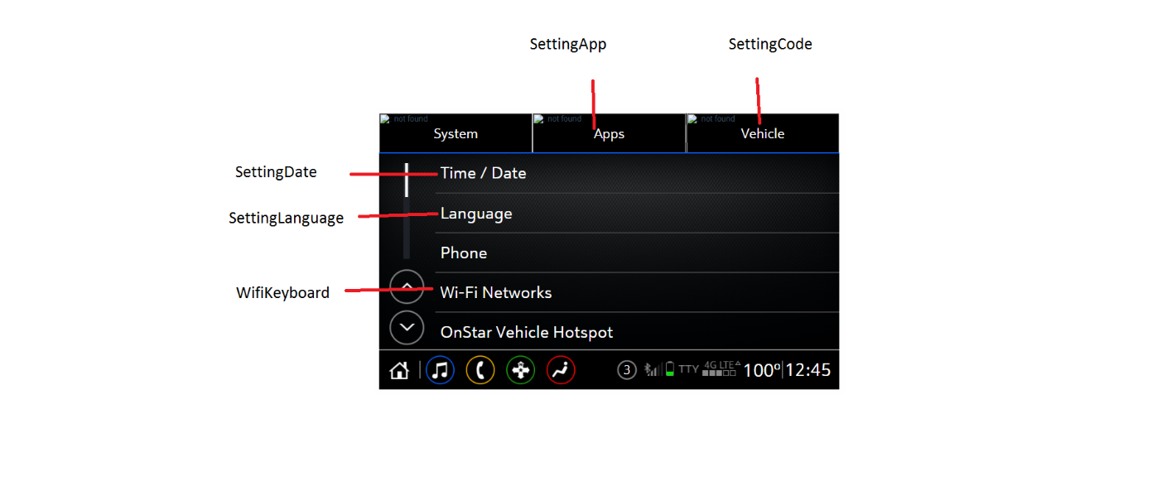

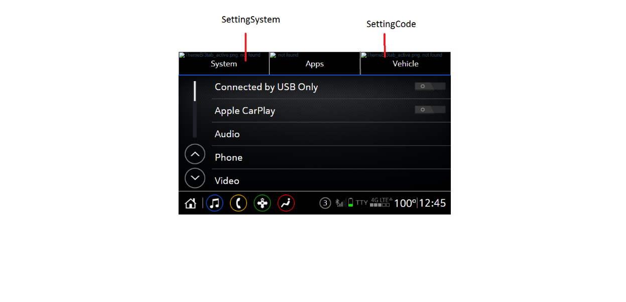

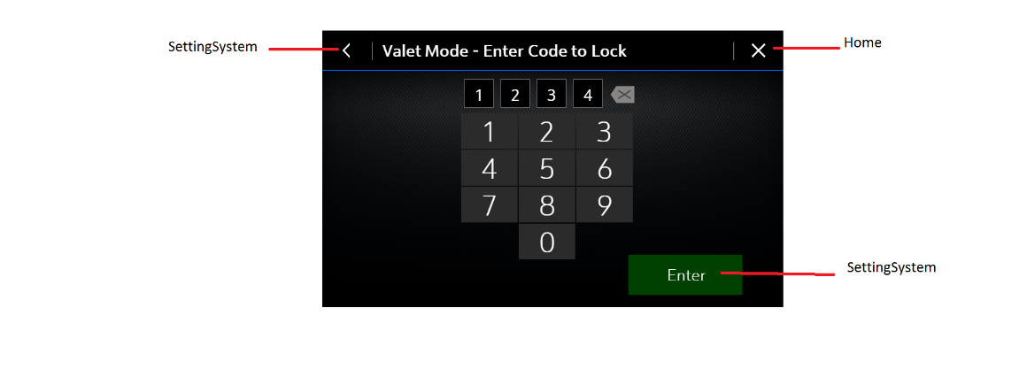

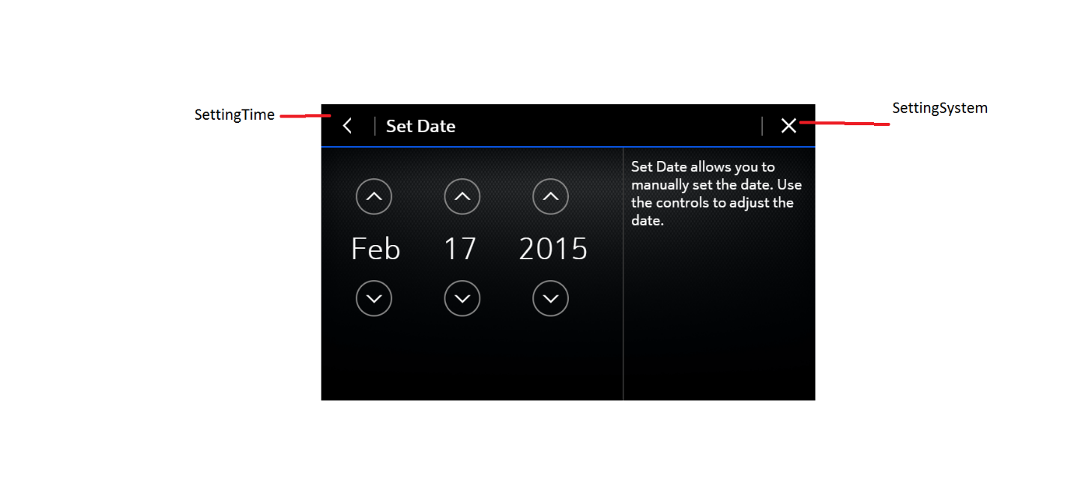

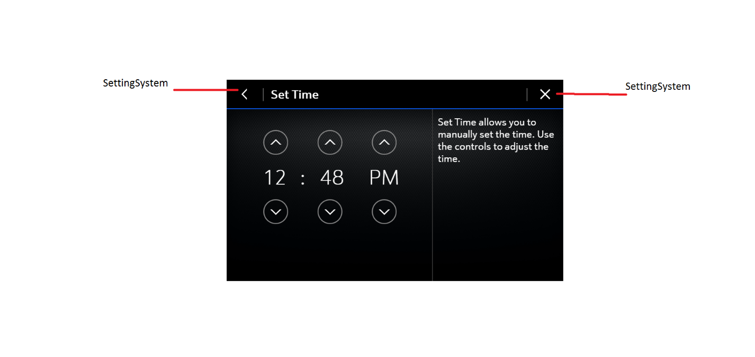

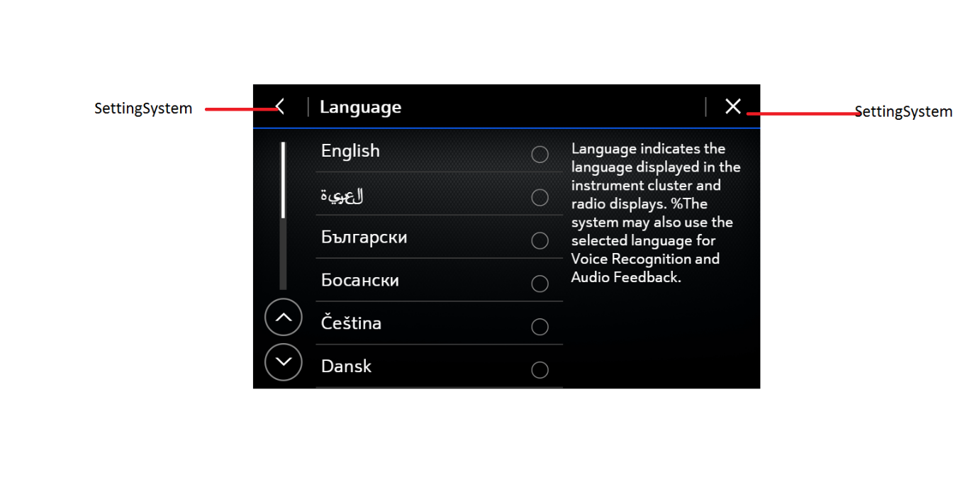

1. OnstarTBT

OnstarTBT show directions to guide user on the way

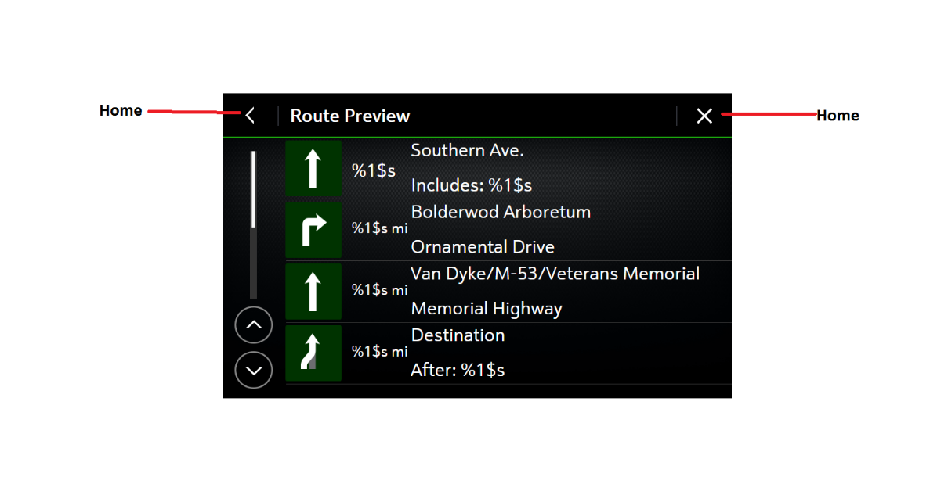

7.Keyboard

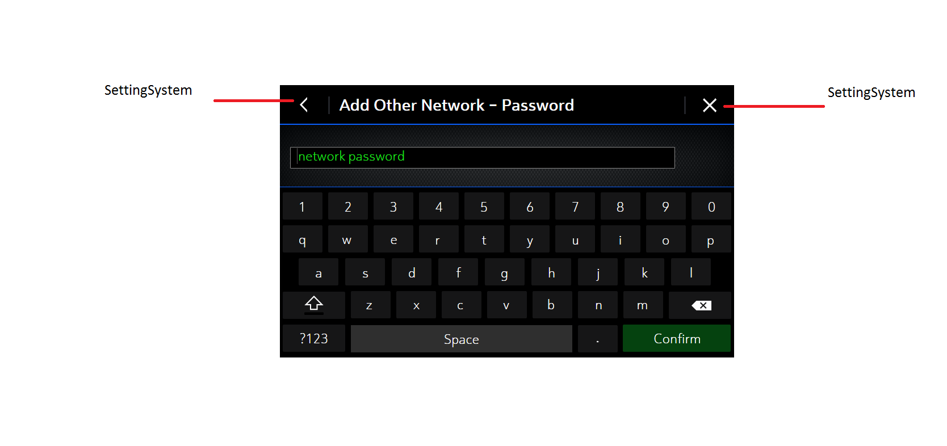

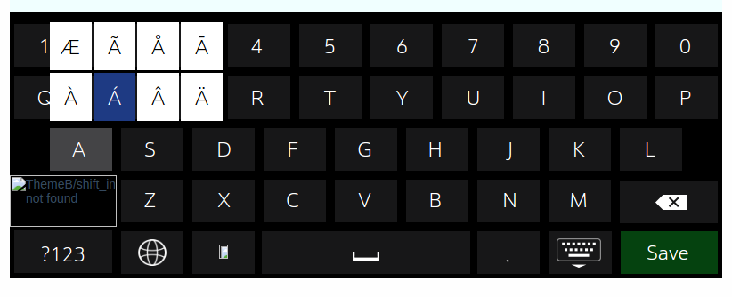

1. **Technical requirement:**

The system runs on Window

QT framework.

Use QML to create Screens.