1.

First two commands will set name and email for our repositories, it will be inside user.name

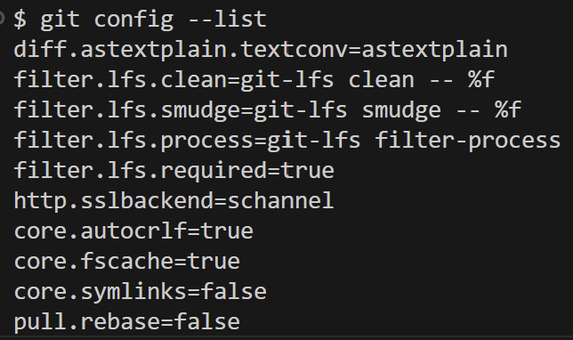

2.

We use “git init”