

Enterprise Web Software Development

**REPORT**

|  |  |
| --- | --- |
| **Department:** | Computing & Mathematical Sci. |
| **Class:** | TCS2405 |
| **Subject code:** | COMP1640 |
| **Student ID:** | 001392753 |
| **Student name:** | Nguyen Hoang Trong Phat |
| **Email ID:** | np4193h@gre.ac.uk |
| **Submission Date:** | 18 April 2024 |

**Table Of Contents**

**1.** **Evaluation of product and process** 3

**2.** **Evaluation of Team** 3

**3.** **Self-evaluation** 4

**Individual reports**

1. **Evaluation of product and process**

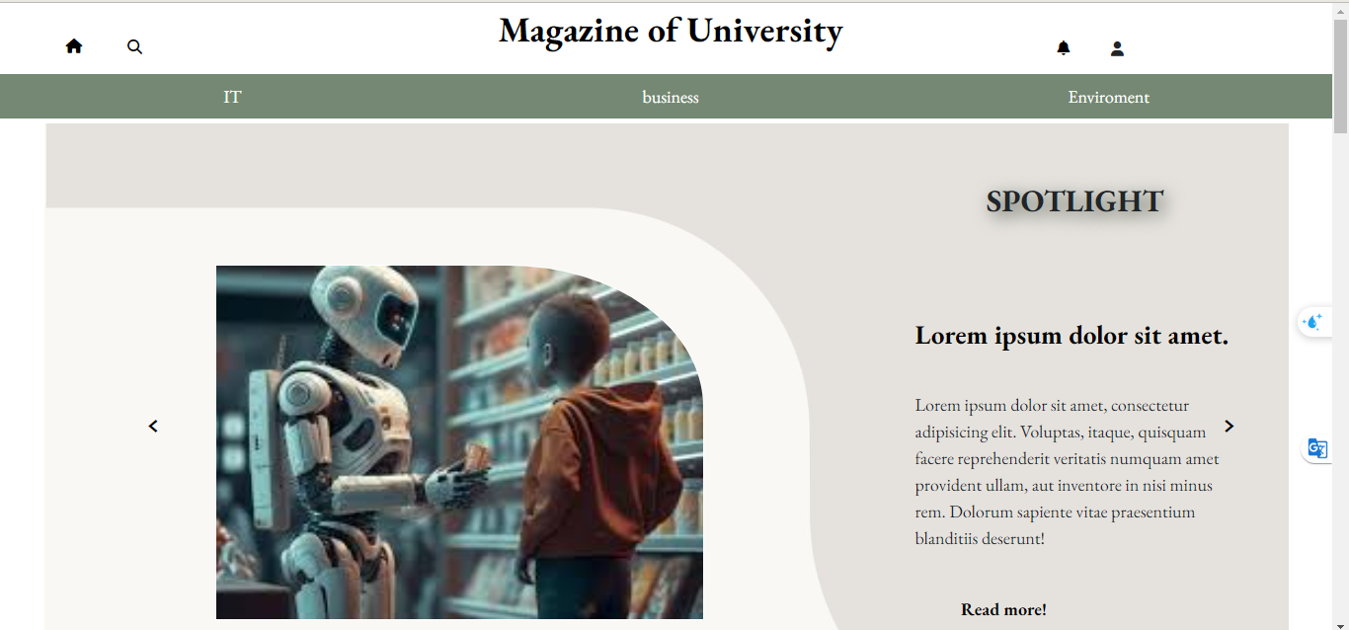

Our product 'School web magazine' has met all the necessary criteria that customers have requested. Thanks to the Agile method, we have the best conditions for product development and responding to rapid user changes. Agile method, dividing work into sprints, each sprint we do in 2 weeks. By dividing the work into smaller parts, problems were better controlled. Every day we have small meetings to update the project status and find ways to solve problems effectively. After each sprint, we can look back and evaluate to improve for the next sprint.

I'll talk briefly about our product, which allows students to participate in the writing process. This will encourage them to develop their writing and research skills. In addition, having a review and review coordinator helps ensure the quality of content on the website, while also creating an open learning and knowledge sharing environment.

Marketing administrator and admin will take on the role of website manager. Admin will ensure the security of information on the website.

Overall, the school newspaper website is not only a platform for sharing information but also a powerful tool to encourage student participation and creativity, creating a positive learning environment. and diversity.

1. **Evaluation of Team**

During the work process, there will certainly be some disagreements, but we still try to create a product together that we are all satisfied with. To evaluate the team members, I think I will evaluate myself first. As a first-time scrum master, I made some mistakes during the project management process. I didn't organize everyone's work very well, causing everyone to not be able to keep up with the tasks in the sprint I had set out. But on the other hand, I have supported people along the way when someone had difficulty with a task. The two frontend workers, Nghiem and Nhu, did their assigned job well. In the group, Hoang is the one who I feel does the best job, he completes the work before the deadline I assigned, it helps me a lot with my work. Thai, I think he did his job well. The last person is Phu, he also contributed to the project, but he did not work very well on schedule.

In short, it's quite difficult though. But my members did an excellent job and I am satisfied with the product our team delivered.

|  |  |  |  |  |  |  |  |
| --- | --- | --- | --- | --- | --- | --- | --- |
| Factor | | Nguyễn H.Tr.Phát | Trương H.G. Hoàng | Nguyễn Ng.Phú | Trần N.Thái | Ka Nghiêm | Phạm Ng.Q.Như |
| Attendance group meeting | 10 | 9 | 8 | 8 | 9 | 10 | 10 |
| Deadline keeping | 10 | 9 | 10 | 7 | 8 | 9 | 9 |
| Group communication | 10 | 9 | 8 | 8 | 9 | 9 | 9 |
| Working collaboration | 10 | 9 | 9 | 8 | 8 | 8 | 9 |
| Working independence | 10 | 10 | 10 | 9 | 10 | 10 | 10 |
| Contribute initiative | 10 | 10 | 9 | 9 | 9 | 10 | 10 |
| Technical competency | 10 | 9 | 10 | 9 | 9 | 9 | 9 |
| Working responsibility | 10 | 9 | 9 | 8 | 8 | 9 | 9 |
| Total | 10 | 9,25 | 9,125 | 8,25 | 8,75 | 9,25 | 9,375 |

1. **Self-evaluation**

As a scrum master I have done quite well, in terms of planning. Guide everyone to complete the project.

I am the one who integrates the code and does the logic to make the website function smoothly.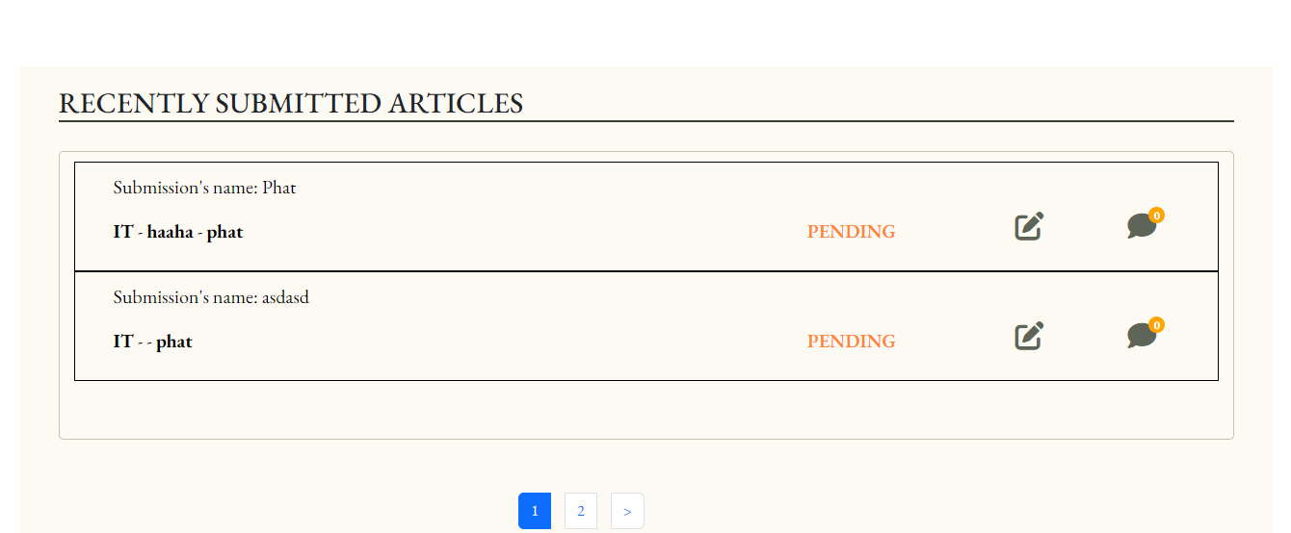

For example, in the image above, I have edited the logic to only display the currently logged in students' work, and display the number of work the student has submitted during the semester.

As for the backend, I do things like create a place to manage admin data and send emails after students submit their work.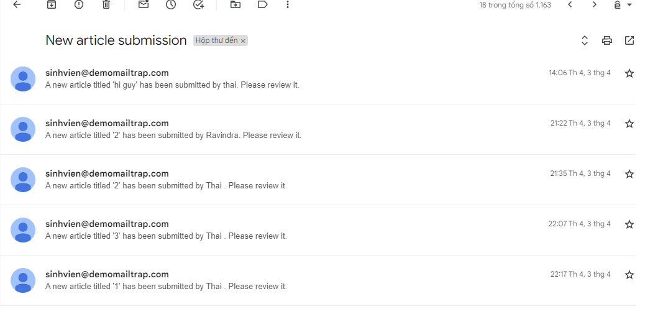

In addition to the above tasks, I also support the backend team when they have problems that cannot be resolved.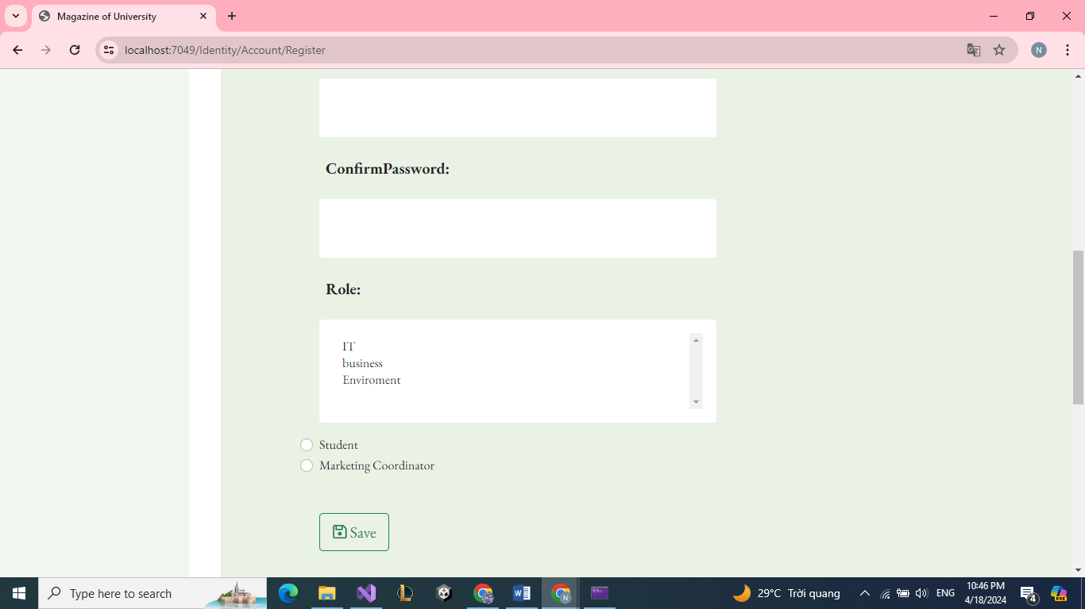

As shown in the image above, at first the member receiving this task had problems accessing the roles to select the department. I helped him fix this part and it worked fine.

In short, there are still some shortcomings in the project management process. But I still feel like I did quite well for my best friend.