Link github : https://github.com/TrongPhungF/AWS-cloud-dev

URL : <http://project-starter-code-dev.us-east-1.elasticbeanstalk.com/filteredimage?image_url=https://upload.wikimedia.org/wikipedia/commons/b/bd/Golden_tabby_and_white_kitten_n01.jpg>  
  
  
Starting the server with npm run dev runs a local instance of the server with no errors  
  
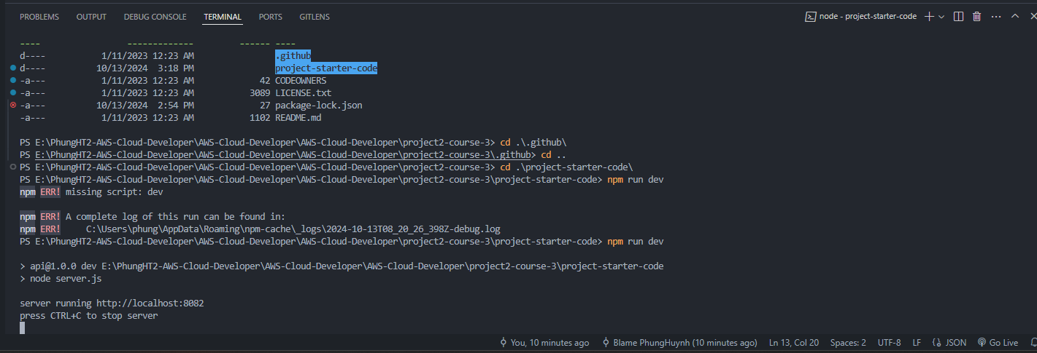  
  
The stubbed @TODO1 endpoint in src/server.js is completed and accepts valid requests including:   
  
  
The project includes functional cloud deployments  
  
