A screenshot shows Docker image pushed to ECR

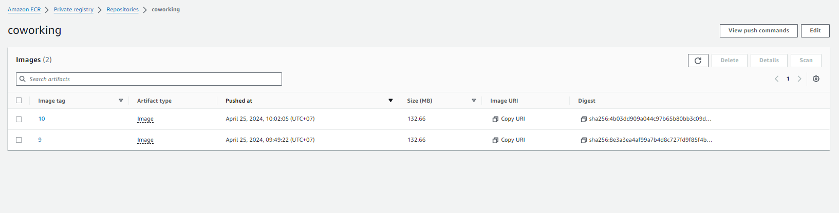

A screenshot of the AWS CodeBuild pipeline shows that the build process was triggered automatically and pushed a built Docker image into ECR

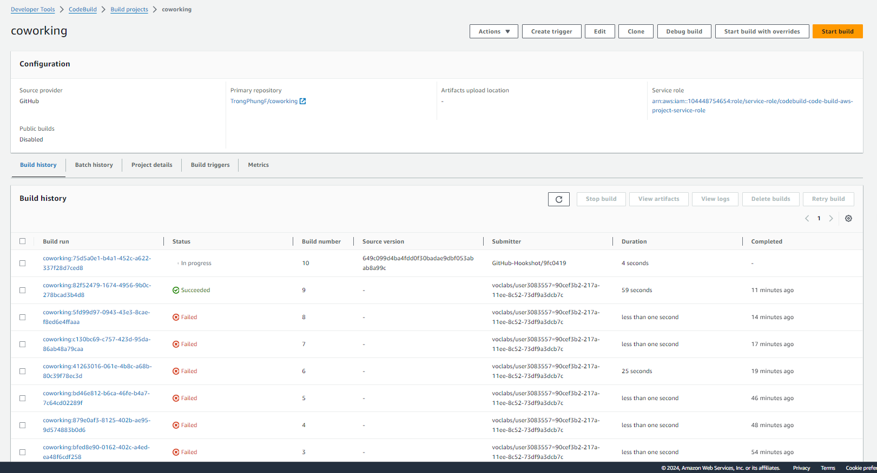  
  
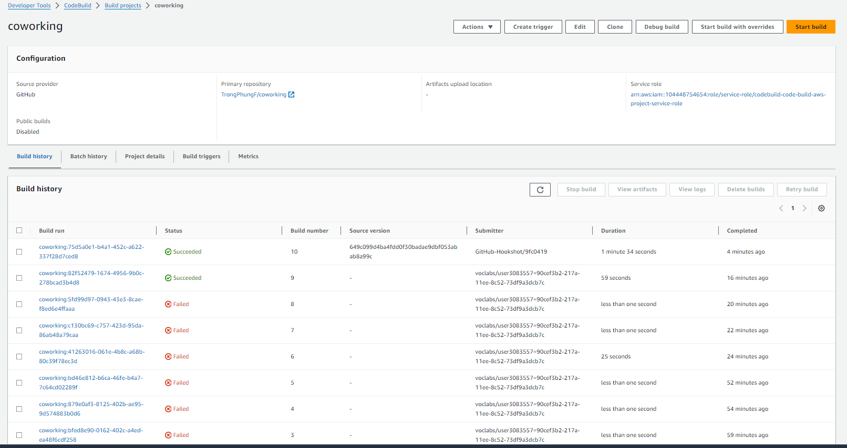

Successfully deploy Kubernetes service  
A screenshot of kubectl get svc shows a newly-created service

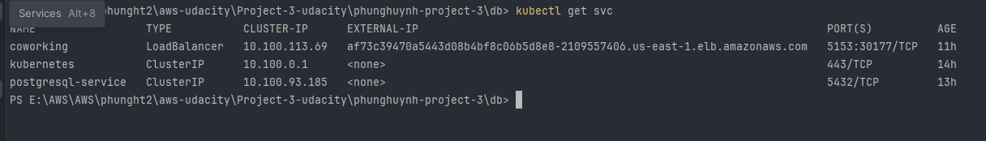

A screenshot of kubectl describes deployment <SERVICE_NAME>

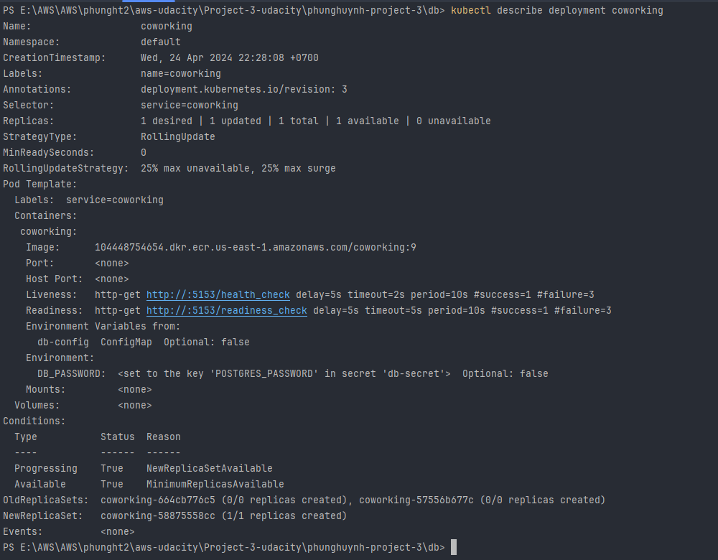

Screenshot of kubectl describe svc <DATABASE_SERVICE_NAME>  
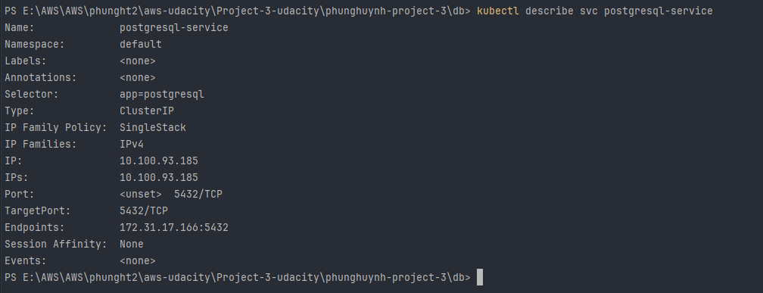

A screenshot of kubectl get pods shows the service in READY state with a RUNNING status.

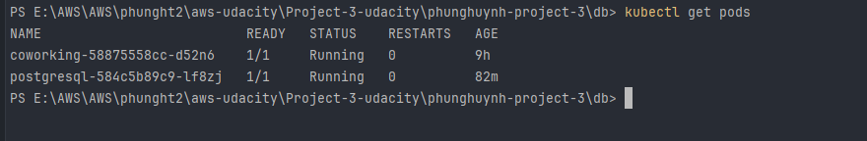

The screenshot of CloudWatch logs shows the logs of the application, which periodically prints the database output.

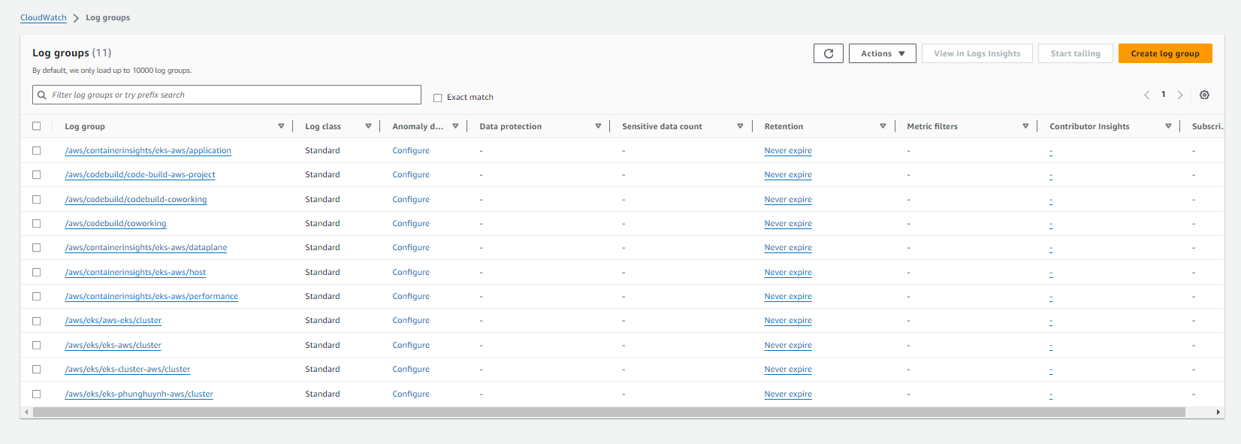

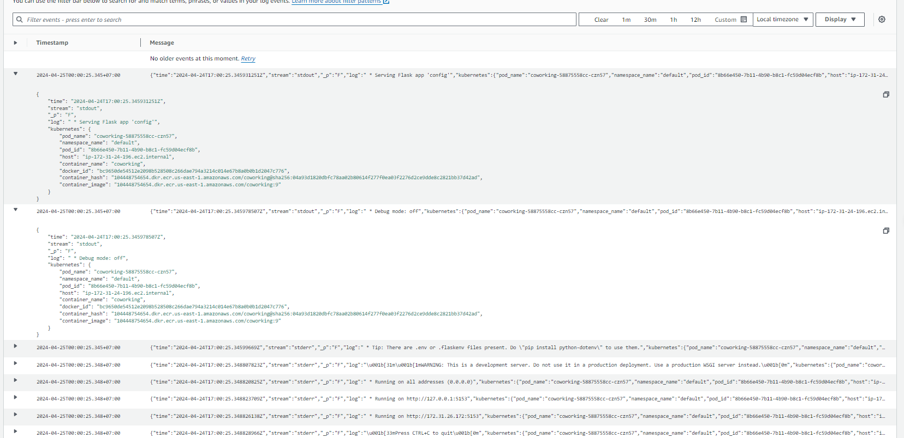

The output indicates that the application runs without errors.

