Create pull request GITHUB  
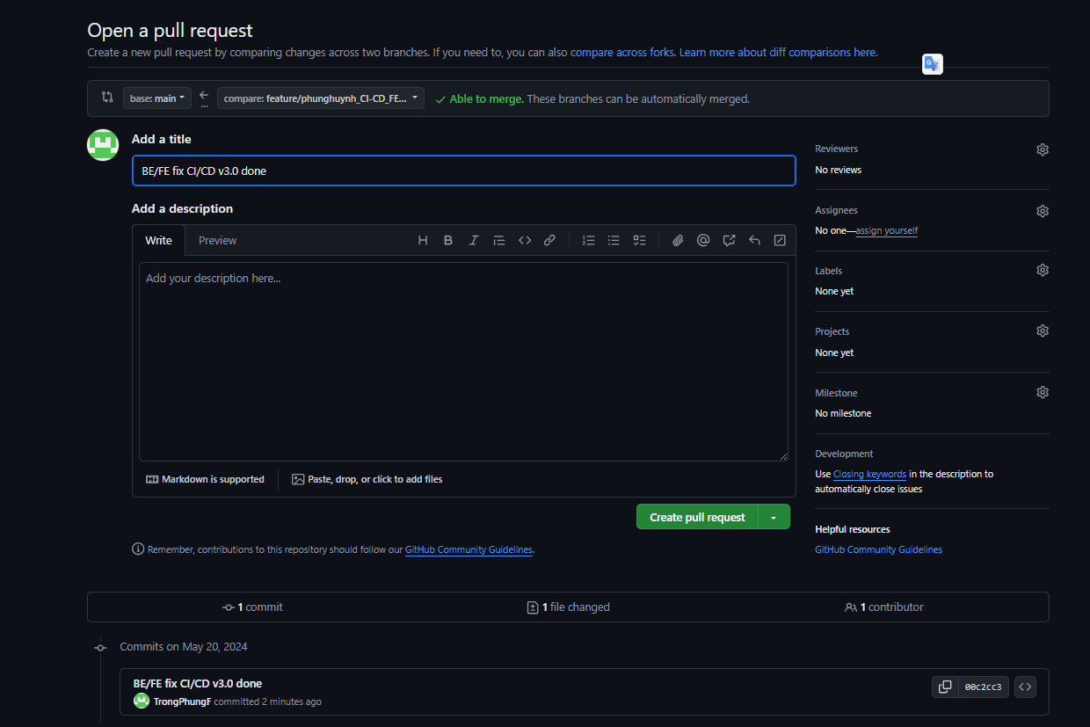  
  
BE-FE CI run  
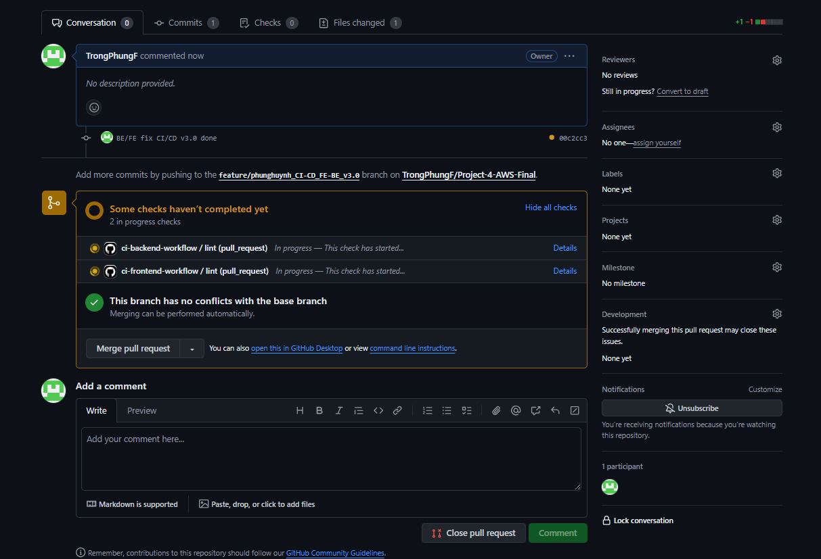  
  
  
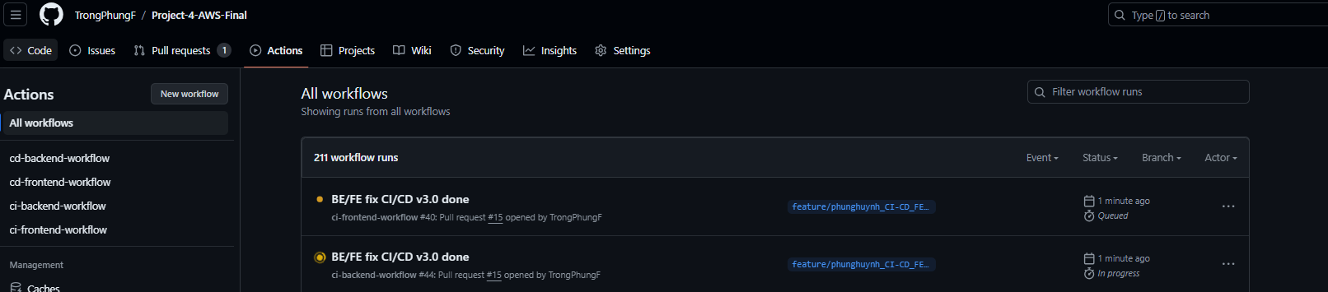

CI fe frontend-ci.yaml  
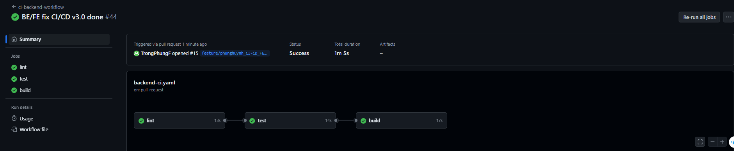

CI BE backend-ci.yaml  
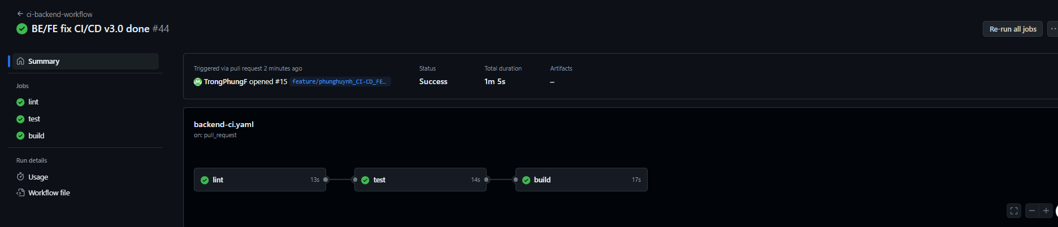  
  
BE-FE run done CI  
  
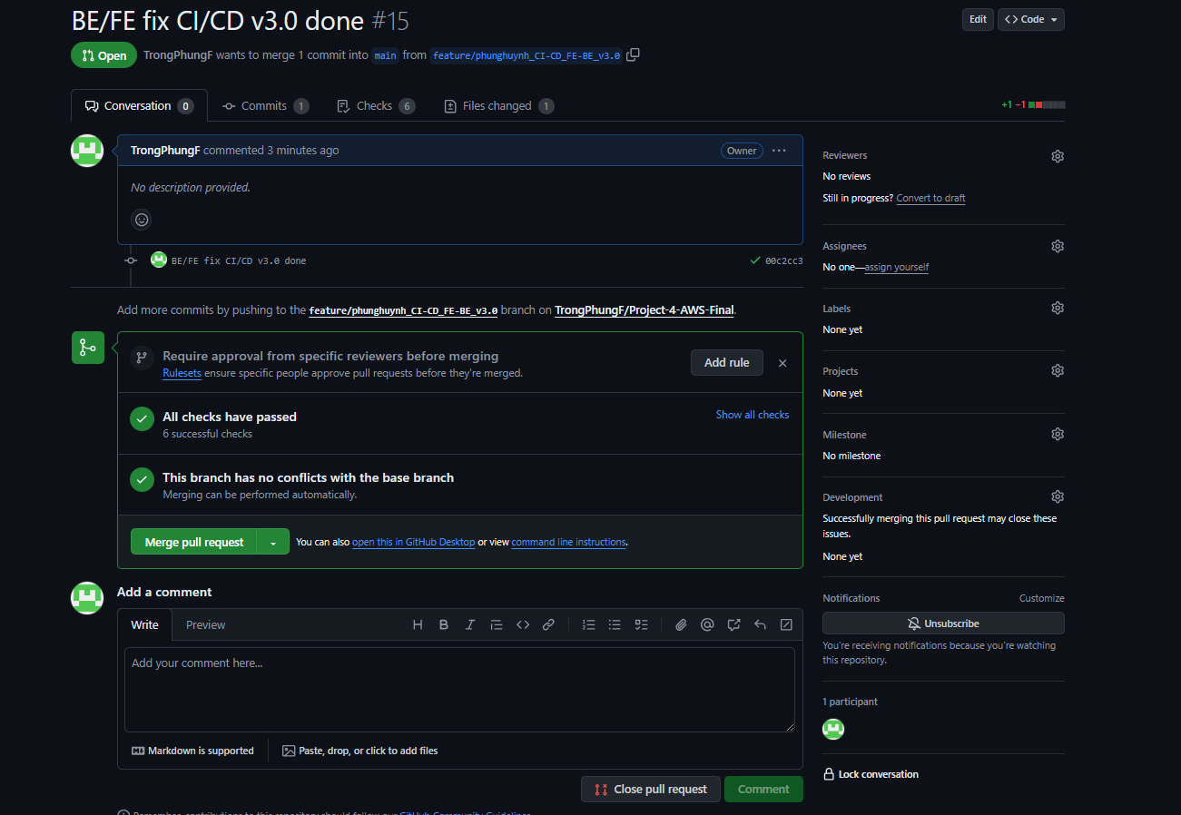  
  
Merge   
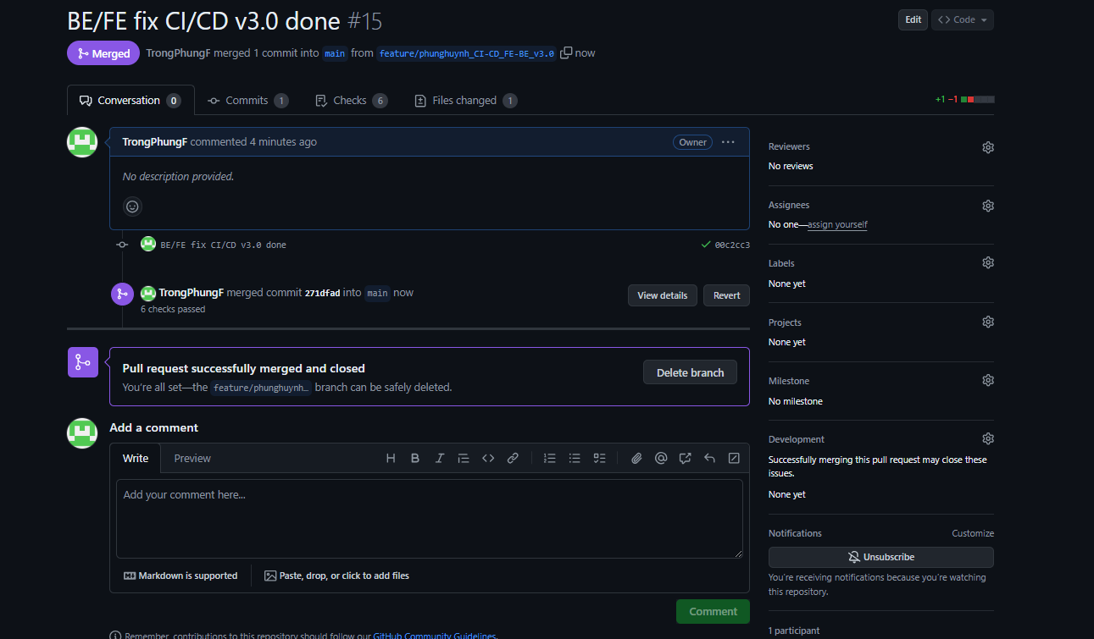  
  
CD FE/BE run  
  
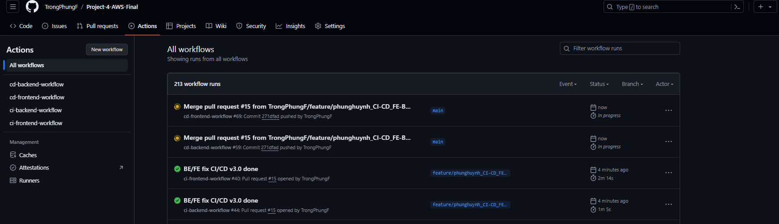  
  
CD backend done   
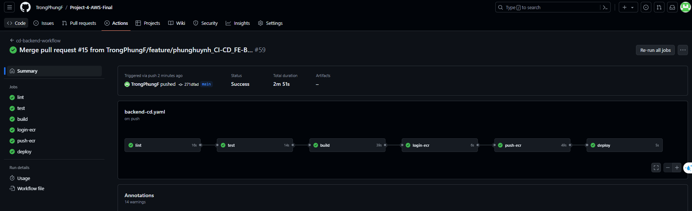

CD frontend done   
