Local machine:

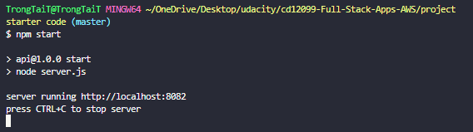

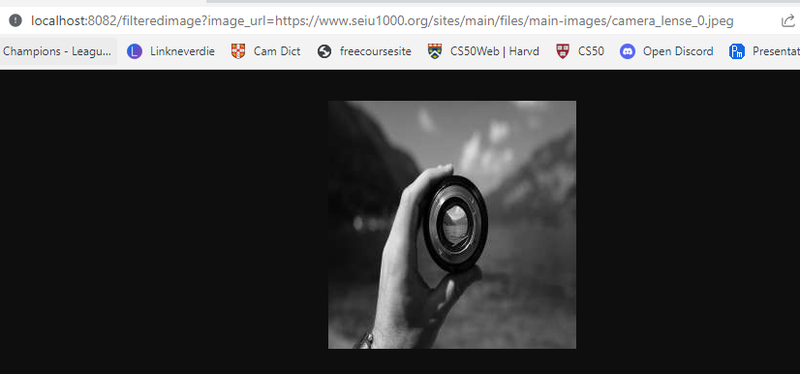

EB init:

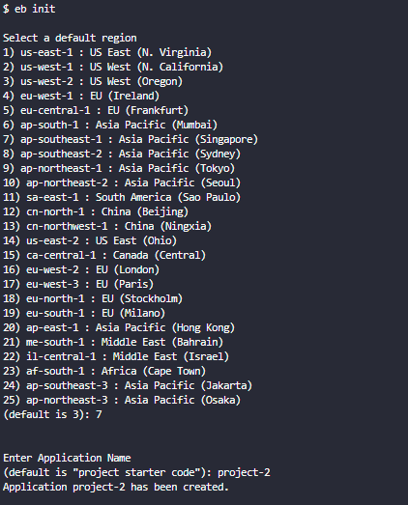

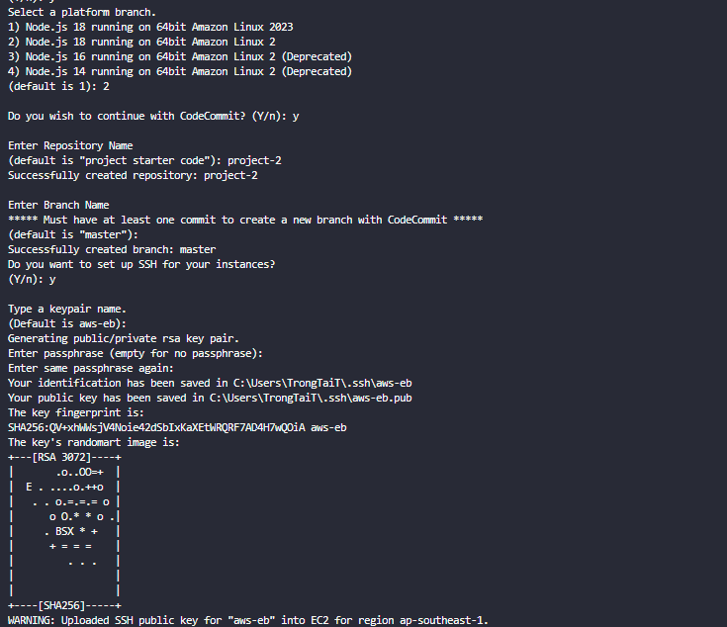

EB create:

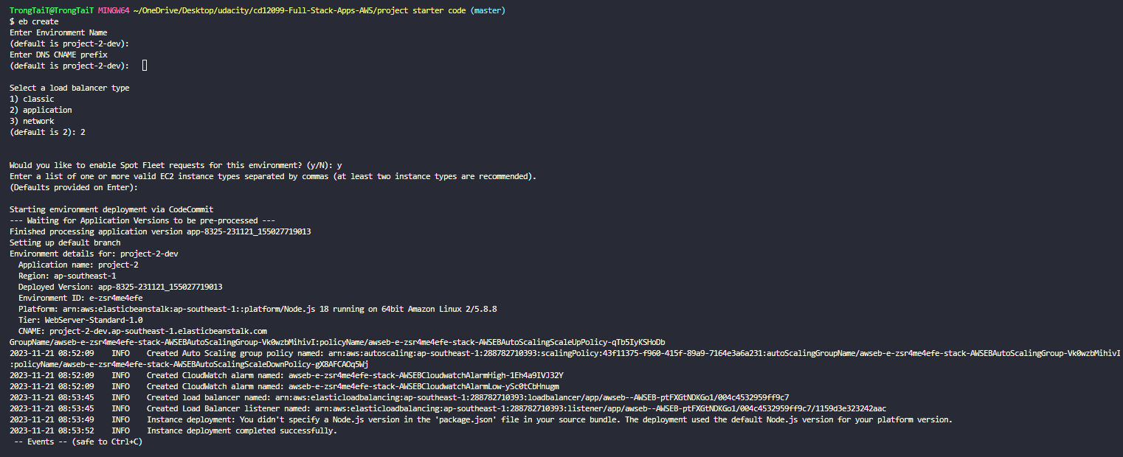

EB Deploy

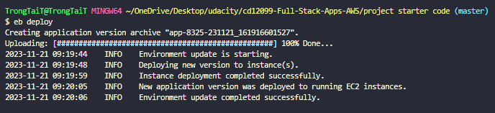

EB Event

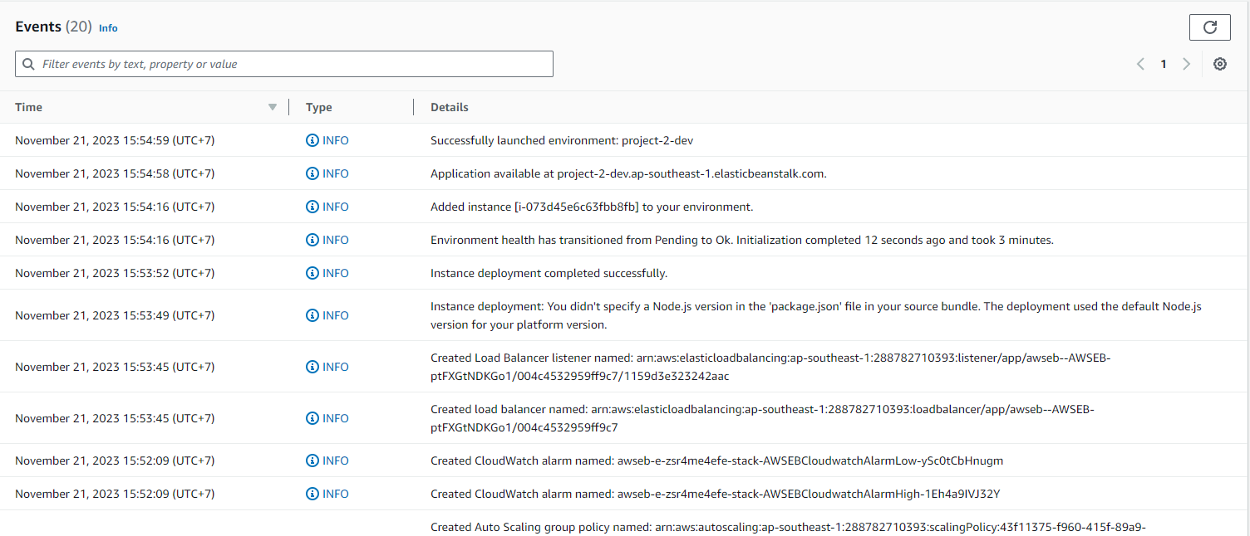  
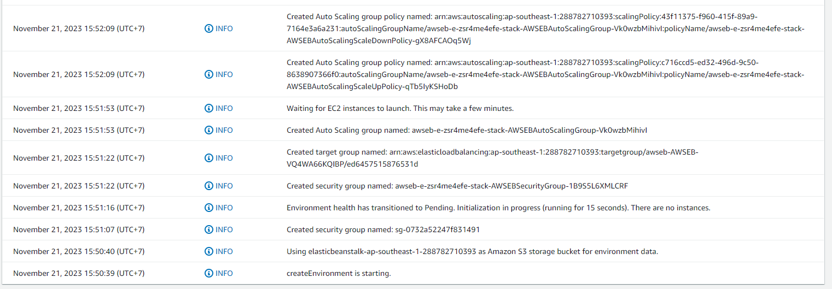

EB dashboard  
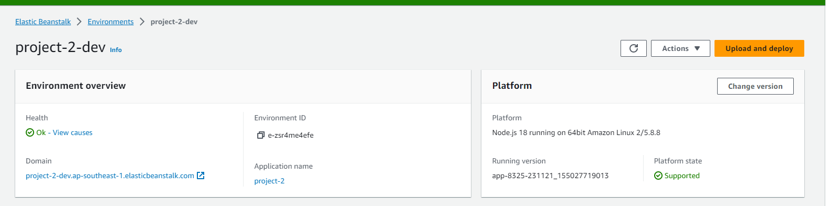

Load Balancer  
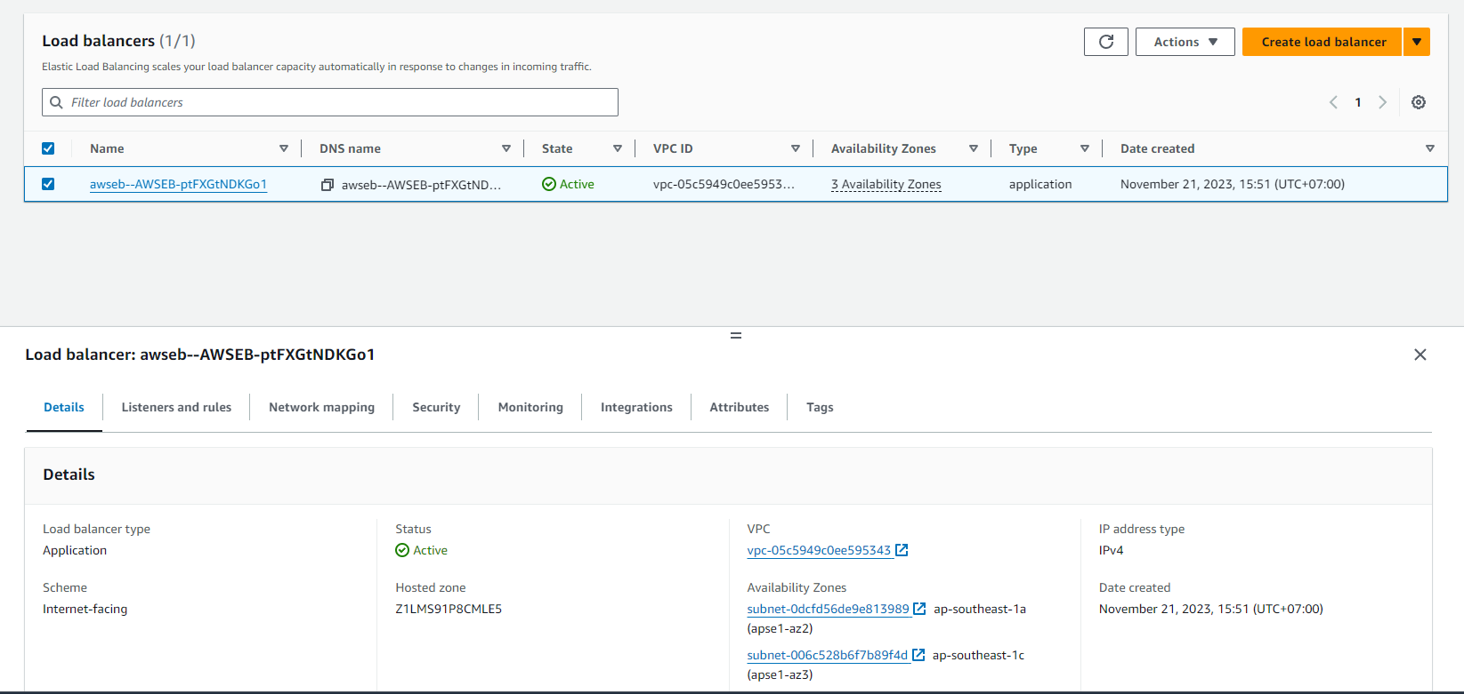

EC2:



Result:  
http://project-2-uda-dev.us-east-1.elasticbeanstalk.com/filteredimage?image_url=https://www.seiu1000.org/sites/main/files/main-images/camera_lense_0.jpeg

