# pi_ager install on Raspberry Pi 3/Pi 4/ Pi zero w under Pi OS (32-bit) with desktop and recommended software or Pi OS Lite

* For Pi 4/3: Download and install Raspberry Pi OS with desktop and recommended software from <https://www.raspberrypi.org/software/operating-systems/>
* For Pi zero: Download and install Raspberry Pi OS Lite from <https://www.raspberrypi.org/software/operating-systems/>
* Enable SSH for remote access

sudo touch /boot/ssh

* Setup WLAN configuration

Generate file wpa_supplicant.conf in /boot:

country=DE

ctrl_interface=DIR=/var/run/wpa_supplicant GROUP=netdev

update_config=1

network={

ssid="WLAN SSID"

psk="WLAN PASSWORT"

}

* Edit config.txt in /boot to support I2C and SPI devices:

# Additional overlays and parameters are documented /boot/overlays/README

# Use Pi-Ager Pins 11/13 GPIO 17/27 for I2C

dtoverlay=i2c-gpio,bus=3,i2c_gpio_sda=17,i2c_gpio_scl=27

# Use Pi-Ager Pin 16 for MCP3204

dtoverlay=spi1-1cs,cs0_pin=16

at the end of config.txt add the following lines to support bluetooth and Nextion TFT displays

via serial port /dev/serial0 :

[all]

start_x=0

enable_uart=1

dtoverlay=miniuart-bt

force_turbo=1

* Add in /boot/cmdline.txt at the end of line this to enable USB camera with fswebcam :

dwc_otg.fiq_fsm_mask=0x3

• Reboot system

* Edit /etc/modules to load i2c-dev at boot, add this line :

i2c-dev

* Add file :

sudo touch /etc/modprob.d/raspi-blacklist.conf

* Get a copy from Pi-Ager repository to your local system:

git clone –b entwicklung <https://github.com/Tronje-the-Falconer/Pi-Ager>

All project file are now in the folder ./Pi-Ager/

* Copy setup.txt from local repository to /boot/ and edit it as needed.
* Copy /etc/modprobe.d/Pi-Ager_i2c_off.conf.on from local repository to /etc/modprobe.d/
* Reboot system
* Install lighttpd:

sudo apt-get update

sudo apt-get upgrade

sudo apt-get install lighttpd

sudo systemctl status lighttpd

sudo nano /etc/lighttpd/lighttpd.conf

and change Parameter

server.document-root = "/var/www/html"

to

server.document-root = "/var/www"

sudo usermod -G www-data -a pi

sudo chown -R www-data:www-data /var/www

sudo chmod -R 755 /var/www

* Reboot system

For testing the web server, generate html-page:

sudo nano /var/www/test.html

with content:

<html>

<head><title>Test-Seite</title></head>

<body>

<h1>Das ist eine Test-Seite.</h1>

</body>

</html>

Enter your IP Address (or localhost) into the browser followed by /test.html

In addition we need .htcredentials to contain user and password.

Fort that we use the Online-Tool https://websistent.com/tools/htdigest-generator-tool/

Username: pi-ager

REALM: Pi-Ager

Password: raspberry

Caution! All entries are case sensitive!

Open this file now

sudo nano /var/.htcredentials

and fill in the string output from the generator tool.

Save file with “STRG+o”, “RETURN” and close with “STRG+x”

Now we have to setup the password authentification in lighttpd:

sudo nano /etc/lighttpd/conf-available/05-auth.conf

The following lines are added under server.modules += („mod_auth“) :

auth.backend = "htdigest"

auth.backend.htdigest.userfile = "/var/.htcredentials"

auth.require = ( "/settings.php" =>

(

"method" => "digest",

"realm" => "Pi-Ager",

"require" => "user=pi-ager"

),

"/admin.php" =>

(

"method" => "digest",

"realm" => "Pi-Ager",

"require" => "valid-user"

),

"/webcam.php" =>

(

"method" => "digest",

"realm" => "Pi-Ager",

"require" => "valid-user"

),

"/notification.php" =>

(

"method" => "digest",

"realm" => "Pi-Ager",

"require" => "valid-user"

)

)

Then we activate this modul:

sudo lighty-enable-mod auth

In addition we have to edit :

sudo nano /etc/lighttpd/conf-available/15-fastcgi-php.conf

add at the end of the line

"broken-scriptfilename" => "enable"

a “,” and in a new line

"allow-x-send-file" => "enable"

Save end exit nano.

Now enable these modules:

sudo lighty-enable-mod fastcgi

sudo lighty-enable-mod fastcgi-php

Now reload the the webserver:

sudo service lighttpd force-reload

Now continue to install additional modules:

* Install Git

sudo apt install git

* Install smbus

sudo apt-get install python3-smbus

* Install sqlite3:

sudo apt install sqlite3

* Install DHT sensor support

sudo pip3 install Adafruit-DHT

* Install SHT1x sensors

sudo pip3 install pi-sht1x

* Install libgd-dev (needed for new version of fswebcam)

sudo apt install libgd-dev

* Install fswebcam:

sudo apt install fswebcam

* Install influxdb

sudo pip3 install influxdb

• Install php 7.3

sudo apt install php7.3-common php7.3-cgi php7.3 php7.3-sqlite3

* Install additional modules for php7.3:

sudo apt install php7.3-apcu php7.3-fpm php7.3-mbstring php7.3-phpdebug

* Install wiringpi:

sudo apt install wiringpi

* Install wiringpi new version with Pi4 support :

cd /tmp

wget https://project-downloads.drogon.net/wiringpi-latest.deb

sudo dpkg -i wiringpi-latest.deb

* Copy gpio to /usr/local/bin

sudo cp /usr/bin/gpio /usr/local/bin

sudo chmod 4755 /usr/local/bin/gpio

* Install PiShrink

wget <https://raw.githubusercontent.com/Drewsif/PiShrink/master/pishrink.sh>

chmod +x pishrink.sh

sudo mv pishrink.sh /usr/local/bin

* Nextion serial client (HMI Dislplay support)

sudo pip3 install nextion

* php zip support:

sudo apt update

sudo apt install php-zip

* Install lsof command:

sudo apt update

sudo apt install lsof

* Install Locale en-GB and de-DE UTF-8 using

sudo raspi-config

* Enable Serial Interface, disable login, needed for HMI Nextion Display

sudo raspi-config

* Install zip and unzip:

sudo apt install zip unzip

* Workaround for Adafruit_DHT for Pi4:

In "/usr/local/lib/python3.7/dist-packages/Adafruit_DHT/platform_detect.py", you can add the followings at line #112 in the elif ladder, so it should workaround the issue.

elif match.group(1) == 'BCM2711':

return 3

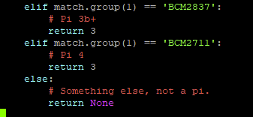

* Unblock wifi for Pi4, add rfkill unblock wifi and disable power management for wlan0:

cd /etc

sudo nano rc.local

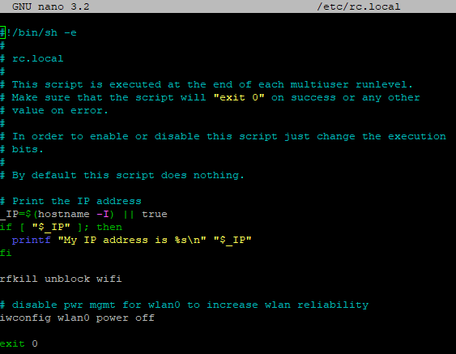

* Generate/edit crontab to prepare for automatic enable pi-ager_backup.sh

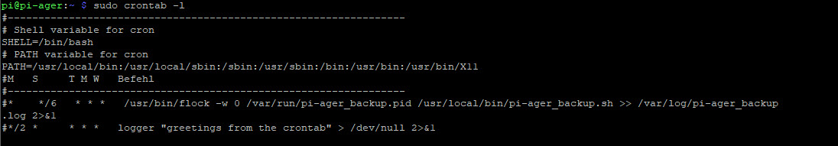

Use visudo to edit /etc/sudoers, so that the www-data User (User of Website) can execute /var/sudowebscript.sh :

sudo visudo

and then in sudoers following

...

#User privilege specification

root ALL=(ALL:ALL) ALL

...

adding:

www-data ALL=NOPASSWD:/var/sudowebscript.sh, /var/show_wifi_connections.sh, /var/updatessid.sh

Save and exit.

* Install Raspberry Pi automatic Hotspot

Information howto install can be found here : <https://www.raspberryconnect.com/projects/65-raspberrypi-hotspot-accesspoints/183-raspberry-pi-automatic-hotspot-and-static-hotspot-installer>

cd ~

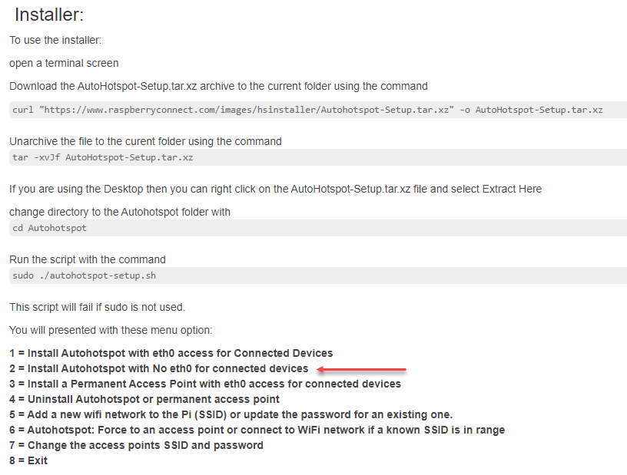

Select option 2:

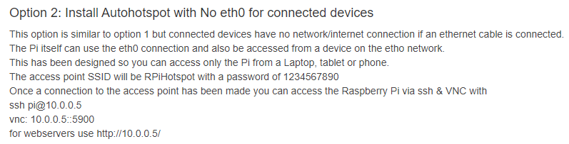

Then exit and reboot

Setup a timer for autohotspot so that connectivity is checked every 2 minutes:

sudo nano /etc/crontab

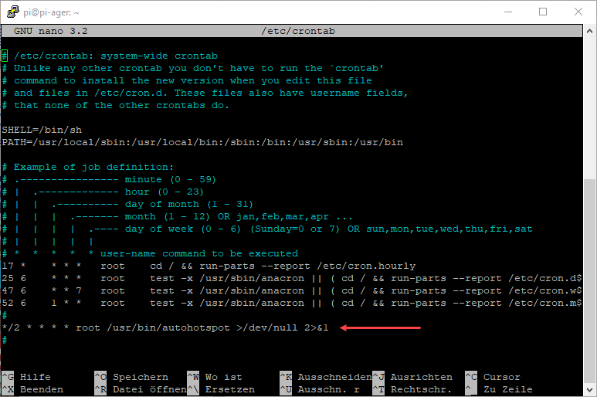

From your local pi-ager repository copy /usr/bin/autohotspot to /usr/bin/ and change rights to 755. This version of autohotspot script checks also if this script is already running and stops execution if an instance of this script is active.

* Install Bluetooth modules to support Bluetooth Temp./Hum Sensor from Xiaomi
* sudo pip3 install bluepy requests
* sudo apt install bluetooth libbluetooth-dev
* sudo pip3 install pybluez pycryptodomex
* cd /opt
* sudo git clone <https://github.com/JsBergbau/MiTemperature2.git>
* copy MiCallback.sh from repository /opt/MiTemperature2 to Pi and enable execute rights for all
* sudo chmod +x MiCallback.sh
* copy my_thermometer.txt from repository /opt/MiTemperature2 to Pi and enable write rights for all
* sudo chmod +w my_thermometer.txt
* Now copy all files and folders from your local git repository /var/www to /var/www/
* from local repository /opt/pi-ager/ to /opt/pi-ager/
* from local repository /var/sudowebscript.sh to /var/ and change rights to 555
* from local repository /var/show_wifi_connections.sh to /var/ and change rights to 555
* from local repository /var/updatessid.sh to /var/ and change rights to 555
* sudo chown –R www-data:www-data /var/www
* sudo chown root:root /var/www/
* sudo usermod –G gpio –a www-data
* sudo chmod 666 /var/www/logs/logfile.txt
* sudo chown –R root:root /var/www/logs
* sudo chmod 755 /var/www/logs/
* sudo chmod 664 /var/www/config/pi-ager.sqlite3
* sudo chown -R www-data:www-data /var/www/config/
* sudo chmod 775 /var/www/config/
* sudo chmod 555 /var/sudowebscript.sh
* from local repository /usr/local/bin/*.sh copy all to /usr/local/bin/

(pi-ager_backup.sh, pi-ager_image.sh,setup_pi-ager.sh)

Set +x mode to the scripts :

sudo chmod +x /usr/local/bin/*.sh

* from local repository /lib/systemd/system copy the following files to

/lib/systemd/system/ :

pi-ager_main.service

setup_pi-ager.service

* from local repository /usr/bin copy the following file to /usr/bin/. This is a newer version of fswebcam with re-get frame on error.

fswebcam

Set +x mode to fswebcam:

sudo chmod +x /usr/bin/fswebcam

* from local repository /usr/share/man/man1/fswebcam.1.gz copy the following file to /usr/share/man/man1/

fswebcam.1.gz

* Enable setup_pi-ager.service to initialize system with data from /boot/setup.txt after next reboot:

sudo systemctl enable setup_pi-ager

sudo reboot