Pi-Ager install on Raspberry Pi 3/Pi 4/Pi zero (2)w under Pi OS 12 Lite bookworm

- For all Pi:
Download and install Raspberry Pi Imager v1.8.4 or later.
Start Raspberry Pi Imager, then select:
Raspberry Pi Device:
NO FILTERING
Operating System:
Raspberry Pi OS Lite (32-bit) ( A port of Debian Bookworm with no desktop environment)
Storage:
Use an USB Reader and choose your SD-Card, min. 8 GB
Then click ‘NEXT’
In popup Window ‘Use OS customisation’ select ‘EDIT SETTINGS’.
In the ‘GENERAL’ Tab edit your settings:

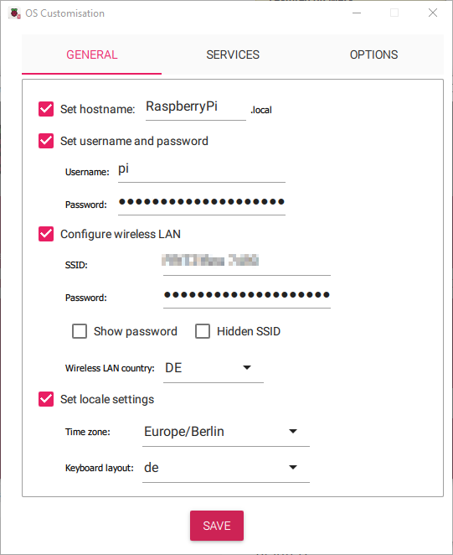

In the ‘SERVICES’ Tab enable SSH:

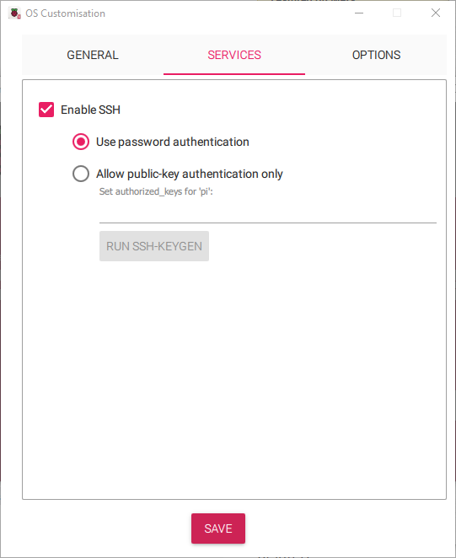

Then ‘SAVE’ and apply OS customisation settings with ‘YES’.
The customized OS is now written to your SD-Card.
Put your SD-Card in your Raspberry Pi and power on your Pi device.
Login via SSH (e.g. use PuTTY) or connect a HDMI monitor and USB keyboard to
your Raspberry device and continue with the setup as described below.

- To allow root login:
In /etc/ssh/sshd_config : remove # from PermitRootLogin and replace prohibit-password to yes. Then restart ssh server: sudo service ssh restart
Set your root password with: sudo passwd root

- Run raspi-config and disable login shell on serial port and enable serial port

- Edit config.txt in /boot/firmware to support I2C and SPI devices:

CAUTION: If you want to edit config.txt ,cmdline.txt and setup.txt under Windows in a Terminal Window, e.g. using Terminal Apps like PuTTY, the Linux folder /boot/firmware on the SD-Card is mapped to a windows partition FAT32 USB Drive named bootfs and contains the above mentioned files.

# Additional overlays and parameters are documented /boot/overlays/README
# Use Pi-Ager Pins 11/13 GPIO 17/27 for I2C
dtoverlay=i2c-gpio,bus=3,i2c_gpio_sda=17,i2c_gpio_scl=27
# Use Pi-Ager Pin 16 for MCP3204
dtoverlay=spi1-1cs,cs0_pin=16

at the end of config.txt add the following lines to support bluetooth and Nextion TFT displays
via serial port /dev/serial0 :
[all]
enable_uart=1
dtoverlay=miniuart-bt
dtparam=uart0=on
# force_turbo=1

- Add in /boot/firmware/cmdline.txt at the end of line this to enable USB camera with fswebcam :
dwc_otg.fiq_fsm_mask=0x3

• Reboot system

- Edit /etc/modules to load i2c-dev at boot, add this line :
i2c-dev

- Add file :
sudo touch /etc/modprobe.d/raspi-blacklist.conf

- Install git: sudo apt install git

- Get a copy from Pi-Ager repository to your local system:
git clone –depth=1 –b master https://github.com/Tronje-the-Falconer/Pi-Ager
All project file are now in the folder ./Pi-Ager/
Change working directory to Pi-Ager
cd Pi-Ager

- Copy setup.txt from local repository to /boot/ and edit it as needed:
sudo cp ./boot/setup.txt /boot/firmware/
Create a symbolic link in /boot to /boot/firmware/setup.txt
cd /boot
sudo ln –s /boot/firmware/setup.txt setup.txt

- Copy /etc/modprobe.d/Pi-Ager_i2c_off.conf.on from local repository to /etc/modprobe.d/
sudo cp ./etc/modprobe.d/Pi-Ager_i2c_off.conf.on /etc/modprobe.d/

- Reboot system

- Update system:
sudo apt-get update
sudo apt-get upgrade

• Install php 8:
sudo apt install php-fpm php-cli
sudo apt install php
sudo apt install php-common php-sqlite3

- Install additional modules for php:
sudo apt install php-mbstring php-zip php-curl

- Install lighttpd:
sudo apt-get install lighttpd
sudo systemctl status lighttpd

sudo nano /etc/lighttpd/lighttpd.conf
and change/add Parameter

server.document-root = "/var/www/html"
to
server.document-root = "/var/www"
add “mod_auth” to server.modules list
add “mod_authn_file” to server.modules list
Save and close nano

To enable PHP8 in Lighttpd, we must modify /etc/php/8.2/fpm/php.ini and uncomment the line cgi.fix_pathinfo=1. In my php.ini file, I found it on line 807. To uncomment, just remove the semicolon in the beginning.

sudo usermod -G www-data -a pi
sudo chown -R www-data:www-data /var/www
sudo chmod -R 755 /var/www

- Reboot system

For testing the web server, generate html-page:

sudo nano /var/www/test.html
with content:

<html>
<head><title>Test-Seite</title></head>
<body>
<h1>Das ist eine Test-Seite.</h1>
</body>
</html>

Change owner: sudo chown www-data:www-data /var/www/test.html

Enter your IP Address into the browser followed by /test.html

In addition we need .htcredentials to contain user and password.

For that we use the Online-Tool https://websistent.com/tools/htdigest-generator-tool/

Username: pi-ager
REALM: Pi-Ager
Password: raspberry
Caution! All entries are case sensitive!

Open this file now

sudo nano /var/.htcredentials

and fill in the string output from the generator tool.

Save file with “STRG+o”, “RETURN” and close with “STRG+x”

Now we have to setup the password authentification in lighttpd:

sudo nano /etc/lighttpd/conf-available/05-auth.conf
The following lines are added under server.modules += („mod_auth“) :

auth.backend = "htdigest"
auth.backend.htdigest.userfile = "/var/.htcredentials"

auth.require = ( "/settings.php" =>
(
"method" => "digest",
"realm" => "Pi-Ager",
"require" => "user=pi-ager"
),
"/admin.php" =>
(
"method" => "digest",
"realm" => "Pi-Ager",
"require" => "valid-user"
),
"/webcam.php" =>
(
"method" => "digest",
"realm" => "Pi-Ager",
"require" => "valid-user"
),
"/notification.php" =>
(
"method" => "digest",
"realm" => "Pi-Ager",
"require" => "valid-user"
)
)

Then we activate this modul:
sudo lighty-enable-mod auth

In addition we have to edit :
sudo nano /etc/lighttpd/conf-available/15-fastcgi-php-fpm.conf

Add “broken-scriptfilename” and “x-sendfile” :
fastcgi.server += ( ".php" =>
((
"socket" => "/run/php/php-fpm.sock",
"broken-scriptfilename" => "enable",
"x-sendfile" => "enable"
))
)

save and close nano

Now enable these modules:
sudo lighty-enable-mod fastcgi-php-fpm

Now reload the the webserver:
sudo service lighttpd force-reload

Now continue to install additional modules:

- Install smbus
sudo apt-get install python3-smbus2

- Install sqlite3:
sudo apt install sqlite3

- Install pip3
sudo apt install python3-pip

CAUTION : sudo pip3 install <module> no longer supported.
If you see an error message, try to install the module with
sudo apt install python3-<module name>. If this does not work, try install modules with
sudo pip3 install <module name> –break-system-packages

error: externally-managed-environment
× This environment is externally managed
╰─> To install Python packages system-wide, try apt install
python3-xyz, where xyz is the package you are trying to
install.

If you wish to install a non-Debian-packaged Python package,
create a virtual environment using python3 -m venv path/to/venv.
Then use path/to/venv/bin/python and path/to/venv/bin/pip. Make
sure you have python3-full installed.

If you wish to install a non-Debian packaged Python application,
it may be easiest to use pipx install xyz, which will manage a
virtual environment for you. Make sure you have pipx installed.

See /usr/share/doc/python3.11/README.venv for more information.
note: If you believe this is a mistake, please contact your Python installation or OS distribution provider. You can override this, at the risk of breaking your Python installation or OS, by passing --break-system-packages.
hint: See PEP 668 for the detailed specification.

- Install SHT1x sensors
sudo pip3 install pi-sht1x

- Install libgd-dev (needed for new version of fswebcam)
sudo apt install libgd-dev

- Install openssl dev package
sudo apt install libssl-dev

- Install fswebcam:
sudo apt install fswebcam

- Install cryptography
sudo apt install python3-cryptography

- Install uuidgen
sudo apt install uuid-runtime

- Install wiringpi new version with Pi 5 support :
cd /tmp
sudo apt purge wiringpi
wget https://github.com/phylax2020/WiringPi/releases/download/3.16/wiringpi_3.16_armhf.deb
sudo apt install ./wiringpi_3.16_armhf.deb

- Install RPi.GPIO new version with support for RPi 5
cd /tmp
sudo apt purge python3-RPi.GPIO or
sudo pip3 uninstall RPi.GPIO –break-system-packages
wget https://github.com/phylax2020/RPi.GPIO/releases/download/v0.8.6/python3-rpi.gpio_0.8.6-1_armhf.deb
sudo apt install python3-rpi.gpio_0.8.6-1_armhf.deb

- Nextion serial client (HMI Dislplay support)
sudo pip3 install nextion

- Install lsof command:
sudo apt update
sudo apt install lsof

- Install Locale en-GB and de-DE UTF-8 using
sudo raspi-config

- Enable Serial Interface, disable login, needed for HMI Nextion Display
sudo raspi-config

- Install zip and unzip:
sudo apt install zip unzip

- Install schedule
sudo apt install python3-schedule

- Install MQTT client
sudo apt install python3-paho-mqtt

- Unblock wifi for Pi4, add rfkill unblock wifi and disable power management for wlan0:
cd /etc
sudo nano rc.local

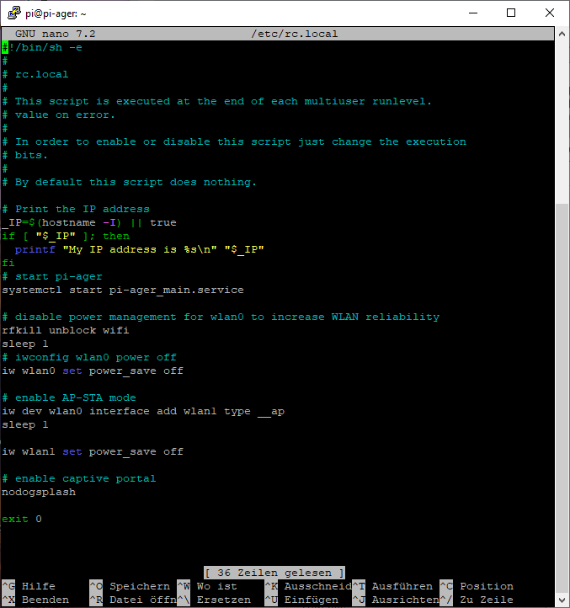

- Only if wanted: Generate/edit crontab to prepare for automatic enable pi-ager_backup.sh
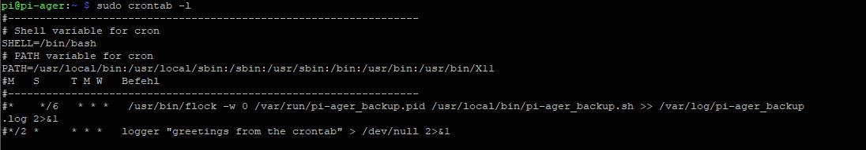

- Use visudo to edit /etc/sudoers, so that the www-data User (User of Website) can execute /var/sudowebscript.sh :
sudo visudo
and then in sudoers following
...
#User privilege specification
root ALL=(ALL:ALL) ALL
...
adding:

www-data ALL=NOPASSWD:/var/sudowebscript.sh, /var/show_wifi_connections.sh, /var/updatessid.sh,/usr/bin/raspi-config,/usr/bin/nmcli

Save and exit.

- Install access point with network manager:
Copy from repository /usr/local/bin/setup_pi-ager-ap.sh to destination.
Create virtual interface wlan1:
sudo iw dev wlan0 interface add wlan1 type __ap
then run script :
cd /usr/local/bin
sudo ./setup_pi-ager-ap.sh

- Install nodogsplash captive portal
sudo apt install iptables
sudo apt install libmicrohttpd-dev
cd ~
git clone https://github.com/nodogsplash/nodogsplash.git
cd ./nodogsplash
make
sudo make install
copy all from repository /etc/nodogsplash to /etc/nodogsplash
sudo chmod +x /usr/bin/nodogsplash
sudo chmod +x /usr/bin/ndsctl

- Install Bluetooth modules to support Bluetooth Temp./Hum Sensor from Xiaomi
- sudo apt install libglib2.0-dev
- sudo pip3 install bluepy requests
- sudo apt install bluetooth libbluetooth-dev
- # sudo pip3 install pybluez pycryptodomex
- Patch btle.py to stop intermittend errors:
File : /usr/local/lib/python3.11/dist-packages/bluepy/btle.py :
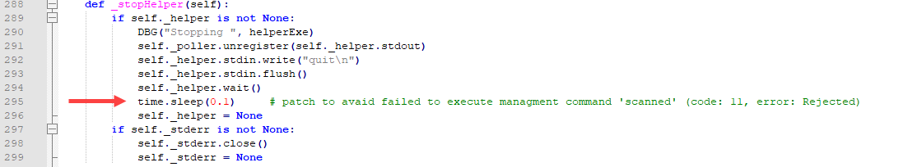

- Now copy all files and folders from your local git repository /var/www to /var/www/
- from local repository /opt/pi-ager/ to /opt/pi-ager/
- from local repository /var/sudowebscript.sh to /var/
- sudo chown –R www-data:www-data /var/www
- sudo usermod –G gpio –a www-data
- sudo chmod 666 /var/www/logs/logfile.txt
- sudo chmod 755 /var/www/logs/
- sudo chmod 664 /var/www/config/pi-ager.sqlite3
- sudo chown -R www-data:www-data /var/www/config/
- sudo chmod 777 /var/www/config/
- sudo chmod 555 /var/sudowebscript.sh /var/updatessid.sh /var/show_wifi_connections.sh
- from local repository /usr/local/bin/*.sh copy all to /usr/local/bin/
(pi-ager_backup.sh, pi-ager_image.sh,setup_pi-ager.sh)
Set +x mode to the scripts :
sudo chmod +x /usr/local/bin/*.sh

- from local repository /lib/systemd/system copy the following files to
/lib/systemd/system/ :
pi-ager_main.service
setup_pi-ager.service
Then activate these services:
sudo systemctl daemon-reload

- from local repository /usr/bin copy the following file to /usr/bin/. This is a newer version of fswebcam with re-get frame on error.
fswebcam
Set +x mode to fswebcam:
sudo chmod +x /usr/bin/fswebcam

- from local repository /usr/share/man/man1/fswebcam.1.gz copy the following file to /usr/share/man/man1/
fswebcam.1.gz

- Restart system
sudo reboot

How to generate and deploy Pi-Ager Images

There are some steps to do for generating and deploying a new image from a running Pi-Ager system:
- Setup a NFS Server to store a new image. The best way is using a Raspi 4B or 5 equipped with an USB Memory stick with 128GB or more. Using RPi 5 it is now possible to add a NVME SSD so that there will be enough space for storing one or more images.
- On the NFS Server System Install Pi Power Tools using the well-known Pi-Apps.
- On the Pi-Ager setup and start an Image backup on the ADMIN page. For example :
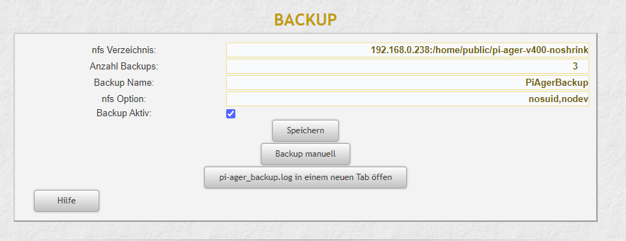

- Next start a terminal on the Pi-Ager and start the pi-ager_image.sh script with option -l:
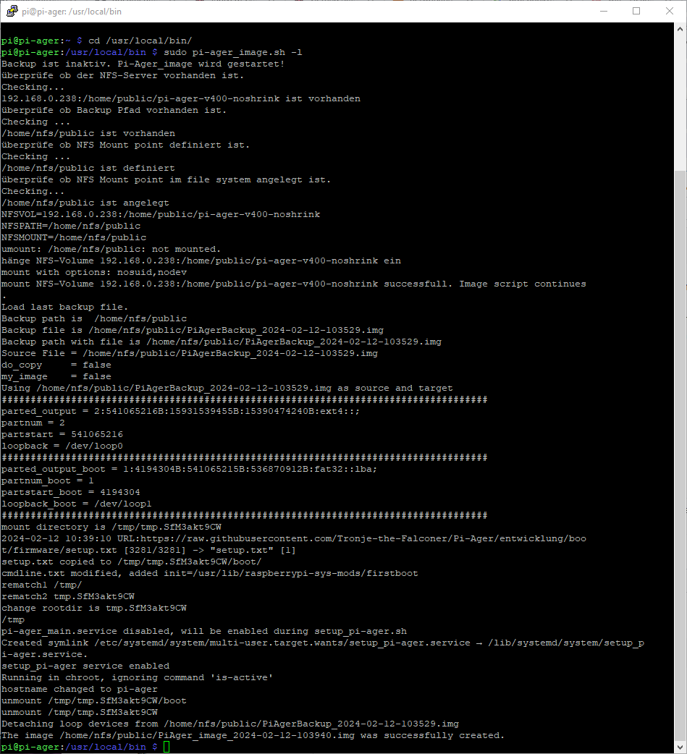
- Zip and deploy your new image.

