Pi-Ager install on Raspberry Pi 3/Pi 4/Pi 5/Pi zero (2)w under Pi OS 12 Lite bookworm

- For all Pi:
Download and install Raspberry Pi Imager v1.8.4 or later.
Start Raspberry Pi Imager, then continue as follows:

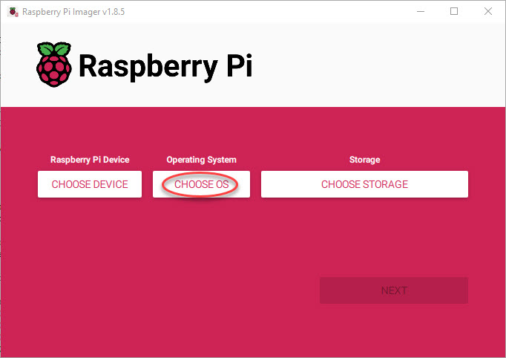

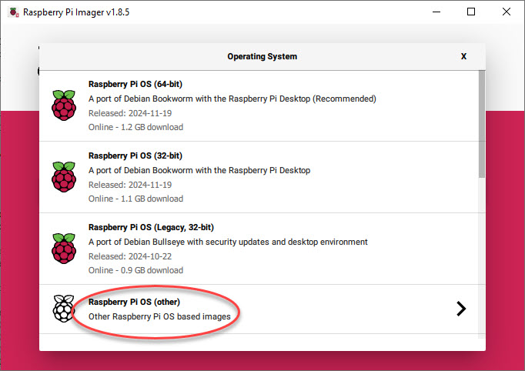

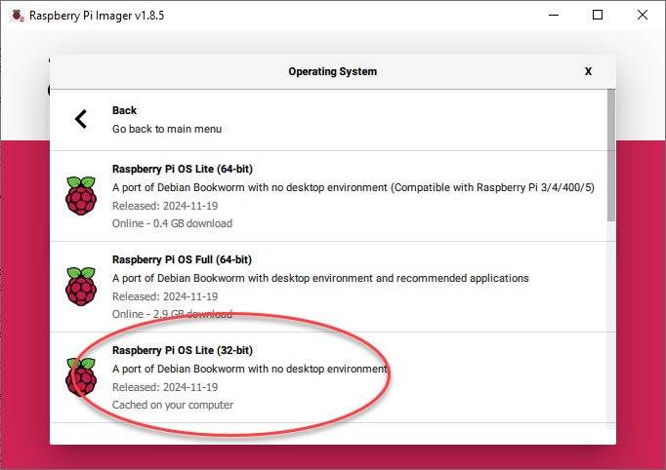

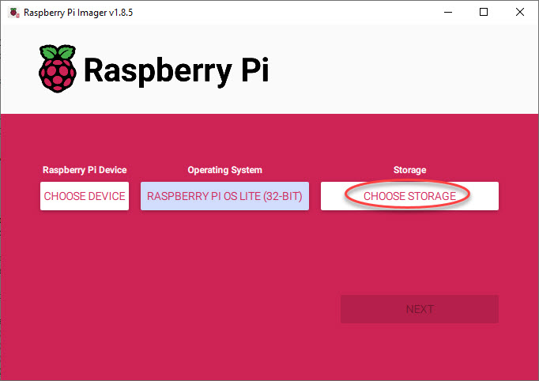

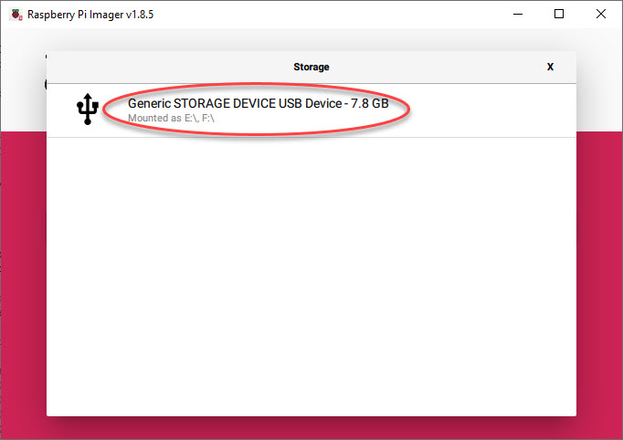

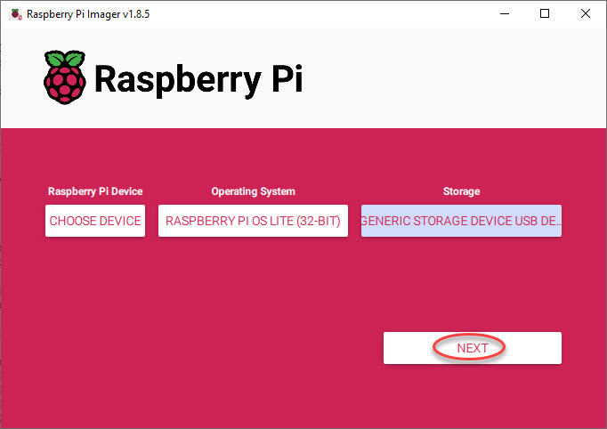

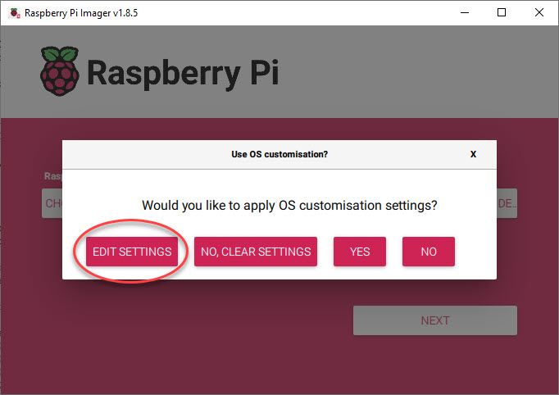

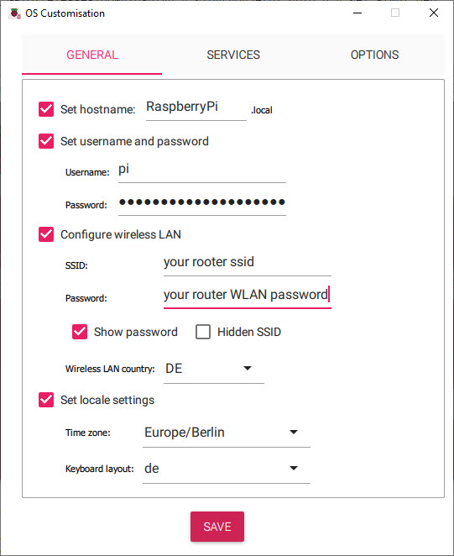

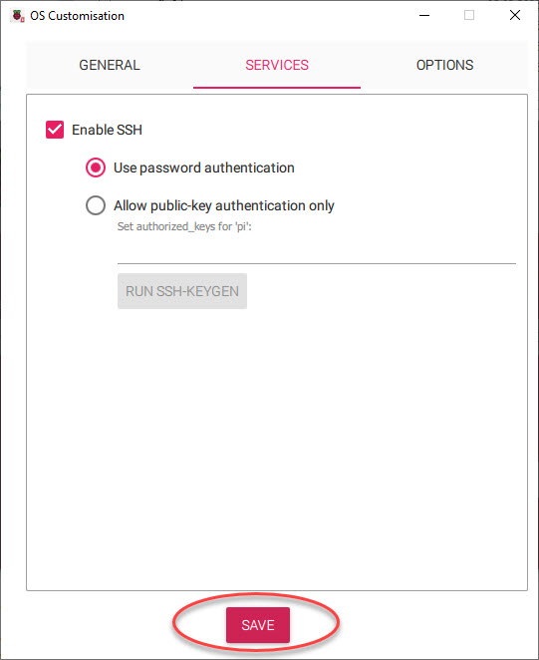

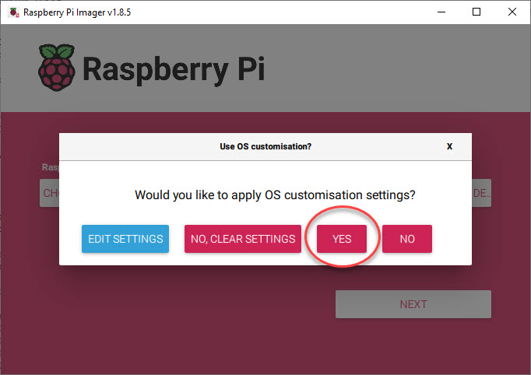

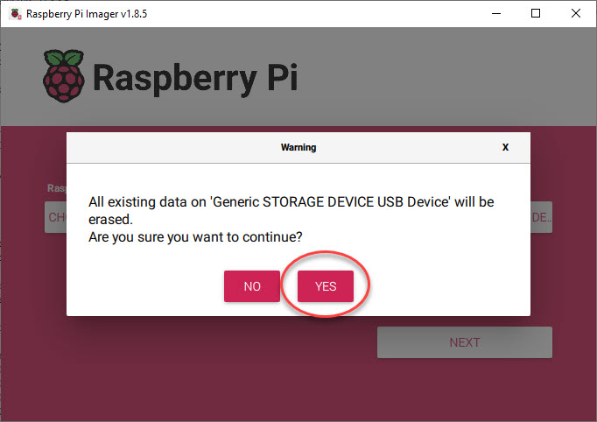

Then ‘SAVE’ and apply OS customization settings with ‘YES’.
The customized OS is now written to your SD-Card.
Put your SD-Card in your Raspberry Pi and power on your Pi device.
Login via SSH (e.g. use PuTTY) or connect a HDMI monitor and USB keyboard to
your Raspberry device and continue with the setup as described below.

- Download system build scripts from github:
cd ~
wget -O pi-ager-build-system.sh -nv https://raw.githubusercontent.com/Tronje-the-Falconer/Pi-Ager/resources/ anleitungen/pi-ager-build-system.sh

wget -O pi-ager-finalize-build.sh -nv https://raw.githubusercontent.com/Tronje-the-Falconer/Pi-Ager/resources/anleitungen/pi-ager-finalize-build.sh

chmod +x *.sh

Start now first phase of Pi-Ager System setup:
sudo ./pi-ager-build-system.sh

You can now follow the system setup, that is divided in 4 steps with rebooting between the steps. After step 3 you should edit the file /boot/firmware/setup.txt that contains information about passwords, WLAN setup parameter, temperature/humidity sensor to use and optional HMI display connected to your Pi-Ager.
After saving setup.txt the last step initializes the Pi-Ager system with data from setup.txt by starting the script pi-ager-finalize-build.sh:

sudo ./pi-ager-finalize-build.sh

The system is then rebooted and ready to start the Pi-Ager. Open your browser window and enter the IP-Address of the Pi-Ager in the address line.

How to generate and deploy Pi-Ager Images

There are some steps to do for generating and deploying a new image from a running Pi-Ager system:
- Setup a NFS Server to store a new image. The best way is using a Raspi 4B or 5 equipped with an USB Memory stick with 128GB or more. Using RPi 5 it is now possible to add a NVME SSD so that there will be enough space for storing one or more images.
- On the NFS Server System Install Pi Power Tools using the well-known Pi-Apps.
- On the Pi-Ager setup and start an Image backup on the ADMIN page. For example :
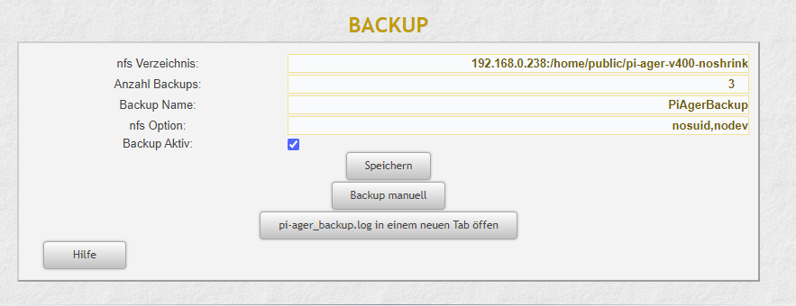

- Next start a terminal on the Pi-Ager and start the pi-ager_image.sh script with option -l:
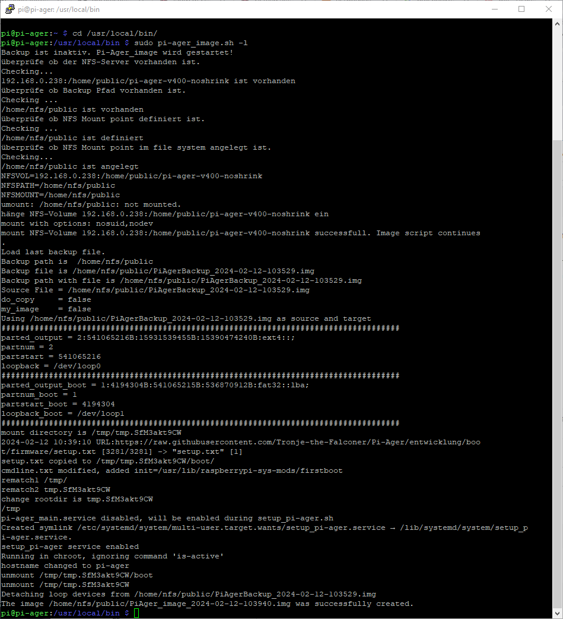
- Zip and deploy your new image.

