Pi-Ager install on Raspberry Pi 3/Pi 4/Pi 5/Pi zero (2)w under Pi OS 12 Lite Bookworm/Trixie

- For all Pi:
Download and install Raspberry Pi Imager v2.0.6 or later from https://www.raspberrypi.com/software/.

Start Raspberry Pi Imager, then continue with the follow steps:

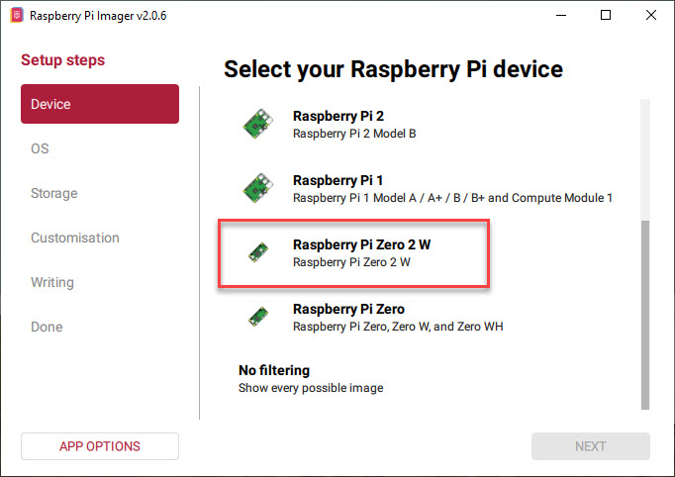

Select Pi-OS 32 Bit Trixie for Pi Zero (32-bit only)
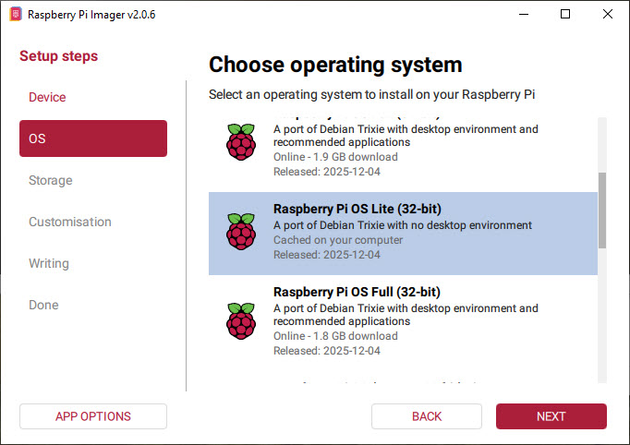

Or select Pi-OS 32 Bit Bookworm:
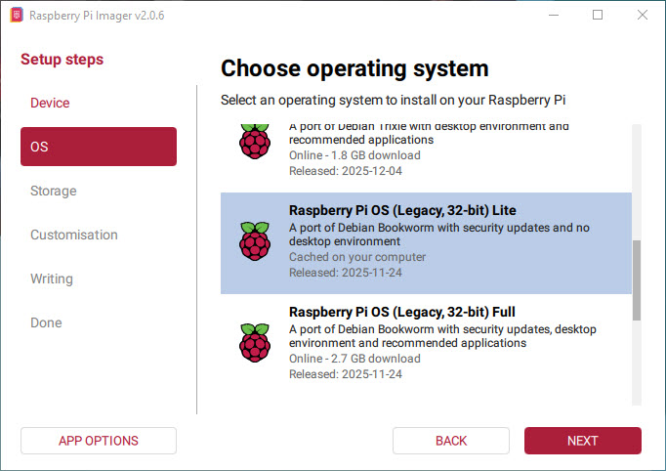

Or if you want to install pi-ager on Raspberry Pi-5 that needs a 64 Bit PI-OS, select Trixie.
Pi-4B, Pi-zero 2W also can use 64-bit Trixie.
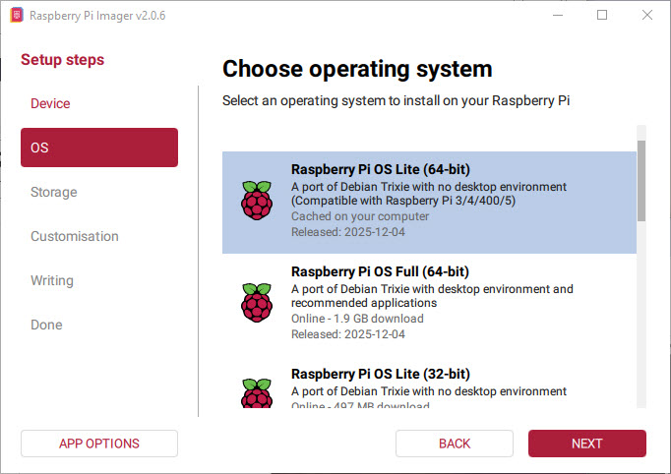

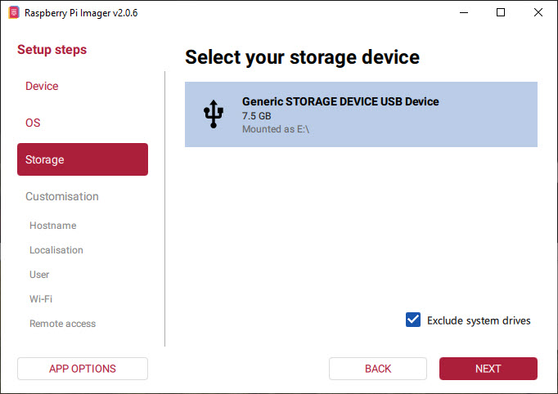

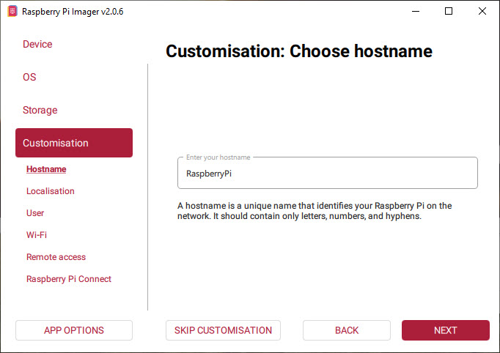

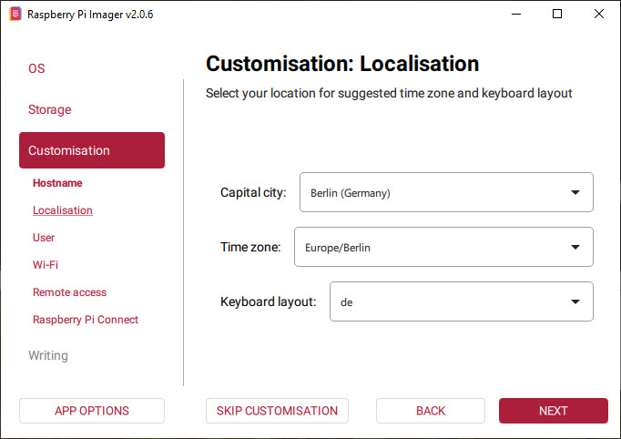

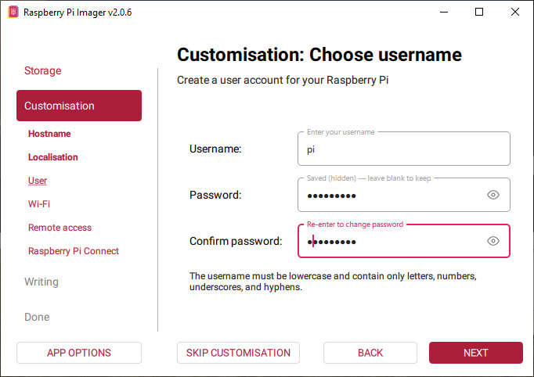

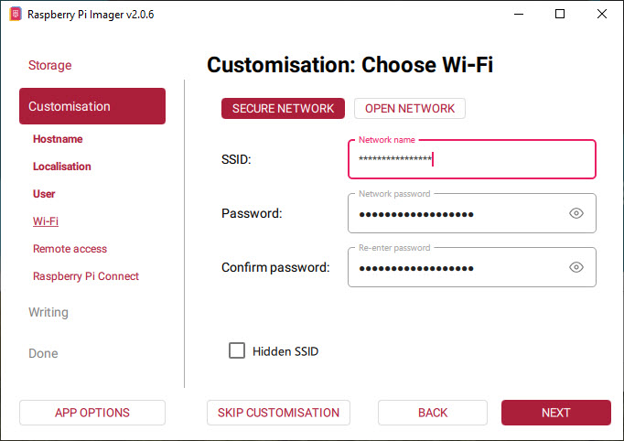

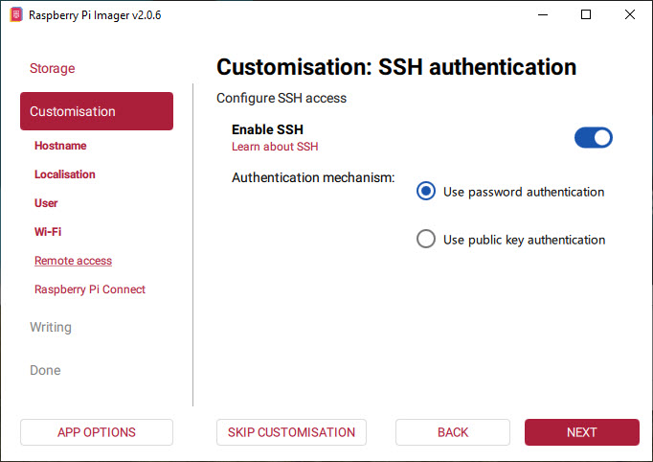

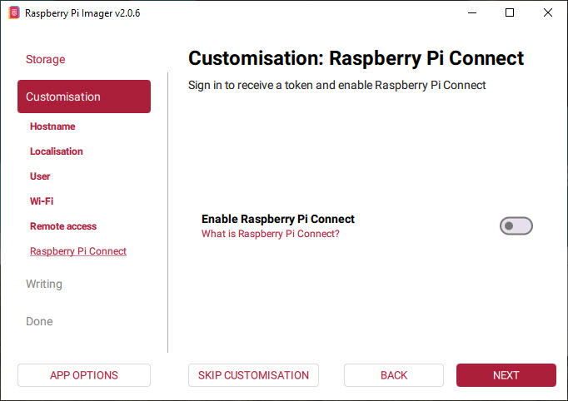

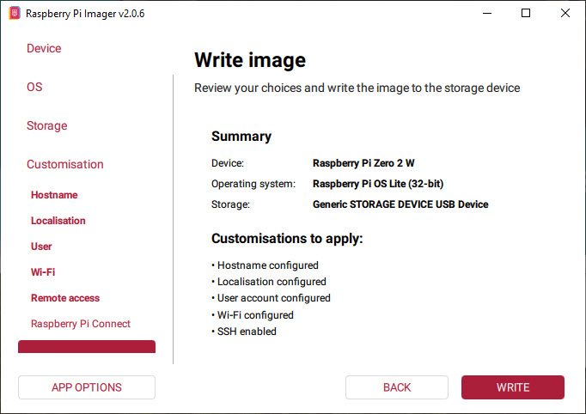

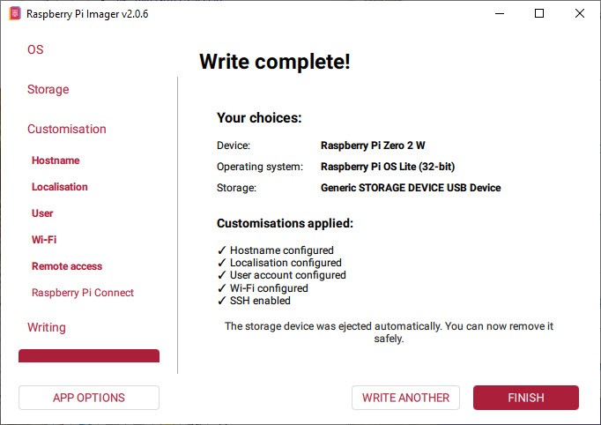

Put your SD-Card in your Raspberry Pi and power on your Pi device.
Login via SSH (e.g. use PuTTY) or connect a HDMI monitor and USB keyboard to
your Raspberry device and continue with the setup as described below.

- Download and install PuTTY from https://www.putty.org/

- Optional download and install WinSCP from https://winscp.net/eng/index.php

- Start PuTTY to connect to Pi-Ager:

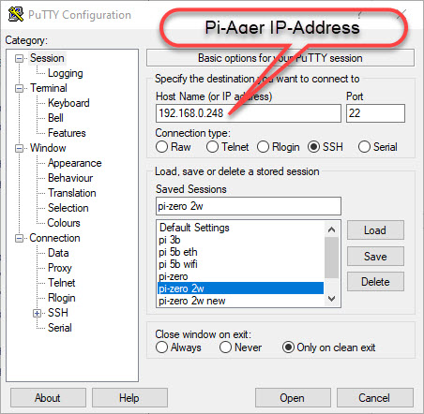

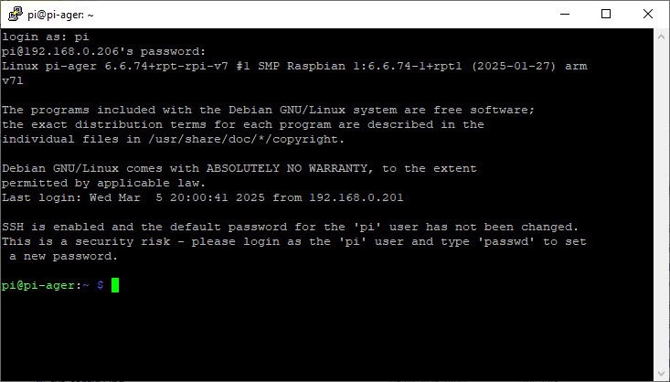

- Download system build scripts from github:
wget -O pi-ager-build-system.sh -nv https://github.com/Tronje-the-Falconer/Pi-Ager/raw/refs/heads/resources/anleitungen/pi-ager-build-system.sh

wget -O pi-ager-finalize-build.sh -nv https://github.com/Tronje-the-Falconer/Pi-Ager/raw/refs/heads/resources/anleitungen/pi-ager-finalize-build.sh

wget -O setup-wifi-ap.sh -nv https://github.com/Tronje-the-Falconer/Pi-Ager/raw/refs/heads/resources/anleitungen/setup-wifi-ap.sh

chmod +x *.sh

Start now first phase of Pi-Ager System setup:
sudo ./pi-ager-build-system.sh

You can now follow the system setup, that is divided in 3 steps with rebooting between the steps. Restart the script after rebooting to continue the system setup :

sudo ./pi-ager-build-system.sh

After step 2 you are informed to edit the file /boot/firmware/setup.txt that contains information about passwords, WLAN setup parameter, temperature/humidity sensor to use and optional HMI display version connected to your Pi-Ager:

sudo nano /boot/firmware/setup.txt
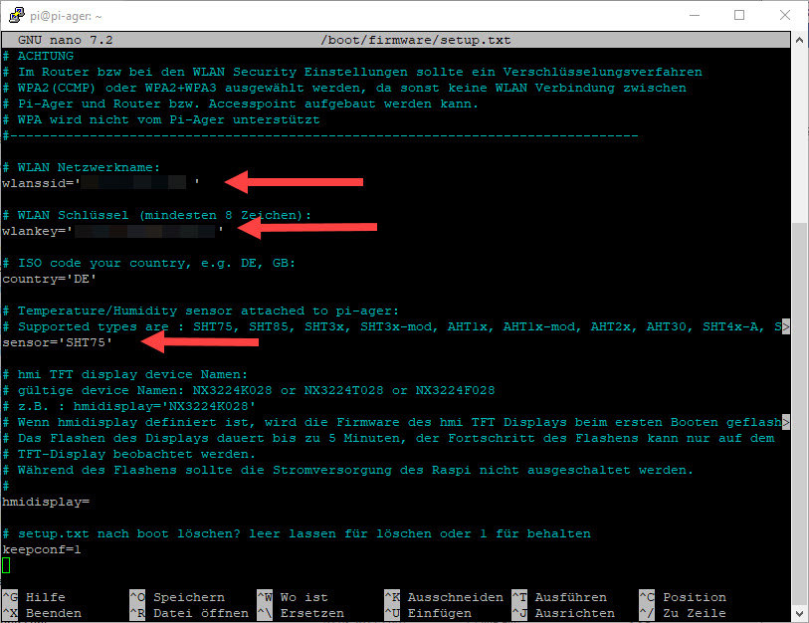

After saving setup.txt the last step initializes the Pi-Ager system with data from setup.txt by starting the script pi-ager-finalize-build.sh:

sudo ./pi-ager-finalize-build.sh

The system is then rebooted and ready to start the Pi-Ager. Open your browser window and enter the IP-Address of the Pi-Ager in the address line.

How to generate and deploy Pi-Ager Images

There are some steps to do for generating and deploying a new image from a running Pi-Ager system:
- Setup a NFS Server to store a new image. The best way is using a Raspi 4B or 5 equipped with an USB Memory stick with 128GB or more. Using RPi 5 it is now possible to add a NVME SSD so that there will be enough space for storing one or more images.
How to setup a NFS Server :
https://www.elektronik-kompendium.de/sites/raspberry-pi/2007061.htm
- On the Pi-Ager setup and start an Image backup on the ADMIN page. For example :

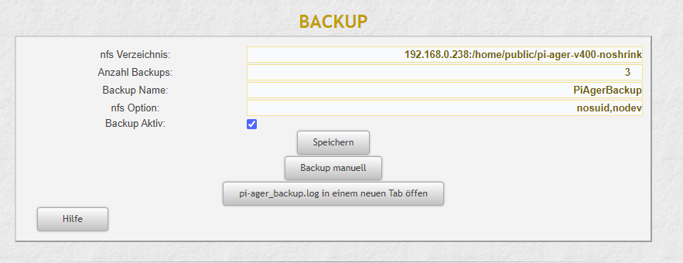

- Next start a terminal on the Pi-Ager and start the pi-ager_image.sh script with option -l: (lowercase ‘L’)
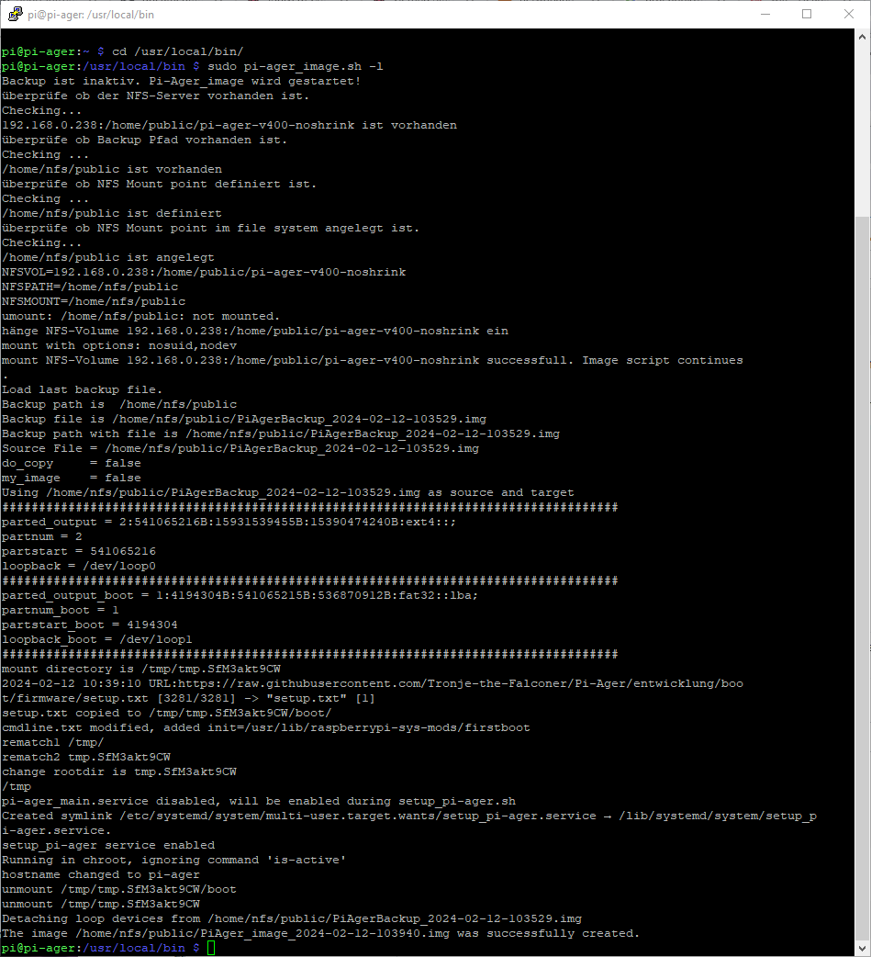
- Zip and deploy your new image.

