A+ Computer Science PONG PART II

Lab Goal : This lab was designed to teach you more object oriented programming and how to write a very simple game. You will show that you understand inheritance as well by creating the Ball class.

Lab Description : Complete the code for the Ball class located in Ball.java. Test the Ball class using the BallTestOne.java and BallTestTwo.java files. As you are testing Ball, you will also be retesting Block as Ball is and extension of Block.
The Ball is going to bounce around the screen. It will bounce around the screen because of checks placed in the BallTest. You can change the boundaries to create a larger field for the Ball. Eventually, the Ball will bounce off of the upper and lower walls and the paddles, but stop when it contacts the left and right walls.

public class Ball extends Block
{
private int xSpeed;
Sample Output ( BallTestOne.java )
200 200 10 10 java.awt.Color[r=0,g=0,b=0] 3 1
100 90 10 10 java.awt.Color[r=0,g=0,b=0] 3 1
100 100 30 50 java.awt.Color[r=0,g=0,b=0] 3 1
100 100 30 50 java.awt.Color[r=0,g=0,b=255] 3 1
100 100 30 50 java.awt.Color[r=0,g=0,b=255] 5 6
100 100 30 50 java.awt.Color[r=0,g=0,b=255] 5 6
false
true
private int ySpeed;

public Ball(){
super(200,200);
xSpeed = 3;
ySpeed = 1;
}

//add other Ball constructors

Files Needed ::
Block.java
Ball.java
BallTestOne.java
BallTestTwo.java
Tester.java

//set methods

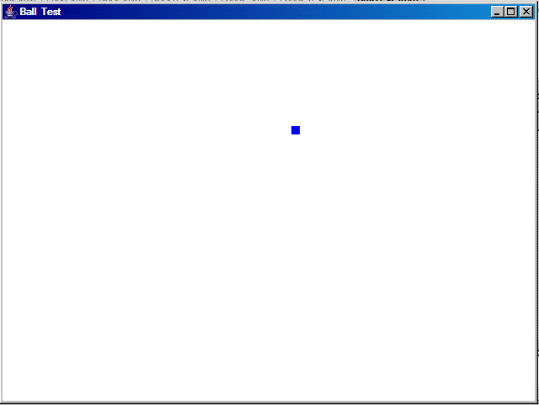
public void moveAndDraw(Graphics window)
{
//draw a white ball at
//old ball location
setX(getX()+xSpeed);
//setY
//draw ball at new location
}

//equals method

//get methods

public String toString(){
return " ";
}
}

